

expense tracker project

STUDENT’S NAME :- SHREYA KUMARI
REGISTRATION NUMBER :- 25BCE11290
BRANCH :- B.TECH[COMPUTER SCIENCE ENGINEERING]
ACADEMIC YEAR :- 2025(SEMESTER-1)

FACULTY NAME :- RAMRAJ DANGI
VITYARTHI TUTOR :- DR. LAKSHMI D

≿━━━━━━━━━━━━༺❀༻━━━━━━━━━━━≾

introduction

Expense tracker :-It is beneficial for effective financial management, whether for personal use or business operations, is crucial for achieving financial stability and making calculated economic decisions.
In today's fast-paced world, individuals and organizations often forget about their infinite uncalculated expense.
These manual processes make it challenging to gain a clear, real-time picture of spending habits and overall financial health.

Main Objective :- The main objectives of this project are to:
- Simplify Expense Logging: Provide a user-friendly interface for more quicker and accurate details like date, amount, and category.
- Enhance Financial Transparency: Allowing users to track their spending.

Target Audience :- This application is designed for individuals, students, who need a reliable and efficient way to manage their income and expenses. It is suitable for anyone seeking to improve their financial awareness and achieve specific financial goals, such as saving money or staying within a budget.

problem statement

Many individuals find it difficult to maintain a clear record of their daily expenses. They often lose track of their spending.
To solve this issue, there is a need for a lightweight and user-friendly tool that allows users to store , manage and view their expenses in an organized manner.
This tracker uses file handling and python programming to securely store expense records.
The system will allow users to add, view, delete expenses easily, helping them maintain a clear overview of their spending and make more informed financial decisions.

≿━━━━━━━━━━━༺❀༻━━━━━━━━━━━━≾

functional requirements

My project it has the following function working in different way:-
- Add expense:-
- Data
- Category
- Amount
- View all expenses:- it shows all the expenses you stored till the date.
- Delete a expense:- it delete the expense you think was wrongly entered.
- Summary :- it summarizes all the thing.
- Then all the data is saved in expenses.txt file.

≿━━━━━━━━━━༺❀༻━━━━━━━━━━━━≾

non-functional requirements

1. Usability: The system should be easy to use with a simple and clear menu interface.

2. Performance: All file operations must be fast and responsive.

3. Reliability: Expense data should be stored safely without loss or corruption.

4. Portability: The program should run on any system with Python installed.

5. Maintainability: The code should be modular so updates and changes can be made easily.

≿━━━━━━━━━━━༺❀༻━━━━━━━━━━━━≾

system architecture

The Expense Tracker follows a simple three-layer architecture that separates user interaction, processing logic, and data storage.
1. User Interface Layer
- Displays the main menu
- Takes user input (add, view, delete)
- Shows results back to the user
2. Application Logic Layer
- Validates inputs
- Processes operations like adding, viewing, deleting expenses
- Communicates between the UI and data layers
- Each feature is handled through separate Python modules
3. Data Storage Layer
- Stores all expense records in a text file (expenses.txt)
- Uses Python file handling (open, read, write)
- Ensures data is saved permanently even after the program is closed

[ User Main.py Function call File read/write Output Back to Main.py ]

use case diagram

work flow diagram

Sequence Diagram

Class/Component Diagram

Design Decisions & Rationale

Component | Decision | Rationale
Execution Environment | Python (Command Line Interface) | Python was selected for its simplicity, powerful standard library, and ease of use in scripting environments. It allows for rapid development of the core data processing logic (parsing, calculation, formatting) without the overhead of a full web framework.
Data Persistence | Plain Text File (.txt or .csv style) | Using a simple, delimited text file (simulating a basic CSV) was chosen to meet the project's requirement for file handling. This approach is the most straightforward demonstration of basic file I/O (read, write, append) and requires zero external dependencies, making the script highly portable and self-contained.
Data Format | Comma-Separated Values (CSV-style per line) | Each expense record will be stored on a new line in the file, with fields (e.g., Date, Category, Amount, Description) separated by a comma.
Interface | Terminal/Console Interface | The application interaction is managed via simple command-line prompts, optimizing for quick data entry and display in a non-GUI environment.

screenshots

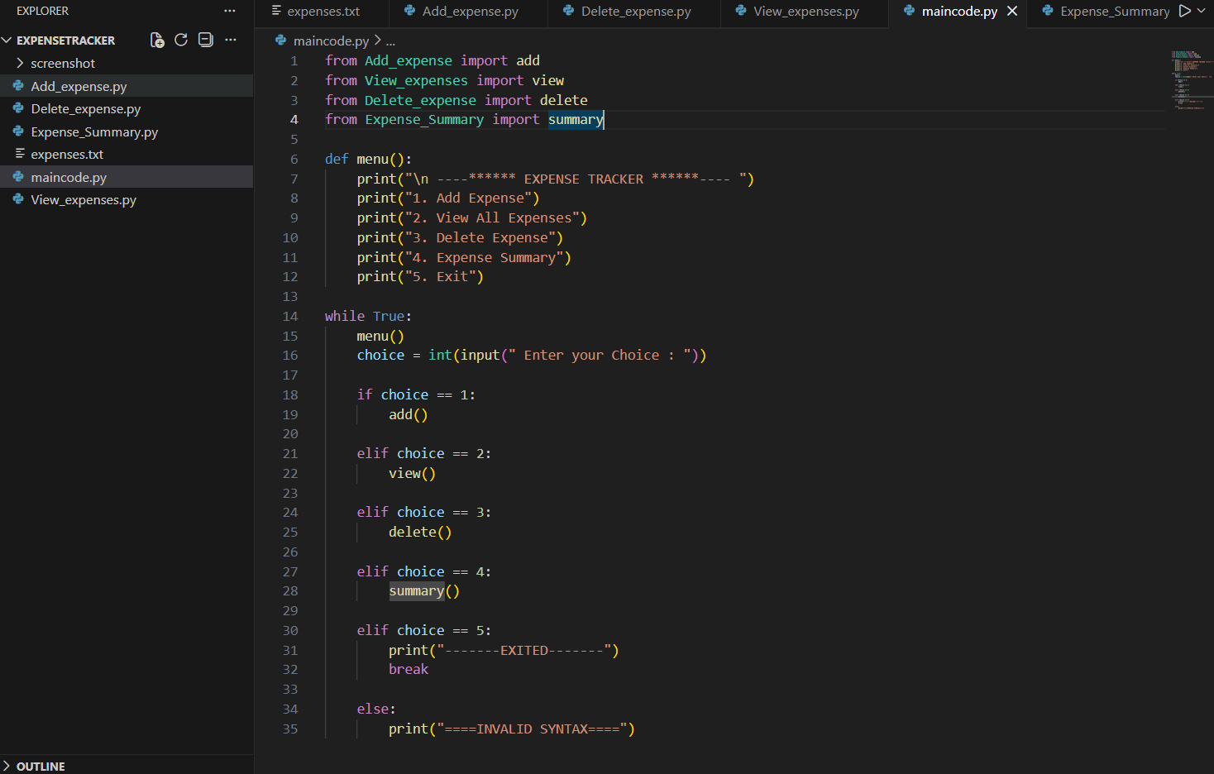

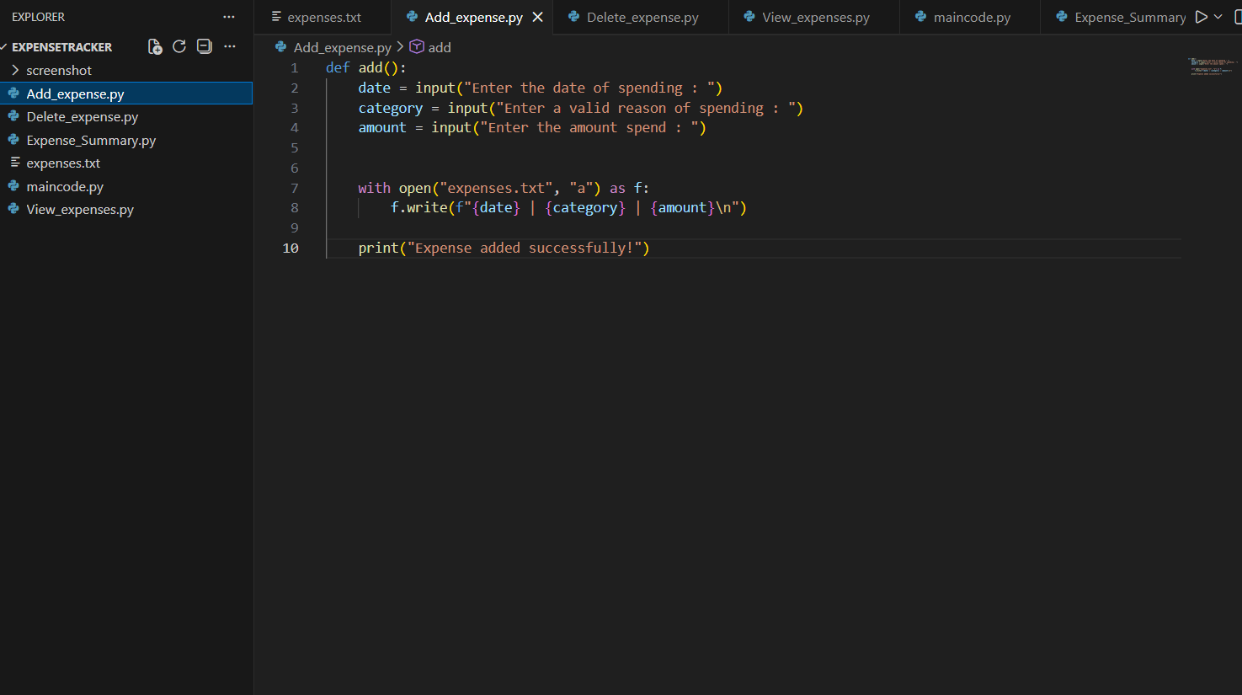
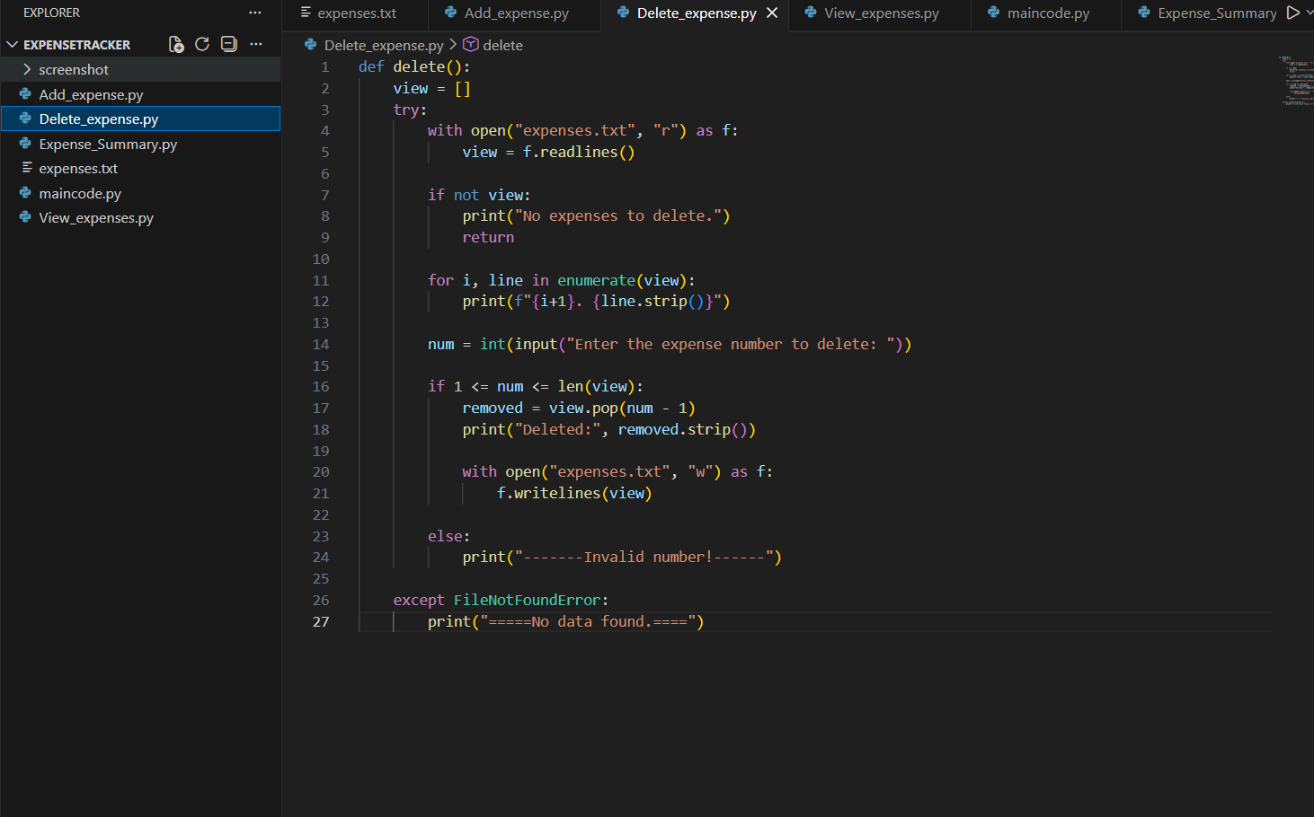

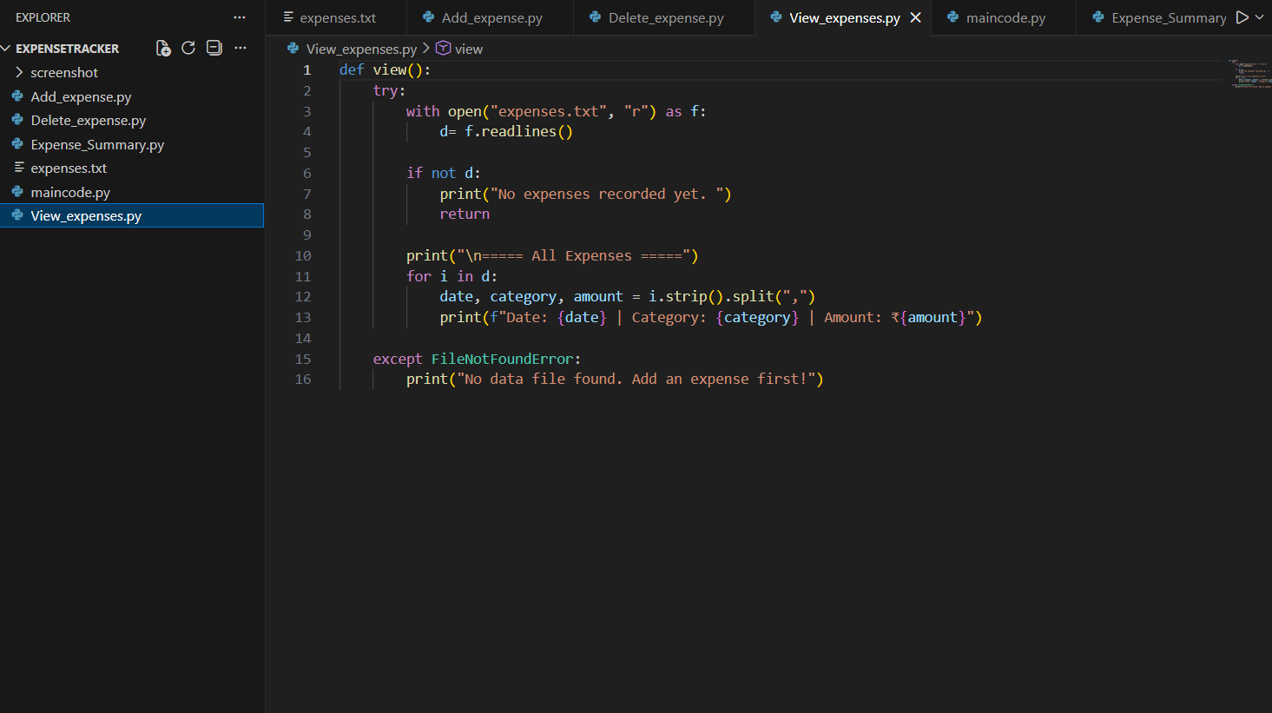
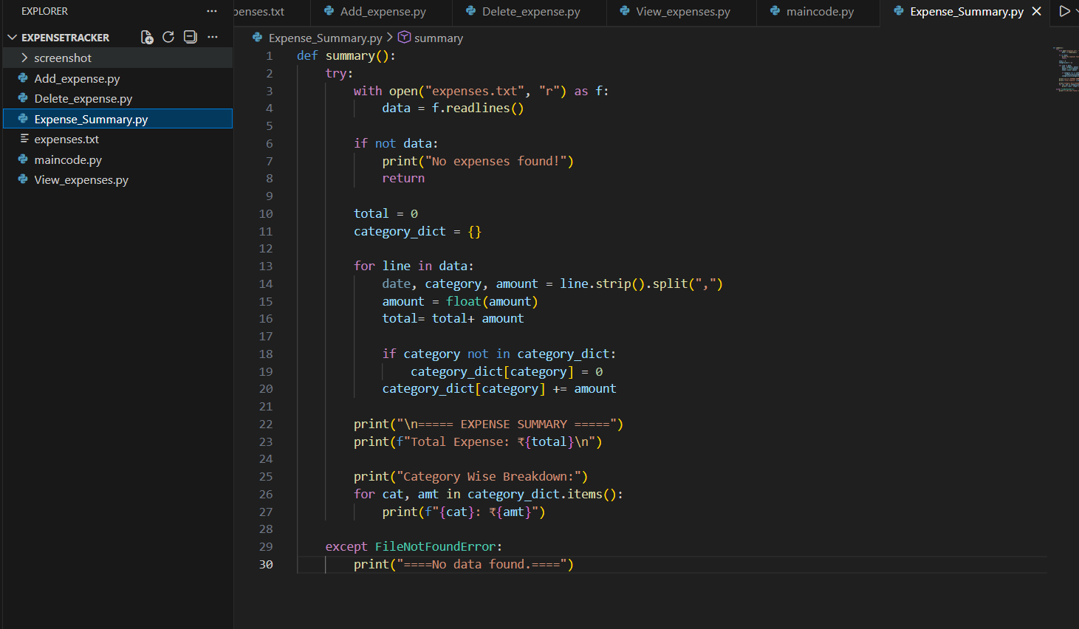

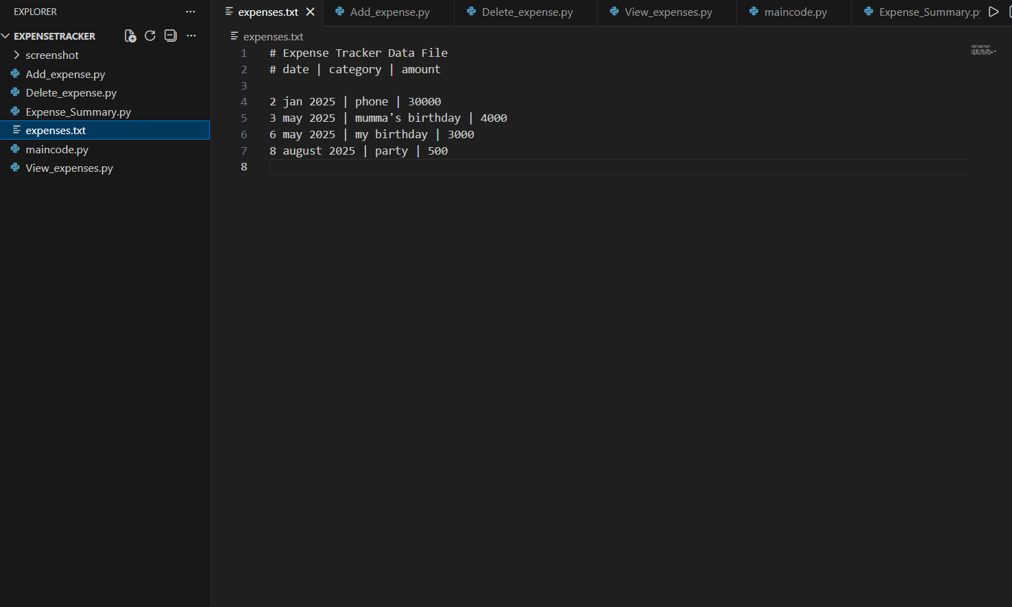
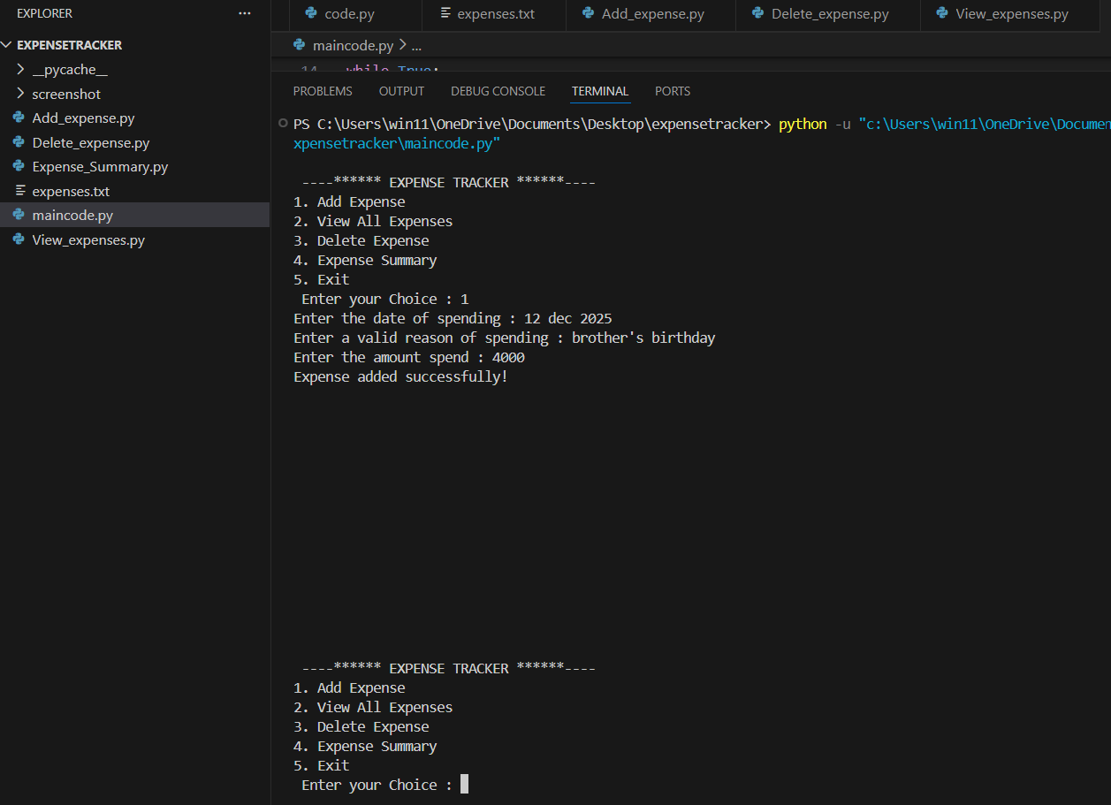

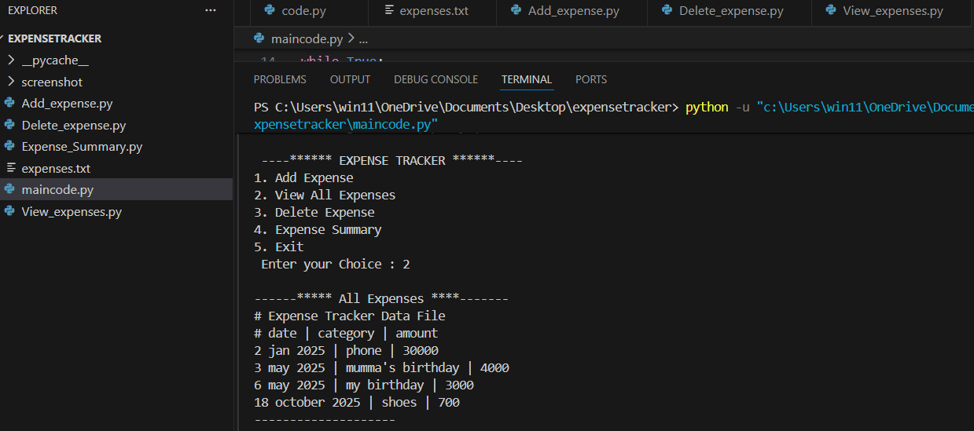

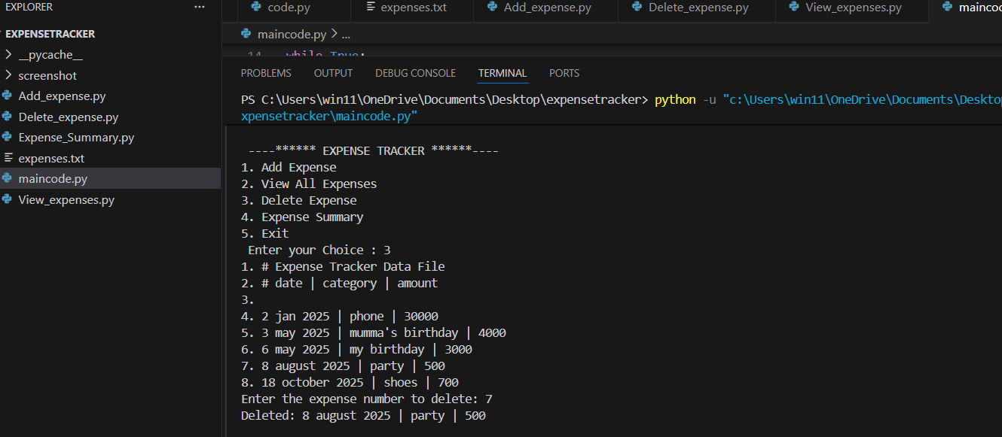

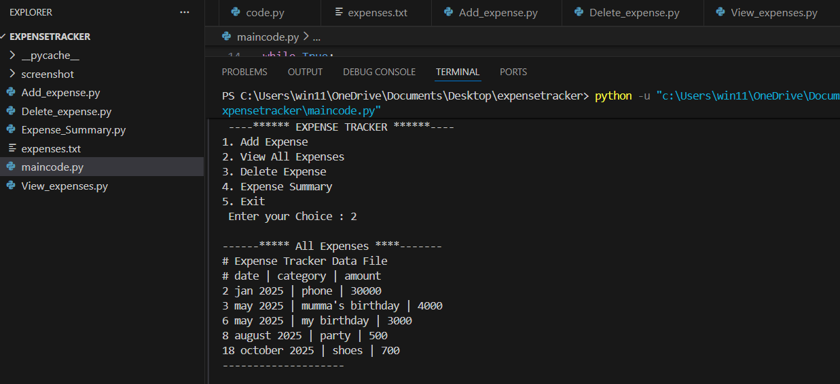

Challenges Faced

The challenges I faced during the working of this project:-
- Python programming as it was my first time doing this big project.
- Microsoft word as I have never used Microsoft word
- And also the designing .
- And git hub was also new to me.

Learnings & Key Takeaways

Financial and User Learnings
- Underestimation of Spending: The most significant financial takeaway is the universal tendency to underestimate personal or project expenditures. Tracking forces a confrontation with actual spending habits, revealing hidden "spending leaks" in areas like dining out or subscriptions.
- Prioritize Value-Adding Experiences: Tracking highlights areas of diminishing returns (e.g., excessive travel or alcohol consumption) versus activities that provide long-term value, such as health, personal growth, or non-material pursuits (books, creative work).
- The "Why" Behind Spending: Understanding the motivation behind purchases helps align spending with current values and long-term goals, promoting intentional spending rather than automatic consumption.
Technical and Project Learnings
- Prioritize Simplicity and Intuitive UI: Users from various backgrounds need an easy-to-use interface. A complex system, even with many features, can lead to user frustration and abandonment. Functional simplicity is key to user adoption.

future enhacements

Future enhancements for an expense tracker project commonly focus on automation, advanced insights, expanded functionality, and improved user experience
- Automation & Efficiency
- Advanced Analytics and Ai
- Expanded Functionality
- User Experience (UX) Enhancements

References

The references I used to complete my project:-

- Vs.code
- File handling
- Python:
- E.balaguruswamy
- Oop python books
- Wikipedia.com

