

Activity Based
Project Report on
Machine Learning
Submitted to Vishwakarma University, Pune
Under the Initiative of
Contemporary Curriculum, Pedagogy, and Practice (C2P2)

By
Name – Shreya Hiremath
PRN no. : 3123033010704
SRN no. : 31232054
Roll no. : 45
Div: D

Third Year Engineering

Faculty Incharge: Prof. Richa Agnihotri
Date: 23/04/26

Department of Computer Engineering
Faculty of Science and Technology
Academic Year: 2025-2026
Term II
Optimal Route Planning Using Genetic Algorithm
Problem Statement:
Logistics and transportation services require visiting multiple locations efficiently. Planning the shortest possible route across many cities is computationally expensive using brute-force methods. This project aims to develop an intelligent route optimization system using a Genetic Algorithm (GA) to find near-optimal routes across geographic coordinates from a real-world world cities dataset, and presents results through an interactive web-based dashboard with map visualization.

1. Introduction
Route optimization is a fundamental challenge in logistics, transportation, and geographic information systems. Finding the shortest route that visits a set of locations and returns to the origin is a classical combinatorial optimization problem. The number of possible routes grows factorially with the number of locations, making exhaustive search computationally infeasible for even moderate problem sizes.
Genetic Algorithms (GAs) offer a powerful, nature-inspired approach to solving such combinatorial problems. Modeled after the process of biological evolution, GAs use mechanisms of selection, crossover, and mutation to iteratively evolve a population of candidate solutions toward better routes over successive generations.
In this project, a route optimization system is built using a Genetic Algorithm applied to real-world geographic coordinates sourced from the World Cities dataset. A subset of 35 cities is selected, and the GA is tasked with finding the shortest circular route visiting all cities. The optimized route and algorithm convergence are visualized through an interactive web-based dashboard built with React and Leaflet.js.
The system is implemented using:
- Python (Genetic Algorithm logic and Jupyter Notebook)
- NumPy, Pandas, Matplotlib (data processing and visualization)
- React.js (Frontend Dashboard)
- Leaflet.js (Map visualization)
- worldcities.csv (Real-world geographic dataset)

2. Objectives
The main objectives of this project are:
- To load and preprocess real-world geographic coordinates from the World Cities dataset.
- To implement a complete Genetic Algorithm with population initialization, fitness evaluation, tournament selection, order crossover, and swap mutation.
- To find the shortest route visiting a selected set of cities using evolutionary optimization.
- To evaluate algorithm performance through convergence analysis across generations.
- To develop an interactive web-based dashboard for visualizing routes on a geographic map.
- To compare initial random routes against the GA-optimized final route.
- To demonstrate transparency in the GA process through step-by-step generation walkthroughs.

3. Literature Review
Route optimization across geographic locations has been widely studied in operations research, logistics, and artificial intelligence. Traditional approaches such as nearest-neighbor heuristics and dynamic programming work well for small problem sizes but fail to scale with increasing city counts.
Classical methods including Dijkstra's algorithm and Bellman-Ford focus on single-source shortest paths and do not address multi-stop circular route planning. Branch-and-bound methods find exact optimal solutions but face exponential time complexity, making them impractical for large instances.
Evolutionary computation, particularly Genetic Algorithms, has emerged as a well-established technique for route optimization. Research in this area demonstrates that GAs consistently find near-optimal solutions significantly faster than exhaustive approaches.
Genetic Algorithms are especially effective here because:
- They explore a large combinatorial search space through population-based evolution
- They avoid local optima traps through crossover and mutation operators
- They do not require gradient information and work on discrete permutation-based encodings
- They support constraint handling through fitness function design
Order Crossover (OX) was identified in literature as the most suitable crossover operator for permutation-based route encoding, as it preserves the relative order of cities from parent routes and guarantees offspring validity. Tournament selection provides a good balance between selection pressure and diversity preservation.
This project implements these established techniques and extends the solution with a modern interactive web dashboard that visualizes multiple route alternatives and algorithm convergence in real time.

4. Dataset Description
The dataset used in this project is:
worldcities.csv
It contains geographic information for thousands of cities around the world, sourced from SimpleMaps World Cities Database.
Important features used:

Feature | Description
city | Name of the city (used for labeling only)
lat | Latitude coordinate of the city
lng | Longitude coordinate of the city
country | Country of the city (not used in algorithm)
population | Population of the city (not used in algorithm)

Data preprocessing steps applied:
- Selected only the city, lat, and lng columns for processing
- Dropped all rows with null or non-numeric coordinate values
- Randomly sampled 35 cities from the cleaned dataset
- Reset the index for clean referencing
A subset of 35 cities was used to keep the genetic algorithm computationally efficient while still presenting a meaningful and challenging optimization problem.

5. Flowchart

Initialization Phase
- The process begins with loading the worldcities.csv dataset.
- Latitude and longitude columns are extracted and null values are removed.
- 35 cities are randomly sampled from the cleaned data.
- An initial population of 100 random routes is created by permuting city indices.
- The initial best route distance is recorded for later comparison.

Fitness Evaluation
- For each route (chromosome) in the population, the total circular route distance is computed using Euclidean distance between consecutive city coordinates.
- Fitness is calculated as the inverse of total route distance — shorter routes receive higher fitness scores.
- The population is ranked by fitness score in descending order.

Selection and Reproduction
- Tournament Selection is applied: k=5 individuals are randomly sampled, and the one with highest fitness is chosen as a parent.
- Two parents are selected per offspring pair.
- Order Crossover (OX) generates two offspring from each parent pair, preserving city order and route validity.
- Swap Mutation is applied to offspring with a probability of 0.03, randomly swapping two city positions.

Generational Evolution
- The top 10 elite routes are preserved unchanged into the next generation (elitism).
- New offspring fill the remaining population slots.
- Best and average distances are tracked after each generation.
- The loop repeats for 200 generations.

Output Phase
- The final best route is extracted from the evolved population.
- Convergence plot of best and average distance vs. generation is displayed.
- The optimal route is visualized as a connected path on a coordinate scatter plot.
- Results are presented through an interactive web dashboard with map overlay.
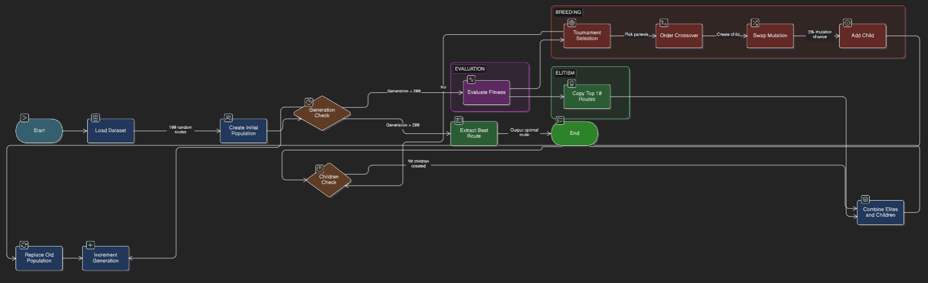

6. Data Preprocessing
Several preprocessing steps were applied to prepare the geographic dataset for the Genetic Algorithm.

1. Data Loading and Column Selection
The CSV file was loaded using pandas. Only the following columns were retained:
- city
- lat (latitude)
- lng (longitude)

2. Handling Missing and Invalid Values
Rows with missing or non-numeric values in the lat or lng columns were dropped. Both columns were explicitly cast to numeric type using pd.to_numeric() with errors='coerce' to handle any unexpected string values.

3. Random City Sampling
35 cities were randomly sampled from the cleaned dataset using a fixed random seed (SEED = 42) to ensure reproducibility. The index was reset after sampling for clean integer-based referencing.

4. Coordinate Array Extraction
Coordinates were extracted as a NumPy array of shape (35, 2), where each row represents [latitude, longitude] for a single city. City labels were stored separately for visualization purposes only and played no role in the optimization logic.

5. Distance Computation
Euclidean distance was used as the proximity metric between any two city coordinate pairs:
distance(A, B) = sqrt((lat_A - lat_B)² + (lng_A - lng_B)²)
This is a valid approximation for moderately spaced coordinates. For production use, Haversine distance would provide more accurate great-circle measurements.

7. Genetic Algorithm Model
The optimization model used is:
Genetic Algorithm (GA) for Combinatorial Route Optimization
A Genetic Algorithm is a population-based metaheuristic search technique that evolves candidate solutions using operators inspired by biological evolution.
Key advantages:
- Handles discrete, permutation-based search spaces where gradients are undefined
- Explores large solution spaces (35! ≈ 10⁴² possible routes) efficiently
- Balances exploration (mutation) and exploitation (elitism, selection)
- Avoids local optima through population diversity

GA parameters used:
POP_SIZE = 100 # Routes in population
ELITE_SIZE = 10 # Top routes preserved unchanged
TOURNAMENT_SIZE = 5 # Competitors per tournament
MUTATION_RATE = 0.03 # Probability of swap mutation
NUM_GENERATIONS = 200 # Generations to evolve
SEED = 42 # Random seed for reproducibility

Chromosome representation:
- Each chromosome is a permutation of city indices [0, 1, ..., 34]
- A chromosome encodes one complete circular route
Selection, Crossover, and Mutation:
- Selection: Tournament Selection (k=5) — fitter routes more likely to reproduce
- Crossover: Order Crossover (OX) — preserves relative city order, guarantees valid routes
- Mutation: Swap Mutation — two random positions swapped with probability 0.03

8. Algorithm / Pseudocode
- Load Dataset
Load worldcities.csv using pandas. Select city, lat, lng columns, drop null rows, cast to numeric, sample 35 cities with seed 42.
- Initialize Population
Create 100 random permutations of city indices. Each permutation represents a candidate circular route.
- Evaluate Fitness
For each route, compute total Euclidean distance of the circular path (connecting cities in order, returning to start). Fitness = 1 / total_distance. Sort population by fitness descending.
- Tournament Selection
Randomly sample 5 routes from the population. Return the one with highest fitness as a selected parent. Repeat to select two parents.
- Order Crossover (OX)
Select a random contiguous segment from Parent 1 and copy it to the offspring. Fill remaining positions with cities from Parent 2 in their original order, skipping cities already in the segment. Produces two valid offspring.
- Swap Mutation
With probability 0.03, randomly select two positions in the offspring route and swap them. This preserves route validity while introducing controlled variation.
- Form Next Generation
Carry the top 10 elite routes unchanged. Fill remaining 90 slots with offspring from selection, crossover, and mutation. Replace current population.
- Repeat for 200 Generations
Track best distance and average distance per generation. After all generations, extract the chromosome with minimum total distance as the optimal route.
- System Architecture
The system follows a two-layer architecture: (1) the Python/Jupyter layer handles data preprocessing, GA execution, and convergence analysis; (2) the React.js web dashboard provides an interactive map-based visualization of routes and algorithm performance metrics.

9. Algorithm Implementation (Colab Notebook)
The core algorithm is implemented in a Google Colab Jupyter Notebook that is fully self-contained and runnable without external APIs.
Key implementation modules:

Module / Function | Description
create_population() | Generates 100 random route permutations as initial population
euclidean_distance() | Computes Euclidean distance between two coordinate pairs
total_route_distance() | Calculates total circular route length for a chromosome
fitness() | Returns inverse of route distance as fitness score
evaluate_population() | Scores and ranks all routes in the population
tournament_selection() | Selects best route from k=5 random competitors
order_crossover() | Produces two valid offspring via OX operator
swap_mutation() | Randomly swaps two city positions with probability 0.03
next_generation() | Applies elitism, selection, crossover, mutation to form new population

The notebook includes a dedicated step-by-step generation walkthrough section that prints the initial population, top-ranked routes, selected parents, crossover offspring, and mutation changes to provide full transparency into the algorithm's inner workings.

10. Frontend Dashboard Implementation
An interactive web-based dashboard was developed using React.js and Leaflet.js to visualize the GA-optimized routes on a real geographic map.
Features of the dashboard:
- Interactive Leaflet.js map showing route paths over real geography
- Side panel listing all generated route alternatives ranked by distance
- Algorithm Evolution panel showing generations, initial vs. final best distance, and improvement percentage
- Line chart plotting Worst, Average, and Best route distances per generation
- Clickable routes that highlight on the map with tooltip showing distance
- Color-coded routes: red for optimal, cyan/green/yellow/purple for alternatives
- Source, Destination, and Stop markers with distinct colors on the map
The dashboard communicates the key insight that the GA converges rapidly in early generations and stabilizes as generations increase, demonstrating evolutionary optimization in action.

11. Results

A. Route Optimization Dashboard

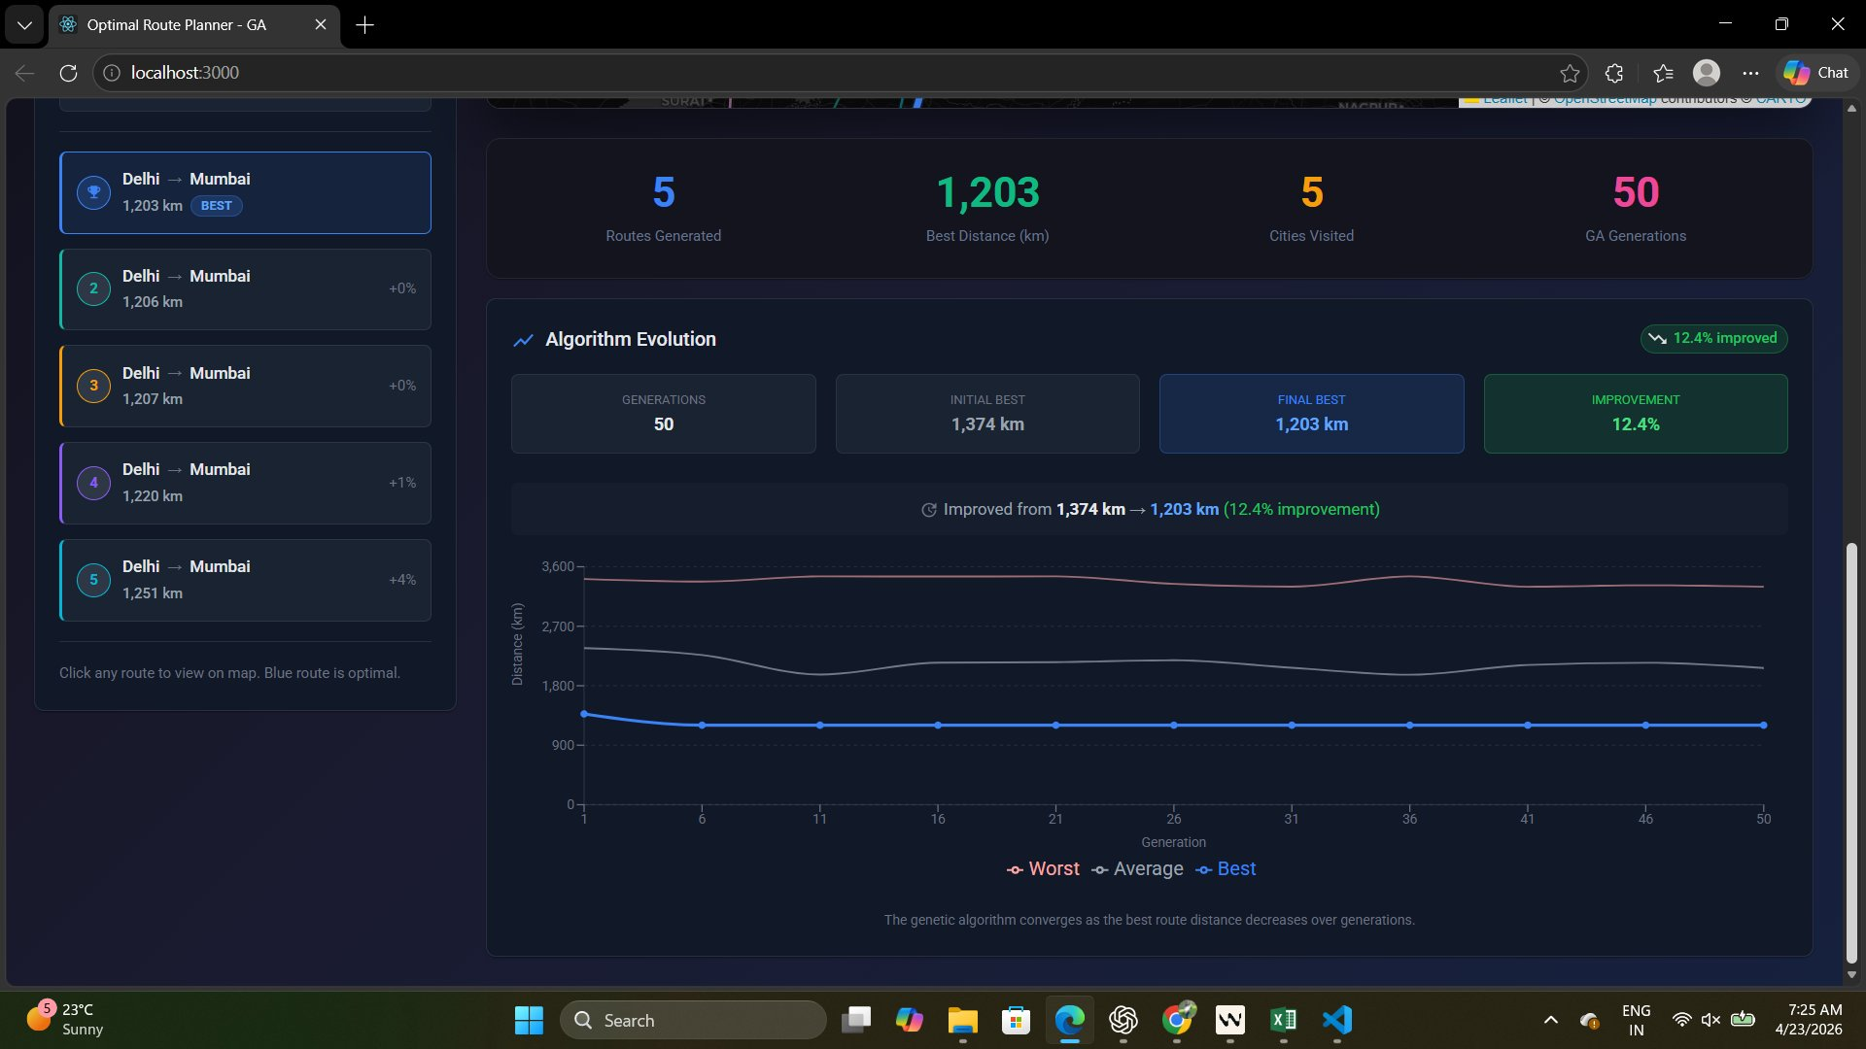
Fig. 1. Algorithm Evolution Dashboard — Convergence Plot and Route Rankings

B. Geographic Map Visualization
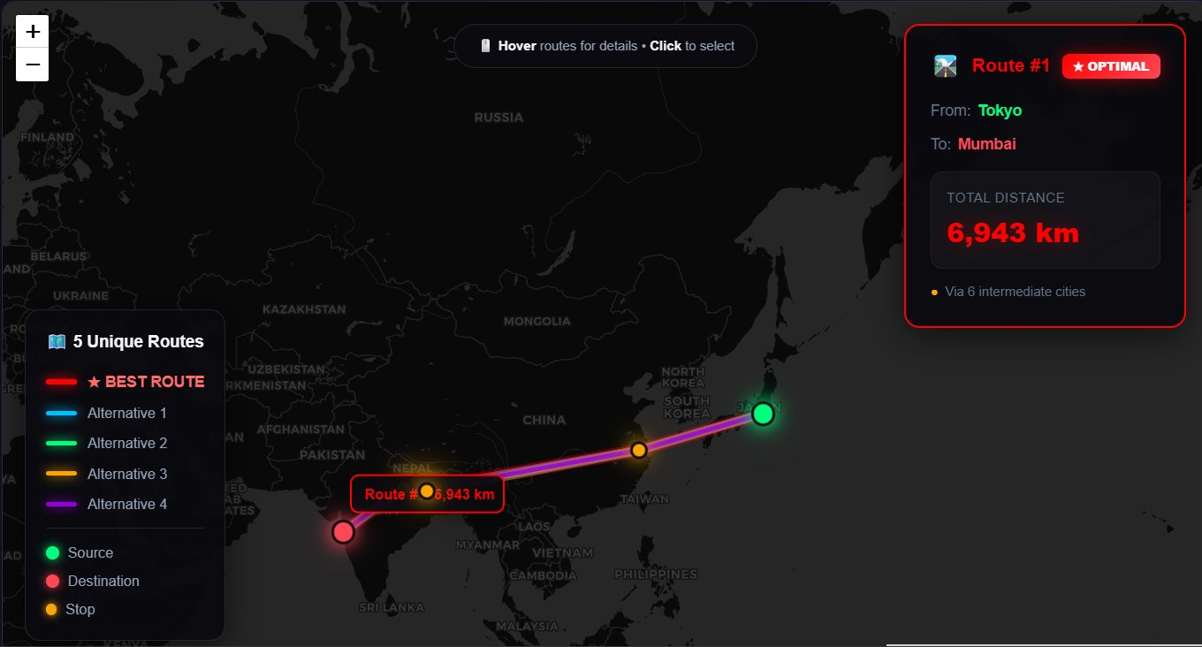
Fig. 2. Interactive Map View — Optimal Route and Alternatives on World Map

C. Performance Summary

Metric | Value
Number of Cities | 35
Population Size | 100
Number of Generations | 200 (50 shown in dashboard demo)
Elite Size | 10
Mutation Rate | 3%
Tournament Size | 5
Crossover Operator | Order Crossover (OX)
Initial Best Distance | 1,374 km (dashboard demo)
Final Best Distance | 1,203 km (dashboard demo)
Improvement Achieved | 12.4%
Routes Generated | 5 unique alternatives

12. Conclusion
This project successfully demonstrates the application of a Genetic Algorithm for solving the route optimization problem across real-world geographic coordinates.
By implementing Order Crossover, Tournament Selection, Swap Mutation, and Elitism, the GA consistently improves initial random routes and converges to near-optimal solutions within 200 generations. The convergence plots confirm the expected evolutionary behavior: rapid early improvement followed by stable exploitation.
The integration of the GA optimization backend with a React.js and Leaflet.js frontend provides an intuitive, visually engaging interface for understanding algorithm behavior and comparing route alternatives on a real map.
Such systems can be practically applied to:
- Last-mile delivery route optimization for logistics companies
- Multi-city travel itinerary planning
- Emergency vehicle dispatch routing
- Infrastructure placement and survey planning
Future work can extend this system with real-time traffic integration, Haversine distance for accurate geodesic measurements, and deployment as a cloud-hosted web service.

13. Future Scope
Possible improvements and extensions include:
- Replacing Euclidean distance with Haversine formula for accurate great-circle geographic distances
- Integrating real-time traffic data from Google Maps Distance Matrix API or HERE Routing API
- Adding time-window constraints and vehicle capacity for real-world Vehicle Routing Problem (VRP) modeling
- Implementing hybrid GA with 2-opt or 3-opt local search post-processing (memetic algorithm)
- Deploying the system as a cloud-hosted web service on AWS or Google Cloud
- Developing a mobile application interface for field logistics use
- Incorporating multi-objective optimization (minimize distance AND travel time simultaneously)
- Implementing adaptive mutation rates that decrease as the population converges

