ARTIFICIAL INTELLIGENCE & SOFT COMPUTING
Project Report

CityCare Voice AI: An Inbound Hospital Voice Receptionist with Fuzzy-Logic Triage and Naive Bayes Department Routing

Submitted by: Shreyaan Datta
Source code: github.com/shreyaandatta/CityCare-Voice-AI

1. Abstract
Hospitals receive many phone calls that range from routine appointment requests to life-threatening emergencies. This project builds an AI voice receptionist for a fictional hospital, CityCare. The agent answers calls in English or Hindi, gives hospital information, and collects patient details. After each call, a soft-computing pipeline decides how urgent the call is using a Mamdani fuzzy inference system, routes it to a department using a Multinomial Naive Bayes classifier, suggests a doctor and time slot, and alerts the emergency desk when needed. Staff see all calls on a dashboard sorted by urgency.

2. Problem Statement and Objectives
Reception desks miss calls at busy times, and urgency is judged inconsistently. Urgency is also vague by nature: 'a lot of pain' or 'an elderly patient' are not crisp values, which makes fixed if-else thresholds brittle. The objectives are to:
- Answer every inbound call with a conversational voice agent.
- Model triage urgency with fuzzy logic so that vague, overlapping symptoms give smooth, explainable decisions.
- Route each call to the correct department with a trained machine-learning classifier.
- Suggest an appointment slot, flag emergencies, and let callers check their appointment status.
- Store every call and show it to staff in priority order.

3. AI & Soft Computing Concepts Used
Concept | Use in this project
Intelligent agent | The voice agent perceives speech and acts by replying and saving records.
Natural Language Processing | Speech-to-text, LLM dialogue, text-to-speech (Retell AI).
Information extraction | Post-call analysis extracts name, phone, age, symptoms, request type.
Fuzzy logic | Fuzzification, 15-rule Mamdani inference, centroid defuzzification for triage.
Machine learning | Multinomial Naive Bayes text classifier for department routing.
Heuristic knowledge | Weighted symptom lexicon with negation handling; expert rule base.
Rule-based reasoning | Safety override: red-flag symptoms go straight to the Emergency department.

3.1 PEAS description of the agent
Element | Description
Performance | Correct triage and department, complete details captured, short calls, no missed emergencies.
Environment | Phone calls from patients and relatives; hospital knowledge base; doctor schedules.
Actuators | Synthesised voice, webhook to n8n, database records, ER alert email.
Sensors | Caller's audio (speech-to-text), caller ID, function-call results.

The environment is partially observable, stochastic, sequential and dynamic.

4. System Architecture
- Retell AI voice agent 'Riya': speech recognition, LLM receptionist, speech synthesis, post-call analysis.
- n8n call pipeline: Webhook → Is call finished? → Extract record → Fuzzy Triage → Department Router → Load Doctors → Pick Doctor & Slot → Save to CityCare_Calls → Is Emergency? → Alert ER desk.
- n8n API workflow: /citycare-status (used by the agent mid-call) and /citycare-calls (dashboard feed, key-protected).
- Data tables: CityCare_Calls (call records) and Doctors (department, days, timings).
- Staff dashboard: a static web page listing calls by triage score.

5. Fuzzy Triage System

5.1 Feature extraction (crisp inputs)
The caller's words are scored against a weighted lexicon, for example 'chest pain' = 6, 'unconscious' = 8, 'fever' = 4, 'cough' = 1 and 'checkup' = −1. Longer phrases are matched first so 'chest pain' is not also counted as 'pain', and negated mentions such as 'no fever' are ignored. Age adds to vulnerability (5 points for under 5 or over 65). Time words such as 'today', 'tomorrow' or 'next week' set the delay.

5.2 Membership functions
All sets are trapezoidal; a triangle is a trapezoid with equal middle points [a, b, b, c].
Variable | Fuzzy set | Points (a, b, c, d)
severity | mild | 0, 0, 2, 4
severity | moderate | 2, 5, 5, 8
severity | severe | 6, 8, 10, 10
distress | calm | 0, 0, 2, 4
distress | anxious | 2, 5, 5, 8
distress | panicked | 6, 8, 10, 10
vulnerability | low | 0, 0, 2, 4
vulnerability | medium | 2, 5, 5, 8
vulnerability | high | 6, 8, 10, 10
delay | immediate | 0, 0, 1, 3
delay | soon | 1, 5, 5, 12
delay | flexible | 8, 15, 30, 30
triage | routine | 0, 0, 25, 45
triage | urgent | 30, 55, 55, 80
triage | emergency | 65, 85, 100, 100

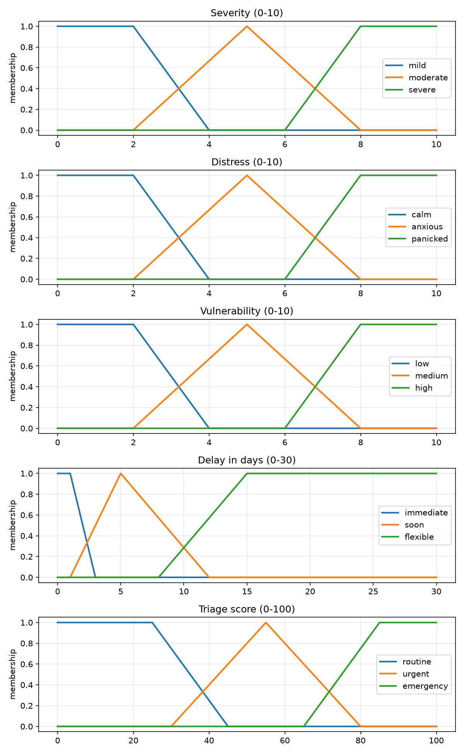
Figure 1: Membership functions

5.3 Rule base
# | IF | THEN triage is
1 | severity is severe | emergency
2 | severity is moderate AND distress is panicked | emergency
3 | severity is moderate AND vulnerability is high | urgent
4 | severity is moderate AND vulnerability is medium | urgent
5 | severity is moderate AND vulnerability is low | urgent
6 | severity is moderate AND delay is immediate | urgent
7 | severity is mild AND distress is panicked | urgent
8 | severity is mild AND vulnerability is high | urgent
9 | severity is mild AND delay is immediate | urgent
10 | severity is mild AND distress is anxious AND delay is soon | urgent
11 | severity is mild AND distress is calm AND vulnerability is low AND delay is flexible | routine
12 | severity is mild AND distress is calm AND vulnerability is low AND delay is soon | routine
13 | severity is mild AND distress is calm AND vulnerability is medium | routine
14 | severity is mild AND distress is anxious AND vulnerability is low AND delay is flexible | routine
15 | severity is mild AND distress is anxious AND vulnerability is medium AND delay is flexible | routine

5.4 Inference and defuzzification
Mamdani inference is used: AND is the minimum of the memberships, each rule clips its output set, and the clipped sets are combined with the maximum. The centroid of the combined area gives a crisp score from 0 to 100: below 40 is Routine, 40 to 70 is Urgent, and above 70 is Emergency.
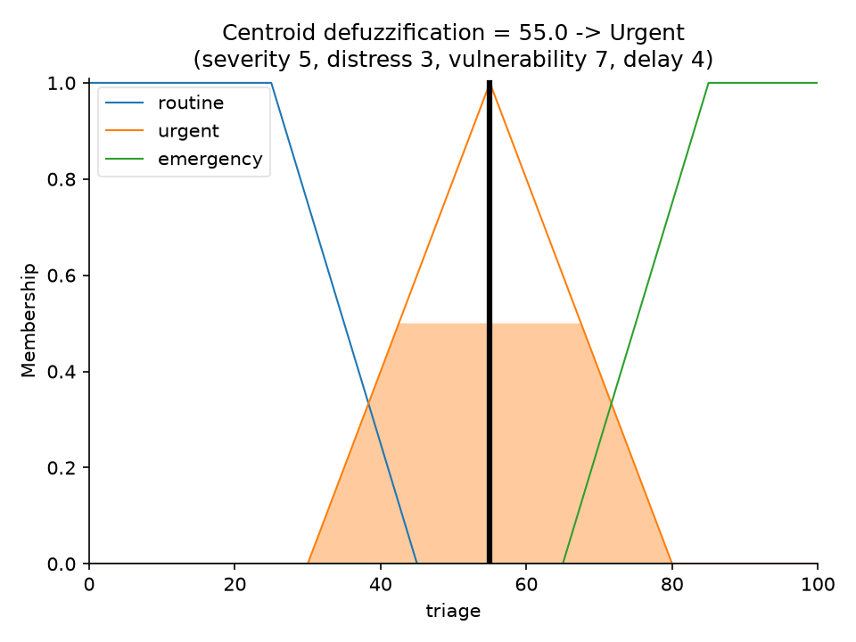
Figure 2: Worked defuzzification example
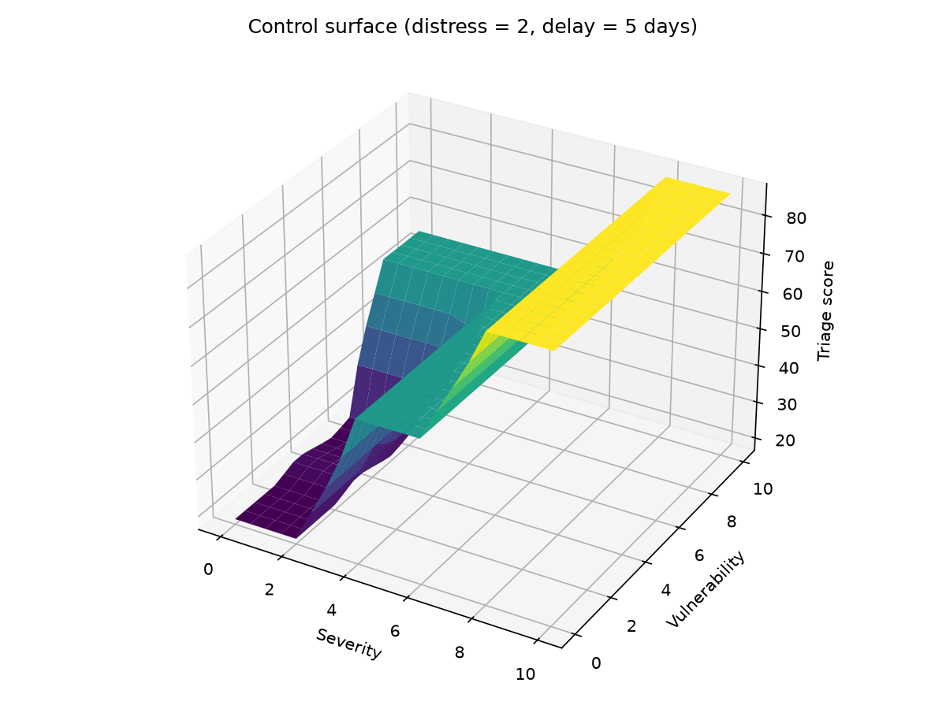
Figure 3: Control surface (severity × vulnerability)

5.5 Results on sample calls
Call | Sev | Dis | Vul | Delay | Score | Label | As expected
Routine check-up | 0.0 | 0.0 | 0.0 | 30.0 | 18.0 | Routine | ✓
Report collection | 0.0 | 0.0 | 0.0 | 9.0 | 20.4 | Routine | ✓
Mild cold | 2.0 | 0.0 | 0.0 | 9.0 | 20.4 | Routine | ✓
Negated symptoms | 0.0 | 0.0 | 0.0 | 20.0 | 18.0 | Routine | ✓
Fever + worried | 4.0 | 3.0 | 0.0 | 4.0 | 55.0 | Urgent | ✓
Child with fever | 4.0 | 0.0 | 10.0 | 1.0 | 55.0 | Urgent | ✓
Pregnant + dizzy | 3.0 | 0.0 | 7.0 | 7.0 | 40.7 | Urgent | ✓
Fracture | 6.0 | 0.0 | 0.0 | 0.0 | 55.0 | Urgent | ✓
Chest pain elderly | 10.0 | 5.0 | 7.0 | 7.0 | 86.8 | Emergency | ✓
Stroke signs | 10.0 | 0.0 | 0.0 | 7.0 | 86.8 | Emergency | ✓
Unconscious | 10.0 | 5.0 | 0.0 | 7.0 | 86.8 | Emergency | ✓
Hinglish emergency | 10.0 | 6.0 | 0.0 | 7.0 | 86.8 | Emergency | ✓

6. Department Router (Naive Bayes)
A Multinomial Naive Bayes classifier works on word counts. For each department c it computes log P(c) + Σ count(w)·log P(w | c) and picks the highest. Laplace-style smoothing (alpha = 0.3) handles unseen words.
- Training set: 1136 sentences generated from symptom lists × everyday sentence templates (English and Hinglish).
- Test set: 132 separate hand-written phrases, never used in training.
- Test accuracy: 90.2%.
- Emergency calls skip the classifier; if the caller names a department, that is used instead.
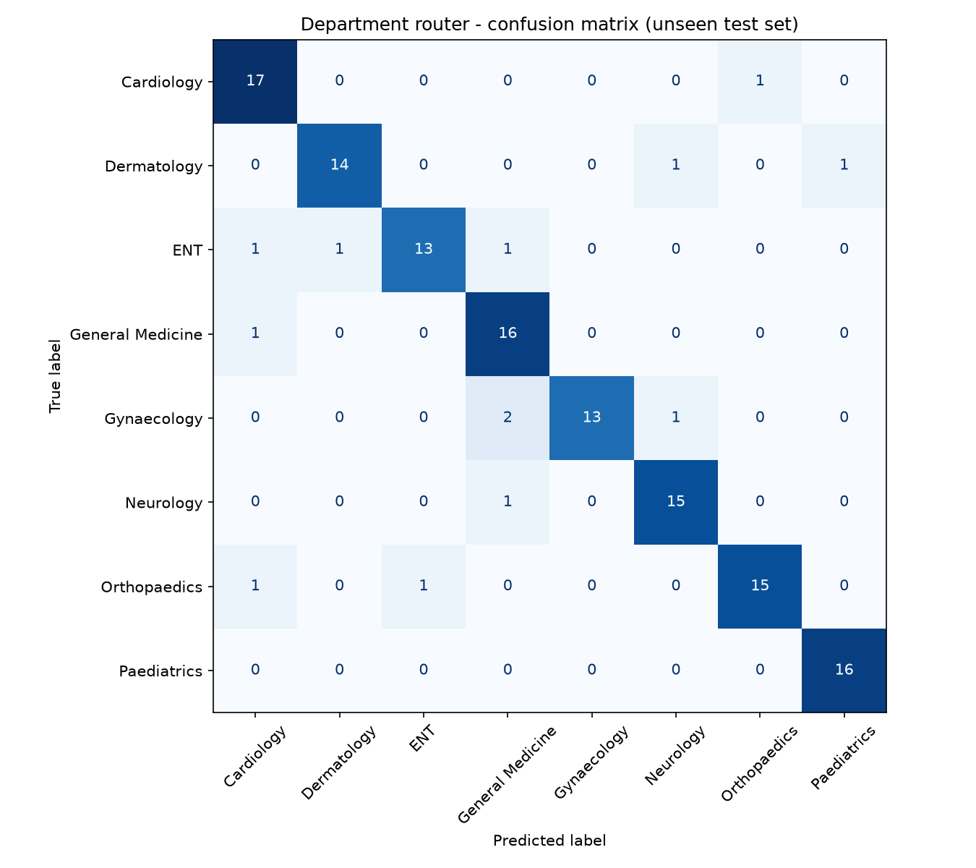
Figure 4: Confusion matrix on the unseen test set

7. Implementation
- Python (scikit-fuzzy, scikit-learn) for designing, testing and plotting the models.
- n8n cloud only runs JavaScript, so a generator script writes the n8n Code nodes from the same lexicon, membership functions, rules and trained weights. A parity check confirms that the JavaScript and Python versions give the same labels.
- Retell AI single-prompt agent with post-call analysis fields and a custom function, check_appointment_status.
- n8n Data Tables for storage; a static HTML dashboard for staff.

8. Testing
Test | Result
Fuzzy triage unit tests (labels, negation, phrase priority, age) | All pass
JavaScript vs Python parity (12 calls, 132 router phrases) | Identical labels and departments
Live webhook: routine call (skin rash, next week) | Routine → Dermatology, slot next week
Live webhook: urgent call (4-year-old with high fever, tomorrow) | Urgent → Paediatrics, slot next day
Live webhook: emergency call (70-year-old, chest pain, breathless) | Emergency → ER, alert branch triggered
Status check with known / unknown number | Returns booking / polite 'not found'
Dashboard feed without key | Rejected

9. Limitations and Future Work
- The lexicon and rules are hand-tuned and not clinically validated.
- The router's training data is synthetic, so accuracy on real calls would be lower.
- Future work: learn the membership functions with ANFIS (neuro-fuzzy) or tune them with a genetic algorithm; use sentence embeddings instead of keywords; real calendar booking and SMS confirmation.

10. Conclusion
The project combines conversational AI with soft computing. The fuzzy triage system turns vague phone descriptions into consistent, explainable urgency levels. The Naive Bayes router sends callers to the right department, and the automated pipeline ensures every call is recorded, prioritised and, for emergencies, escalated.

References
- L. A. Zadeh, 'Fuzzy sets', Information and Control, 1965.
- E. H. Mamdani and S. Assilian, 'An experiment in linguistic synthesis with a fuzzy logic controller', 1975.
- S. Russell and P. Norvig, Artificial Intelligence: A Modern Approach, 4th ed.
- scikit-fuzzy and scikit-learn documentation.
- Retell AI and n8n documentation.

