Orbit Website
Heuristic Evaluation using Nielsen's 10 Usability Heuristics

1. Purpose and scope
This document evaluates the Orbit landing page against Jakob Nielsen's ten usability heuristics. The page introduces Orbit, a meditation, goal-tracking and self-growth app for Gen Z users, and is built from the same brand, five-tab structure and personas (Ananya Rao and Kabir Mehta) used in the earlier assignments.
Scope: a single-page marketing site with a navigation bar, hero, five feature cards, a three-step explainer, a stats band, two persona cards, an FAQ, a closing call to action and a footer. It was checked at 1280px (desktop) and 390px (mobile) widths.

2. Design decisions carried over from earlier work
- Five spaces (Home, Goals, Meditate, Explore, Profile) are presented as the product's core structure, matching the app navigation.
- Secular, non-guru positioning responds to Ananya's preference and the competitive audit's trust concerns.
- The page states that Orbit has no points, badges or leaderboards, consistent with the audit's recommendation to avoid gamification. The phone mockup avoids showing a streak for the same reason.
- Goals are framed across 1, 5 and 10 years, which speaks to Kabir's long-term thinking.

3. Method
Each heuristic was applied by walking through every section of the page on desktop and mobile, then inspecting keyboard use and colour contrast. Each issue is given a severity rating on Nielsen's 0–4 scale:
Rating | Meaning
0 | Not a usability problem
1 | Cosmetic only; fix if time allows
2 | Minor problem; low priority
3 | Major problem; high priority
4 | Usability catastrophe; must fix
Ratings below show the highest severity found for that heuristic. No issue was rated 3 or 4, which reflects how limited the page's interactivity is, not that the design is finished.

4. Summary of results
Heuristic | Severity
1. Visibility of system status | 2
2. Match between system and the real world | 1
3. User control and freedom | 1
4. Consistency and standards | 2
5. Error prevention | 0
6. Recognition rather than recall | 1
7. Flexibility and efficiency of use | 2
8. Aesthetic and minimalist design | 1
9. Help users recognise, diagnose and recover from errors | 0
10. Help and documentation | 2
The most useful fixes, in priority order: (1) replace the placeholder call-to-action with a real destination and confirmation; (2) make the footer links functional or remove them; (3) add a sign-in route for returning users; (4) improve the legibility of the mockup tab bar; (5) add privacy and contact information.

5. Detailed findings

1. Visibility of system status (severity 2)
What works | Sticky nav stays visible; FAQ items show open/closed state natively; buttons have hover and focus states.
Issues | Nav does not highlight the section the visitor is currently in. Both "Enter Orbit" buttons scroll to the features section rather than starting anything, with no feedback explaining that the app is not live yet.
Recommendation | Add scroll-spy highlighting to the nav. Replace the placeholder CTA with a real destination (store link, waitlist form) that confirms the action.

2. Match between system and the real world (severity 1)
What works | Plain, non-jargon language ("Quick Reset", "Today's Plan", "Why you're here"). Tab names match the app (Home, Goals, Meditate, Explore, Profile) so the site and product speak the same language.
Issues | "Enter Orbit" is slightly metaphorical for a first-time visitor who may not realise it means "get the app".
Recommendation | Pair the CTA with a literal label such as "Get the app" or "Join the waitlist" once a destination exists.

3. User control and freedom (severity 1)
What works | Sticky nav and a mobile menu let visitors jump anywhere at any time. FAQ items are individually collapsible. No modals, popups or forced flows.
Issues | No "back to top" control on a long single page. Mobile menu has no explicit close button (it closes only by re-pressing Menu).
Recommendation | Add a back-to-top link in the footer and let the mobile menu close on link tap or Escape.

4. Consistency and standards (severity 2)
What works | One colour system, one button style per role (primary gradient, secondary glass), consistent card treatment and heading scale. The logo links the same way in nav and footer.
Issues | Footer links (About, Careers, Contact, Privacy, Terms) are non-functional placeholders. Persona name in the mockup ("Kai") does not match either documented persona (Ananya, Kabir).
Recommendation | Wire or remove placeholder links. Use Ananya or Kabir in the phone mockup.

5. Error prevention (severity 0)
What works | The page has no forms or destructive actions, so there is little that can go wrong. Native <details> elements avoid broken custom accordions.
Issues | Not applicable to the current scope. This will become relevant as soon as a sign-up or waitlist form is added.
Recommendation | When a form is added: inline validation, clear required markers and a confirmation step.

6. Recognition rather than recall (severity 1)
What works | Five spaces are shown together with icons and one-line descriptions, so visitors never have to remember what a tab does. The phone mockup previews the real tab bar. Section order follows a familiar pattern (what, how, who, questions, action).
Issues | The mockup tab bar uses 9px text that is hard to read and has no icons, unlike the feature cards above it.
Recommendation | Increase mockup tab labels and add the same icons used in the feature cards.

7. Flexibility and efficiency of use (severity 2)
What works | Skip-to-content link, anchored sections, smooth scroll (disabled for reduced-motion users), keyboard-operable FAQ and menu.
Issues | No shortcut for returning users: there is no "Sign in" or "I already have an account" link on the site, even though the app's welcome screen has one. Experienced users get nothing faster than first-timers.
Recommendation | Add a secondary "Sign in" link in the nav, mirroring the app's welcome screen.

8. Aesthetic and minimalist design (severity 1)
What works | A single clear message per section, generous spacing and a restrained palette. No pop-ups, carousels or autoplay. The three-line hero carries one idea. Stat band deliberately states what Orbit does not have (no points, no leaderboards).
Issues | The dark, glow-heavy theme with the star field is atmospheric but decorative; the fixed star layer adds visual noise behind body text. The glow behind the phone is purely ornamental.
Recommendation | Lower star opacity or remove it behind text-heavy sections. Keep decoration to the hero.

9. Help users recognise, diagnose and recover from errors (severity 0)
What works | No error states exist on the current page.
Issues | Not applicable yet. There is no custom 404 page and no handling for a failed form submission, both needed once the site has more than one page or a form.
Recommendation | Design a friendly 404 and form-failure message in the same tone as the rest of the site.

10. Help and documentation (severity 2)
What works | A four-question FAQ addresses the biggest concerns for the documented personas (is it religious, how long, account, points).
Issues | No search, no contact route (the Contact link is a placeholder), and no explanation of privacy or data handling, which matters for a wellbeing app. Four questions will not cover support needs.
Recommendation | Add a working contact route, a privacy summary, and expand the FAQ from real user questions.

6. Accessibility checks
Check | Result
Body text contrast (#b9b4cf on #0a0a14) | 9.8:1, passes WCAG AA
Lowest-contrast text (#7c7794 on #0a0a14) | 4.6:1, passes AA but only just; used for small footer and mockup text
Button text (#0a0a14 on #8b7cf6) | 5.9:1, passes AA
Keyboard use | Skip link, visible focus ring, operable menu and FAQ
Reduced motion | Smooth scrolling and transitions are turned off when requested
Horizontal scrolling at 390px | None

7. Screenshots
Desktop, 1280px:
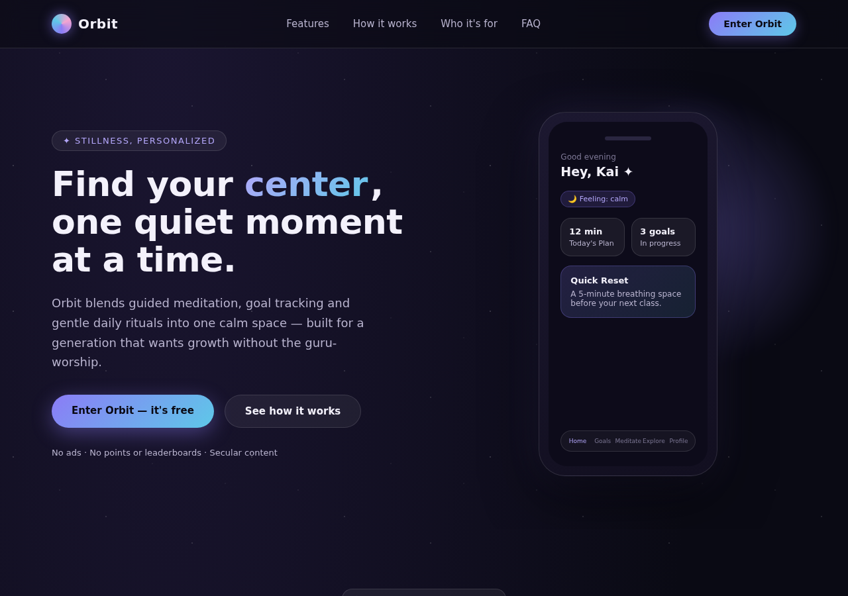
Mobile, 390px:
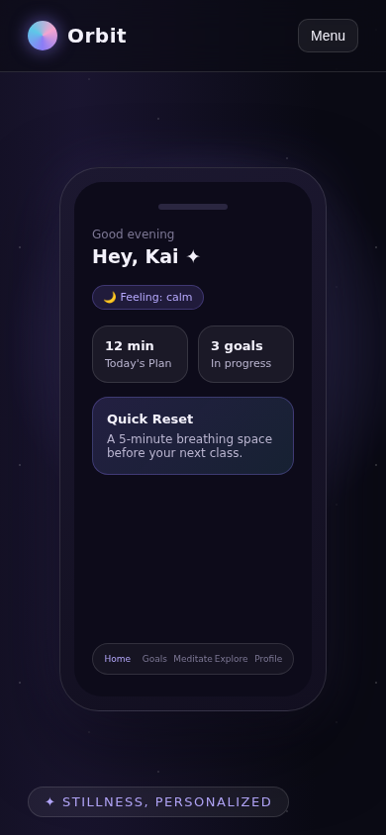

8. Limitations
- This is a self-evaluation by the person who designed the page, so it is likely to miss problems the designer is too close to. Nielsen recommends three to five independent evaluators, because one evaluator typically finds only a minority of the issues.
- No real users tested the page, so findings are expert judgement, not observed behaviour.
- Statements such as "free" on the CTA and the persona quotes are design placeholders for the assignment and have not been validated with real users or a real pricing decision.
- Several heuristics (error prevention, error recovery) could only be assessed lightly because the page has no forms.
Next step: ask two or three classmates to do a quick independent pass using the same checklist and compare their findings with this one.

