Open Source Graphics and Animation Tools Lab

Mid-Semester

4th March 2020

Phase-2 Blender

Submitted To: Submitted By:

Dr. Durgansh Sharma Shreya Badhran

Professor, Cybernetics SCS Btech CSE-OSOS 2nd year

Sap Id: 500067404

Roll no: R100218059



**School of Computer Science**

**University of Petroleum and Energy Studies,**

**Dehradun – 248007: Uttarakhand**

STEPS:

1. Open a new project.

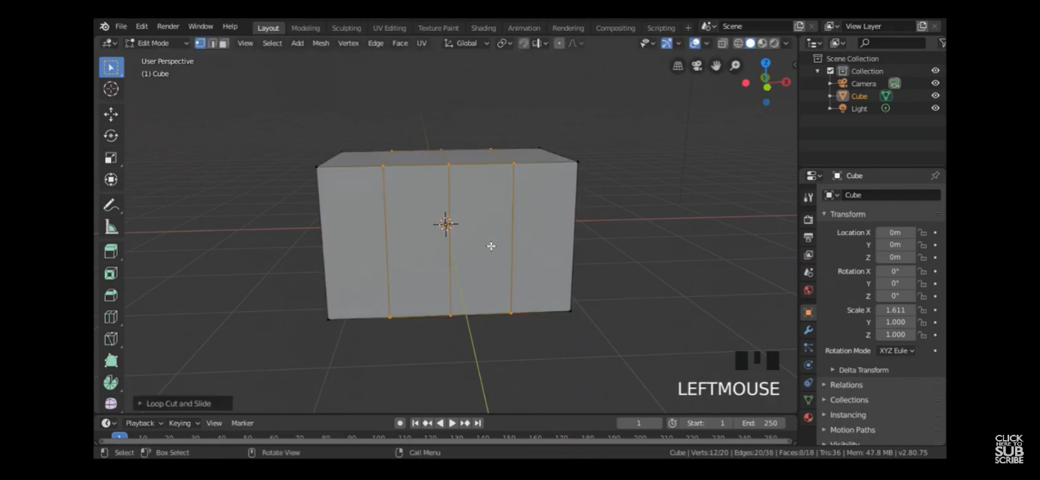

1. select the cube and scale the dimensions x,y,z.
2. select edit mode.
3. Select cut loops and three layers.

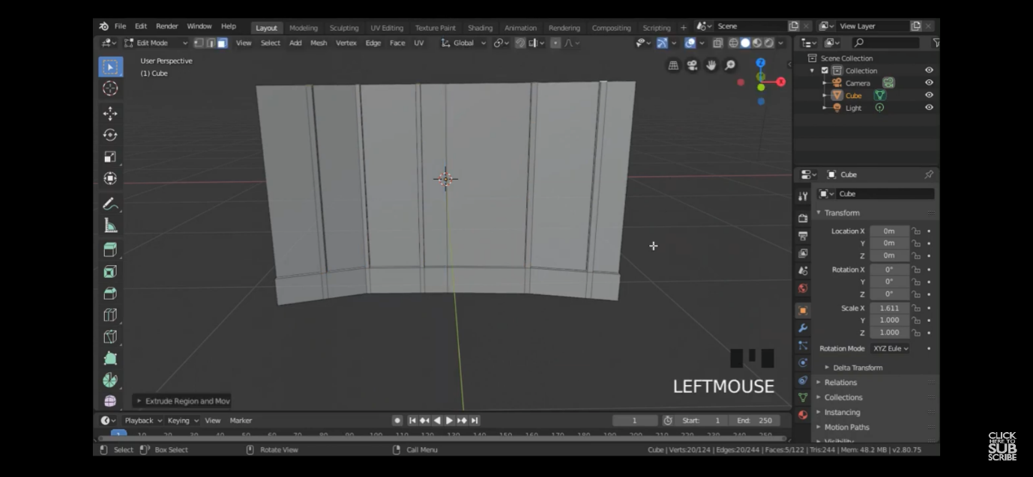

1. Select g and vertices move the blocks to shape them.
2. Again add cut loops and select the lower area

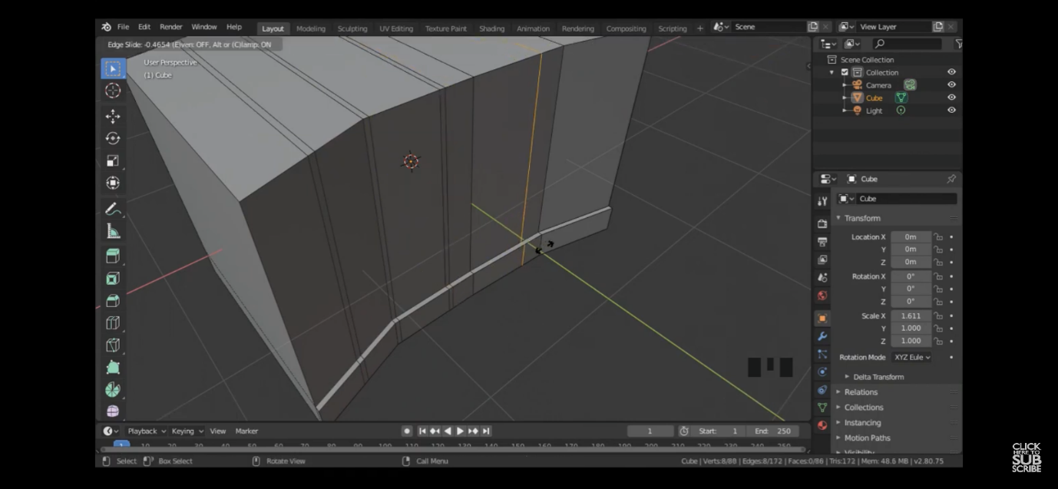

1. Extend the lower part and add more cut loops
2. Select the area between the cut loops.
3. Extend them to top pressing e.

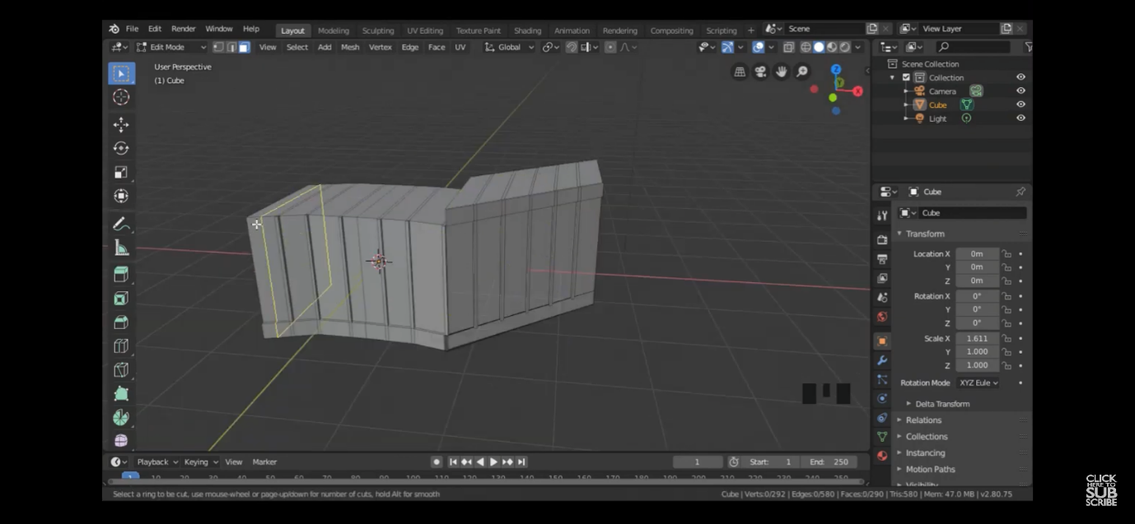

1. Repeat the steps.
2. Now side walls and faces .

# Steps to create the tree:

1. Go to edit-> preferences-> add ons -> sapling tree gen
2. Now on the main area, right click. Select curve->sapling tree.
3. A tree like structure will appear.

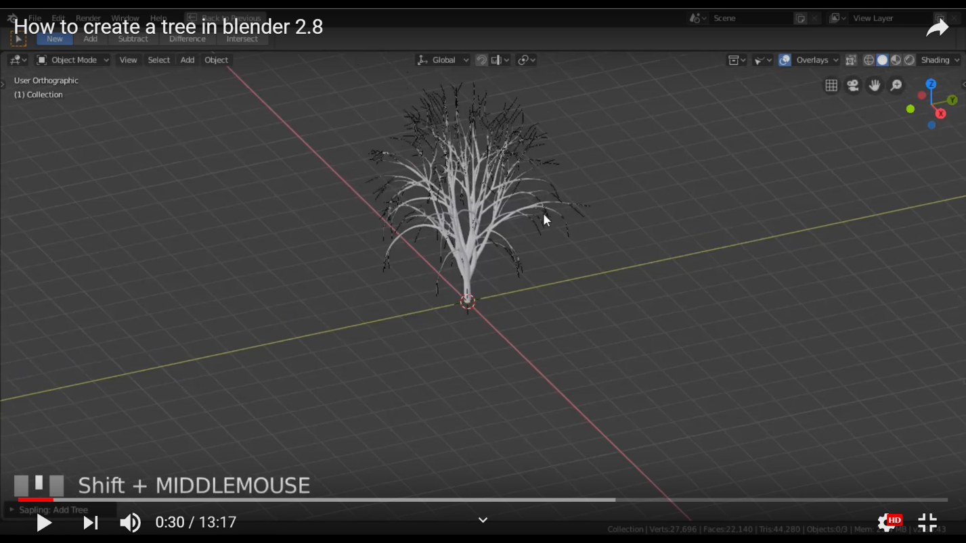

1. There will a drop down menu at the bottom to make changes to the tree.
2. A box will appear with many options to make changes to the tree.

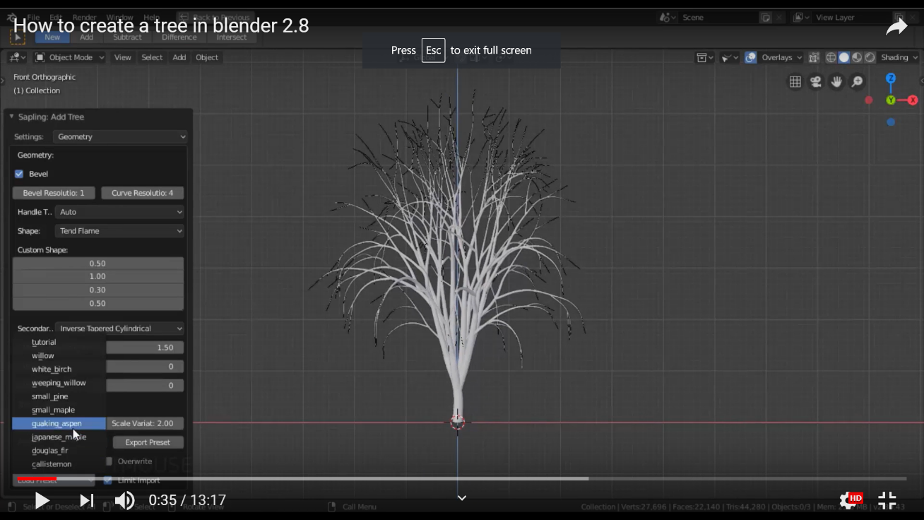

1. In the settings option, geometry is used to define the shape and size of the tree.
2. Branching splitting is used to divide the branches in further branches.
3. Branch growth is used to decide the growth of the branch accordingly.

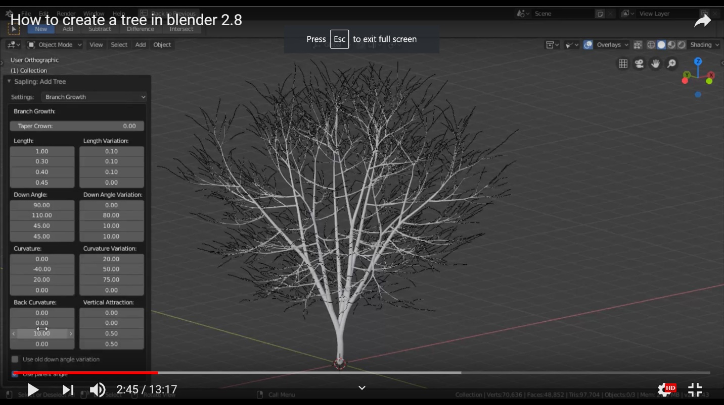

1. For adding other trees, select the tree. And click on object->duplicate the object. Then place the duplicate object wherever you want.

