Open Source Graphics and Animation Tools Lab

Mid-Semester

4th March 2020

Phase-1 GIMP

Submitted To: Submitted By:

Dr. Durgansh Sharma Shreya Badhran

Professor, Cybernetics SCS Btech CSE-OSOS 2nd year

Sap Id: 500067404

Roll no: R100218059



**School of Computer Science**

**University of Petroleum and Energy Studies,**

**Dehradun – 248007: Uttarakhand**

STEPS:

1. Open a new image with dimensions 1920x1080px.
2. Fill the background with colour contrast: fedbc5.
3. Add a new transparent layer.
4. Pick free select tool and draw rough hand hill.
5. Fill the drawn area with colour contrast: 2d102f
6. Select the move tool to adjust the first hill.
7. Create a new layer and duplicate this layer.

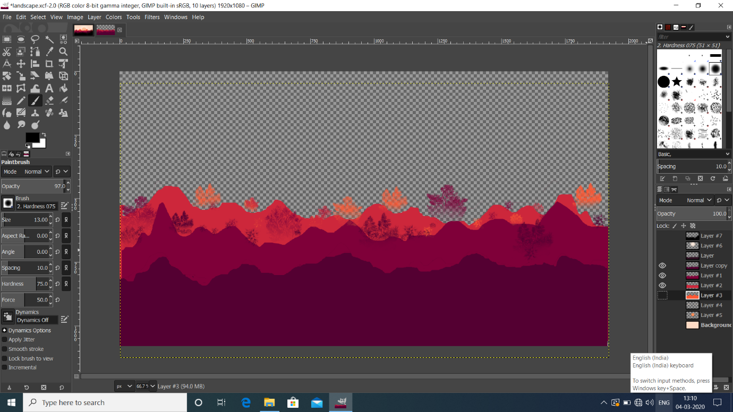

1. Select the option alpha to selection and fill colour:540032.
2. Select fill tool and flip it horizontally.
3. Create a new layer.
4. Repeat steps 4 to 9 once more.
5. Select paint brush and select vegetation 2 to draw.

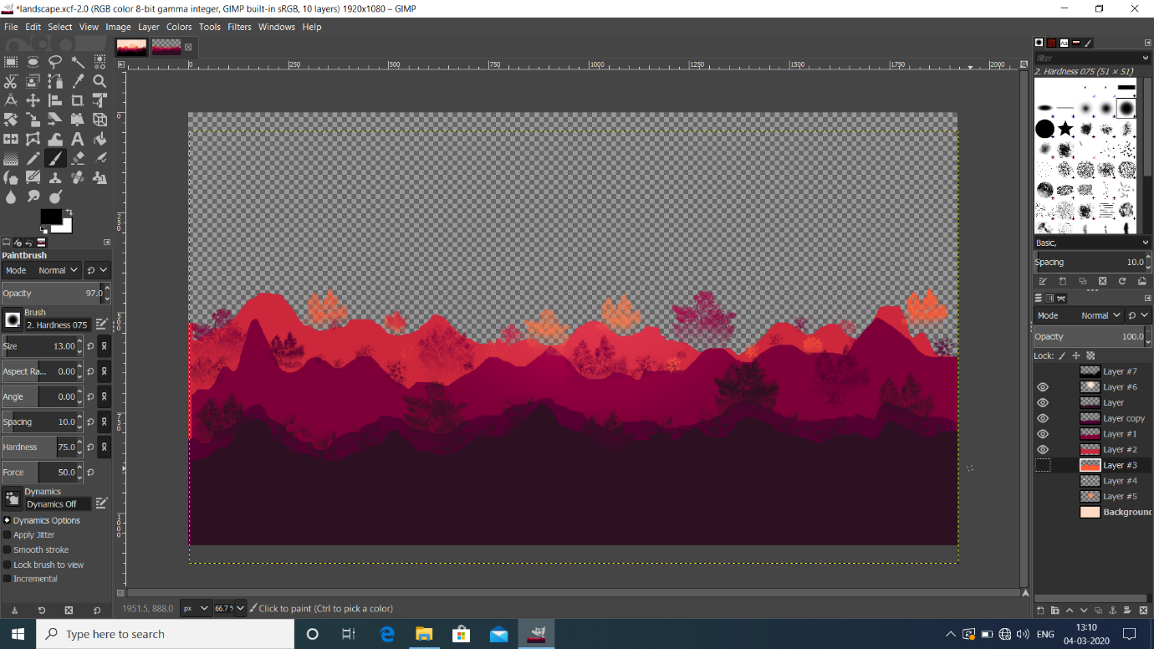

1. In each layer draw trees with respective colours used above.
2. Create a new layer.
3. Use select tool and draw clouds.
4. Create a new layer.
5. Select elliptical tool to draw sun.
6. Pick hardness075 and put overlay effect on sun.
7. Typography used is Segoe UI Emoji with kerning 3.0px.

Effects of Channel

In the standard distribution of the GIMP, channels are eight bits deep, meaning that each pixel in a layer is represented by up to 32 bits. However, there is a special development version of the GIMP that uses channels that are 16 bits deep, making for layers with pixels represented by up to 64 bits.

There are three types of channel:

1. Red

2. Green

3. Blue

Effect of channel on my gimp project:

1. Redhannel

In the standard distribution of the **GIMP**, **channels** are eight bits deep, meaning that each pixel in a layer is represented by up to 32 bits. However, there is a special development version of the **GIMP** that uses **channels** that are 16 bits deep, making for layers with pixels represented by up to 64 bits.

There are three types of channel:

Red

Green

Blue

Effect of channel on my gimp project:

Red

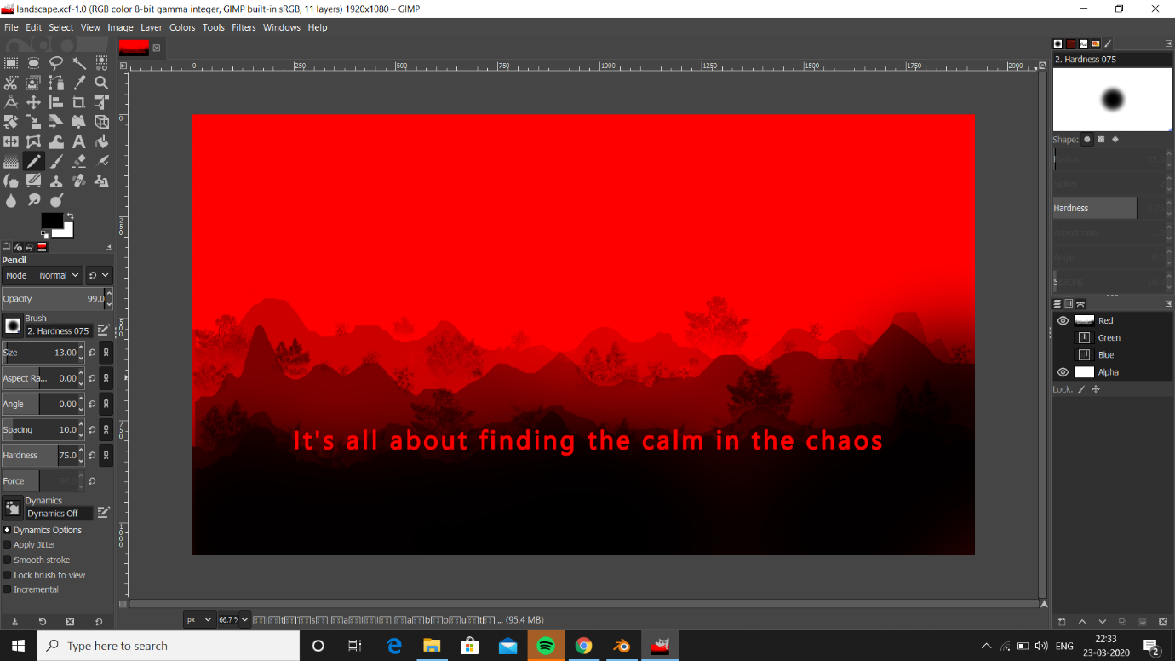

Green

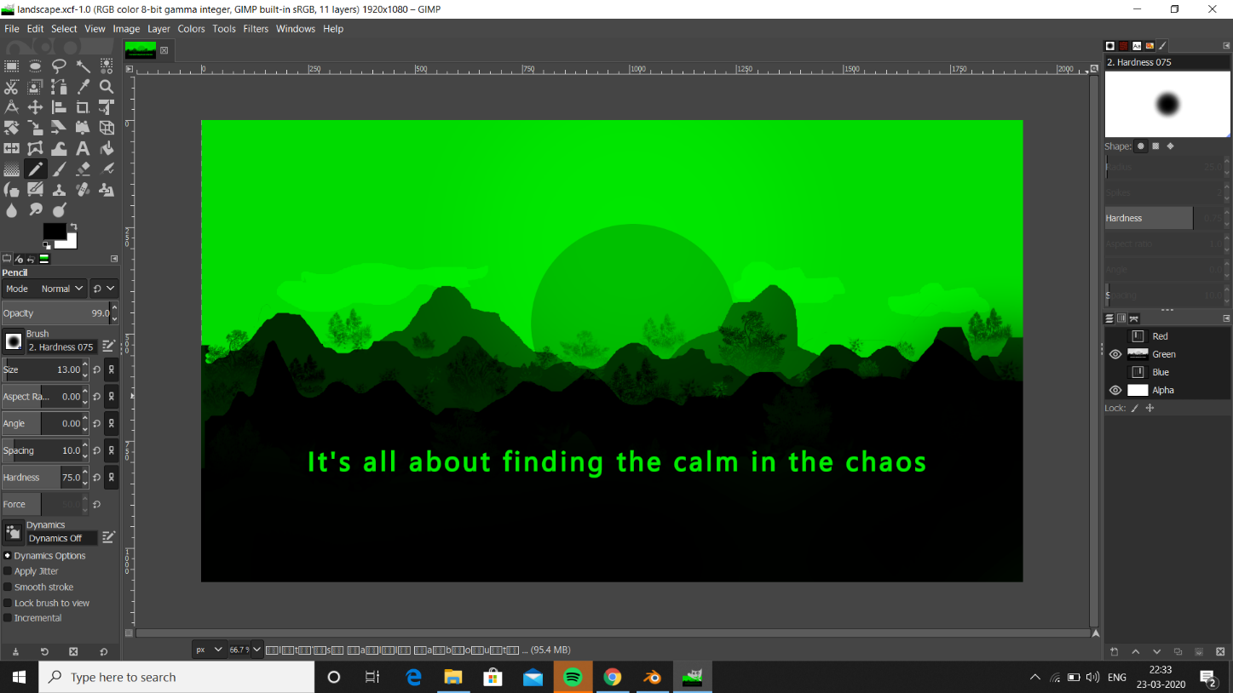

Blue

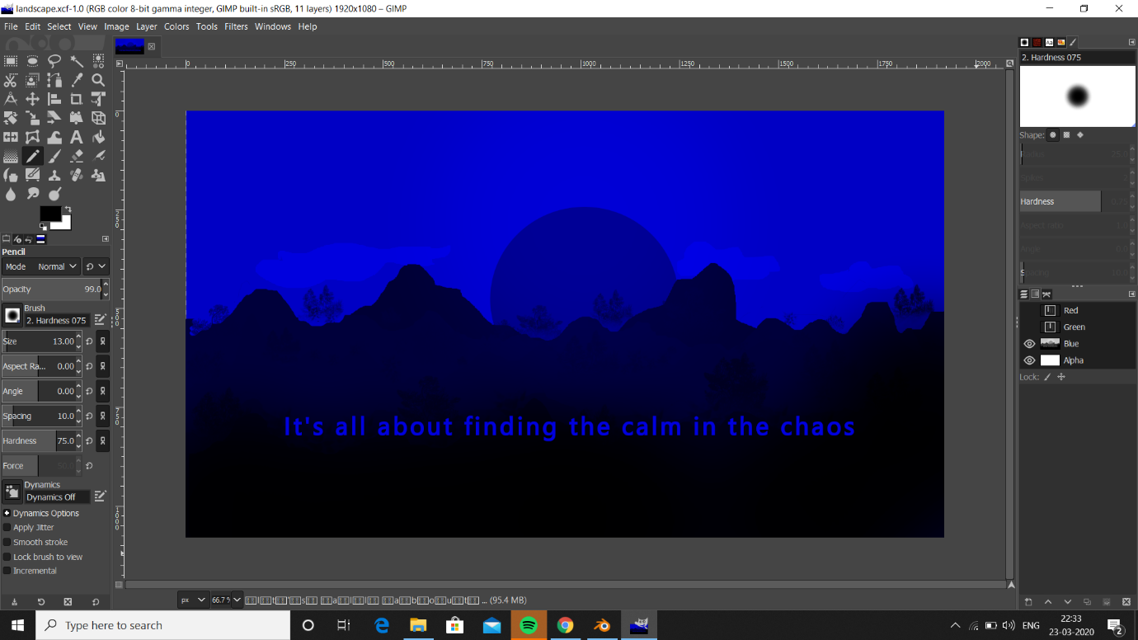

Final Outcome

