What is a Computer?
What is a Computer?
What is a Computer?
What is a Computer?
What is a Computer?
What is a Computer?
What is a Computer?

Hadiyah Ibrahim Sayed [2VX24UE024]

What is a Computer?
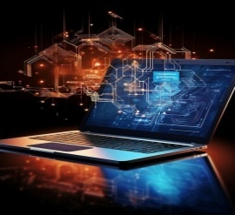
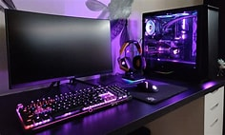
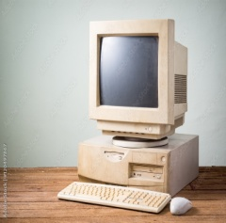
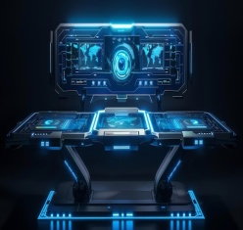
Today's workstations have both kinds of programming. A workstation is a device that accepts information (in the form of digitalized data) and manipulates it for some result based on a program or sequence of instructions on how the data is to be processed. Complex workstations also include the means for storing data (including the program, which is also a form of data) for some necessary duration. A program may be invariable and built into the workstation (and called logic circuitry as it is on microprocessors) or different programs may be provided to the workstation (loaded into its storage and then started by an administrator or user). Today's workstations have both kinds of programming.

Today's workstations have both kinds of programming. A workstation is a device that accepts information (in the form of digitalized data) and manipulates it for some result based on a program or sequence of instructions on how the data is to be processed. Complex workstations also include the means for storing data (including the program, which is also a form of data) for some necessary duration. A program may be invariable and built into the workstation (and called logic circuitry as it is on microprocessors) or different programs may be provided to the workstation (loaded into its storage and then started by an administrator or user).

