Practical #4
Practical Title:
To apply GitHub-based collaboration techniques including merging and remote repository management
Theory:
1. What is Merging in Git?
Merging in Git is the process of combining changes from one branch into another branch. It is commonly used to integrate feature branches into the main branch.
2. Types of Merge:
1. Fast-forward Merge:
- Happens when there is a straight path (no divergence).
- Git simply moves the pointer forward.
- No extra merge commit is created.
2. Three-way Merge:
- Happens when branches have diverged.
- Git uses a common ancestor to merge changes.
- Creates a new merge commit.
3. What is Remote Repository?
A remote repository is a version of your project hosted on the internet or network, usually on platforms like GitHub.
It allows multiple developers to access, collaborate, and manage code remotely.
4. Common Remote Commands:
git remote
git push
git pull
git fetch
Procedure:
Step 1: Create Local Repository
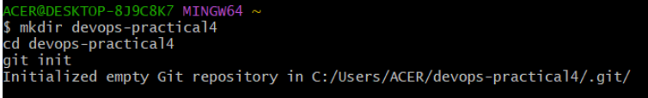
Step 2: Add Remote Repository
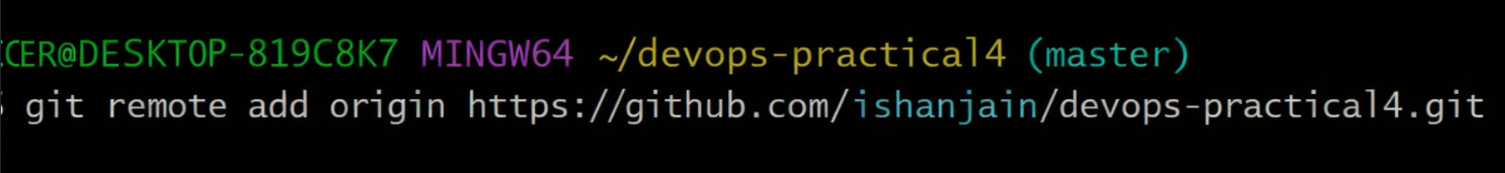
Step 3: Create Branch and Commit Changes
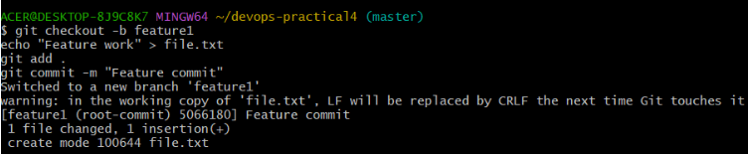
Step 4: Push Branch to Remote
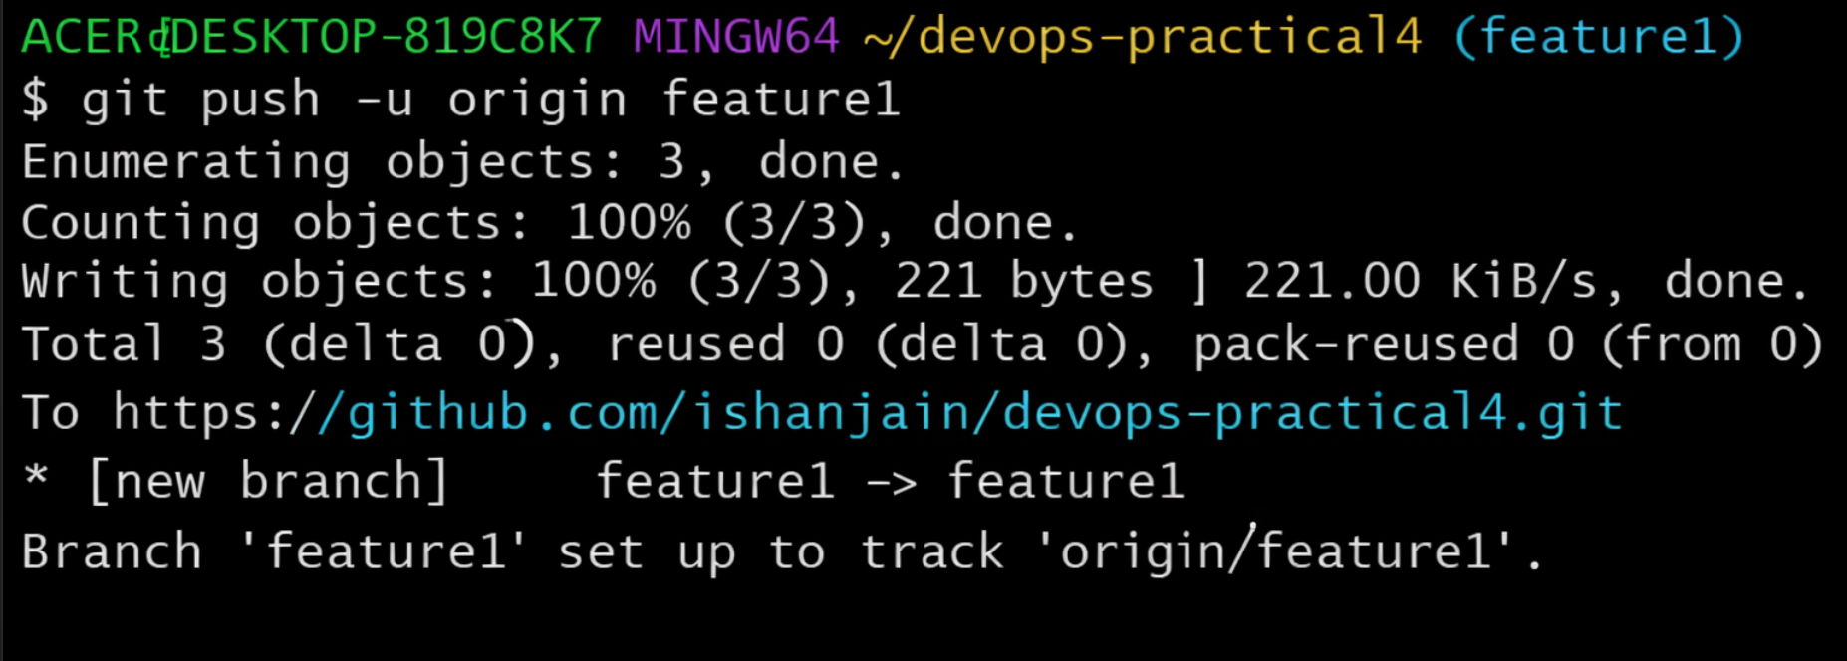
Step 5: Merge Branch into Main
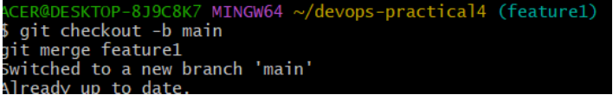

Step 6: Push Merged Code
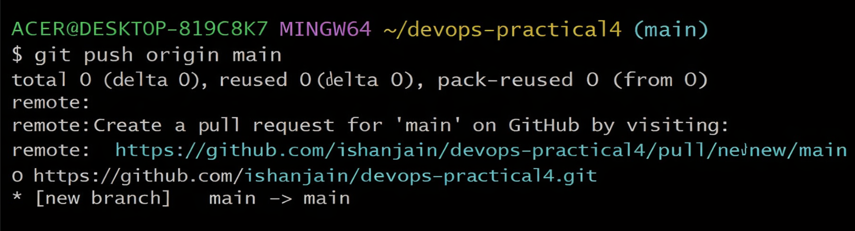
Step 7: Fetch and Pull Updates
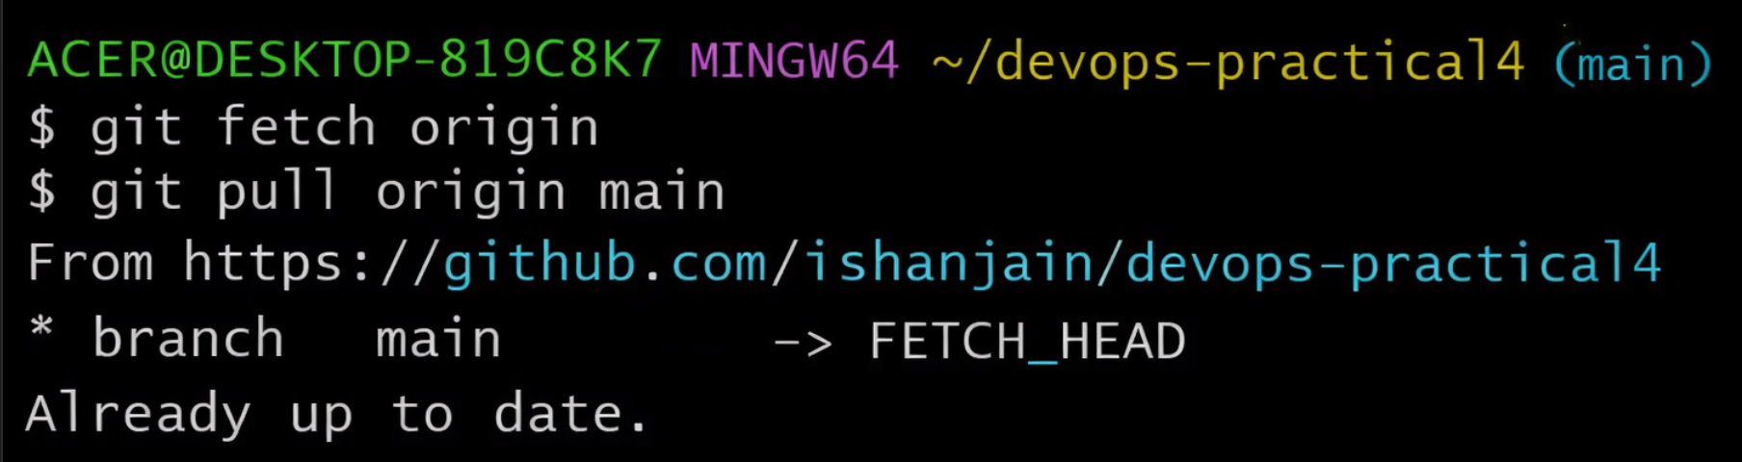
Output Screenshots:
(Paste screenshots of all steps)
Activity / Task:
Task 1:
Create a remote repository and link it with local repository.
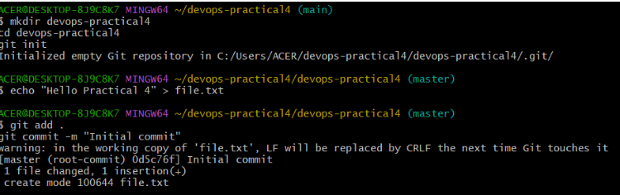
Repository Link:
Task 2:
Perform branch merging and push changes to GitHub.
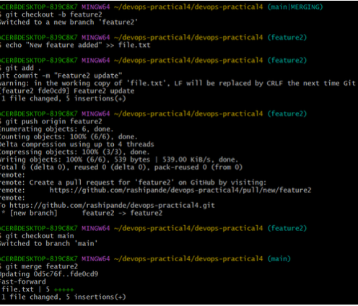
Commands Used:
git branch feature
git checkout feature
git add .
git commit -m "Feature added"
git push origin feature
git checkout main
git merge feature
git push origin main
Task 3:
Explain the difference between git fetch and git pull.
Difference between git fetch and git pull:
git fetch | git pull
Downloads changes only | Downloads + merges changes
Does not modify working directory | Updates working directory
Safer for review | Direct update
Manual merge required | Automatic merge
Advantages:
- Easy collaboration using remote repositories
- Efficient branch management
- Backup of code on remote servers
- Supports team development
- Tracks complete project history

Challenges:
- Merge conflicts
- Requires understanding of commands
- Network dependency for remote operations

