Practical #5
Practical Title:
To understand the structure of a basic web application and its role in a DevOps pipeline
Theory:
1. What is a Web Application?
A web application is a software program that runs on a web server and is accessed through a web browser over the internet. It allows users to interact with the system without installing any software locally.
2. Components of a Web Application:
Frontend:
The user interface of the application that users interact with. It is built using HTML, CSS, and JavaScript.
Backend:
The server-side logic that processes user requests, performs operations, and communicates with the database.
Database:
Stores and manages application data such as user information, records, and transactions.
3. What is DevOps Pipeline?
A DevOps pipeline is a set of automated processes that allow developers to build, test, and deploy applications continuously and efficiently. It includes stages like integration, testing, deployment, and monitoring
Procedure:

Step 1: Create a Basic Web Page (HTML)
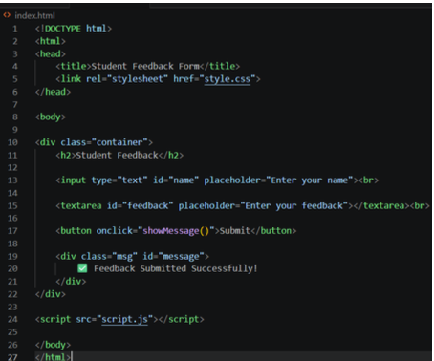
Step 2: Add Styling using CSS
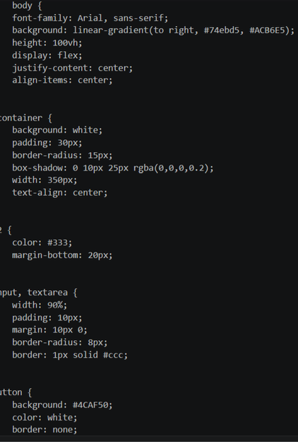
Step 3: Add Simple JavaScript Functionality
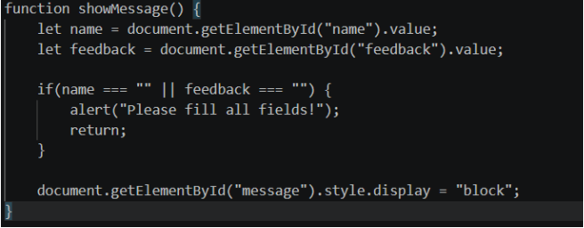
Step 4: Run the Web Page in Browser
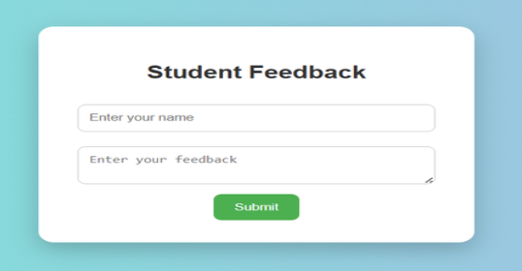
Step 5: (Optional) Upload the Web App to GitHub
Activity / Task:
Task 1:
Create a simple web application (e.g., Student Form or Feedback Form)
Description:
A simple Student Form web application that collects user details such as name, email, and feedback. It uses HTML for structure, CSS for styling, and JavaScript for basic validation or interaction
Task 2:
Explain how this application can be used in a DevOps pipeline.
How this application can be used in a DevOps pipeline:
- Code is written and stored in a repository
- Changes are integrated using CI tools
- Automated tests are run on the web app
- Application is deployed to a server automatically
- Performance is monitored and improved continuously
Task 3:
List steps to deploy this application on a server.
Steps to deploy this application on a server:
- Create the web application files
- Push code to a repository (GitHub)
- Set up a server (e.g., Apache or Nginx)
- Transfer files to the server
- Configure server to host the application
- Access the app using server IP or domain
Advantages:
- Easy to access from any device
- No installation required
- Centralized data management
- Easy updates and maintenance
- Supports DevOps automation

Challenges:
- Security issues
- Requires internet connection
- Performance depends on server

