Practical #6
Practical Title:
To deploy and manage a simple web application using version control and hosting techniques
Theory:
1. What is Web Hosting?
Web hosting is a service that allows individuals or organizations to store their website files on a server and make them accessible on the internet. It ensures that the website is available to users anytime.
2. What is GitHub Hosting (GitHub Pages)?
GitHub Pages is a free hosting service provided by GitHub that allows users to deploy static websites directly from a repository. It is commonly used for portfolios, projects, and simple web apps.
3. Role of Version Control in Deployment:
Version control helps in managing and tracking code changes during deployment. It allows:
- Easy updates and rollback
- Collaboration among developers
- Maintaining history of changes
- Automated deployment through integration tools
Procedure:

Step 1: Create a simple web application (index.html)

Step 2: Initialize Git repository
Step 3: Add and Commit files
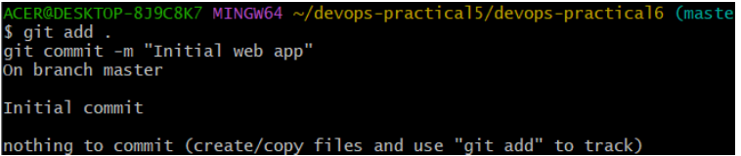
Step 4: Create GitHub repository

Step 5: Push code to GitHub
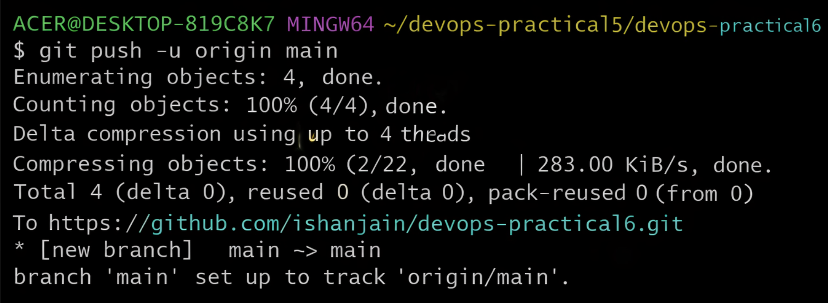
Step 6: Enable GitHub Pages
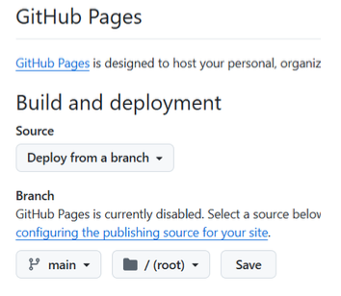
Step 7: Access deployed website using provided link

Activity / Task:
Task 1:
Deploy your own web application using GitHub Pages.
Repository Link:
https://github.com/ishanjain/devops-practical6
Live Website Link:
https://ishanjain.github.io/devops-practical6/

Task 2:
Make changes in your code and update the live website.
Commands Used:
git add .
git commit -m "Updated website"
git push origin main
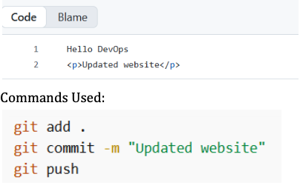
Task 3:
Explain the benefits of using GitHub for deployment.
Benefits of using GitHub for deployment:
- Free hosting for static websites
- Easy integration with Git version control
- Automatic deployment on push
- Supports collaboration
- Provides version history and rollback
Advantages:
- Free and easy hosting
- Quick deployment process
- Version control integration
- Accessible from anywhere
- Supports continuous updates

Challenges:
- Only supports static websites
- Limited customization options
- Requires basic Git knowledge

