Practical #2
Practical Title:
To understand version control concepts and perform basic source code management using Git
Theory:
1. What is Version Control System (VCS)?
A Version Control System (VCS) is a tool that helps developers track changes in source code, manage different versions, and collaborate efficiently. It allows reverting to previous versions if needed.
2. Types of Version Control Systems
(Centralized vs Distributed)
1. Centralized Version Control System (CVCS):
- Uses a central server to store code.
- Developers access files from this central repository.
- Example: SVN
- Disadvantage: If the server fails, work may be lost.
2. Distributed Version Control System (DVCS):
- Each developer has a full copy of the repository.
- Work can be done offline.
- Example: Git
- More secure and flexible.
3. What is Git?
Git is a distributed version control system used to track code changes, manage projects, and enable team collaboration efficiently.
4. Key Git Terminologies:
Repository:
A storage location where project files and their history are kept.
Commit:
A snapshot of changes made to the files with a message describing the update.
Branch:
A separate line of development used to work on features independently.
Merge:
Combining changes from one branch into another.
Clone:
Creating a copy of an existing repository to your local system.
Procedure:
Step 1: Install Git and verify installation
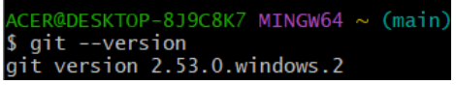
Step 2: Configure Git
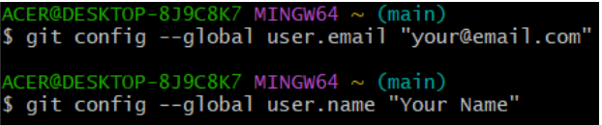
Step 3: Create a Repository
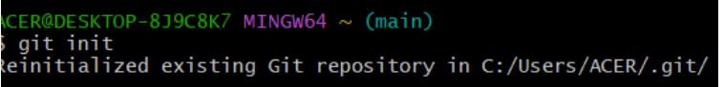

Step 4: Create a file and add content
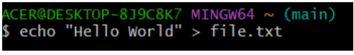
Step 5: Add and Commit
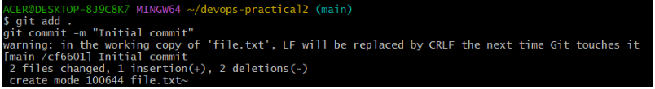
Step 6: Connect to GitHub and Push
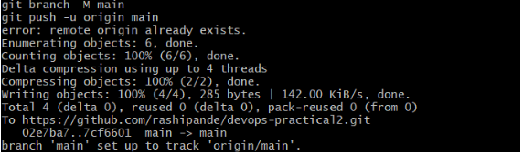
Step 7: Pull changes

Activity / Task:
Task 1:
Create your own GitHub repository and push at least one file.
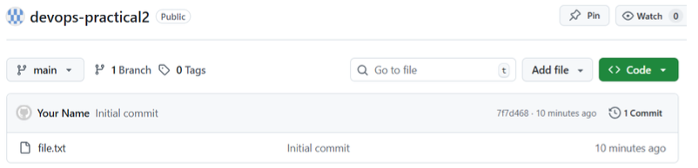
Repository Link:
Task 2:
Create a new branch and merge it with main branch.
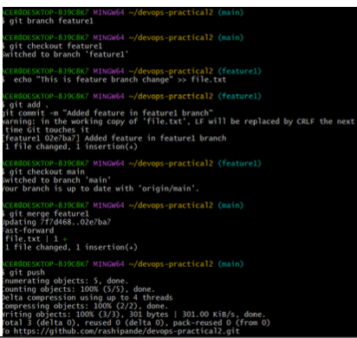
Commands Used:
git branch new-branch
git checkout new-branch
# make changes
git add .
git commit -m "Changes in new branch"
git checkout main
git merge new-branch

Advantages of Git:
- Distributed system (offline work possible)
- Fast and efficient performance
- Strong branching and merging support
- Data integrity and security
- Easy collaboration among teams

Challenges in Version Control:
- Learning curve for beginners
- Merge conflicts
- Requires proper management and discipline

