Practical #8
Practical Title:
To design and execute automated test scripts using Selenium for functional testing
Theory:
1. What is Functional Testing?
Functional testing is a type of testing where we verify that the application works according to the given requirements.
👉 It checks:
- Login functionality
- Form submission
- Buttons, links, and features

2. Advantages of Selenium for Testing
Using Selenium:
- Supports multiple browsers (Chrome, Firefox, Edge)
- Supports multiple programming languages
- Open-source and free
- Easy integration with CI/CD tools
- Automates repetitive testing tasks

Procedure:
Step 1: Setup Selenium environment
Step 2: Launch browser using WebDriver
Step 3: Navigate to a web application
Step 4: Locate elements using locators (id, name, xpath, etc.)
Step 5: Perform actions (click, send keys, submit)
Step 6: Validate output using assertions
Step 7: Close the browser
Output Screenshots:
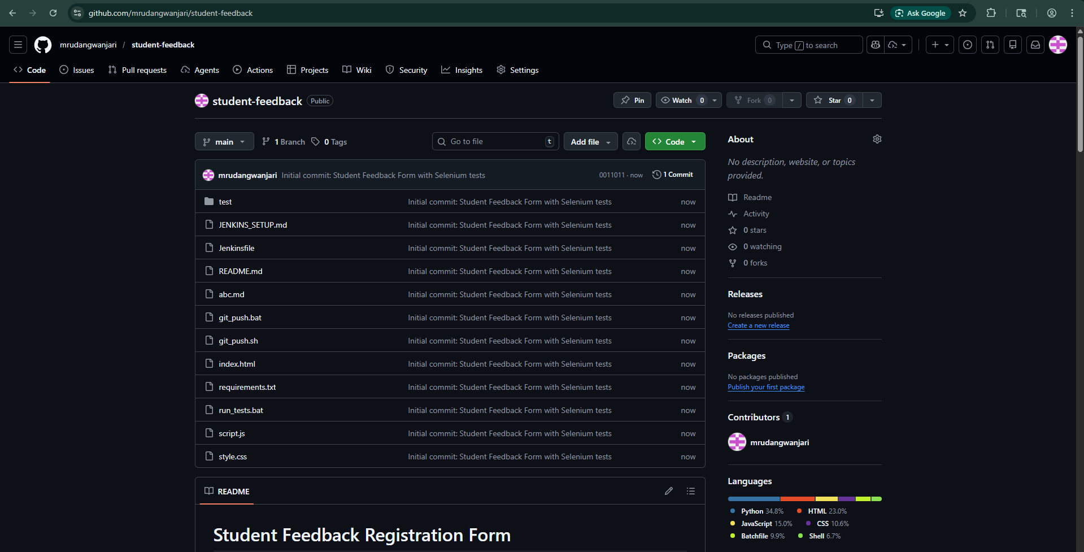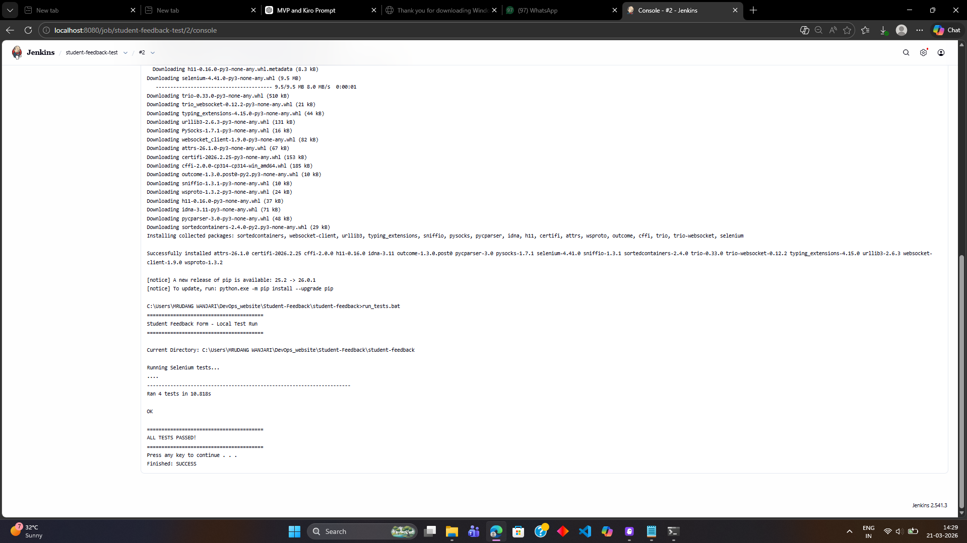
Activity / Task:
Task 1: Selenium Login Test Script
Code (Python Example):
from selenium import webdriver
from selenium.webdriver.common.by import By
from selenium.webdriver.common.keys import Keys
import time
driver = webdriver.Chrome()
# Open demo login page
driver.get("https://the-internet.herokuapp.com/login")
# Enter username and password
driver.find_element(By.ID, "username").send_keys("Mrudang")
driver.find_element(By.ID, "password").send_keys("SuperSecretPassword!")
# Click login
driver.find_element(By.CSS_SELECTOR, "button[type='submit']").click()
# Validate login success
time.sleep(2)
assert "secure area" in driver.page_source.lower()
# Close browser
driver.quit()

Task 2: Form Testing (Valid & Invalid Inputs)
Description:
- Valid Input Test:
  - Enter correct data (username, password)
  - Submit form
  - Verify success message
- Invalid Input Test:
  - Enter wrong data
  - Submit form
  - Verify error message
This ensures:
- Form validation works properly
- Error handling is correct

Advantages
- Faster execution than manual testing
- Supports automation of functional tests
- Reusable scripts
- Cross-browser testing
- Integration with DevOps pipelines

Challenges
- Requires coding knowledge
- Maintenance of scripts
- Handling dynamic elements can be difficult

