Using ONLINE IDE

CREATE TABLE TeamDetails

(

SlNo INTEGER(50) not null ,

TeamName VARCHAR(255) NOT NULL,

Captain VARCHAR(255),

TeamOwner VARCHAR(255) NOT NULL,

HomeGround varchar(100),

PRIMARY KEY(SlNo)

);

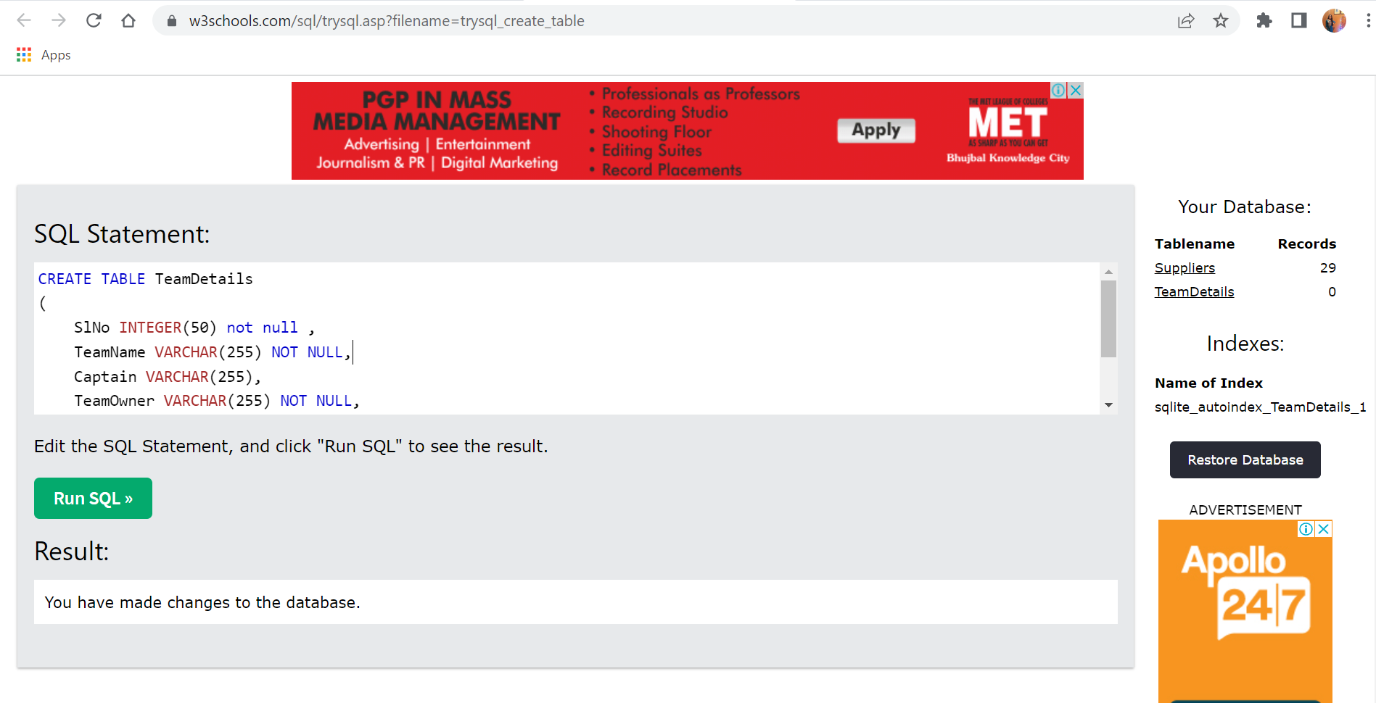

INSERT INTO TeamDetails (SlNo, TeamName, Captain, TeamOwner, HomeGround)

VALUES

(1, ‘MI’, ‘Rohit Sharma’, ’Ambanis’, ‘Mumbai’)

(2,'CSK', 'MS Dhoni','India Cements','Chennai'),

(3, 'PK', 'R Ashwin','Preety Zinta','Mohali'),

(4, 'DC', 'Shreyas Iyer' ,'Jindal', 'Delhi'),

(5, 'KKR','Dinesh Kartik' ,' SRK', 'Kolkata')

(6, 'RCB','Virat Kohli','United Spirits','Bangalore'),

(7, 'SRH','David Warner','SunTV', 'Hyd'),

(8, 'RR', 'Ajinkya Rahane','Emerging Media','Jaipur');

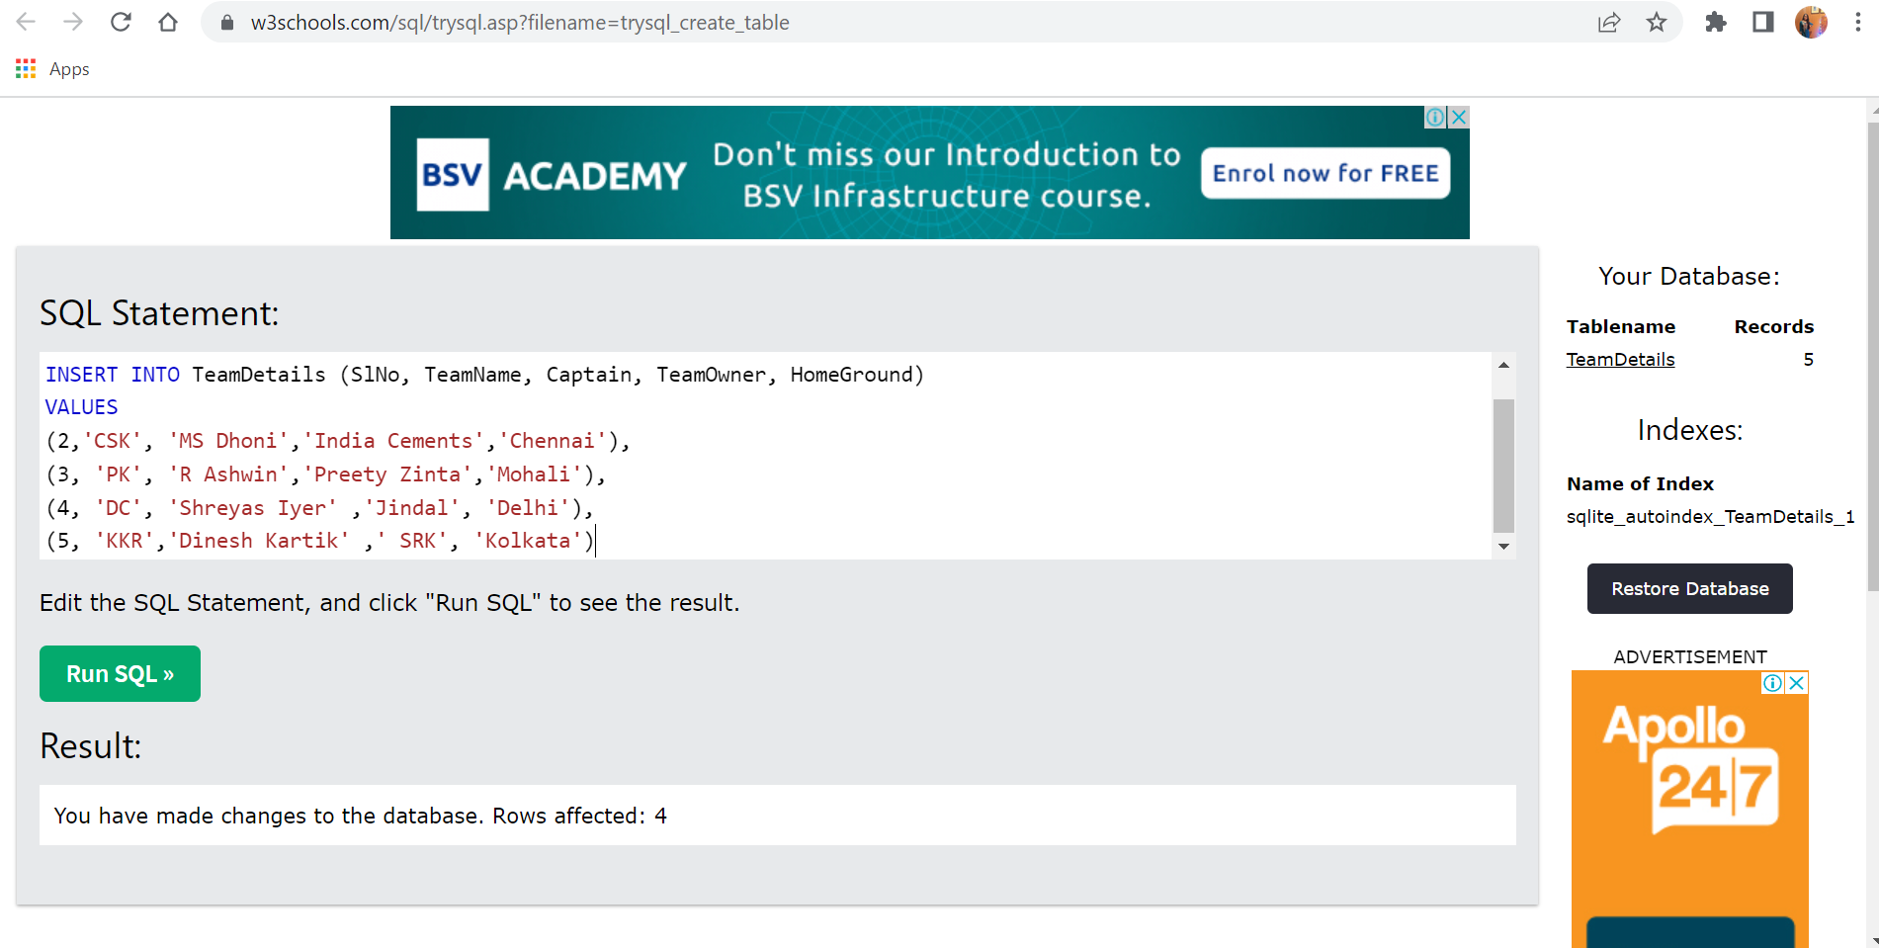

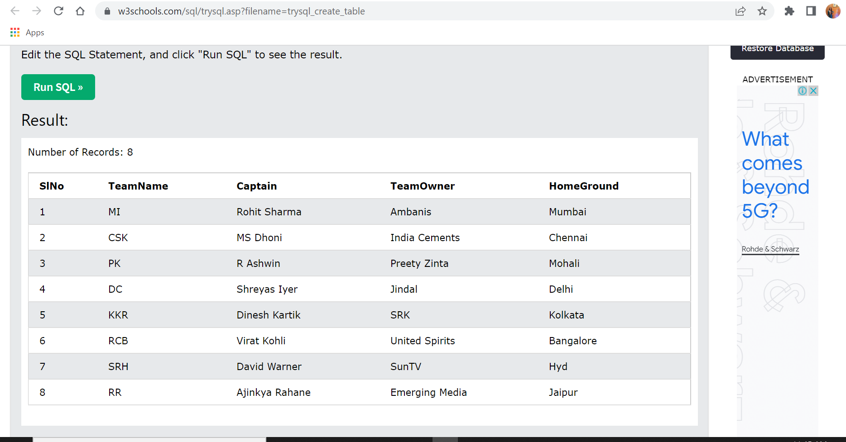

CREATE TABLE Fixtures

(

MatchNumber integer(50),

HomeTeam VARCHAR(100) NOT NULL,

AwayTeam VARCHAR(100),

Venue VARCHAR(100) NOT NULL,

TeamWon varchar(100),

TeamLost varchar(100)

);

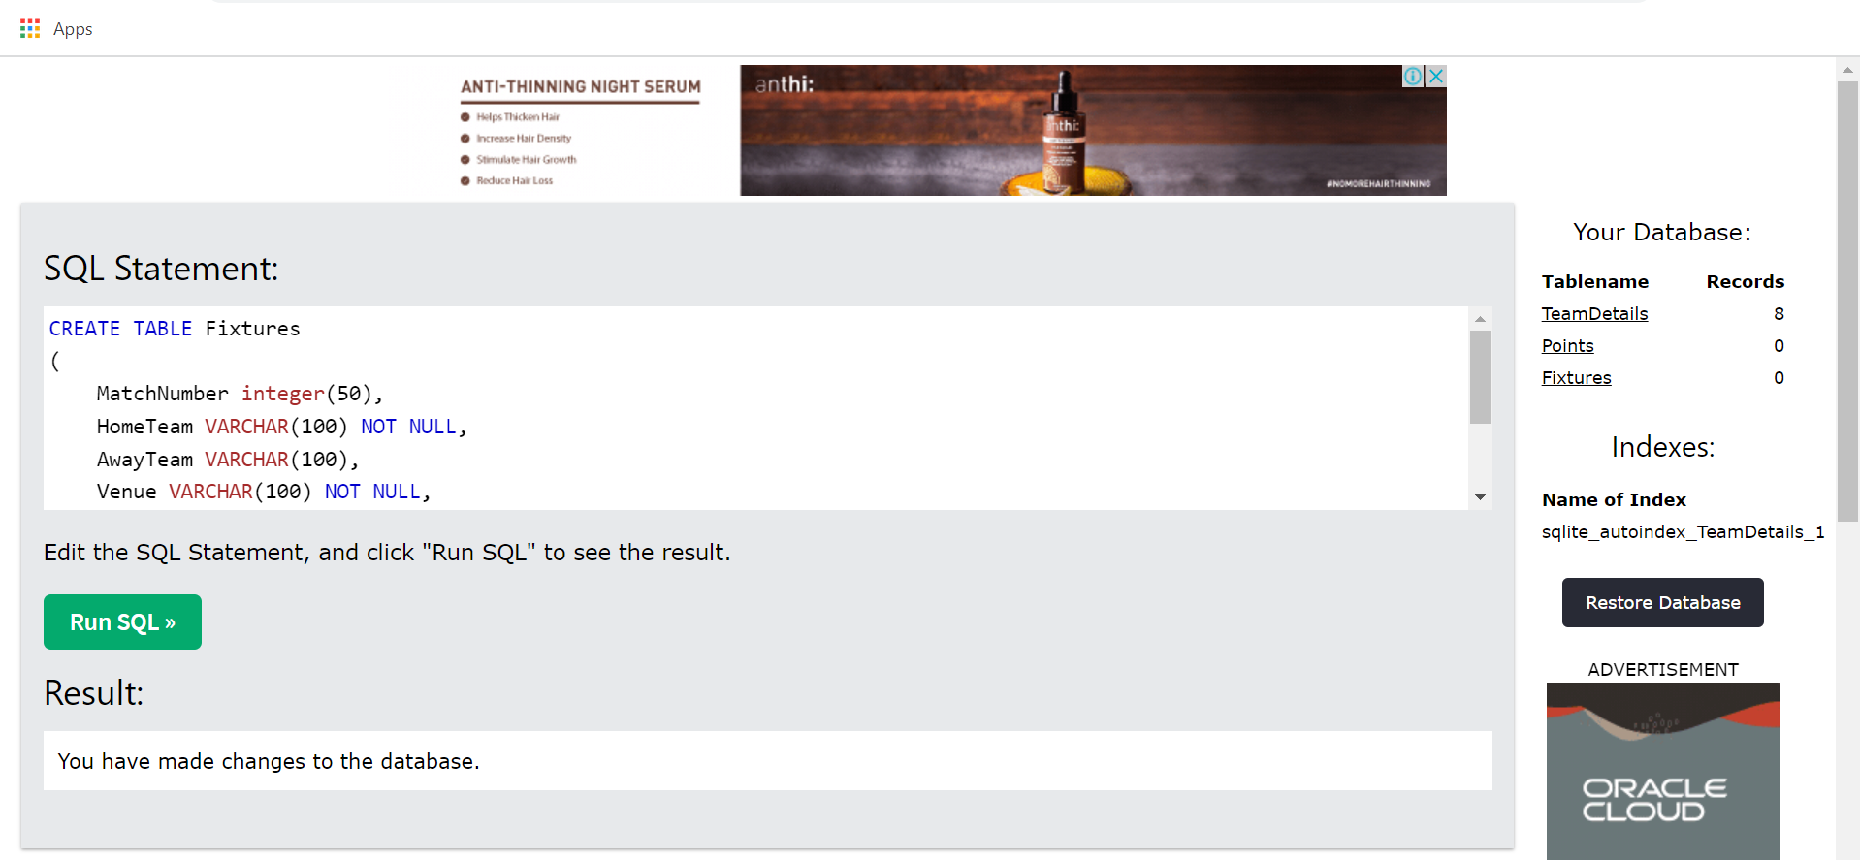

INSERT INTO Fixtures (MatchNumber, HomeTeam, AwayTeam, Venue, TeamWon,TeamLost)

VALUES

(1, 'MI','CSK','Mumbai','CSK','MI'),

(2, 'PK', 'DC', 'Mohali','PK','DC'),

(3, 'KKR', 'RCB', 'Kolkata', 'KKR','RCB'),

(4, 'SRH', 'RR', 'Hyderabad','SRH','RR')

;

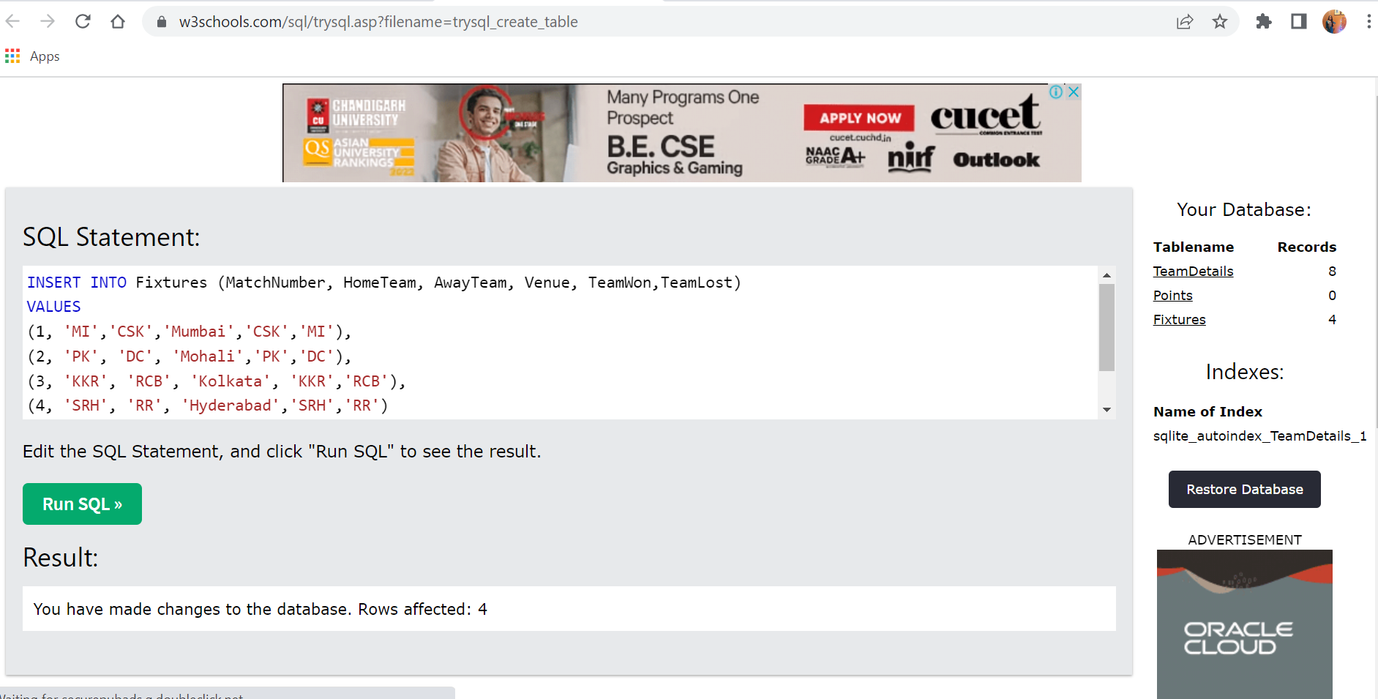

CREATE TABLE Points

(

TeamName Varchar(100),

NoofWins int(100),

NoofLosses int(100),

Points int(255)

);

SELECT count(TeamName) as totalNumberOfTeams FROM TeamDetails

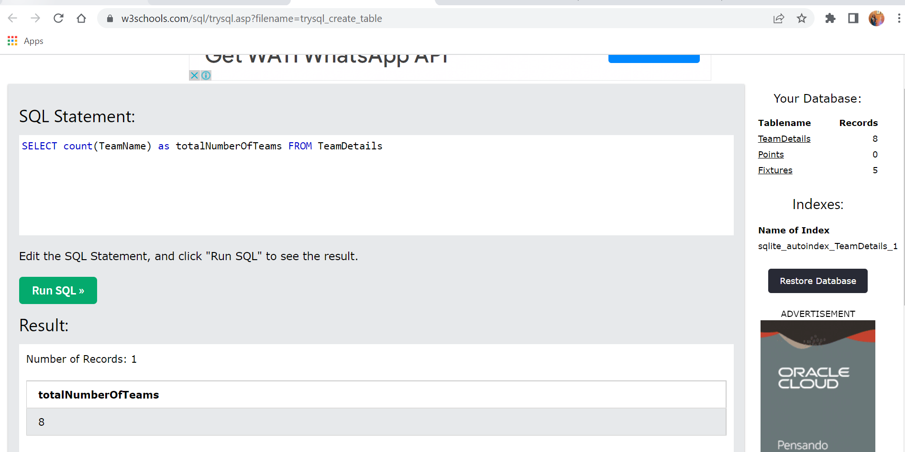

SELECT \* FROM Fixtures

where TeamWon = "RCB"

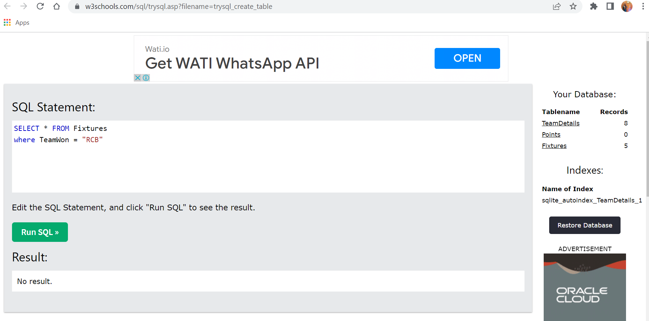

Select count(TeamDetails.TeamName) as lostNumber, Fixtures.TeamLost,Fixtures.Venue

FROM Fixtures

INNER JOIN TeamDetails ON TeamDetails.HomeGround = Fixtures.Venue

where Fixtures.Venue = 'Kolkata'

