Business trip database

Consider the business trip database that keeps track of the business trips of salesman in an office.

Create database business_trip;

Use database business_trip;

Following are the tables

1. SALESMAN (SNO INTEGER, S_NAME CHAR (30), START_YEAR YEAR, DEPTNO VARCHAR (10))

create table SALESMAN (

SNO INTEGER PRIMARY KEY,

S_NAME VARCHAR (30),

START_YEAR year ,

DEPTNO VARCHAR (10),

sd int,

st int,

foreign KEY(sd) references DEPT(sd),

foreign KEY(st) references TRIP (st)

)

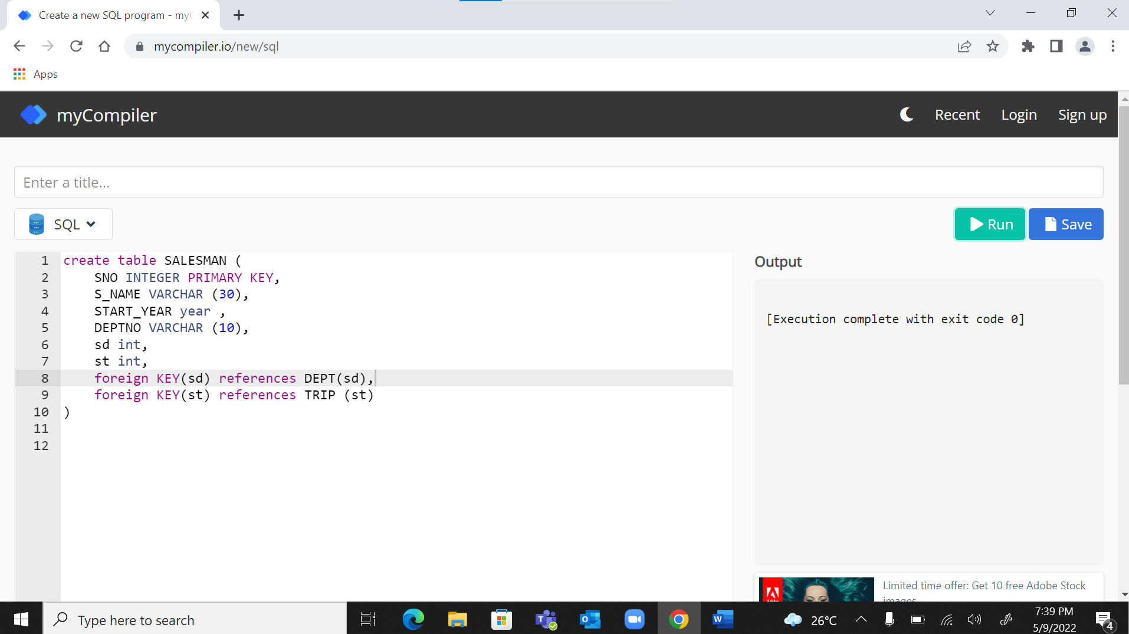

INSERT INTO students VALUES (1, 'Shreya','2014','IE1',11,21);

INSERT INTO students VALUES (2, 'Mon','2015','IE1',13,23);

INSERT INTO students VALUES (3, 'Som','2016','IE1',17,27);

1. TRIP (TNO INTEGER, FROM_CITY CHAR (20), TO_CITY CHAR (20), DEPARTURE_DATE DATE, RETURN DATE)

create table TRIP (

TNO INTEGER primary key,

FROM_CITY CHAR (20),

TO_CITY CHAR (20),

DEPARTURE_DATE DATE,

RETURN_DATE DATE,

TE int,

st int,

foreign KEY(TE) references EXPENSE (TE),

foreign KEY(st) references SALESMAN(st)

) 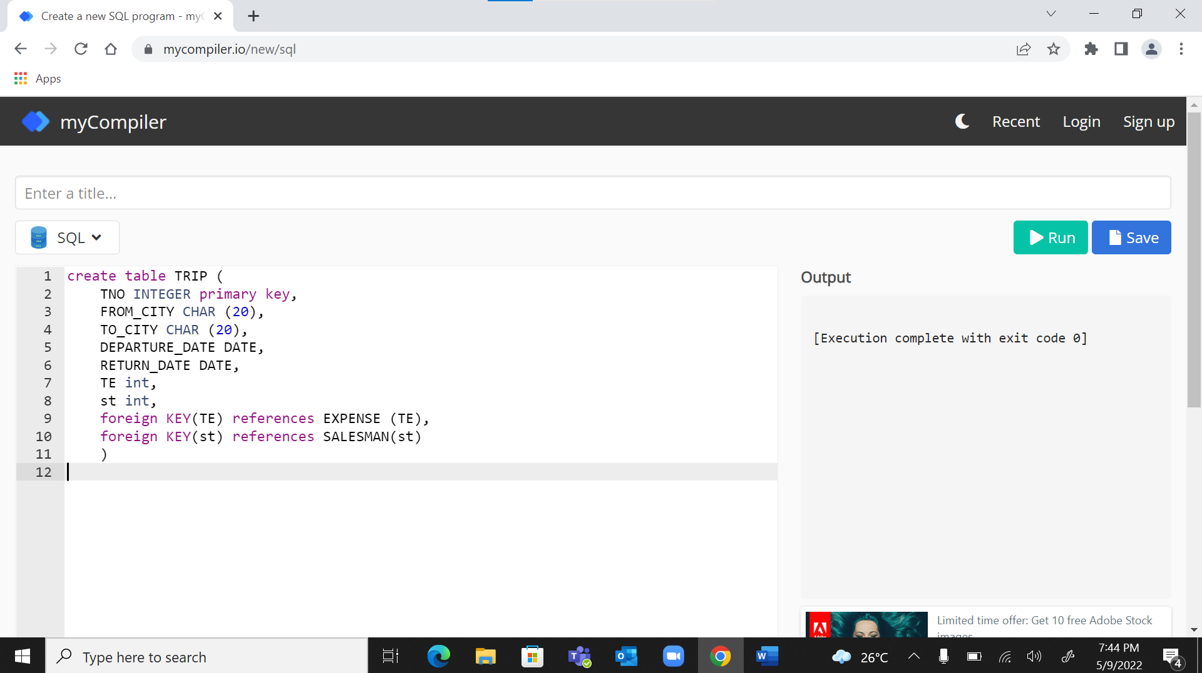

1. DEPT (DEPTNO VARCHAR (10), DEPT_NAME CHAR(20))

create table DEPT (

DEPTNO VARCHAR (10),

DEPT_NAME CHAR(20),

sd int,

foreign KEY(sd) references SALESMAN (sd)

)

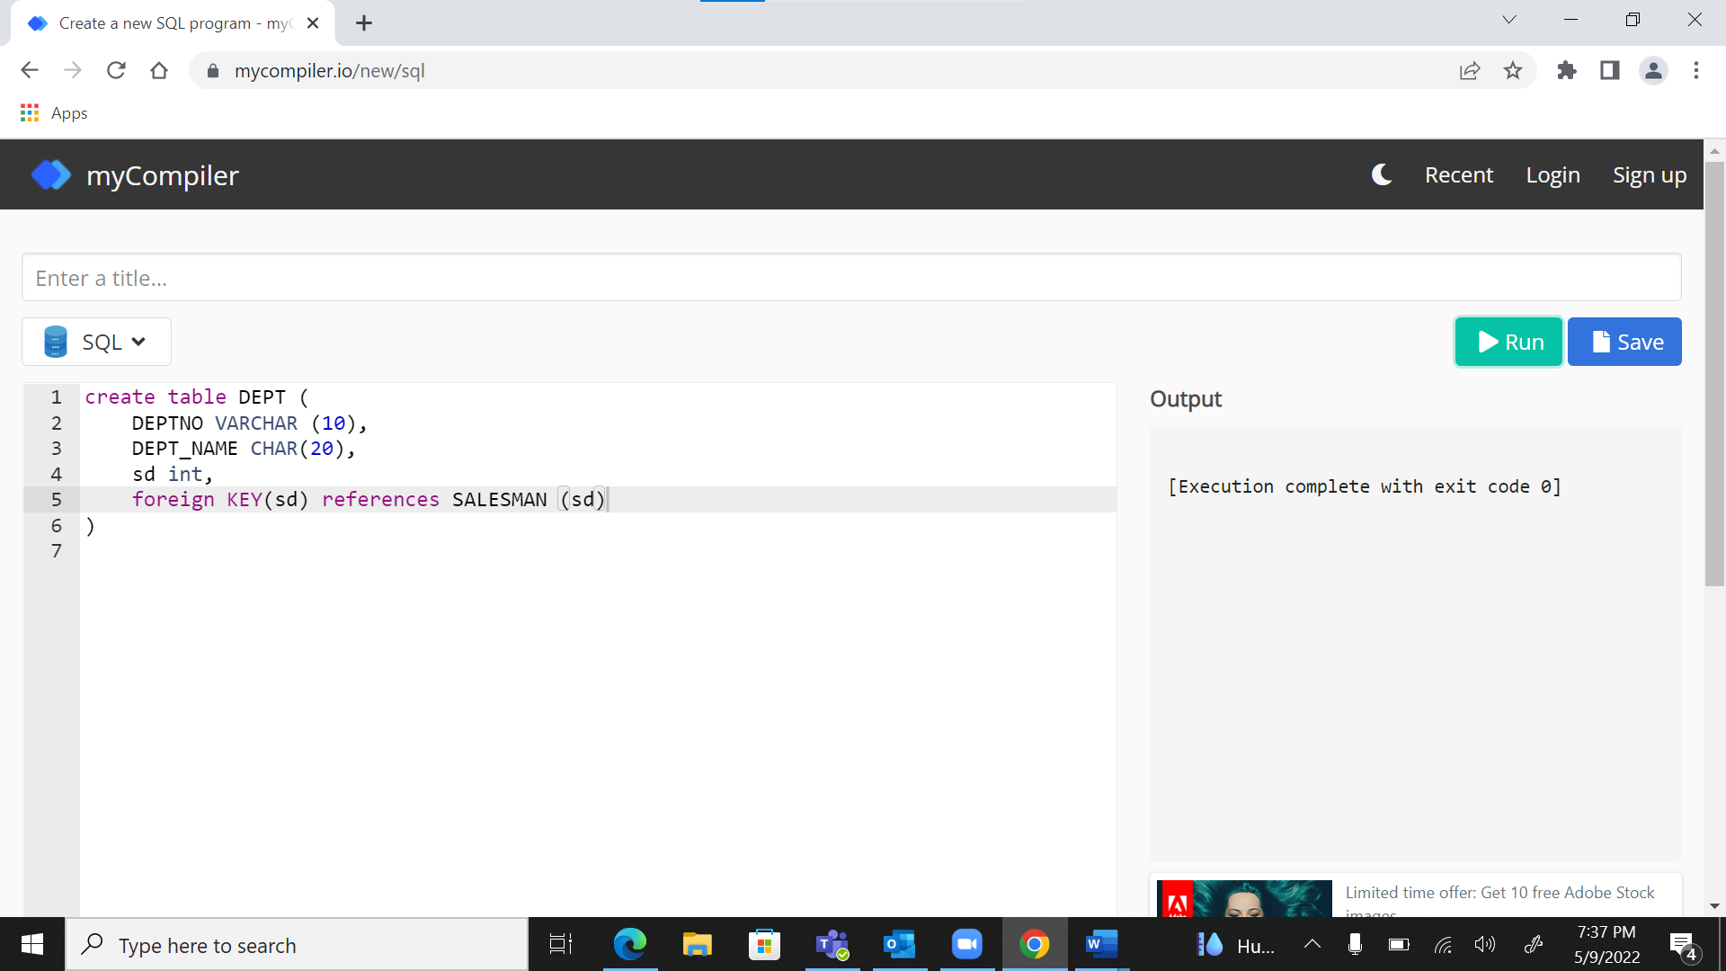

1. EXPENSE (EID INTEGER, AMOUNT MONEY)

create table EXPENSE (

EID INTEGER,

AMOUNT MONEY

)

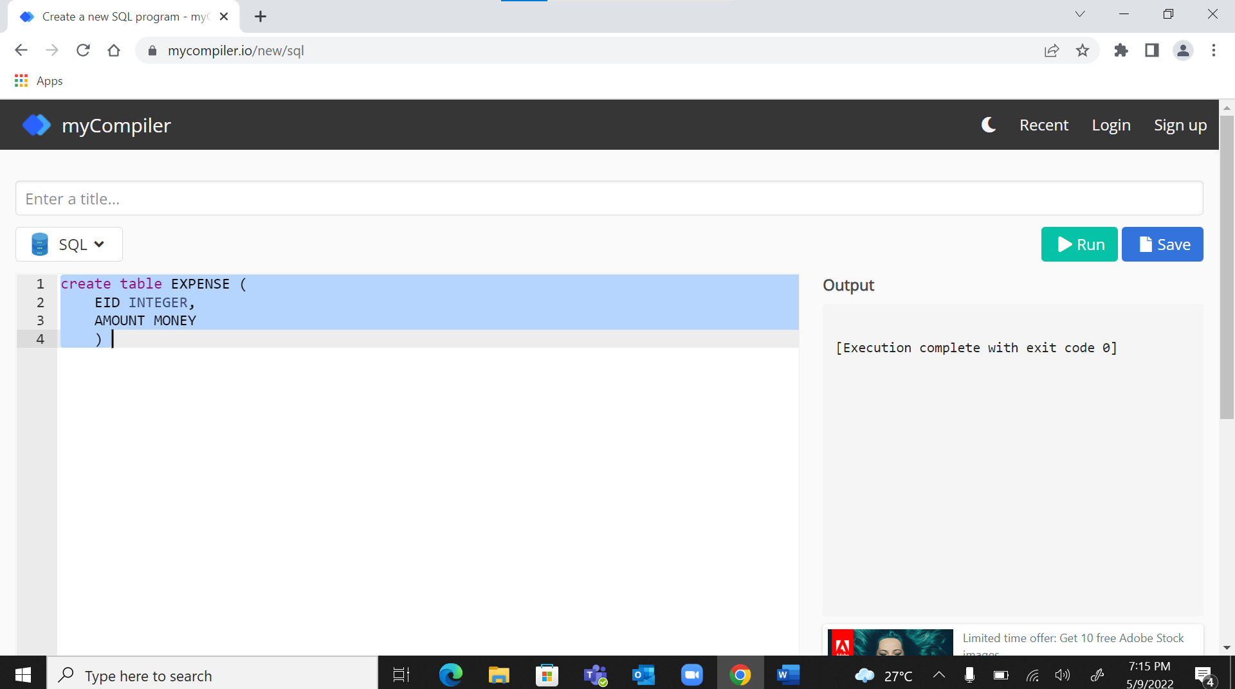

Select * from EXPENSE

Where AMOUNT MONEY=10000;

DEPT-SALESMAN 1 TO M SALESMAN - TRIP 1 TO M TRIP - EXPENSE 1 TO 1

**Please identify the necessary primary and foreign key and update the schema as per requirements.**

Questions

|  |  |  |
| --- | --- | --- |
| **Milestone 1** | Create Tables | 2 |
| **Milestone 2** | Insert Records into database.   * **\*\*\*Add expenses in thousands\*\*\*** | 1 |
| **Milestone 3** | Give the details for trips that exceed Rs. 10,000 in expenses. | 1 |
| **Milestone 4** | List the salesman numbers and names of the salesmen who made trips to Calcutta | 1 |
| **Milestone 5** | Delete all the trips made by department “computer” having expenses more than Rs. 15000. | 2 |
| **Milestone 6** | Find the departments from which the salesmen have done highest number of trips. | 1 |
| **Milestone 7** | Create an Empty repository in the local system in a folder | 1 |
| **Milestone 8** | Add all sql query in text file and staged them | 1 |
| **Milestone 9** | Commit them with meaningful message | 1 |
| **Milestone 10** | Create a remote repository in Deloitte GitHub | 1 |
| **Milestone 11** | Push those local changes to this remote repository in Deloitte GitHub. | 1 |
| **Milestone 12** | Create another directory in same folder | 1 |
| **Milestone 13** | Clone the above repository from the remote in the new directory. | 1 |
| **Milestone 14** | Move to the original repository and create a new file containing a new set of sql queries. | 1 |
| **Milestone 15** | Commit those changes and push them and also pull them in new directory | 1 |
| **Milestone 16** | Move to the original repository and create a new branch develop. | 1 |
| **Milestone 17** | Add .sql files(put query inside .sql files) to develop branch and Push develop branch to remote repository | 1 |
| **Milestone 18** | Fetch the created develop branch in the cloned repository | 1 |
| **Milestone 19** | Pull that branch from remote into cloned repository | 1 |
| **Milestone 20** | Merge the develop branch with the master branch in the cloned repository. | 1 |
| **Milestone 21** | Push the changes to remote repository from cloned repository | 1 |
| **Milestone 22** | Pull these changes in the original local copy of this repository | 2 |