**Advanced SQL & JDBC Exercise**

**Shreya Bhardwaj**

1. Find all employees whose Employee name ends with 'N'. List the employee number, the Employee name, and the last character of the Employee name.

Employee Table:

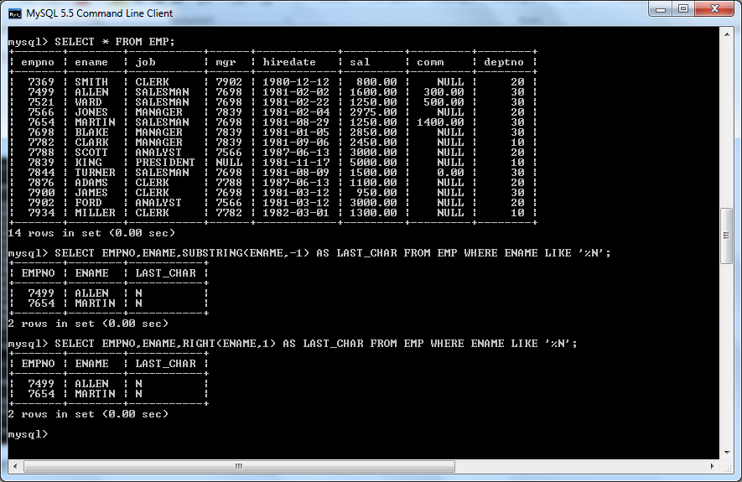

Queries:



Can be solved using two queries:

Query 1: SELECT EMPNO,ENAME,SUBSTRING(ENAME,-1) AS LAST_CHAR FROM EMP WHERE ENAME LIKE '%N';

Query 2: SELECT EMPNO,ENAME,RIGHT(ENAME,1) AS LAST_CHAR FROM EMP WHERE ENAME LIKE '%N';

1. write a procedure to increment the salary of employee who works in sales department

Original Emp and Dept Tables:



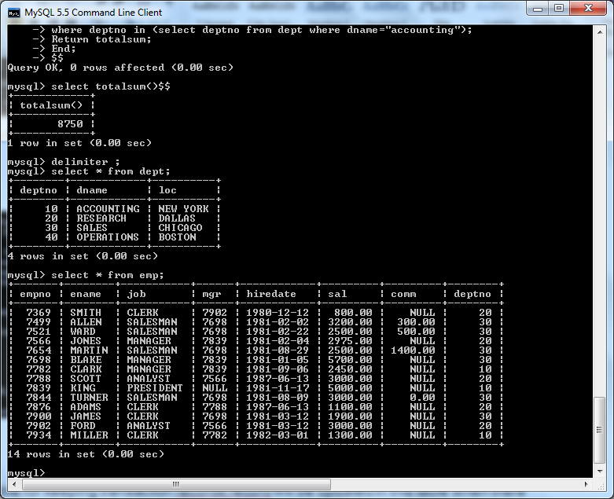

Procedure defination and Procedure call:

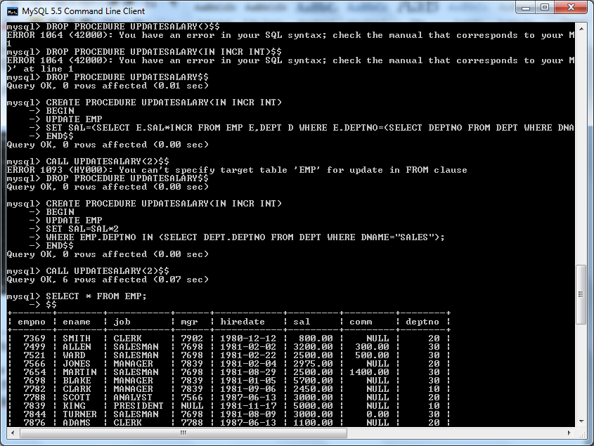

Updated Emp Table:

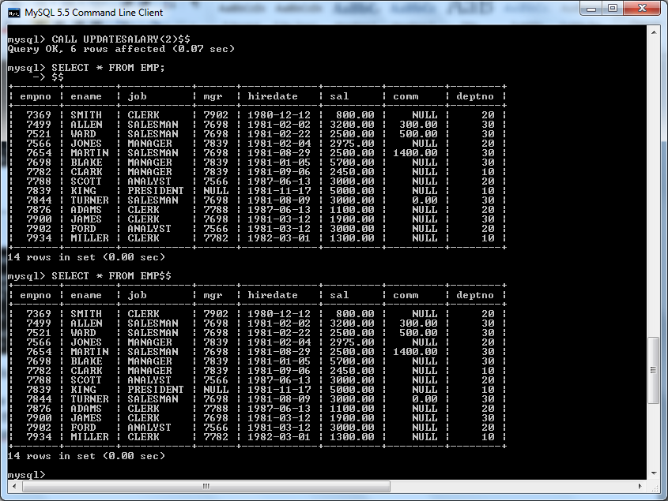

1. write a function to find the total salary of employees, who works in Accounts department

Function :

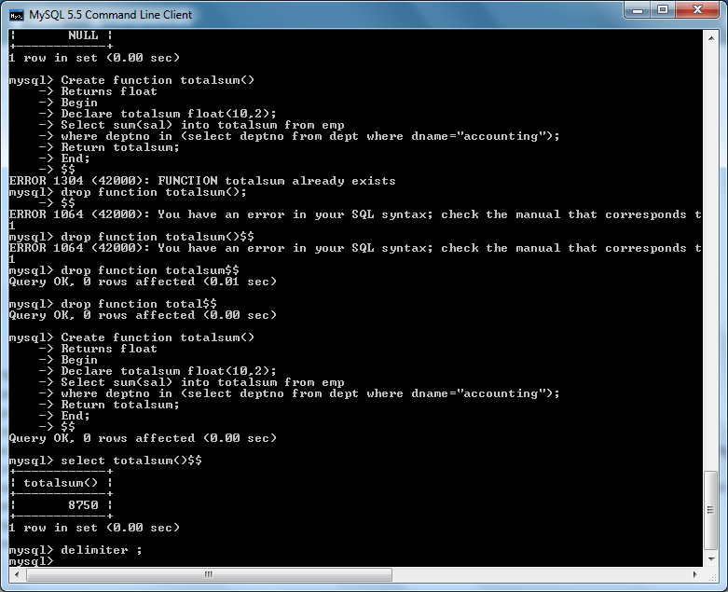

Contents of Department and Employee Tables:



4) create a new  table for keeping transaction records,record will be updated in this table when there is deduction in the salary,when salary is deducted a trigger is executed which insert employee name ,updatedby ,changedsalary,updateddate in new table.

Trigger:

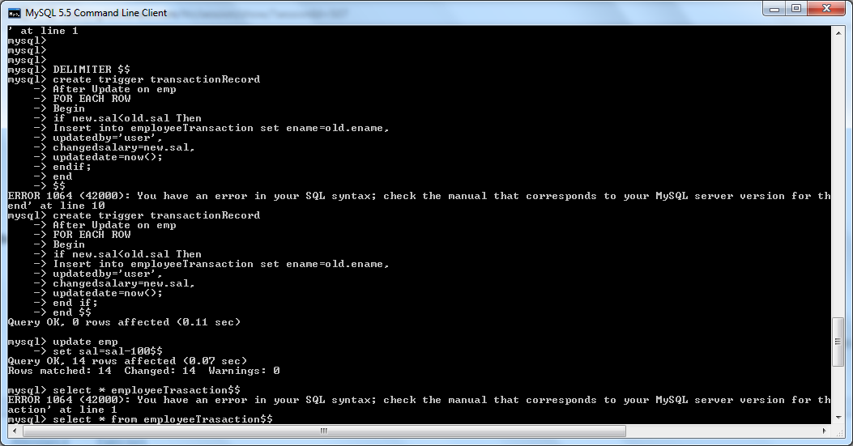

Original Employee Table:



Update Command(firing the trigger):

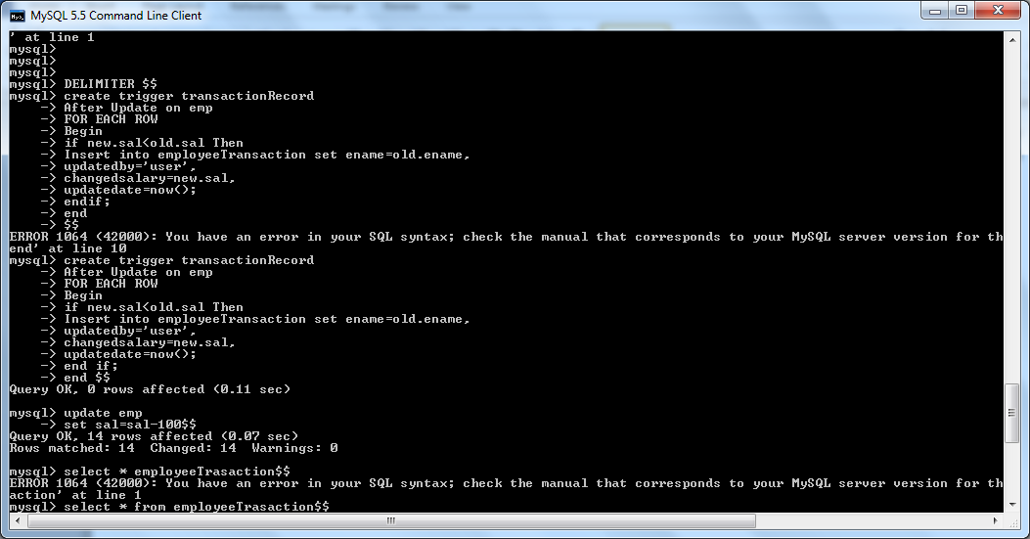

EmployeeTransaction Table and the updated Emploee Table after the Trigger was fired:

