Issues in Product listing

* The highlighted text is not visible on chard page.

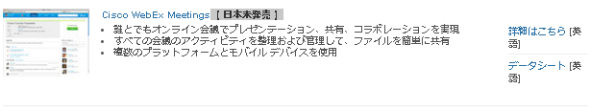

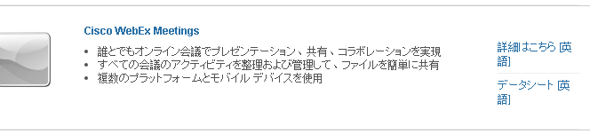

<http://www.cisco.com/web/JP/solution/collaboration/products.html>

<http://chard.cisco.com:4502/content/ja_jp/solutions/collaboration/product-listing.html>

* For en_hk the Show products content is different when compared WEB URL

<http://www.cisco.com/web/HK/solutions/borderless/portfolio.html>

<http://chard.cisco.com:4502/content/en_hk/solutions/enterprise-networks/product-listing.html>

* For en_il the drawer panels exists in chard but when compared with WEB URL they are missing

<http://www.cisco.com/web/IL/products/storage/products.html>

<http://chard.cisco.com:4502/content/en_il/products/storage-networking/product-listing.html>

Issues in Technology:

**Issues to be FIX:**

* For ru_ru, Technology page is not migrated fully, only header hyperlinks are migrated.

<http://chard.cisco.com:4502/content/ru_ru/products/servers-unified-computing/technology.html>

<http://www.cisco.com/web/RU/products/uc/technology.html>

* For es_mx, Technology page, Page has migrated completely, even though we got report saying “**MisMatch in list components. Additional Elements found in Locale Page. Locale page has ( 2 )Elements and Available nodes are (1)”**

<http://chard.cisco.com:4502/content/es_mx/products/servers-unified-computing/technology.html>

<http://www.cisco.com/web/LA/productos/uc/technology.html>