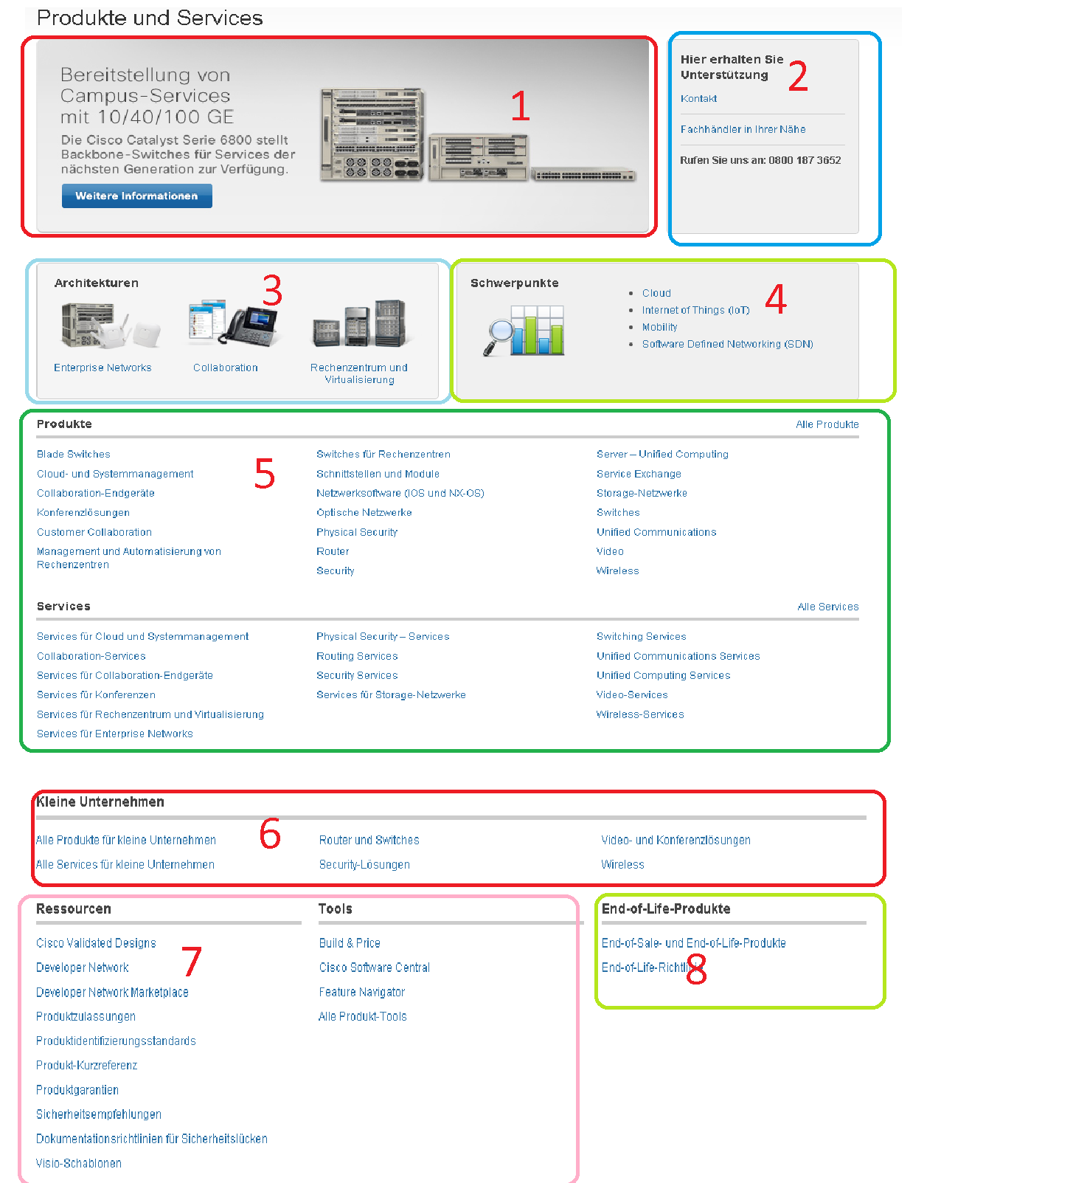

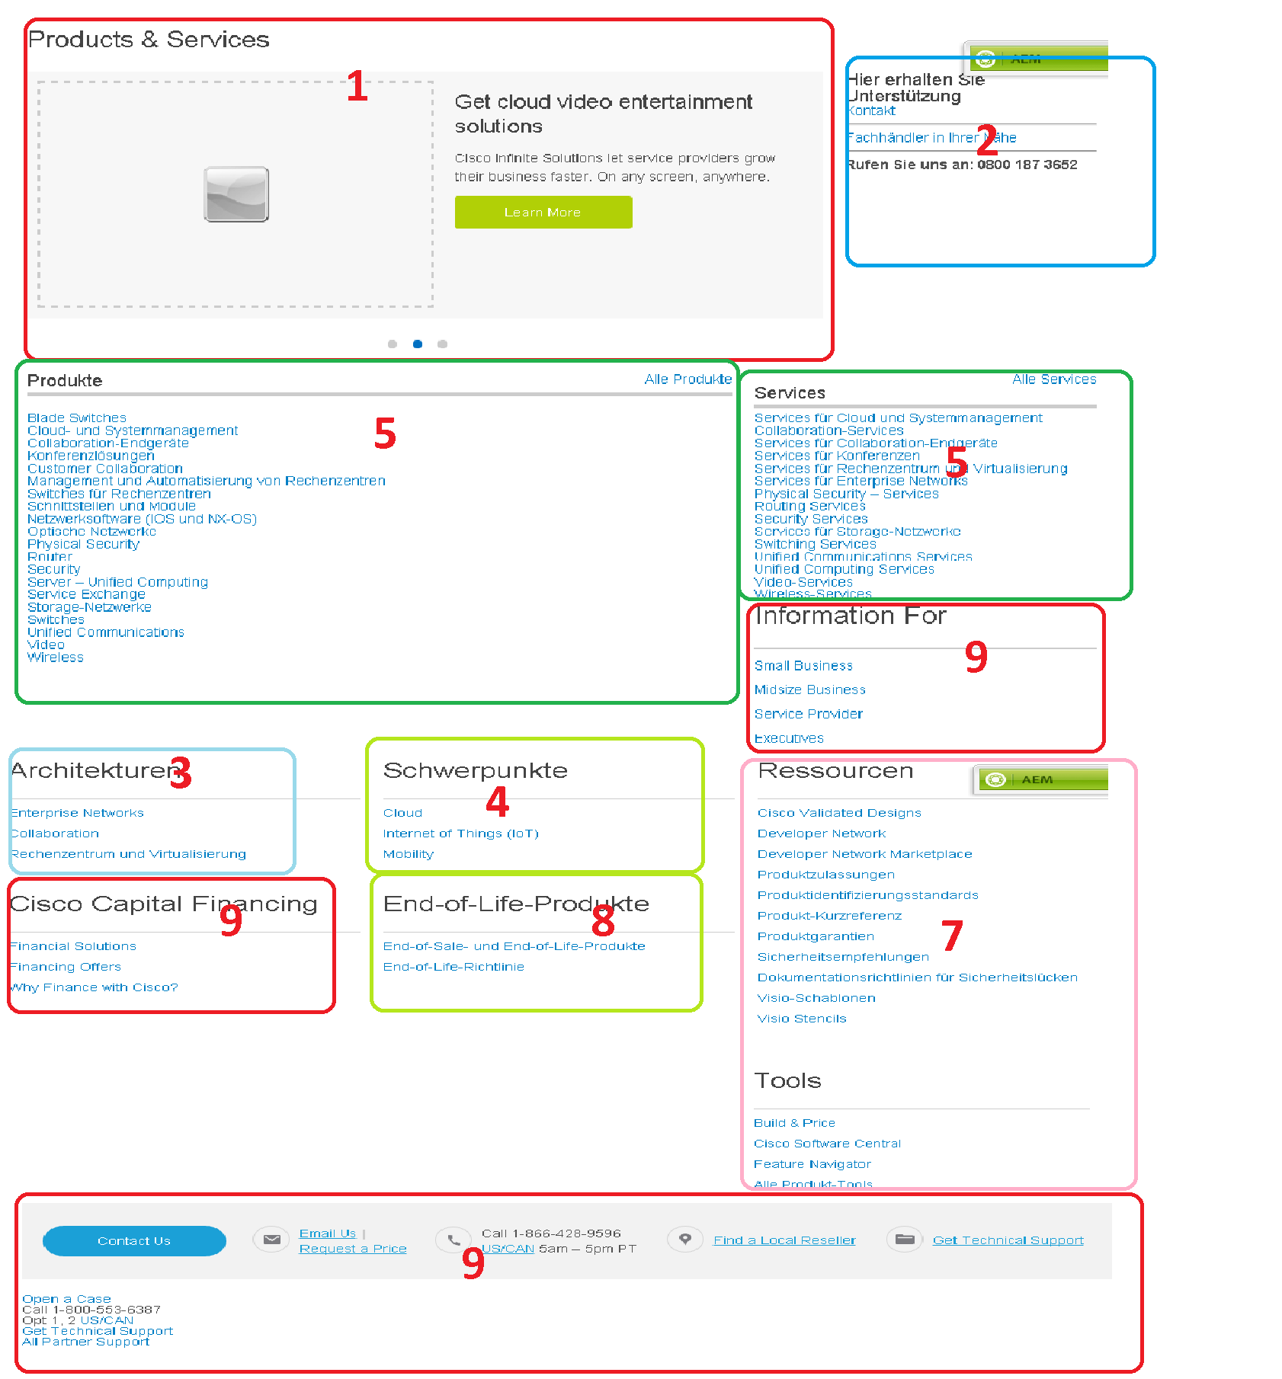

Migration Status and Issues:

1. Not migrated, issue : In node structure this element is a hero large with 3 carousels but on the other side in local page it is simple html blob image.
2. Migrated
3. Migrated
4. Migrated
5. Migrated , issue : At local page we have same div classes for list headings for all components of the page so we can’t differ them hence we hard coded a value to get the data.
6. Not Migrated , issue : We don’t have respective nodes to migrate it.
7. Migrated
8. Migrated
9. Extra us content after migration which need to be deleted manually.