Local Page URl : <http://www.cisco.com/web/DE/solutions/index.html>

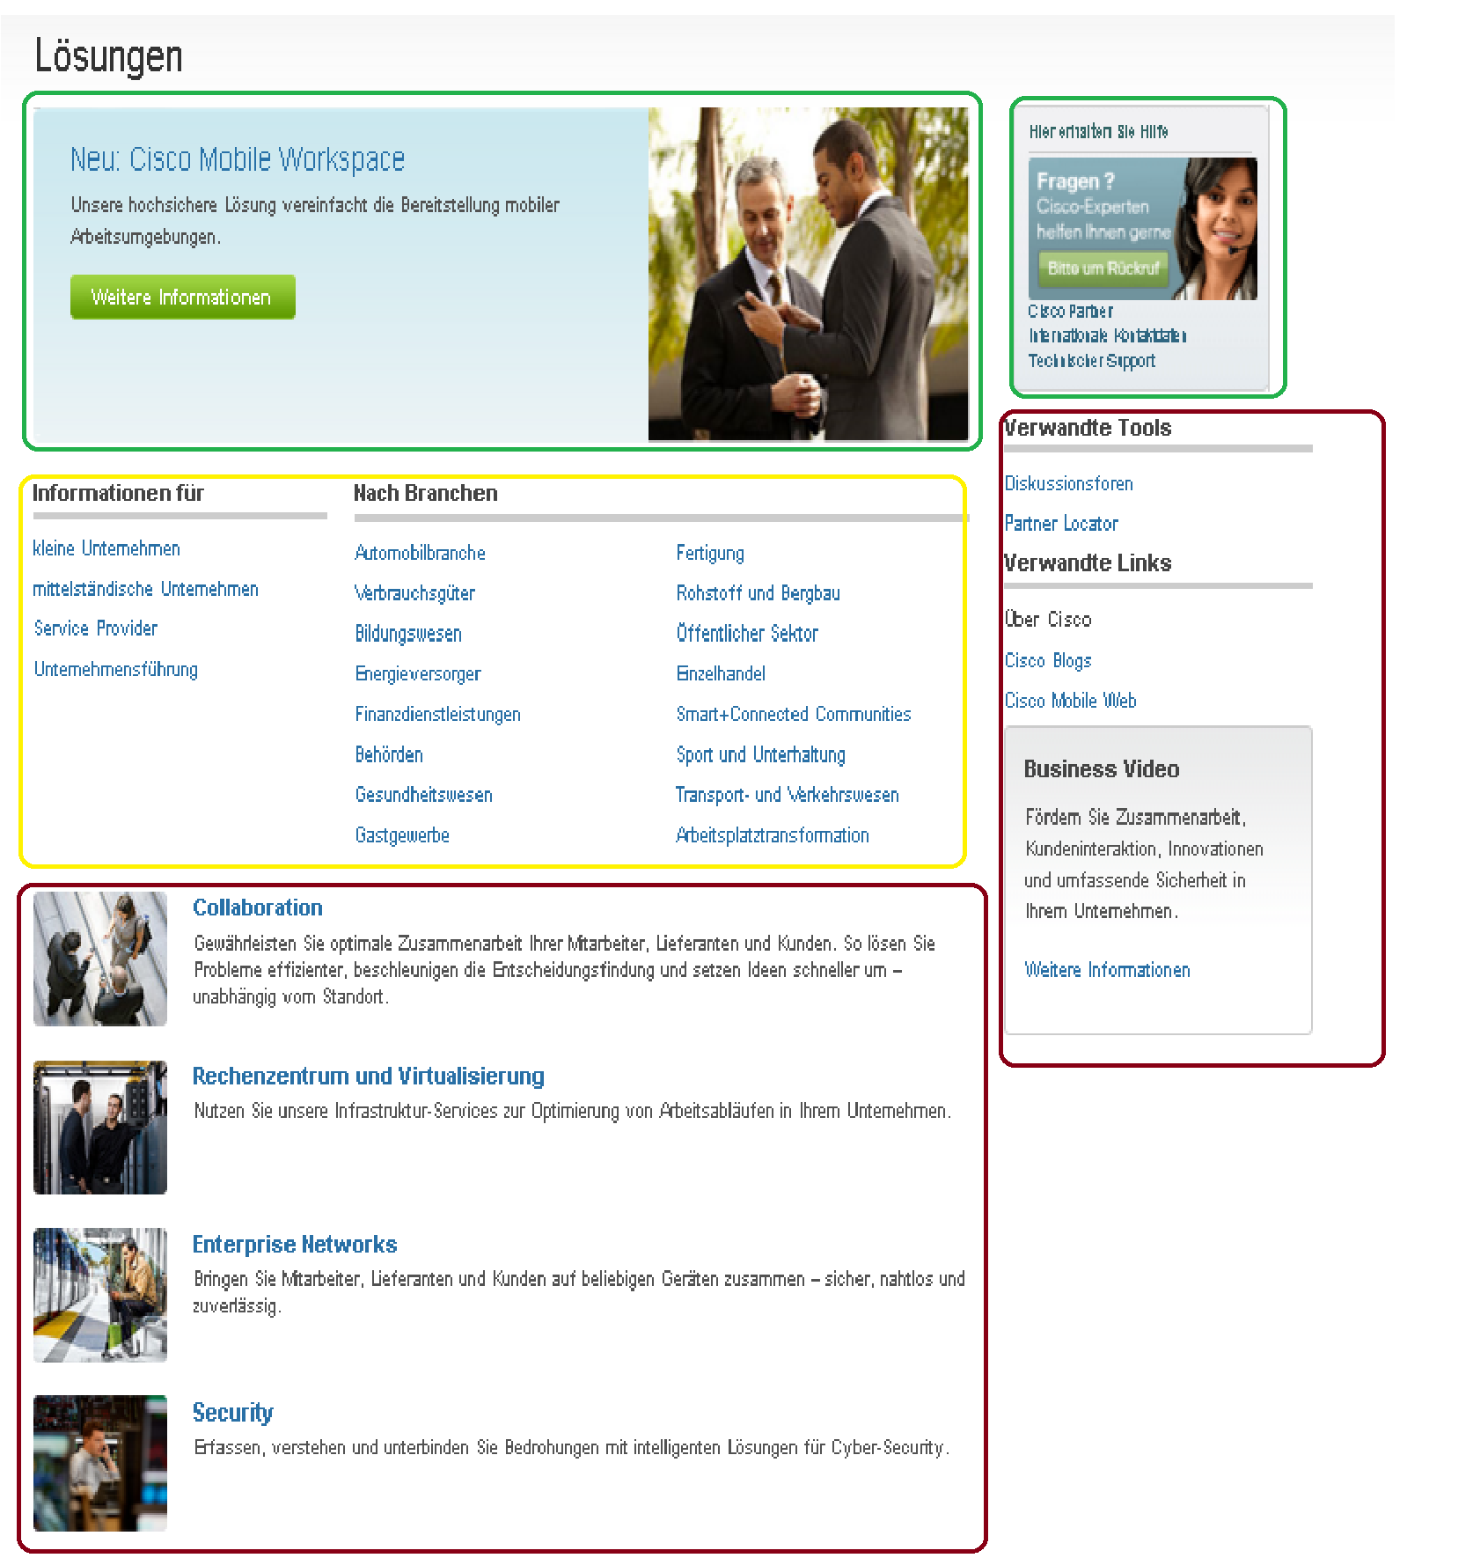

Chard Page URL : <http://rdevalka-8l34v:4502/content/de_de/solutions/index.html>

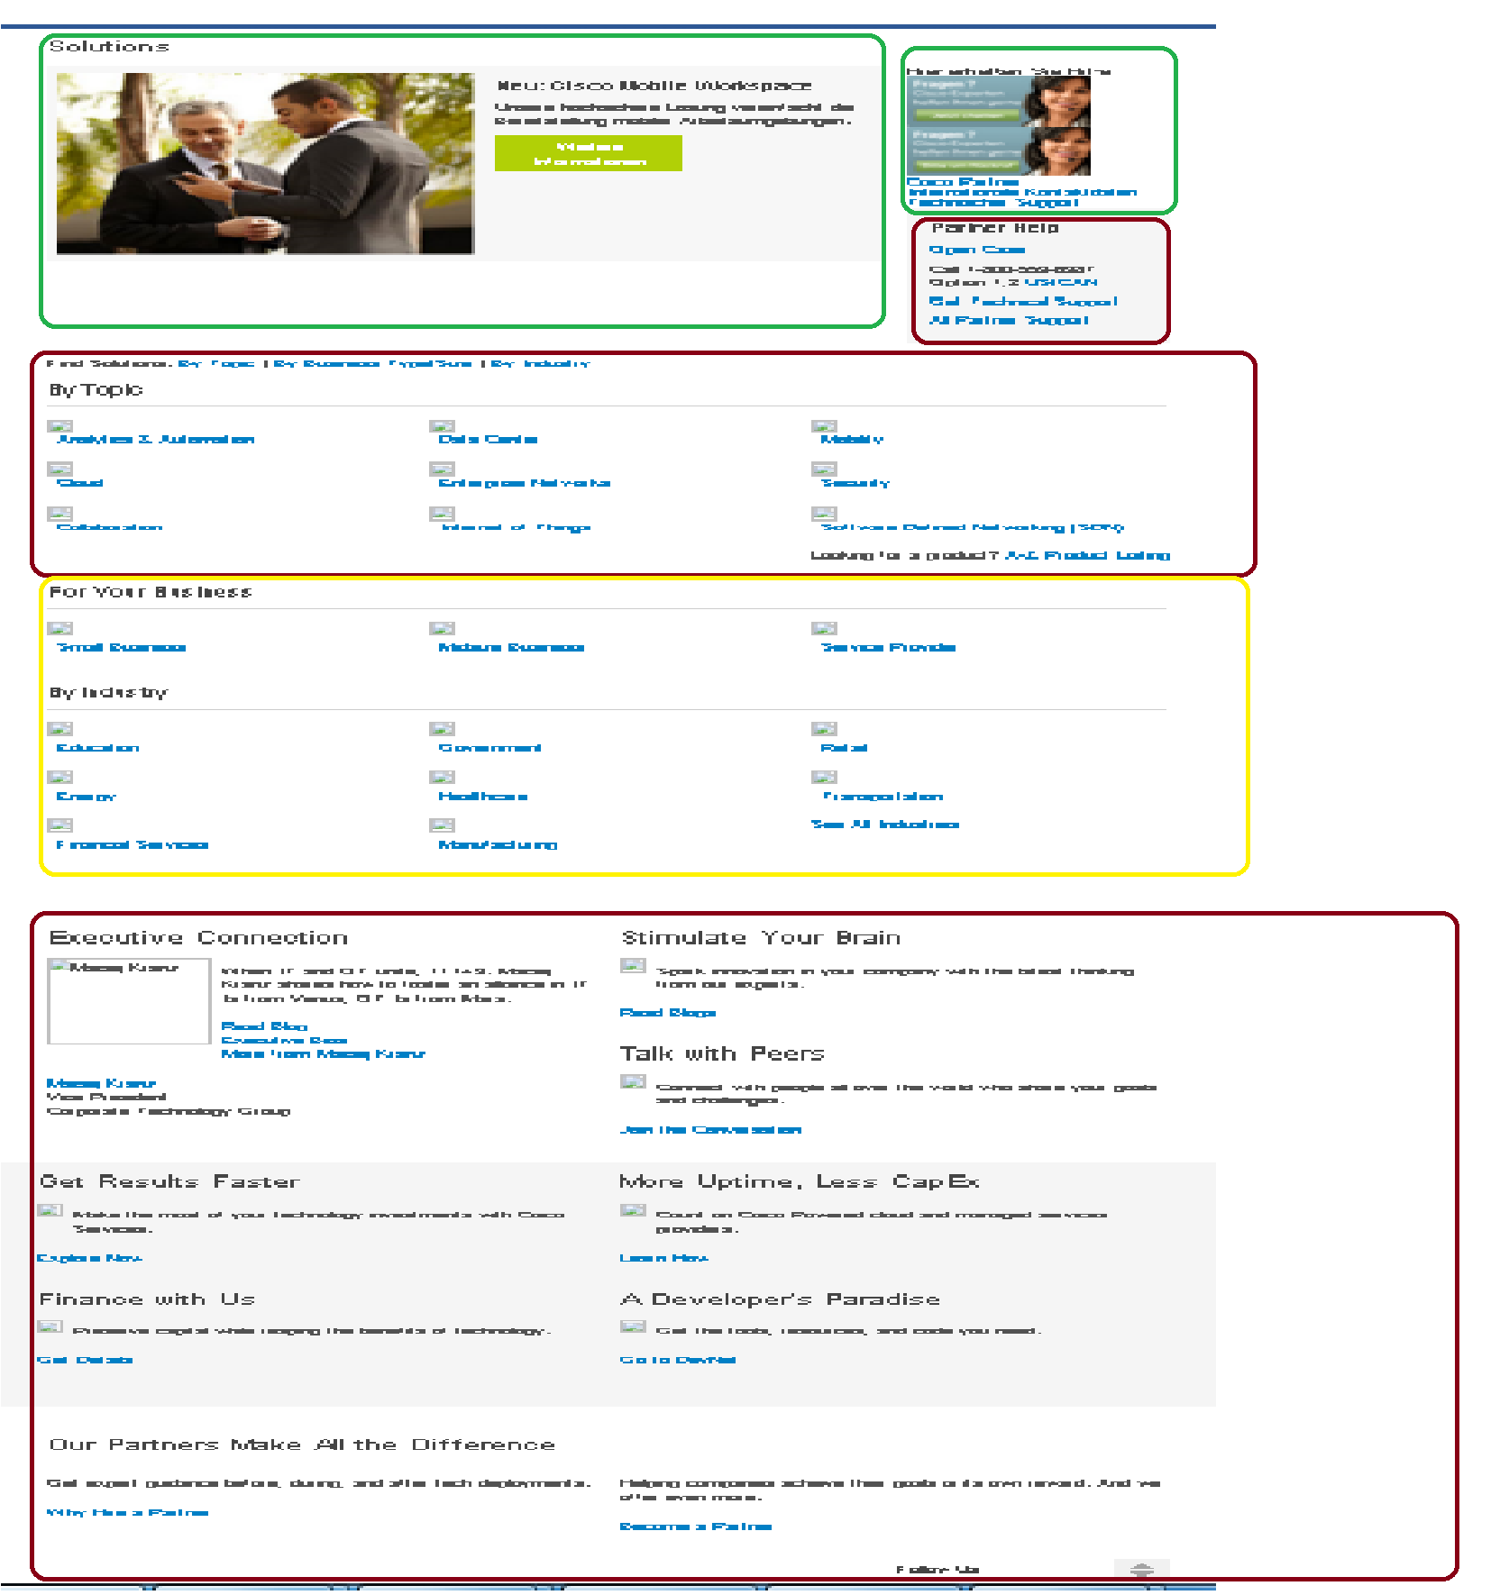

DEVEATIONS : -

1 . As we can see above two URL’s we have two green blocks that has been migrated but after migration we found couple of issues in those migrated content:

* 1. :- Hero image and content are coming in reverse order after migration.
  2. :- Contact Us image is coming twice in right rail, since it is html blob and in that we have two images “Active” & “inactive” which are displaying by some script, but we don’t have that kind of script in chard side so both images are getting displayed.

2. We have yellow block in the above URL’s , Although content is matching but still we can’t migrate that content because we have separate nodes for each & every link on chard side but on locale page side we have all links in one ul component.

3. All red blocks on locale page we can’t migrate them at all because we don’t have nodes for them. On the other hand all Red blocks on chard side for those nodes we don’t have respective content on locale page.