Eng Page Path: /content/en/us/solutions/collaboration/service-listing

1

4

3

2

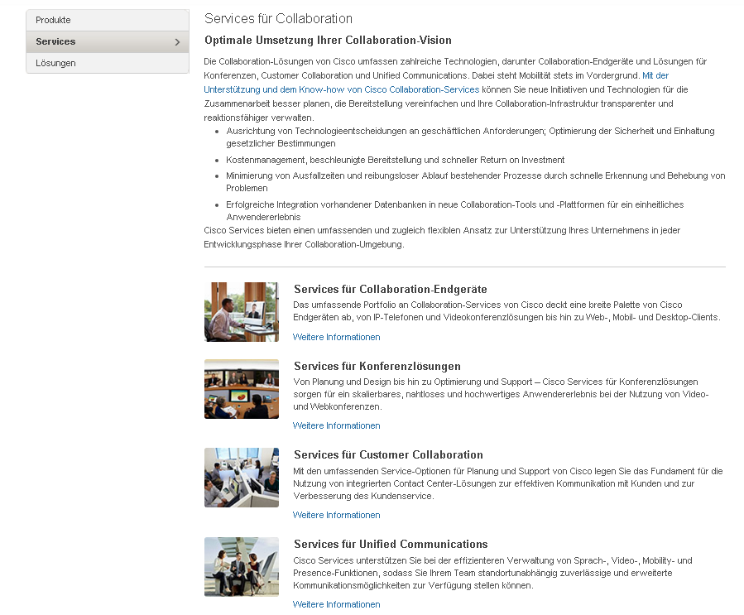

|  |  |  |  |
| --- | --- | --- | --- |
| 1 | /content/<locale>/solutions/<solution-category>/service-listing/jcr:content/content_parsys/services/layout-services/gd21v1/gd21v1-mid/text/text |  |  |
| 2 | /content/<locale>/solutions/<solution-category>/service-listing/jcr:content/content_parsys/services/layout-services/gd21v1/gd21v1-mid/spotlight_medium*/title |  |  |
| 3 | /content/<locale>/solutions/<solution-category>/service-listing/jcr:content/content_parsys/services/layout-services/gd21v1/gd21v1-mid/ spotlight_medium*/description |  |  |
| 4 | /content/<locale>/solutions/<solution-category>/service-listing/jcr:content/content_parsys/services/layout-services/gd21v1/gd21v1-mid/ spotlight_medium*/linktext  /content/<locale>/solutions/<solution-category>/service-listing/jcr:content/content_parsys/services/layout-services/gd21v1/gd21v1-mid/ spotlight_medium*/linkurl |  |  |