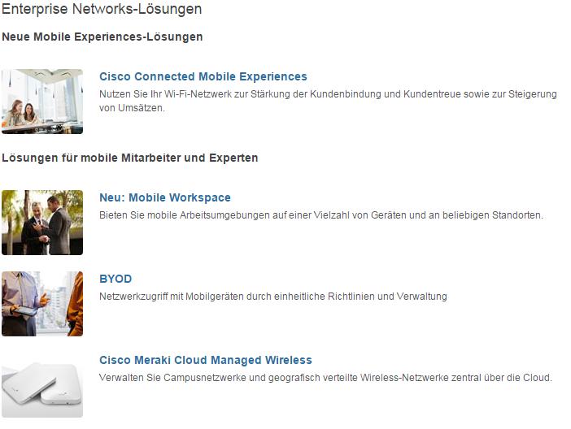

6

7

5

4

3

2

1

8

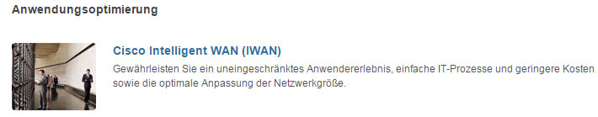

|  |  |  |  |
| --- | --- | --- | --- |
| 1 | /content/<locale>/solutions/enterprise-networks/solution-listing/jcr:content/content_parsys/solutions/layout-solutions/gd21v1/gd21v1-mid/text/text |  | Select(“div.gd-right”).select(“div.c00-pilot”).getElementByTag(“h2”) |
| 2 |  |  |  |
| 3 | /content/<locale>/solutions/enterprise-networks/solution-listing/jcr:content/content_parsys/solutions/layout-solutions/gd21v1/gd21v1-mid/spotlight_medium_v2*/title  /content/<locale>/solutions/enterprise-networks/solution-listing/jcr:content/content_parsys/solutions/layout-solutions/gd21v1/gd21v1-mid/spotlight_medium_v2*/title-linkurl |  | Select(“div.gd-right”).select(“div.c11-pilot”)- this will return elements for(each elements){ getElementByTag(“h2”).getElementByTag(“a”)} |
| 4 | /content/<locale>/solutions/enterprise-networks/solution-listing/jcr:content/content_parsys/solutions/layout-solutions/gd21v1/gd21v1-mid/spotlight_medium_v2*/description |  | Select(“div.gd-right”).select(“div.c11-pilot”)- this will return elements for(each elements){ getElementByTag(“p”) |
| 5 |  |  |  |
| 6 | /content/<locale>/solutions/enterprise-networks/solution-listing/jcr:content/content_parsys/solutions/layout-solutions/gd21v1/gd21v1-mid/spotlight_medium*/title  /content/<locale>/solutions/enterprise-networks/solution-listing/jcr:content/content_parsys/solutions/layout-solutions/gd21v1/gd21v1-mid/spotlight_medium*/title-linkurl |  | Select(“div.gd-right”).select(“div.c11-pilot”)- this will return elements for(each elements){ getElementByTag(“h2”).getElementByTag(“a”)}  Select(“div.gd-right”).select(“div.c11-pilot”)- this will return elements for(each elements){ getElementByTag(“h2”).getElementByTag(“a”)  attr(href”)} |
| 7 | /content/<locale>/solutions/enterprise-networks/solution-listing/jcr:content/content_parsys/solutions/layout-solutions/gd21v1/gd21v1-mid/spotlight_medium*/description |  | Select(“div.gd-right”).select(“div.c11-pilot”)- this will return elements for(each elements){ getElementByTag(“p”) |
| 8 |  |  |  |

Deviation

* There are 3 additional text components on this page.
* For the spotlight_medium_v2* title link url is missing