Version History

|  |  |
| --- | --- |
| 1.0 | Added mappings for Solution-Listing template |
|  |  |
|  |  |
|  |  |

English Page Path: /content/en/us/solutions/collaboration/solution-listing

­­­­­­­­­­­­­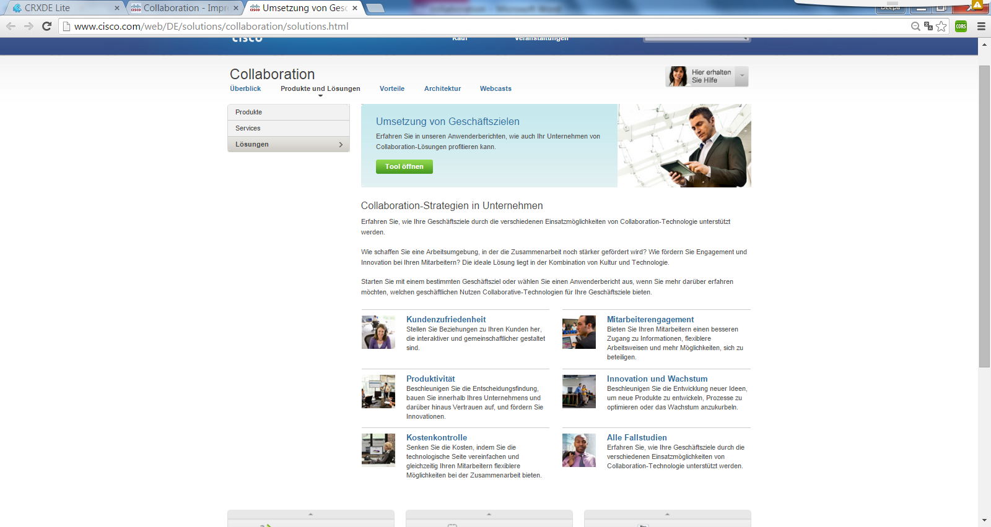

4

3

2

1

13

|  |  |  |  |
| --- | --- | --- | --- |
| 1 | /content/<locale>/solutions/<product-category>/solution-listing/jcr:content/content_parsys/solutions*/layout-solutions*/gd21v1*/gd21v1-mid*/htmlblob */html |  |  |
| 2 | /content/<locale>/solutions/<product-category>/solution-listing/jcr:content/content_parsys/solutions*/layout-solutions*/gd21v1*/gd21v1-mid*/text*/text |  |  |
| 3 | /content/<locale>/ solutions /<product-category>/solution-listing/jcr:content/content_parsys/solutions*/layout-solutions*/gd21v1*/gd21v1-mid*/spotlight_medium*/title  /content/<locale>/ solutions /<product-category>/solution-listing/jcr:content/content_parsys/solutions*/layout-solutions*/gd21v1*/gd21v1-mid*/spotlight_medium*/title-linkurl |  |  |
| 4 | /content/<locale>/ solutions /<product-category>/solution-listing/jcr:content/content_parsys/solutions*/layout-solutions*/gd21v1*/gd21v1-mid*/spotlight_medium*/description |  |  |