Version History

|  |  |
| --- | --- |
| 1.0 | Added mappings for Solution-Listing template |
|  |  |
|  |  |
|  |  |

English Page Path: /content/en/us/products/security/solution-listing

­­­­­­­­­­­­­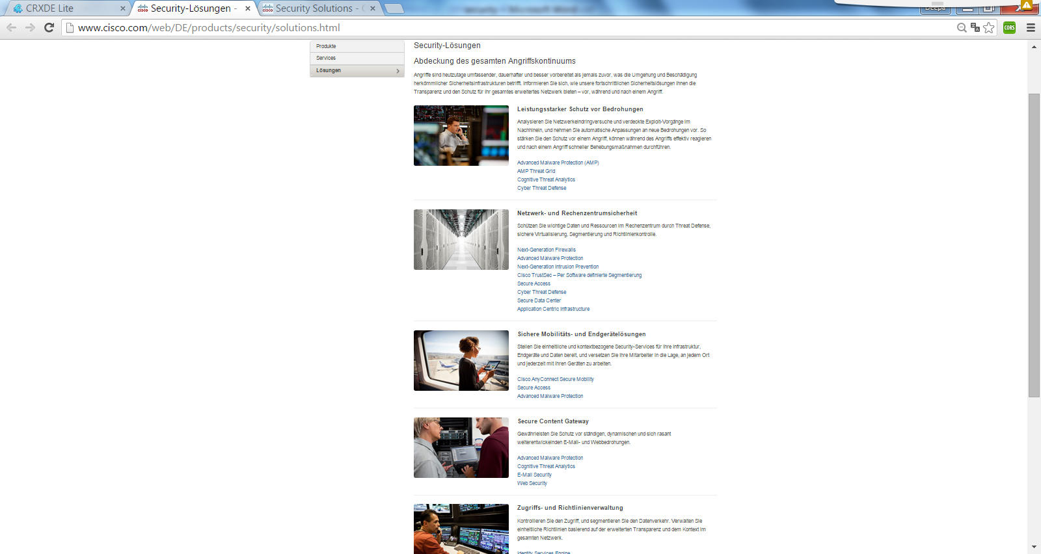

2

2

2

2

1

2

1

13

|  |  |  |  |
| --- | --- | --- | --- |
| 1 | /content/<locale>/products/<product-category>/solution-listing/jcr:content/content_parsys/solutions*/layout-solutions*/gd21v1*/gd21v1-mid*/text*/text |  |  |
| 2 | /content/<locale>/products/<product-category>/solution-listing/jcr:content/content_parsys/solutions*/layout-solutions*/gd21v1*/gd21v1-mid*/htmlblob*/html |  |  |