Version History

|  |  |
| --- | --- |
| 1.0 | Added mappings for Solution-Listing template |
|  |  |
|  |  |
|  |  |

English Page Path: /content/en/us/products/servers-unified-computing/solution-listing

­­­­­­­­­­­­­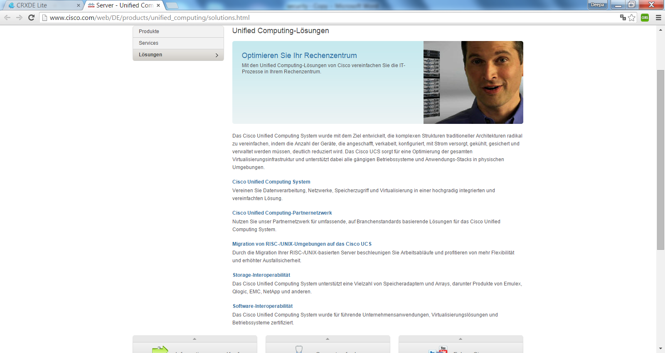

3

2

1

13

|  |  |  |  |
| --- | --- | --- | --- |
| 1 | /content/<locale>/products/<product-category>/solution-listing/jcr:content/content_parsys/solutions*/layout-solutions*/gd21v1*/gd21v1-mid*/text/text |  | Select(“div.gd-right”).first().getElementsByTag("h1").first().outerHtml() |
| 2 | /content/<locale>/products/<product-category>/solution-listing/jcr:content/content_parsys/solutions*/layout-solutions*/gd21v1*/gd21v1-mid*/htmlblob*/html |  | Select(“div.gd-right”).Select(“div.c39”) |
| 3 | /content/<locale>/products/<product-category>/solution-listing/jcr:content/content_parsys/solutions*/layout-solutions*/gd21v1*/gd21v1-mid*/text_0/text |  | Select(“div.gd-right”).first().select("div.c00-pilot") |