Page URL: /content/en/us/solutions/service-provider/solutions-listing

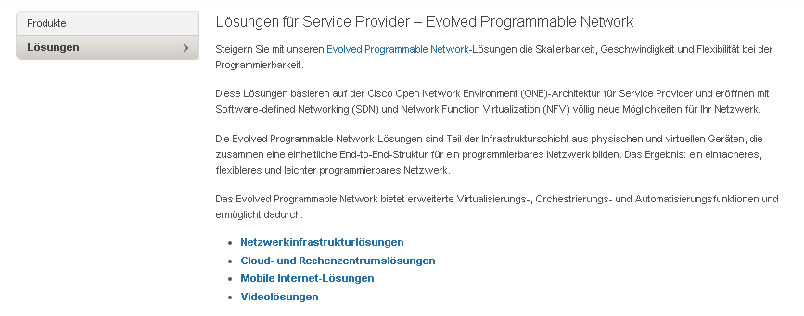

1

|  |  |  |
| --- | --- | --- |
| 1 | /content/<locale>/solutions/service-provider/solutions-listing/jcr:content/content_parsys/solutions/layout-solutions/gd21v1/gd21v1-mid/text/text | Select(“div.gd-right”) |
|  |  |  |