SLE-3: Architectural Design using Full C4 Model
BFS / DFS Maze Search System
Name | Shreya Bhosale
PRN | 25UAM140
Course | 02AML204 – Introduction to Artificial Intelligence
GitHub / Portfolio | https://github.com/shreyabhosale2912-debug/AI_SLE-3

1. System Title & Short Description
The BFS/DFS Maze Search System is a search-based AI system that finds a path through a maze from a start position to a goal position. The system accepts maze and search information as input and applies Breadth-First Search (BFS) or Depth-First Search (DFS). It maintains visited positions to avoid repeated exploration and produces a path or search result. This SLE-3 represents the same system used in SLE-2 using all four levels of the C4 architecture model.

2. Context Diagram (Level 1)
The context diagram shows the complete system at a high level. The user provides a maze and search request to the Maze Search System, which returns the solved path or result.
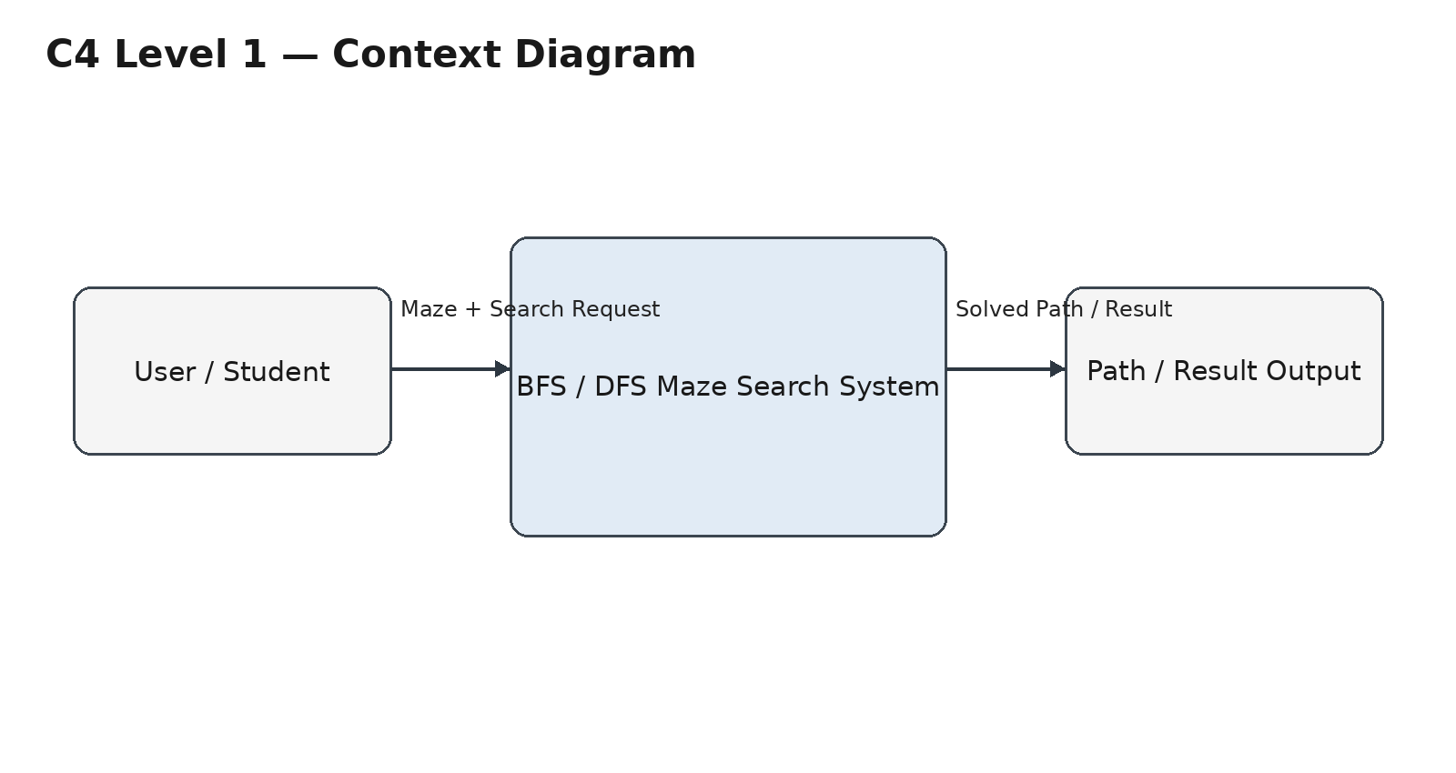

3. Container Diagram (Level 2)
The container level divides the Maze Search System into its major functional building blocks.
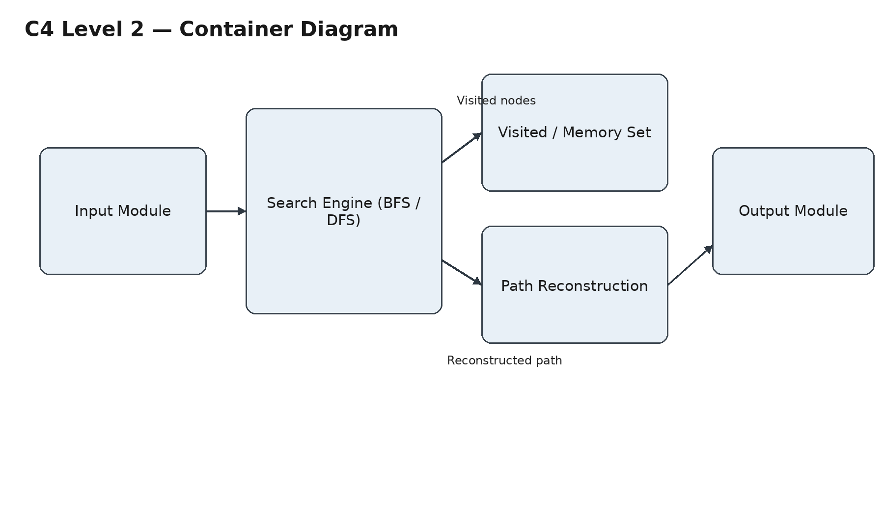
Container | Responsibility
Input Module | Takes the maze and required search input.
Search Engine | Runs BFS or DFS to explore the maze.
Memory / Visited Set | Stores visited positions to avoid repeated processing.
Output Module | Shows the final path or search result.

4. Component Diagram (Level 3)
Only the main Search Engine container is expanded at this level. Its internal components work together to perform the search and generate the final path.
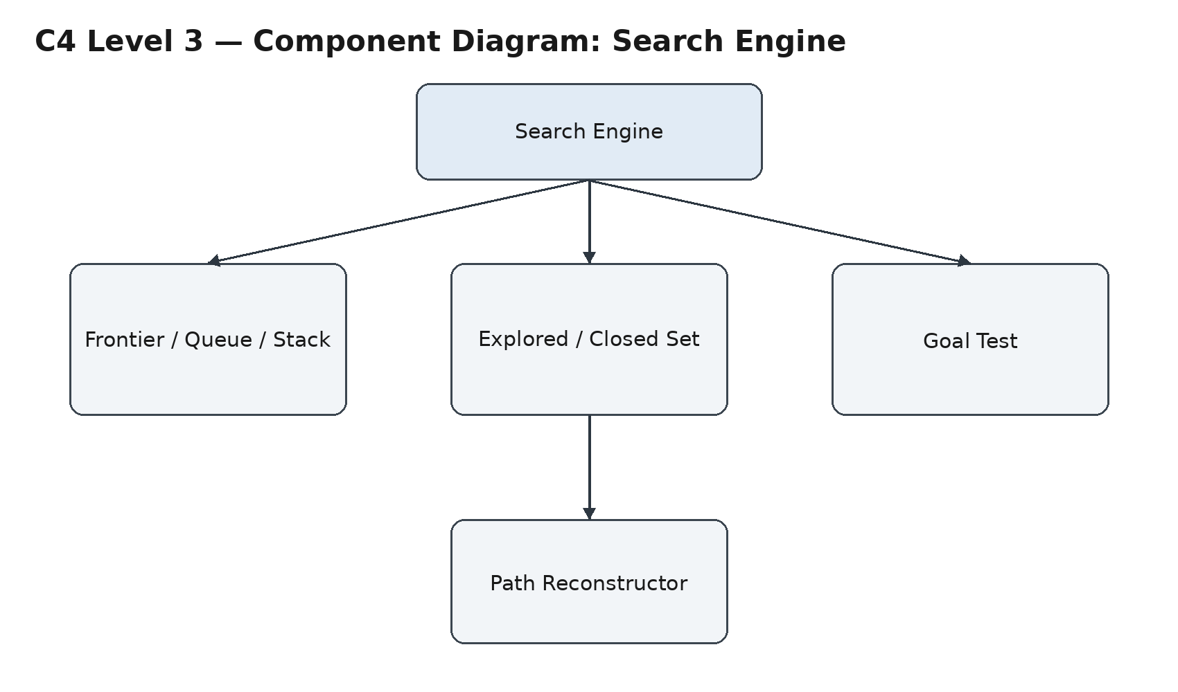
Components: Frontier stores nodes waiting to be explored; Explored Set stores visited nodes; Goal Test checks whether the destination is reached; Path Reconstructor rebuilds the path from the goal to the start.

5. Code Level Overview (Level 4)
Main Function / Part | Responsibility
bfs() | Performs Breadth-First Search.
dfs() | Performs Depth-First Search.
get_neighbors() | Finds valid neighboring positions in the maze.
Path reconstruction | Builds the final path from the goal back to the start.
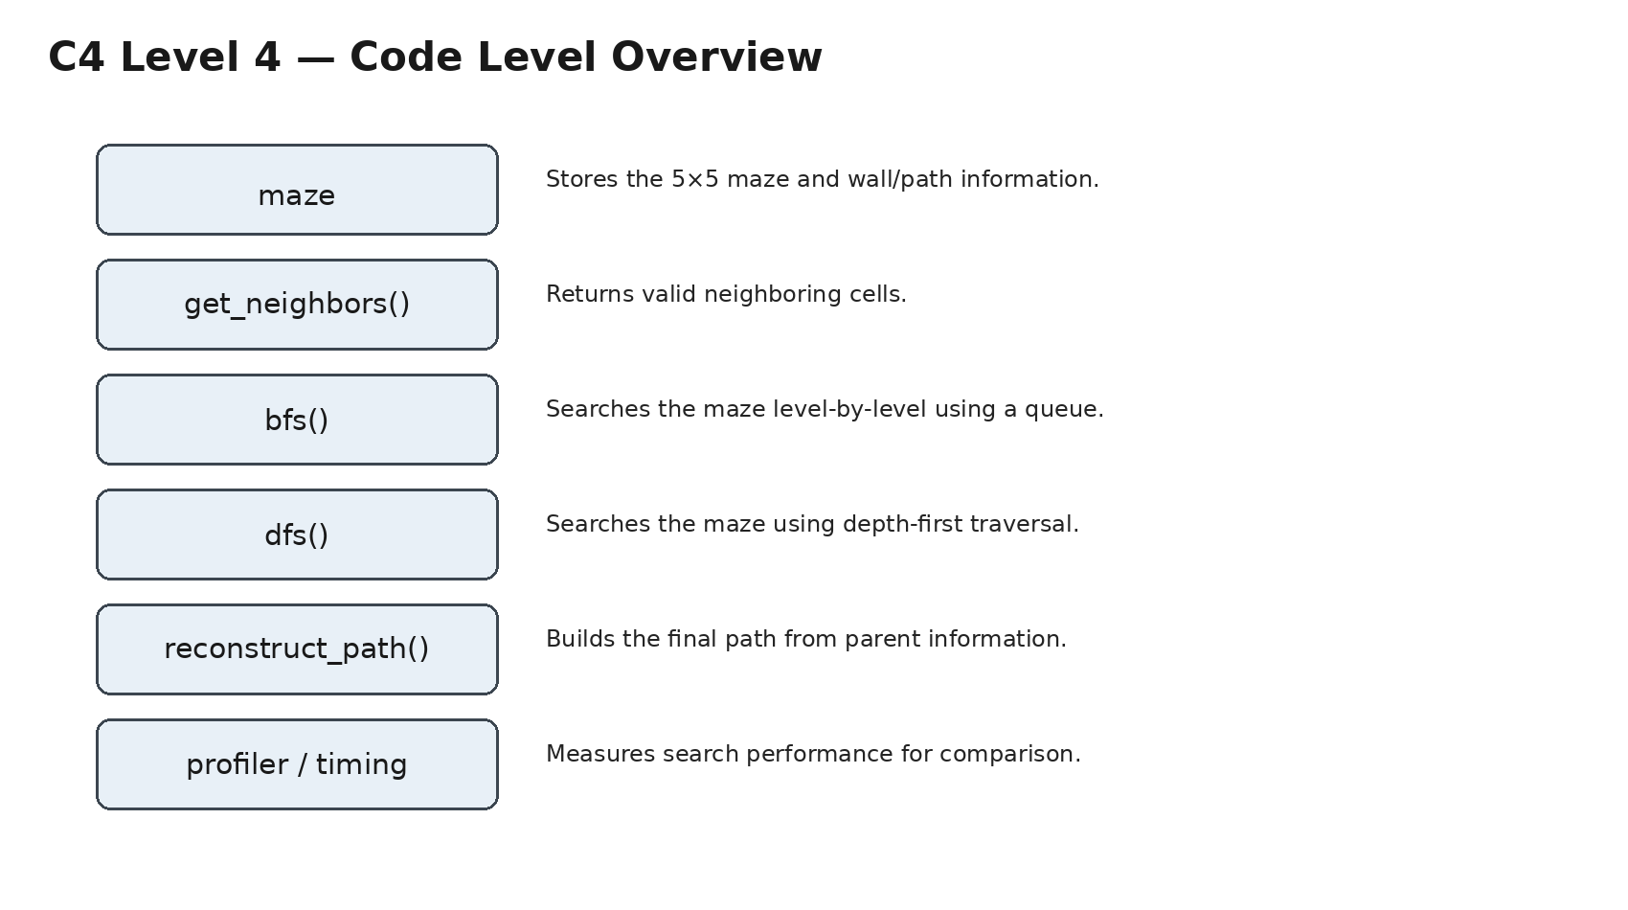

6. Design Decisions
- The same Maze Search System from SLE-2 was continued so that the architecture directly connects with the previous performance analysis.
- The Search Engine was selected for the Component level because it is the core part that executes BFS/DFS.
- The architecture is kept simple and modular so that each responsibility can be understood separately.

7. AI Contribution Note
AI tools used | AI was used as a supporting tool for understanding the C4 Model, organizing the architecture, and improving explanations.
What AI helped with | Understanding C4 levels, structuring the diagrams, and preparing concise report descriptions.
What I did myself | Selected the BFS/DFS Maze Search System, reviewed the architecture, understood the diagrams, and prepared the final submission.

8. Conclusion
This SLE-3 helped in understanding how a search-based AI system can be represented as a complete software architecture. The four C4 levels provide views from the overall system interaction to the main implementation functions. By continuing the BFS/DFS Maze Search System from SLE-2, the work connects performance analysis with architectural design.

GitHub Repository
https://github.com/shreyabhosale2912-debug/AI_SLE-3

