M.B.M. Engineering College, Faculty of Engineering

Department of Computer Science and Engineering

Jai Narain Vyas University, Jodhpur, Rajasthan



Usage Manual for the Minor Project On

**“GO CORONA GO”**

**HOSPITAL MANAGEMENT SYSTEM**

Made By Shreya Suroliya(19UITE9029) and Lakshita Sharma(19UITE9025)

**Submitted by:**

Harsh Gupta(19UITE9010)

Ritisha Gupta(19UITE9027)

Table of Contents

| **Sr. No.** | **TOPIC** | **Pg. No.** |
| --- | --- | --- |
| 1 | Introduction | 2 |
| 2 | Hardware Requirements | 3 |
| 3 | Software Requirements | 3 |
| 4 | Proposed Work | 4 |
| 5 | E-R Diagram | 5 |
| 6 | Result | 6 |
| 7 | References | 6 |

1. INTRODUCTION

The Covid-19 pandemic has created a multitude of acute challenges for health care delivery organizations, including inadequate capacity, supply shortages, the need for care redesign, and financial loss. Complexity science views health care delivery organizations as complex adaptive systems that operate in highly complex and unpredictable environments. The perspective assumes that much of organizational life is unknowable, uncertain, or unpredictable and thus cannot be standardized and controlled. In the midst of these challenges lies an opportunity for health care leaders to better position and transform their organizations for a future of unpredictable surprise. Health care delivery organizations have faced a myriad of important management challenges during the Covid-19 pandemic. Some of the challenges are idiosyncratic to the individual organization; others, however, are broadly faced by almost every health care delivery organization and are likely to be faced in any major disaster. Some of the key challenges are the lack of adequate capacity to handle the surging patient volume. In many places, the need for intensive care unit (ICU) beds and ventilators as well as staffing far exceeds the maximum capacity. For example, the number of ICU patients treated at the New York City Health + Hospitals (NYC H+H) during the peak was over three times the system’s ICU capacity. Secondly, management of medicines, oxygen cylinders, vaccines and all the databases of patients to be properly managed and monitored under lack of staff.

So, this Project basically focuses on the management of a Hospital System using simple rules of efficiency, how to manage a database and simplicity for the persons from each domain.

SCREENSHOT OF HOME PAGE

1. HARDWARE REQUIREMENTS

The most common set of requirements defined by any operating system or software application is the physical computer resources, known as Hardware. For current project Hardware Requirements are:

**Processor**: Intel core i5 + versions

**RAM**: minimum 4GB

**Hard Disk**: minimum 256GB

1. SOFTWARE REQUIREMENTS

Software requirements deal with defining software resource requirements and prerequisites that need to be installed on a computer to provide optimal functioning of an application.

For current project Software Requirements are:

**Operating System:** Windows 7 / Windows 10 / Linux / Mac

**Front End:** HTML, CSS, Bootstrap

**Back End:** PHP

**Development Environments/Tools:** Xampp(Apache, MySQL), Visual Studio or any Text editors,etc.

1. PROPOSED WORK

The ***Go Corona Go Hospital Management System*** is designed for any hospital working for COVID-19 treatment to replace their existing manual paper-based system. The new system is to control the information of patients as well as necessary equipment and services according to their needs. These services are to be provided in an efficient, cost effective manner, with the goal of reducing the time and resources currently required for such tasks so that the needy should not remain deprived of resources and innocent lives should be saved.

We’ll have features to keep track of all necessities digitally and system directing about the shortage of any necessary facilities inside the hospital.

**The complete set of rules & procedures related to Hospital’s day to day activities and generating reports is called “Hospital Management System”, and our system emphasising on keeping track of the necessary equipments and reports, amid Covid-19 situation will be known as “GO CORONA GO Hospital Management System”.**

It is a computerized management system. This system also keeps the records of hardware assets besides software of this organization. This project has GUI based software that will help in storing, updating and retrieving the information through various user-friendly menu-driven modules.

1. E-R DIAGRAM



1. Navigation and Screenshots

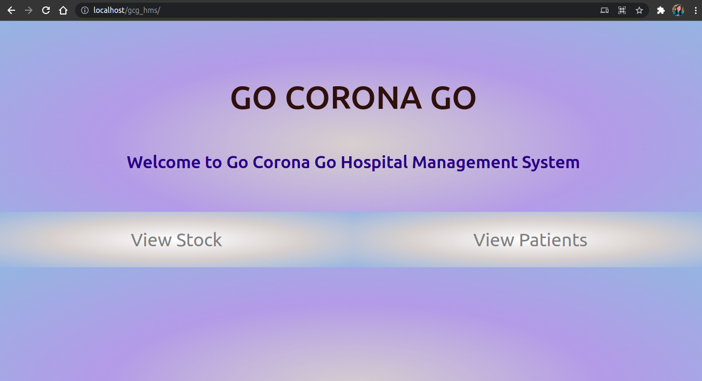

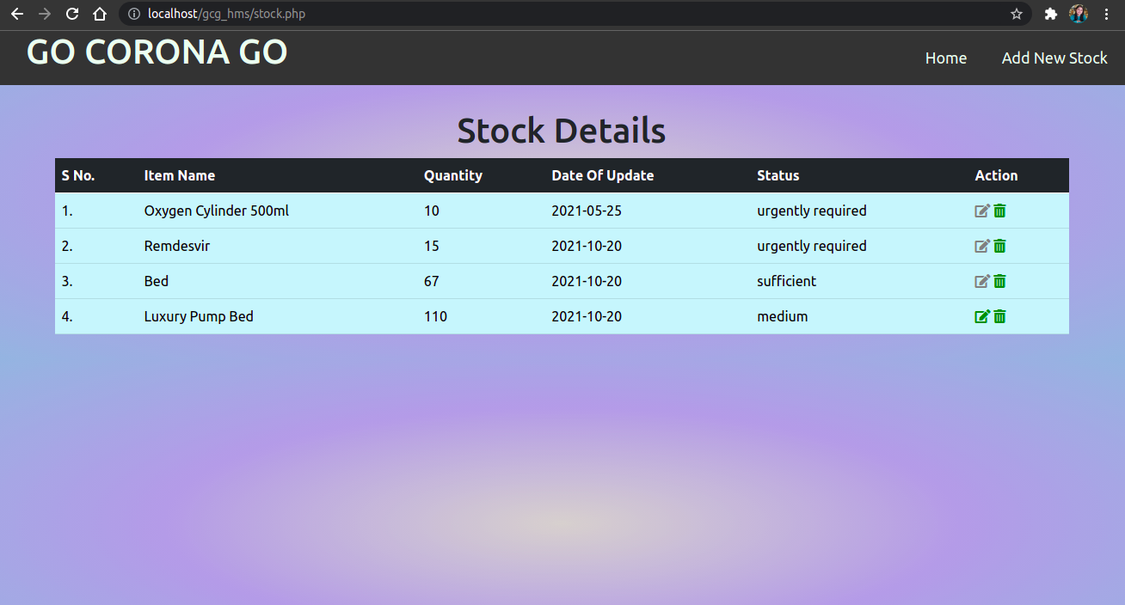

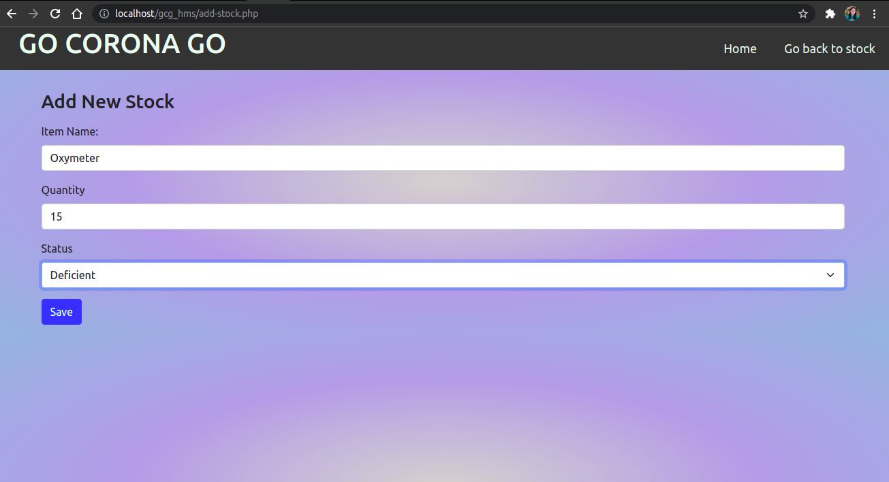

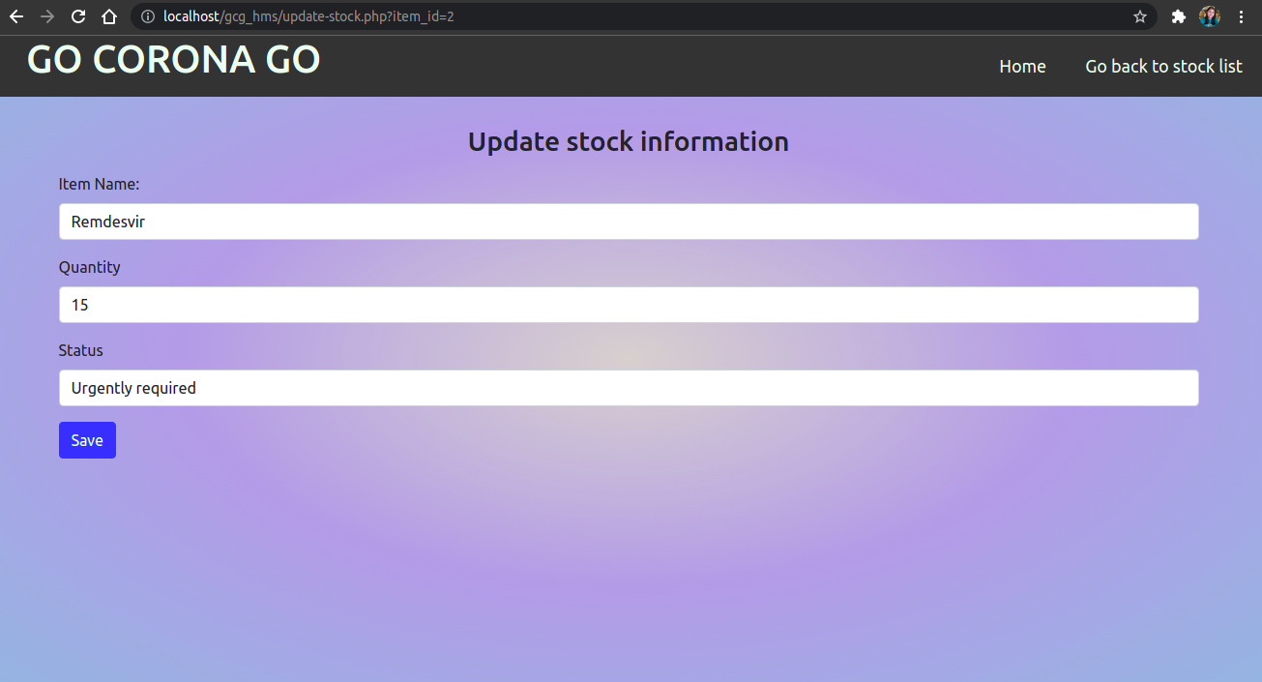

Similarly Patient also has following features:

1)List of Patients

2)Edit Patient Info

3)Add Patient Record

In addition to this it also has add report/view report:

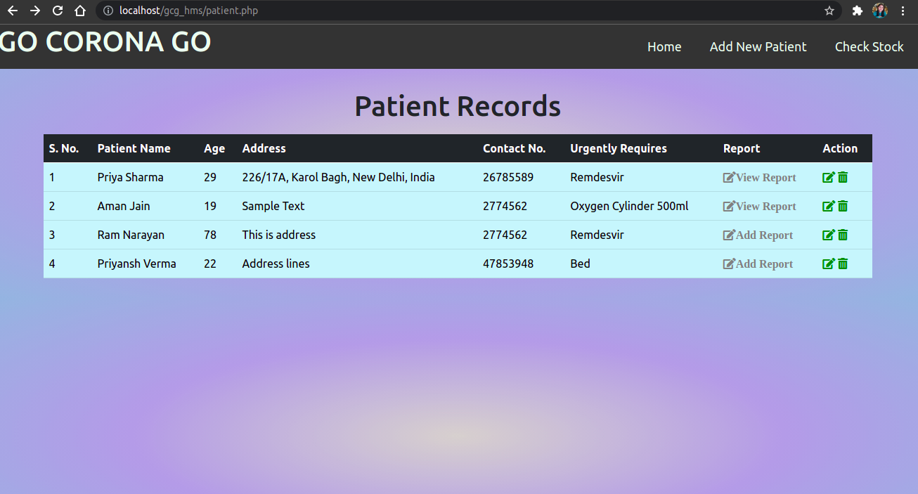

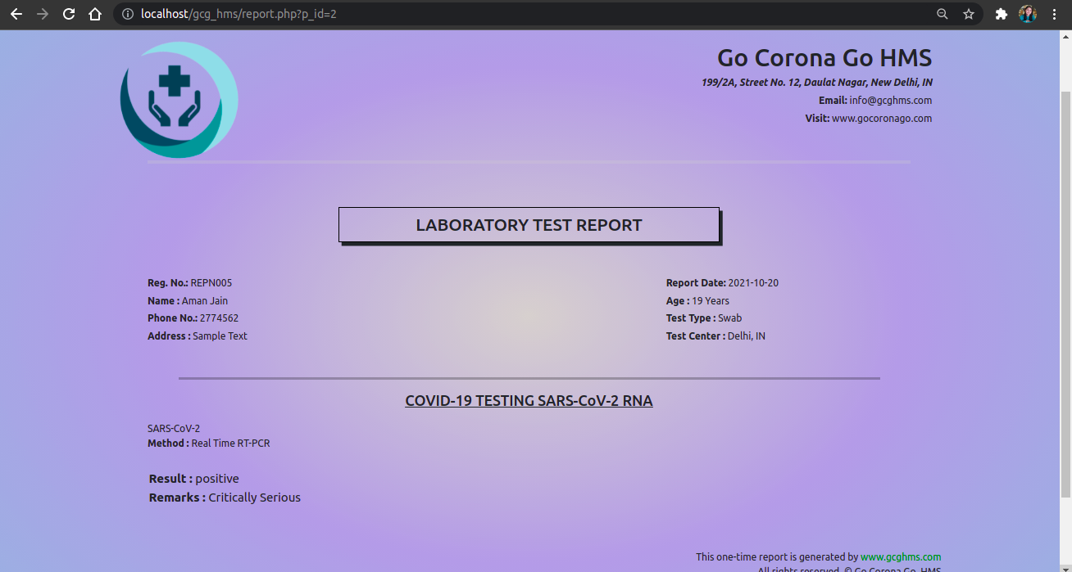

1. RESULTS

**Goals of proposed system:**

1. The system is easy to operate.
2. The working in the organization is well planned and organized.
3. The level of accuracy in the proposed system is higher.
4. The reliability of the proposed system is high due to proper storage of information.
5. Provide quick and efficient retrieval of information.

**Expected outcomes:**

1. System is efficient to keep track of patients' reports.
2. Proper arrangements and database of COVID-19 related equipment.
3. Hospital Stock which includes Vaccines (Covishield, Covaxin etc.), Medicinal Injections (Remdesvir), Beds, Oxygen Cylinders etc. properly managed and provided.
4. Along with stock all the COVID-19 reports is stored for further evaluation and examination of patients.