**Name: Shreya Chauhan**

**Enrolment no: 2302031030008**

**Branch: B tech IT**

**Subject: WT**

**Semester: 4**

**Class: IT 3**

**ASSIGNMENT 1 (TASK 1)**

To create a Git repository from start, you can follow these steps using platforms GitHub:

1. **Sign up for a Git hosting service:**

* Choose a Git hosting service like GitHub, GitLab, or Bitbucket.
* Go to the website of the chosen Git hosting service.
* Look for the "Sign up" or "Register" button and click on it.
* Fill out the required information to create your account, including your username, email address, and a secure password.

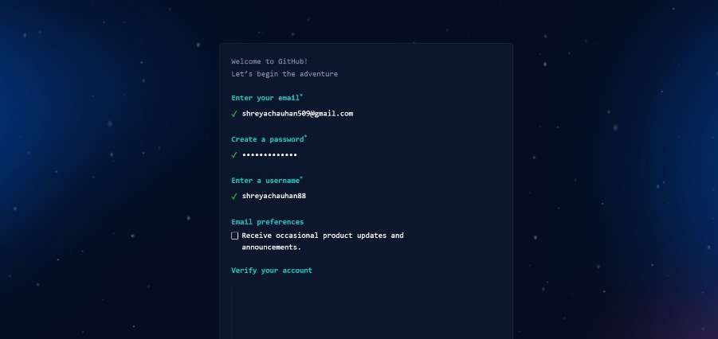

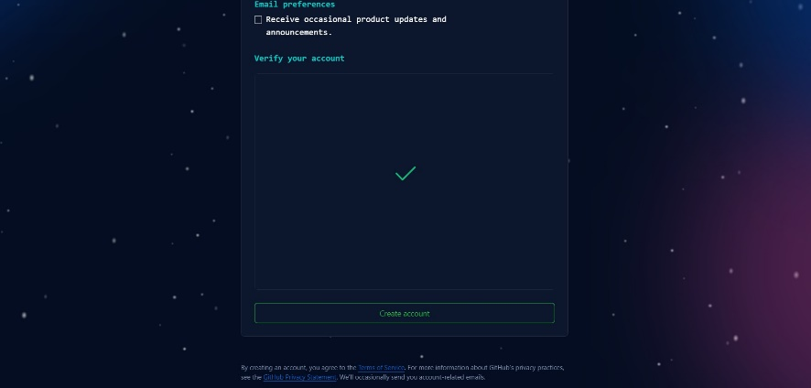

1. **Verify your email:**

* After signing up, check your email inbox for a verification email from the Git hosting service.
* Click on the verification link provided in the email to confirm your email address.

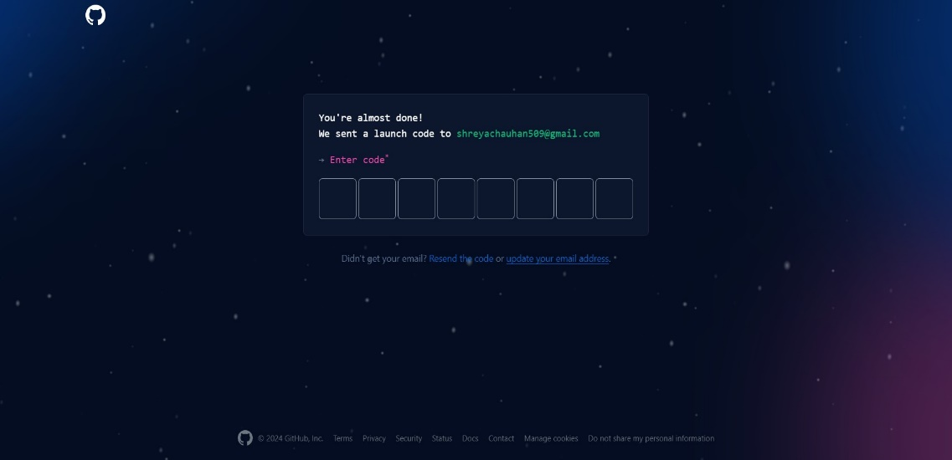

1. **Log in to your account :**

* Once your email is verified, go back to the Git hosting service's website.
* Click on the "Log in" or "Sign in" button.
* Enter your username/email and password to log in to your account.

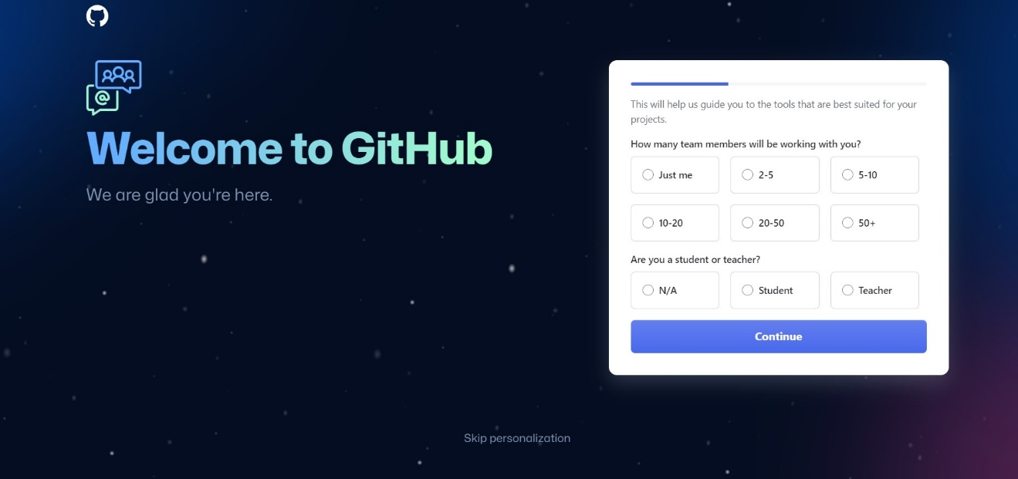

1. **Create a new repository :**

* After logging in, you should see an option to create a new repository.
* Click on the "New" or "Create" button to start creating a new repository.

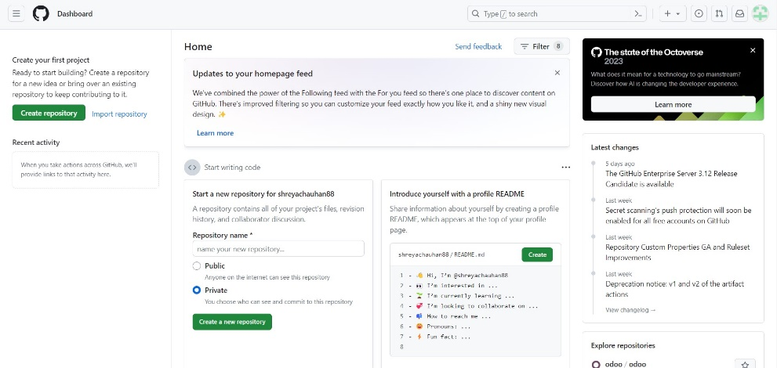

* Choose a name for your repository.

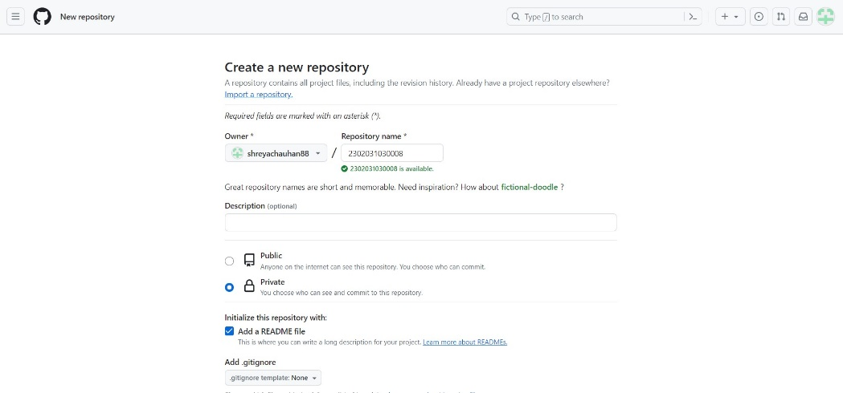

* Optionally, add a description to provide more context about your project.
* Choose the visibility of your repository (public or private).
* Click on the "Create repository" or similar button to create your new repository.

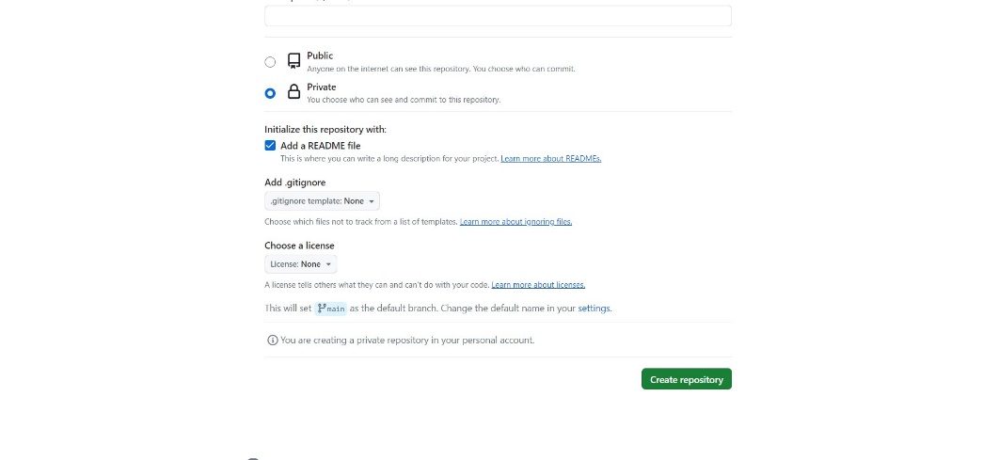

1. **Create a New File or Folder :**

* Look for an option like "Add file" or "Create new file" or "New folder". Click on it to start creating a new file or folder.

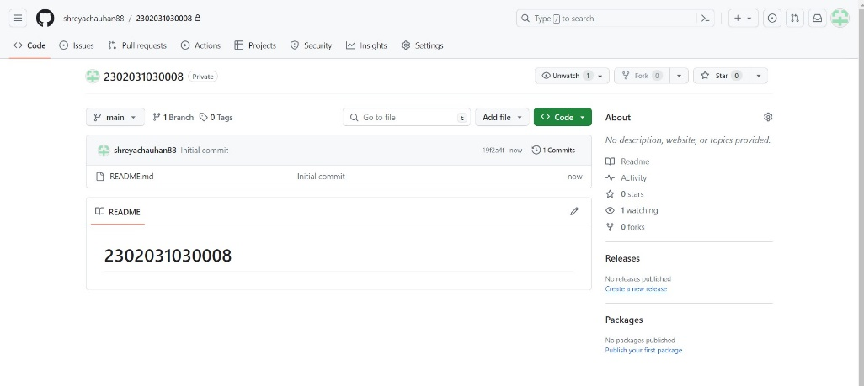

1. **Name the Folder:**

* If you're creating a folder, give it a name. You can typically do this by typing the folder name followed by a forward slash ("/") at the end of the filename. For example, if you want to create a folder named "example", you would type "example/".

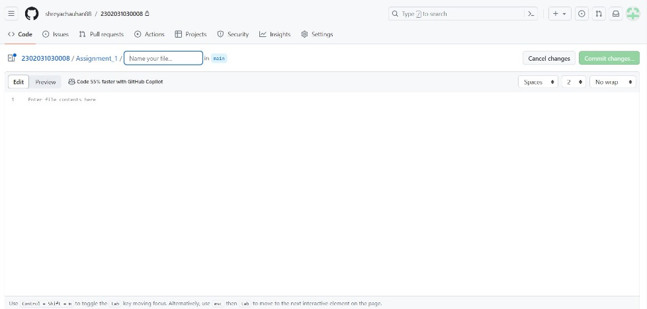

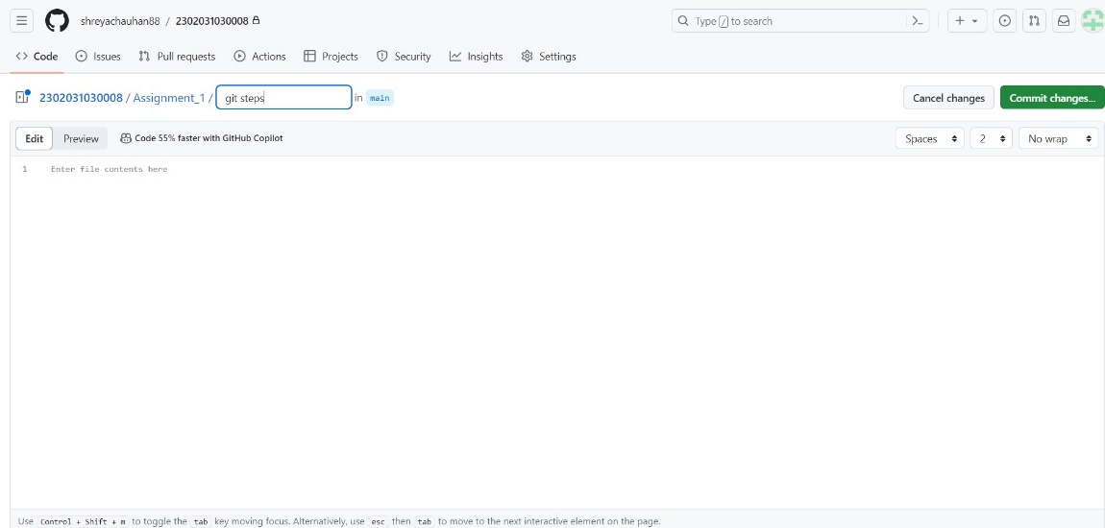

1. **Commit Changes :**

* After adding the file or folder, you need to commit your changes. This typically involves providing a commit message that describes the changes you made.

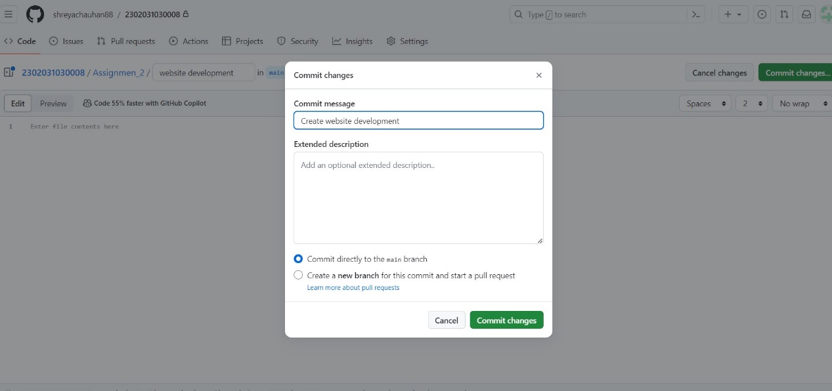

1. **Result :**

* As per Task Assigned Create a GIT repository named as your enrolment number. Create 2 folder in your repository named as Assignment_1 and Assignment_2.

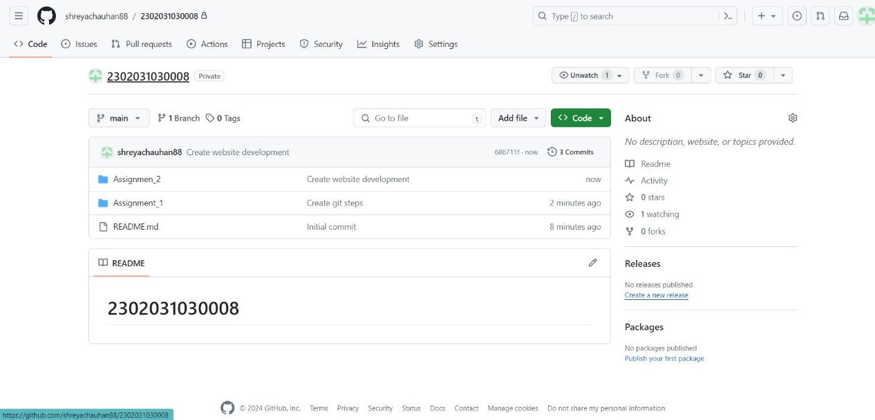

By following these steps, you should be able to create a folder and file in a Git repository using a web interface.