D.K.T.E. Society’s Textile and Engineering Institute, Ichalkaranji
(An Autonomous Institute, Affiliated to Shivaji University, Kolhapur)
Accredited with ‘A+’ Grade by NAAC

Department of Computer Science and Engineering
(Artificial Intelligence and Machine Learning) 2025-2026.
THE COMMUNITY ENGAGEMENT PROJECT REPORT ON
“NGO CONNECT”
Under the guidance of: Miss. S.S. Demanna
Developed By:
1. Anushri Shinde 25UAM013
2. Shravani Asawale 25UAM021
3. Shreya Chavan 25UAM018
4. Diya Telnade 25UAM015
5. Pradnya Desai 25UAM020
CERTIFICATE
This is to certify that,
1. Anushri Shinde 25UAM013
2. Shravani Asawale 25UAM021
3. Shreya Chavan 25UAM018
4. Diya Telnade 25UAM015
5. Pradnya Desai 25UAM020
Have successfully completed the project work, entitled
“NGO CONNECT”
In partial fulfilment for the award of degree of Bachelor of Technology in Computer Science and Engineering (Artificial Intelligence and Machine Learning). This is record of their work carried out during academic year 2026-27.
Miss. S.S. Demanna  [Project Guide] | Prof. Dr. S.K. Shirgave  [Head of Department]

Date:
Place: Ichalkaranji

DECLARATION
We the undersigned students of S.Y.C.S.E.(AIML) declare that the Community Engagement Project work report entitled "NGO CONNECT" written and submitted under the guidance of Prof. S.S Demanna is our original work. The empirical findings in this report are based on the data collected by us. The matter assimilated in this report is not reproduction from any readymade report.

NAME PRN

1. Anushri Shinde 25UAM013
2. Shravani Asawale 25UAM021
3. Shreya Chavan 25UAM018
4. Diya Telnade 25UAM015
5. Pradnya Desai 25UAM020

Date:
Place: Ichalkaranji

INDEX
CONTENTS PAGE

1. Introduction 5

2. Problem Statement 6

3. Problem Description 7

4. Facility Requirement Related To Problem 8

5. Field Visit Report 9

6. Technical Solution on Problem 10

7. Authority Letter 14
8.Conclusion 15

9. References 16

1. INTRODUCTION
In today's urban landscape, the growing population of homeless and street children remains one of the most pressing social challenges. These children lack access to safe shelter, quality education, and basic necessities, while many NGOs work sincerely but struggle with sustainable, recurring funding. At the same time, communities want to help but do not know where or how to contribute. A visible bridge between children in need, NGOs, and everyday donors is missing.
NGO Connect is designed to address this gap by creating a transparent digital bridge between homeless children, partner NGOs, and compassionate donors. The platform enables users to discover verified NGOs, contribute through a simple '1 Rupee per Household' micro-funding model, and track the impact of their contributions through regular updates and reports.
The primary goal of NGO Connect is to help admit homeless children into partnered NGOs with shelter and education, while simultaneously building trust through transparency and regular impact reporting. The app empowers communities to participate in child welfare initiatives through small, consistent actions that collectively create lasting change.
By leveraging technology, NGO Connect transforms micro-donations into sustainable funding streams for NGOs, increases community awareness of local child welfare initiatives, and creates a replicable model that other student groups and cities can adopt. It is more than a donation platform—it is a movement that turns small, consistent actions by many into lasting change for children who need it most.

2. PROBLEM STATEMENT
The gap we aim to close:
- Homeless children lack access to safe shelter and quality education.
- Many NGOs work sincerely but struggle with sustainable, recurring funding.
- Communities want to help but do not know where or how to contribute.
- A visible bridge between children in need, NGOs, and everyday donors is missing.
The absence of a structured, transparent platform leads to missed opportunities for children in need, financial instability for NGOs, and frustration for donors who wish to contribute but lack trustworthy channels. NGO Connect addresses these issues by providing a digital platform that connects homeless children with partner NGOs, enables micro-funding through a simple '1 Rupee per Household' model, and ensures transparency through regular impact updates and reports.

3. PROBLEM DESCRIPTION
In urban areas, the rising population of homeless and street children has become a critical concern. These children are deprived of safe shelter, nutritious food, and quality education, perpetuating cycles of poverty and vulnerability. While many NGOs work tirelessly to address these issues, they often struggle with sustainable, recurring funding to support their daily operations and expand their reach.
Simultaneously, communities and individuals want to help but face significant barriers:
- They do not know which NGOs are genuine and trustworthy.
- They lack a simple, accessible way to contribute.
- They are unsure how their contributions are being utilized.
The widening gap between NGOs and public support networks, combined with the lack of transparency and trust, results in wasted resources and missed opportunities to create meaningful impact. Micro-donations (as small as ₹1) have proven high adoption when made easy, yet no structured platform exists to facilitate this at scale.
NGO Connect addresses these problems by:
- Creating a transparent digital bridge between donors and NGOs.
- Launching a simple '1 Rupee per Household' micro-funding model.
- Building trust through regular impact updates and reports.
- Helping admit homeless children into partnered NGOs with shelter and education.

4. FACILITIES REQUIREMENT RELATED TO PROBLEMS
- User-Friendly Interface: Provide an intuitive interface for donors, NGOs, and administrators.
- NGO Profiles: Allow NGOs to create and update profiles with their mission, activities, and impact reports.
- Donation Management: Enable donors to contribute through micro-donations (₹1 per household) and track their contributions.
- Transparency Dashboard: Display real-time updates on fund utilization and impact.
- Child Onboarding System: Coordinate with NGOs to identify and onboard homeless children.
- Impact Reports: Publish regular progress and impact reports for donors and the community.
- Notification System: Keep donors informed about updates, success stories, and funding needs.
- Admin Control Panel: Admins monitor activity, verify NGO profiles, and ensure transparency.
- Database Management: Central storage of donor data, NGO details, child records, and impact metrics.

5. FIELD VISIT

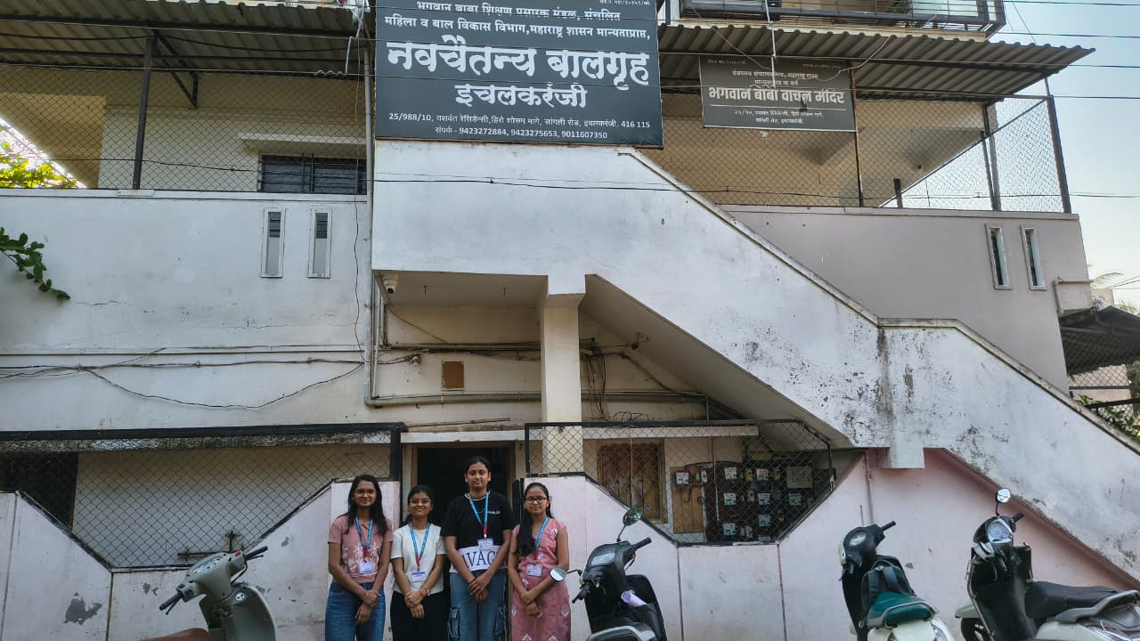

6. TECHNICAL SOLUTIONS

6.1 Mobile Application Development
Description:
Develop a mobile application compatible with Android and iOS platforms. The app will serve as the primary interface for donors, NGOs, and administrators.
Implementation Strategies:
- Use cross-platform frameworks like Flutter or React Native.
- Ensure responsive design for various screen sizes.
- Implement intuitive navigation and a simple user interface.
Benefits:
- Increases accessibility for donors and NGOs.
- Reduces the time required to contribute.
- Enhances overall user experience.

6.2 NGO Profile System
Description:
A comprehensive profile system allows NGOs to showcase their mission, activities, and impact. Donors can view verified NGO profiles and choose causes to support.
Implementation Strategies:
- Include fields for NGO mission, location, beneficiaries, and impact metrics.
- Allow document uploads for verification.
- Display real-time funding needs and progress.
Benefits:
- Builds credibility and trust.
- Helps donors make informed decisions.
- Streamlines verification and transparency.

6.3 Micro-Funding System ('1 Rupee per Household')
Description:
A simple, recurring micro-funding model that allows households to contribute ₹1 regularly, creating a sustainable funding stream for NGOs.
Implementation Strategies:
- Integrate UPI, Paytm, Razorpay, or similar payment gateways.
- Enable recurring payments and reminders.
- Provide tax exemption receipts and contribution history.
Benefits:
- Low barrier to entry for donors.
- Creates sustainable, recurring funding.
- Encourages widespread community participation.

6.4 Transparency Dashboard
Description:
A real-time dashboard displaying fund utilization, impact metrics, and success stories to build trust and accountability.
Implementation Strategies:
- Display total funds raised, funds utilized, and beneficiaries impacted.
- Include visual charts and graphs.
- Publish regular impact reports.
Benefits:
- Builds trust and transparency.
- Encourages continued donor participation.
- Provides valuable feedback for improvements.

6.5 Child Onboarding System
Description:
A coordinated system to identify homeless children and connect them with partner NGOs for shelter, food, and schooling.
Implementation Strategies:
- Collaborate with local NGOs and community workers.
- Maintain secure records of children onboarded.
- Track progress and well-being.
Benefits:
- Ensures children receive timely support.
- Creates a structured approach to rehabilitation.
- Enables impact measurement.

6.6 Notification System
Description:
Real-time notifications keep donors and NGOs updated on funding needs, success stories, and impact reports.
Implementation Strategies:
- Use push notifications for instant updates.
- Integrate email and in-app alerts.
- Include reminders for recurring contributions.
Benefits:
- Improves communication and engagement.
- Keeps donors informed and connected.
- Enhances operational efficiency.

6.7 Secure Payment Integration
Description:
A secure payment system ensures seamless, reliable transactions between donors and NGOs.
Implementation Strategies:
- Integrate popular digital payment gateways like UPI, Paytm, or Razorpay.
- Encrypt all payment transactions for security.
- Include options for one-time and recurring payments.
Benefits:
- Provides a safe, hassle-free donation experience.
- Reduces risk of fraud and payment disputes.
- Encourages more donors to contribute.

6.8 Impact Reporting System
Description:
Regular impact reports showcase the outcomes of donations, building trust and encouraging continued support.
Implementation Strategies:
- Publish monthly/quarterly impact reports.
- Include success stories, beneficiary numbers, and fund utilization.
- Share reports via app, email, and social media.
Benefits:
- Builds trust and accountability.
- Encourages donor retention.
- Provides valuable feedback for improvements.

6.9 Admin Control Panel
Description:
The admin panel allows platform administrators to monitor activity, verify NGO profiles, and ensure transparency.
Implementation Strategies:
- Include dashboards for user activity, donations, and impact metrics.
- Implement verification systems for NGO documents.
- Set up complaint resolution workflows.
Benefits:
- Ensures platform reliability and compliance.
- Protects users from fraud or misuse.
- Supports decision-making and strategic improvements.

6.10 Database Management
Description:
A robust database stores donor data, NGO details, child records, and impact metrics for easy retrieval and analysis.
Implementation Strategies:
- Use a scalable relational database like MySQL or PostgreSQL.
- Include backup, recovery, and security measures.
- Enable queries for reporting, analytics, and audits.
Benefits:
- Centralizes all data for efficient management.
- Supports analytics to improve services.
- Ensures data security and reliability.

6.11 Location-Based Services
Description:
GPS integration connects donors with nearby NGOs to increase local participation and impact.
Implementation Strategies:
- Use Google Maps API for real-time location tracking.
- Include features like distance calculation and route optimization.
- Allow NGOs to update their location and needs.
Benefits:
- Minimizes time for donor-NGO matching.
- Improves community engagement.
- Optimizes resource allocation.

AUTHORITY LETTER

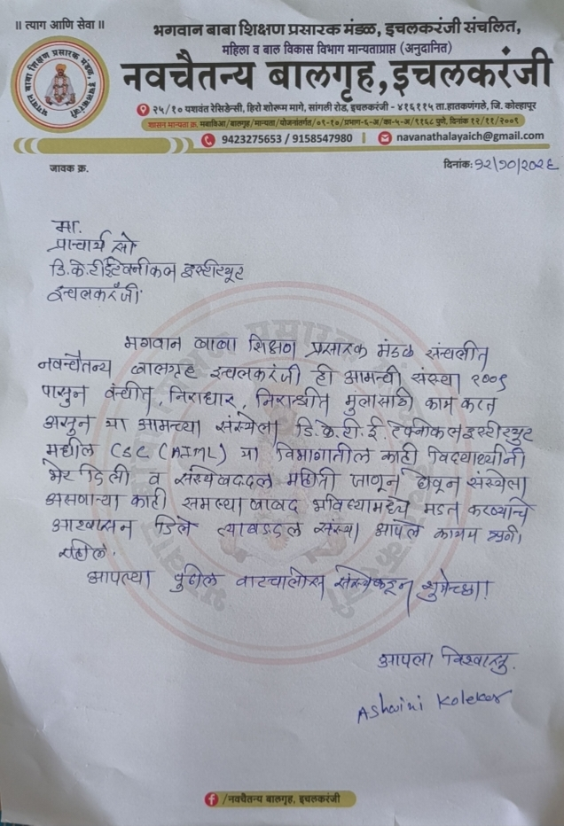

7. CONCLUSION
NGO Connect is a comprehensive solution designed to bridge the gap between homeless children, NGOs, and compassionate donors. With features like micro-funding, transparency dashboards, real-time notifications, and impact reporting, it ensures trust, accountability, and convenience for all stakeholders. The integration of technical solutions such as mobile applications, database management, and secure payment systems enhances operational efficiency and fosters community engagement.
By turning small, consistent actions by many into lasting change, NGO Connect not only simplifies the process of supporting child welfare but also promotes accountability, skill recognition, and community development. It is a valuable tool for modern social impact needs, creating a replicable model that other student groups and cities can adopt.
Every rupee, every voice, every child matters.

8. REFERENCES

Research Papers / Journals:
- Ministry of Women & Child Development — wcd.nic.in
- UNICEF India reports on street & homeless children
- Local NGO partner list (to be filled by team)
- Articles on micro-donation models and community giving
- Census & NSSO data on urban homelessness

Books:
- Mulcahy, D. (2016). The Gig Economy: The Complete Guide to Getting Better Work, Taking More Time Off, and Financing the Life You Want. AMACOM.
- Parker, G. G., Van Alstyne, M. W., & Choudary, S. P. (2016). Platform Revolution: How Networked Markets Are Transforming the Economy and How to Make Them Work for You. W. W. Norton & Company.

