SLE-3: ARCHITECTURAL DESIGN (FULL C4 MODEL)
BFS / DFS Search System
Course | 02AML204 – Introduction to Artificial Intelligence
PRN | 25UAM018
Name | Shreya Chavan ___________________
Division | A
Date | ____________________________
GitHub / Portfolio: shreyachavan25/SLE2-BFS-DFS-Profiling

1. System Title & Short Description
The BFS / DFS Search System is a graph-search system that explores connected nodes to find a path from a starting node toward a goal node. The system supports two search strategies: Breadth-First Search (BFS) and Depth-First Search (DFS). BFS explores nodes level by level using a queue, while DFS explores deeper nodes using a stack/recursive strategy. The SLE-2 work profiled the two search methods and compared their execution behaviour. SLE-3 represents the same system using the four C4 architecture levels.

2. Context Diagram (Level 1)

C4 Level 1 – Context Diagram
The user provides a graph search problem to the BFS / DFS Search System. The system performs the selected search and produces a search result or path. The diagram shows only the system boundary and its interaction with the outside user.

3. Container Diagram (Level 2)

C4 Level 2 – Container Diagram
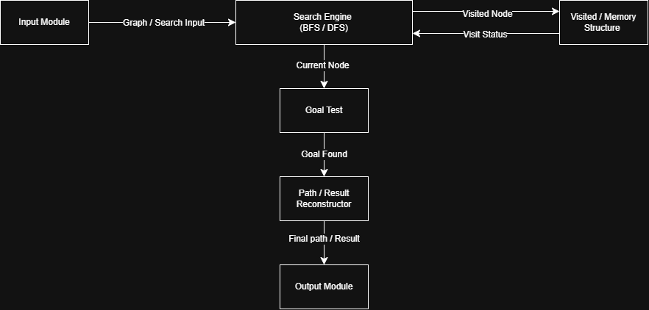

Container | Responsibility
Input Module | Accepts the graph/maze and start/goal information.
Search Engine (BFS / DFS) | Runs the selected BFS or DFS search strategy.
Visited / Memory Structure | Tracks nodes that have already been explored to avoid repeated processing.
Goal Test | Checks whether the current node is the required goal.
Path / Result Reconstructor | Uses stored search information to form the final result/path.
Output Module | Displays the final search result to the user.

4. Component Diagram (Level 3)

C4 Level 3 – Component Diagram
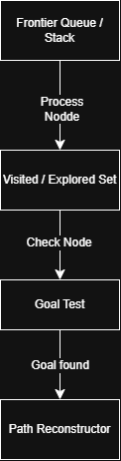
The Search Engine is the main container selected for decomposition.

- Frontier: stores nodes waiting to be explored; BFS uses FIFO queue behaviour and DFS uses LIFO stack behaviour.
- Visited / Explored Set: records explored nodes so that the same node is not repeatedly processed.
- Goal Test: checks whether the current node matches the target.
- Path Reconstructor: uses stored parent/path information to produce the final path or search result.

5. Code Level Overview (Level 4)

C4 Level 4 – Code Level Overview

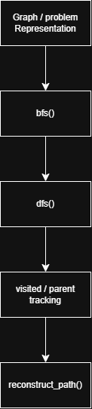

- Graph / Problem Representation — stores the nodes and their connections.
- bfs() — performs breadth-first search using queue/frontier behaviour.
- dfs() — performs depth-first search using stack/depth-first behaviour.
- Visited / Parent Tracking — records explored nodes and path relationships.
- reconstruct_path() — rebuilds the path/result from stored relationships.
Note: The code level is an architectural overview only; large source-code blocks are not required by the SLE-3 guideline.

6. Design Decisions
- BFS and DFS are kept inside one Search Engine because both solve the same search problem but use different exploration strategies.
- Visited tracking is separated from the search logic so both BFS and DFS can avoid unnecessary repeated exploration.
- The Goal Test and Path Reconstructor are shown separately to make the responsibilities of searching and producing the final result clear.
- The architecture is intentionally small and readable, matching the guideline's recommendation to avoid crowded diagrams.

7. AI Contribution Note
- AI tools used: ChatGPT / AI assistance for understanding the C4 Model, organizing the architecture, and preparing diagram/document formatting.
- What AI helped with: Converting the existing BFS/DFS project into Context, Container, Component, and Code views and improving the presentation.
- What I did myself: Implemented/worked on the BFS/DFS system, performed the SLE-2 profiling, checked the results, and verified that the architecture represents my project.

8. Conclusion
This SLE-3 helped represent the BFS/DFS search system at different levels of detail. The Context view shows the system and user, the Container view shows the major modules, the Component view explains the internal Search Engine, and the Code view identifies the main functions. This makes the relationship between the implementation and its software architecture easier to understand.

