This project use CNN (Convolution Neural Network) algorithm to predict chilli plant disease by analysing its leaf images. CNN algorithm will be trained with healthy and disease effected leaf images and then build a disease prediction model. This model can be applied on any new leaf image to detect it as normal or disease effected.

To trained CNN model we have pepper chilli images from Plant Village dataset and below screen showing images from that dataset

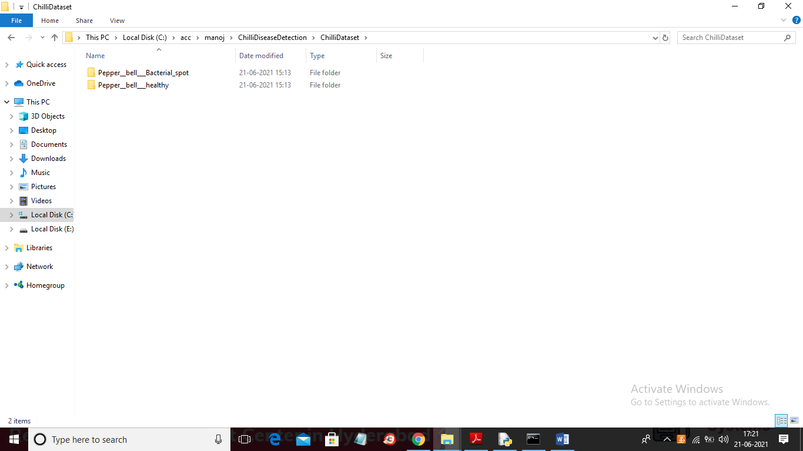

In above screen one folder contains healthy leaf images and one contains disease images and just go inside any folder to see those images and below screen showing images from disease leaf

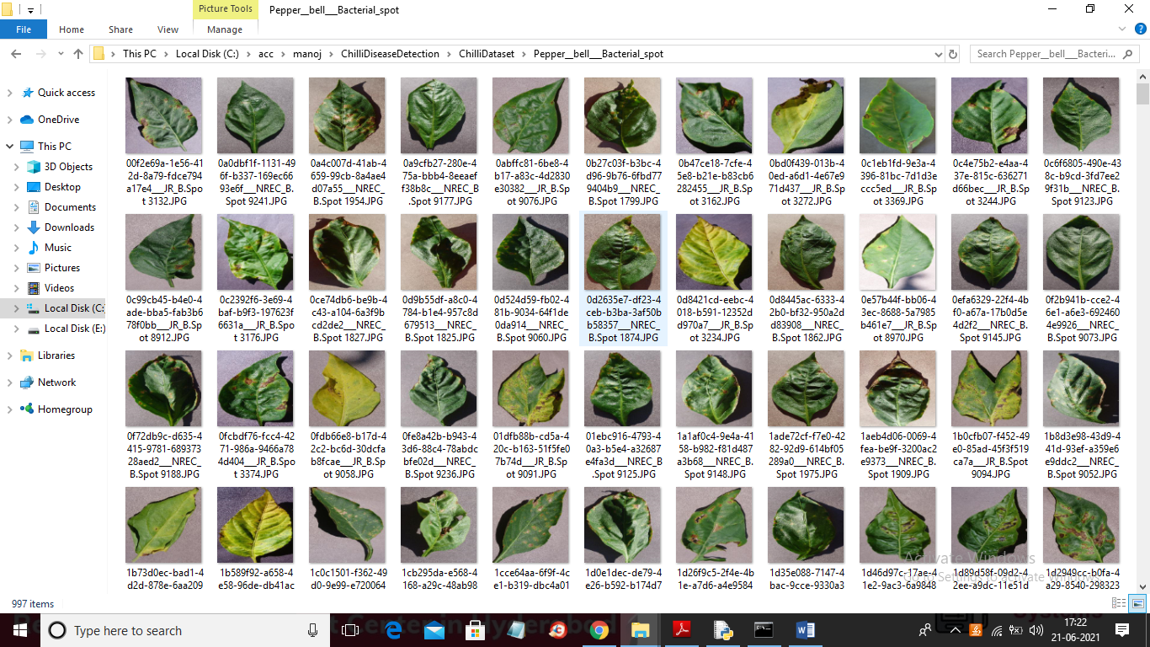

Below code screen showing implementation of CNN model

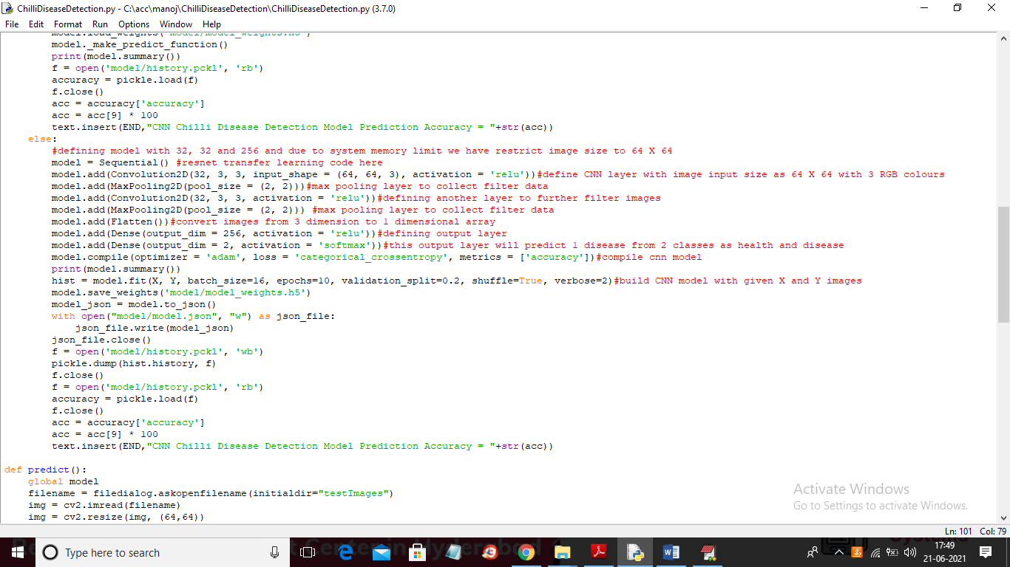

In above screen read red colour comments to know CNN implementation on chilli disease. In propose paper author is identifying soil condition also by using sensors but we don’t have any sensor so we cannot know about soil condition.

SCREEN SHOTS

To run project double click on ‘run.bat’ file to get below screen

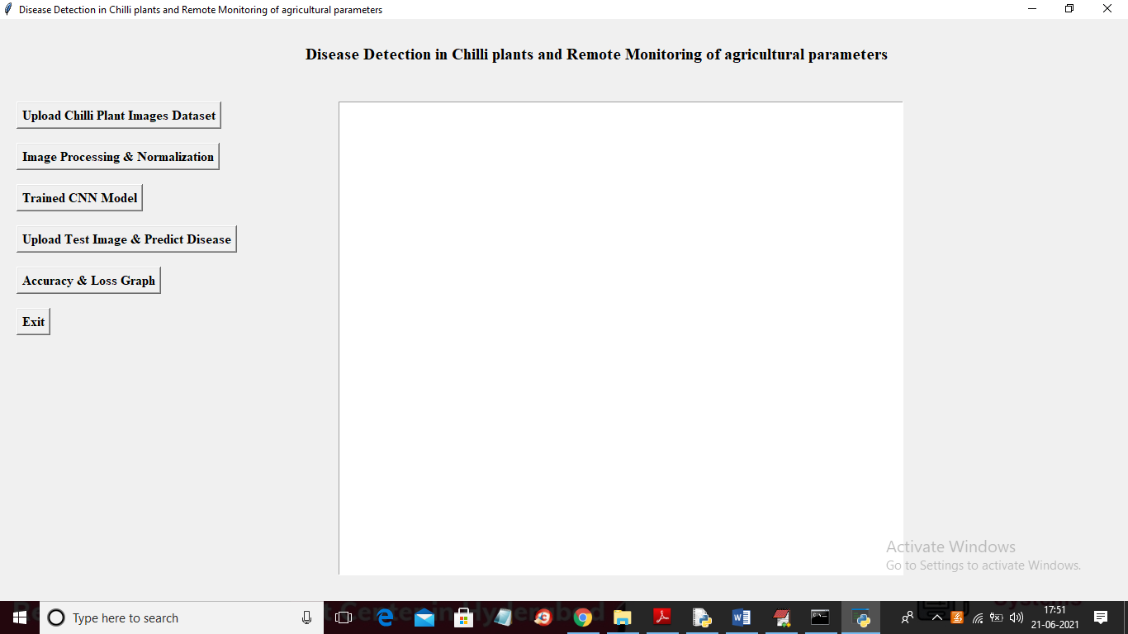

In above screen click on ‘Upload Chilli Plant Images Dataset’ button to upload dataset

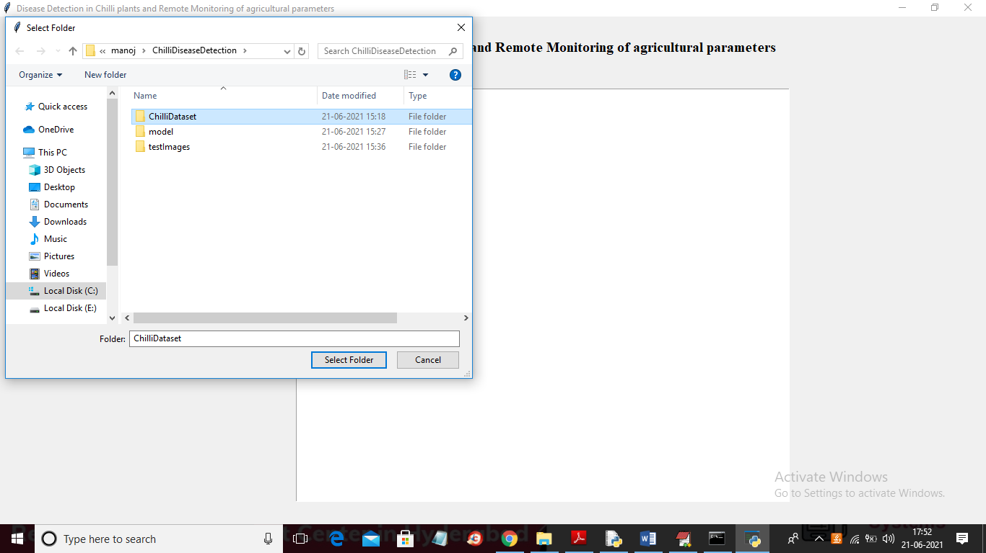

In above screen selecting and uploading entire ‘ChilliDataset’ folder and then click on ‘Select Folder’ button to load dataset and to get below screen

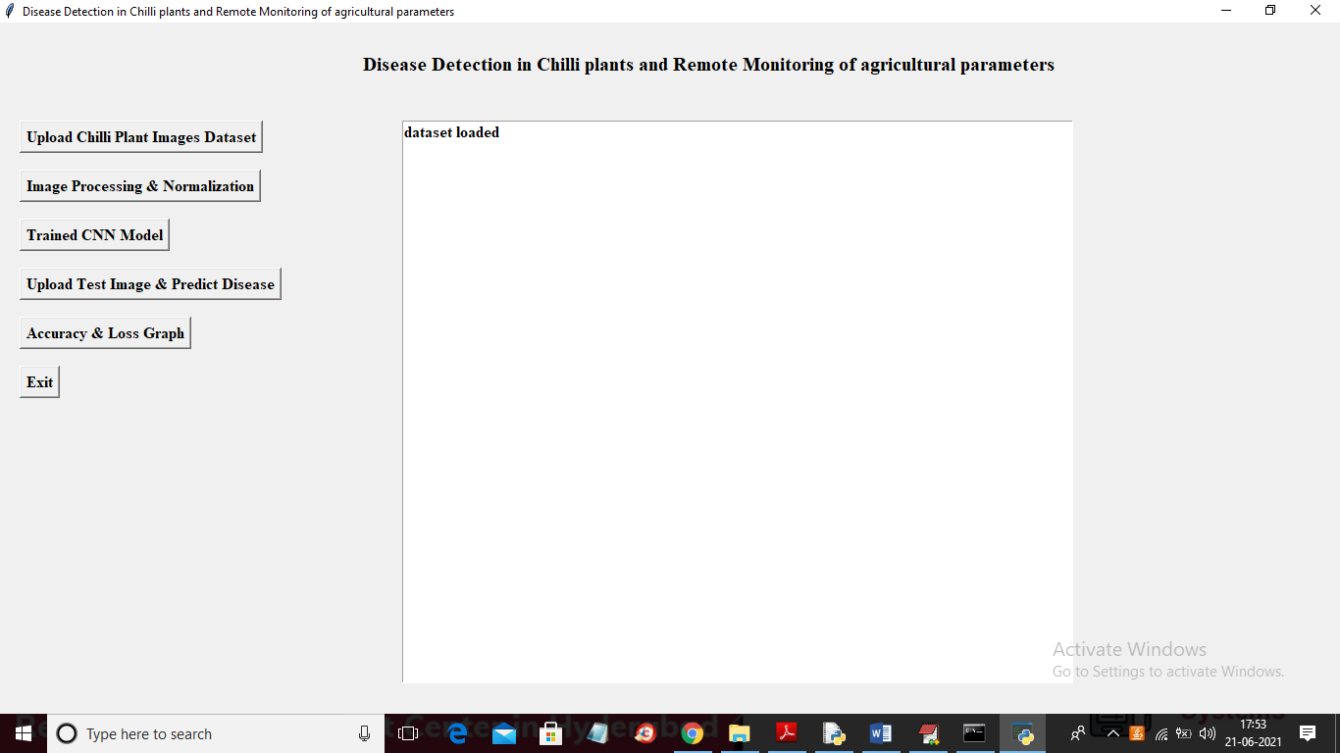

In above screen dataset loaded and now click on ‘Image Processing & Normalization’ button to read all images and then resize all images into equals size and then normalize image by converting pixel values between 0 and 1 range. Just divide image pixel with 255 then will get image pixel value as 0 or 1.

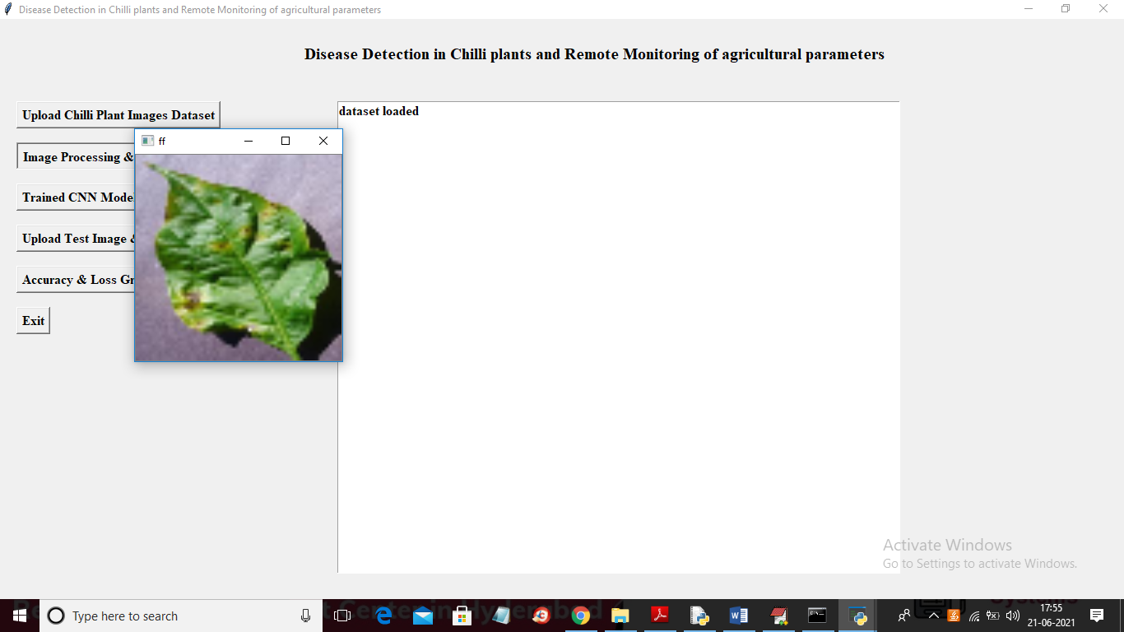

In above screen all images are normalized and to check all Images are processed successfully I am displaying one sample image and now close above image to get below screen

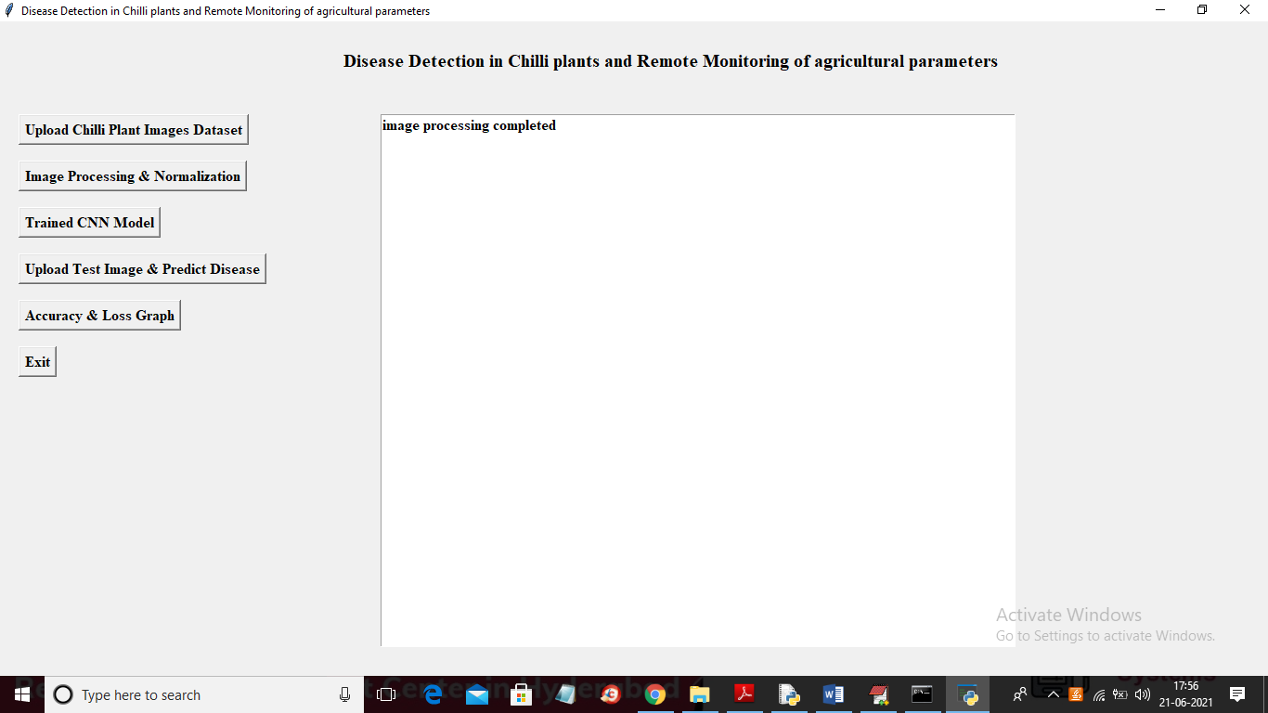

In above screen image processing completed and now images are ready and now click on ‘Trained CNN Model’ button to train CNN with above images

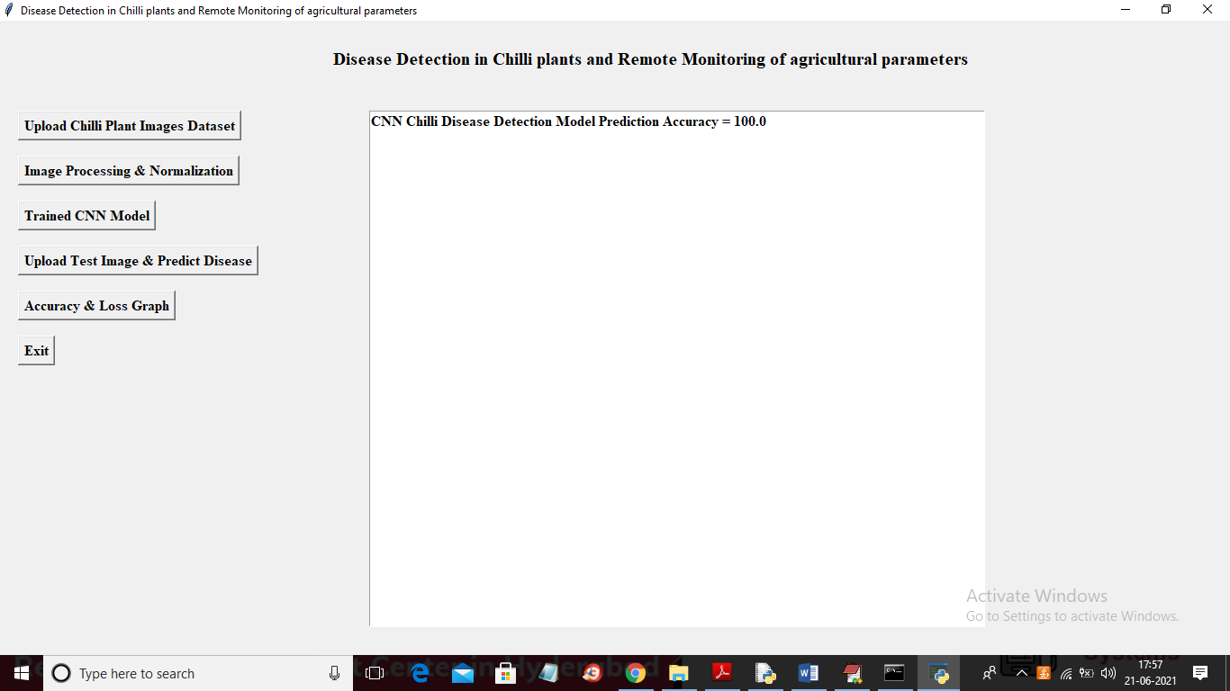

In above screen CNN trained and we got its accuracy as 100% and now click on ‘Upload Test Image & Predict Disease’ button to upload test image and then CNN will predict disease

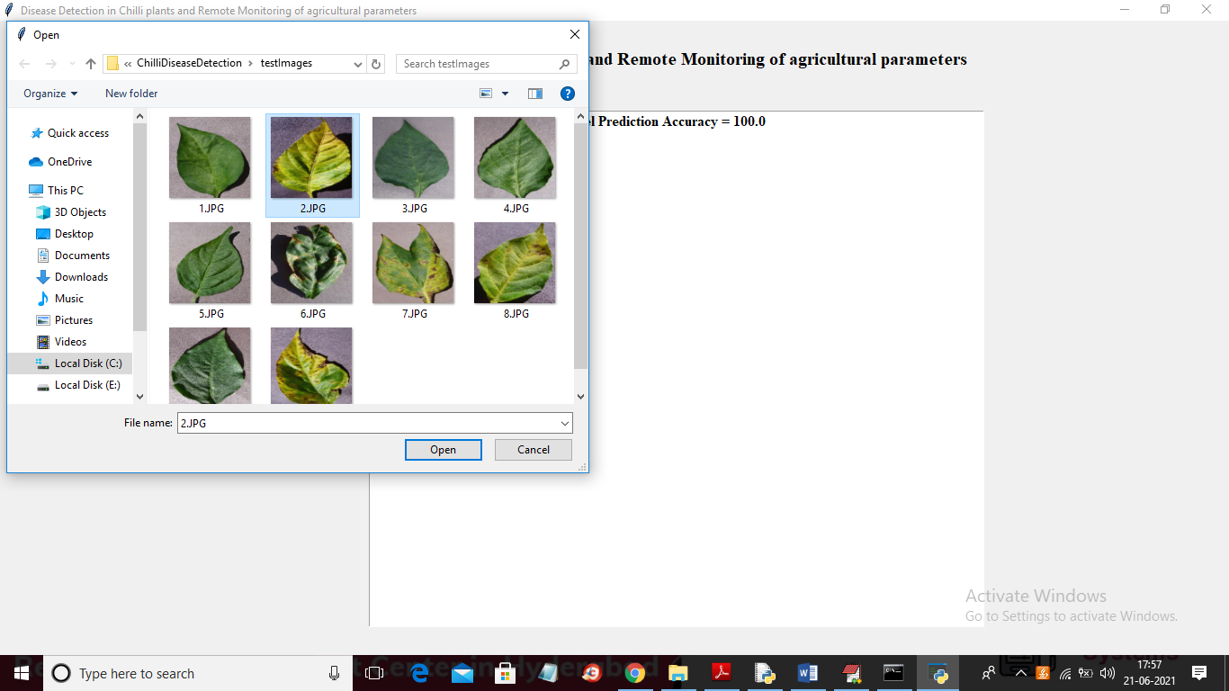

In above screen selecting and uploading ‘2.JPG’ file and then click on ‘Open’ button to get below prediction result

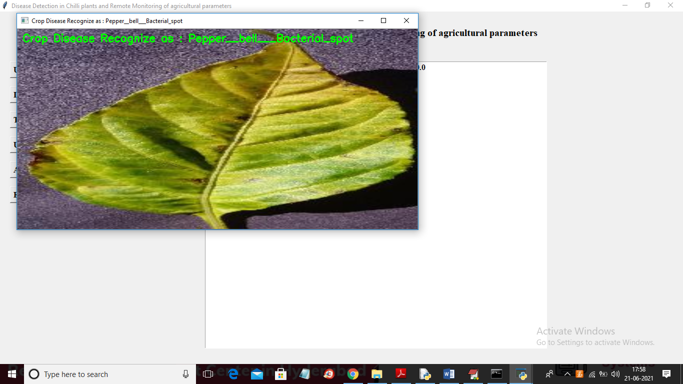

In above screen disease predicted as ‘Pepper_bell_Bacterial_spot’ and now upload another image and test

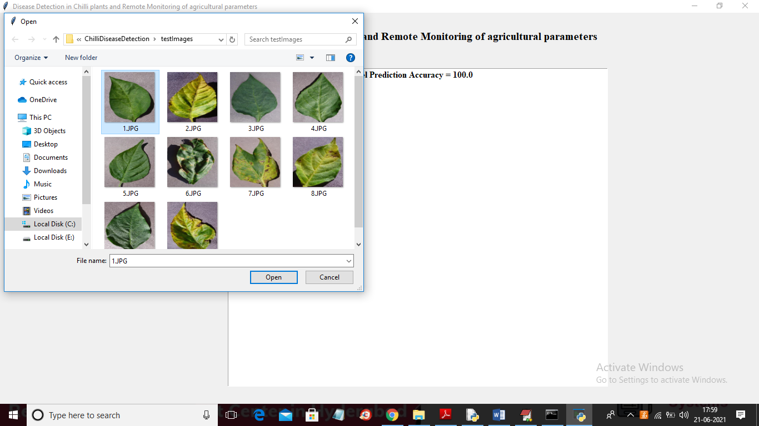

In above screen selecting and uploading ‘1.JPG’ image and then click on ‘Open’ button to get result

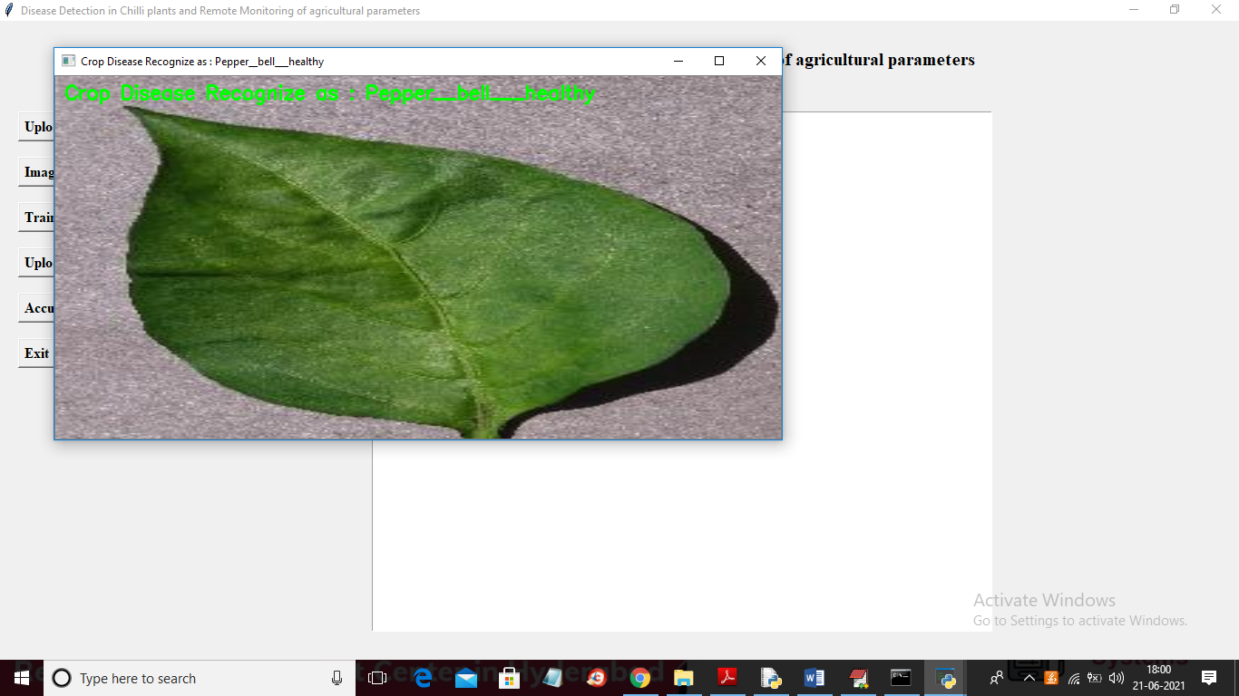

In above screen disease predicted as ‘HEALTHY’ and similarly you can upload other image and test and now click on ‘Accuracy & Loss Graph’ button to get below graph

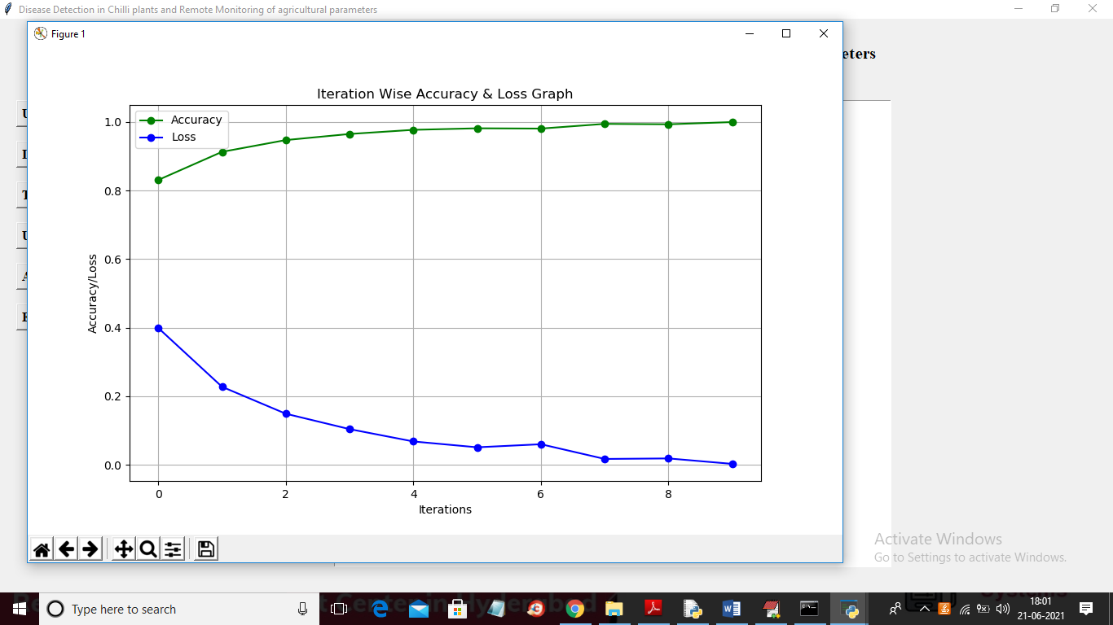

In above graph x-axis represents CNN EPOCH and I took 10 EPOCH and in above graph y-axis represents accuracy and LOSS value and in above graph green line represents accuracy and blue line represents LOSS and in above graph we can see with each increasing EPOCH accuracy is getting increase and loss getting decrease. This increasing accuracy will consider model as accurate.