Why do birds use green nest material? A systematic review and meta-analysis of experiments
Abstract
Many animals construct nests. Nests are often considered extended phenotypes that shape survival and reproduction beyond the builder’s body. Birds are key examples of nest builders, and many add fresh green plant material to their nests. Yet, the adaptive value of this behaviour remains debated. Non-mutually exclusive hypotheses propose roles in courtship signalling, parasite defence, or direct enhancement of offspring condition. Here, we conducted a pre-registered systematic review and meta-analysis of 28 experimental studies (published and unpublished), spanning seven bird species and 274 effect sizes, to test whether green nest material influences fitness, and to evaluate the competing functional explanations. Our synthesis shows that while green nest material can enhance avian fitness, this effect depends on the fitness proxy used, and its functional role remains unresolved. The strongest predictor was experimental design, strongly influencing the outcomes, challenging the role of aromatic compounds in the fitness benefits of green nest material. Our meta-analysis supports the importance of green nest material on fitness, but calls for more research to elucidate its mechanisms.

Introduction
Nest and nest-building are fundamental across a diverse range of animals, including arthropods (e.g., ants, spiders), mammals (e.g., platypus, rodents), and perhaps more famously, birds. Nests provide structural support for eggs, parents, and offspring, and protect them against predators and other environmental pressures, and are thus key to reproductive success and survival [1–3]. Most birds use organic plant materials such as twigs, branches, grass, and moss to build their nests. Some even incorporate inorganic items, including mud, stones, feathers, snake skins and anthropogenic materials like plastic and cigarette butts [4–7]. The latter are considered non-structural additions and suggest that nests are more than just physical shelters; they can be complex tools shaped by both natural and sexual selection for multiple functions. Indeed, nests can play a key role in sexual display, and features such as nest size have been shown to act as sexually selected signals of parental quality in several bird species [e.g., 8,9], even interspecifically by brood parasites [10]. Nest-building behaviour is increasingly recognised as an expression of the extended phenotype (reviewed by [11]), and phylogeny has been shown to be an important factor explaining nest morphology [12]. Yet, despite hundreds of scientific articles studying nests and nesting behaviour in birds being published each year, much remains unknown.
An intriguing nesting behaviour observed in some bird species is the addition of fresh, often aromatic, plant material to the nest. This green nest material (hereafter GNM) often corresponds to leaves, sprigs, herbs and branches, and is typically added from the start of nest building until egg laying, although some species like the blue tit (Cyanistes caeruleus) keep adding it after that. Contrary to the structural nest materials (e.g., twigs, mud), GNM is selected from a small, non-random subset of local flora [13–15]. The selected plants often possess high levels of aromatic volatile compounds (commonly used by songbirds; [16]) or secondary metabolites such as oils and resins (commonly used by raptors; [17]). GNM is unlikely to be gathered opportunistically, and collecting these uncommon plants and replenishing them, sometimes over weeks, requires extra time and, in some cases, flying outside one’s territory [18]. Thus, the general costs associated with nest-building [19], and the additional effort, time and energy devoted to add these non-structural materials, suggest an adaptive function of GNM.
Multiple hypotheses have been proposed to explain the adaptive function of GNM (reviewed in [20]; [21]). First, the courtship hypothesis suggests that (mostly) males use GNM as visual or olfactory signals to attract females and/or advertise nest site occupancy to other males (e.g., [22]; [23]; [24]), particularly in cavity-nesting species where visual cues inside the nest are limited. For instance, the seminal study of [25] showed that male European starlings (Sturnus vulgaris) carry fresh plant material to their nests while singing and displaying to females. Subsequent studies in European and spotless starlings (Sturnus unicolor) supported this view by showing that females often prefer nests with fresh GNM, and that unpaired males conspicuously deliver GNM during courtship, stopping right after the onset of egg laying [24,26]. Additionally, males increase the addition of GNM in the presence of potential mates [22]. Altogether, these studies offered support for the courtship hypothesis, which was later extended to explain GNM addition solely by females in blue tits, suggesting that GNM might serve as a sexually selected signal of female quality [27].
Second, the most widely tested hypothesis is the nest protection hypothesis, which proposes that the volatile compounds in GNM reduce the amount of parasites and pathogens in the nests, enhancing offspring survival. This hypothesis was first suggested in a comparative study in raptors (Falconiformes) that provided only indirect evidence by comparing nest reuse, diet composition and GNM presence [28]. Soon after, a preference for GNM containing insect-repellent and antimicrobial volatiles was experimentally confirmed in European starlings and suggested three key criteria for evaluating the nest protection hypothesis (i.e., selective plant use, bioactive chemical properties and demonstrable adaptive benefits; [13]]. Observational and experimental studies on raptors [17,29] and passerines [16,30–32] have shown mixed results. In some cases, GNM was shown to improve offspring condition without reducing the amount of parasites in the nests [33], leading to the development of the drug hypothesis. This alternative hypothesis suggests that the volatiles present in GNM directly enhance offspring immune function and/or health independent of parasite or pathogen control[33,34]. While both the nest protection and drug hypotheses suggest that GNM enhances offspring survival, the drug hypothesis attributes this effect to a pharmacological mechanism, whereas the nest protection hypothesis emphasises parasite and pathogen repellency. Importantly, these two hypotheses are not mutually exclusive, and their potential effects on offspring survival are difficult to disentangle.
Last, several additional functional hypotheses of GNM that do not refer to its aromatic (i.e., volatiles and secondary metabolites) properties have also been proposed. These include benefits such as enhancing the crypticity of the nest [35], providing insulation or sun protection for eggs and offspring [36], or simply fulfilling a structural function [37]. However, these alternative functional roles have received little support or attention.
Despite decades of research, abundant observational and experimental studies, and two crucial narrative reviews [20,21], we still do not know the overall adaptive significance of GNM, its generality across bird species, and the relative importance of each of the suggested functions. Given that nest building is widespread across taxa, including but not limited to birds, and is increasingly recognised as an expression of the extended phenotype, a quantitative synthesis of this field is both timely and has potentially far-reaching implications.
To address this gap, we conducted a pre-registered systematic review and meta-analysis of experiments testing the effect of GNM on various fitness proxies across birds. Our meta-analysis explicitly evaluates the overall evidence for the adaptive significance of GNM, as well as assesses the relative importance of the main suggested hypotheses: the courtship hypothesis and parental care hypothesis (i.e., a combination of both the nest protection and drug hypotheses). In addition, we tested potential moderators that might explain the observed context-dependency (i.e., high heterogeneity among effect sizes). Specifically, we tested whether the effect of GNM varied depending on the experimental design used, the timing of GNM addition, the focal species studied, the category of fitness proxy investigated (e.g. morphological, reproductive, etc.), and the type of parasite. Our meta-analysis of experimental studies is the first quantitative synthesis testing the causal relationship between GNM and fitness across birds.

Methods

Registration and reporting
We pre-registered our study protocol on the Open Science Framework [38] prior to exploring or analysing the data. The pre-registration details our objectives, a priori hypotheses and predictions, methods and planned data analyses. Unless stated otherwise, we adhered to the registered protocol. We followed the PRISMA-EcoEvo guidelines [39] for reporting this study (Table S1; Figure S1). All resources associated with this study, including data and code, are available at [https://github.com/shreyadimri/Green_Nest_Material] (insert Zenodo citation later).

Information source and search
We conducted a systematic search on Web of Science Core Collection and Scopus on the 7th of September, 2022 (see update below). The keyword search query was designed as a three-block query including terms related to our treatment of interest ((“green*” OR “herb*” OR “aromatic*”) AND “nest*”), population of interest (“bird*” OR “aves” OR “avian” OR “ornithol*” OR “passerine*” OR “passeriform*” OR “songbird*” OR list of all bird genera) and to limit the search results to experimental studies only (“experiment*” OR “manipulat*”). The complete search strings tailored to each specific platform are provided in Figure S16. Although our search string only included keywords in English, we planned to screen any study in English, Spanish, Portuguese and Hindi, but found studies only in English. We searched through titles, abstracts and keywords with no restrictions on publication date or study type. We validated our search using an initial library of 15 relevant articles that we had previously identified (Figure S2), ensuring all were retrieved. Additionally, we used the R package ‘litsearchr’ v1.0.0 [40], which did not yield any new relevant terms, confirming our queries. After removing 152 duplicates using the R package ‘revtools’ v0.4.1 [41], we identified 383 unique records.

Eligibility criteria
All titles and abstracts were equally allocated and screened independently by at least two screeners (SD, TR, JMGS) using the R package ‘revtools’ following a pre-designed decision tree with all inclusion/exclusion criteria (Figure S3). We included all studies on birds that experimentally manipulated the GNM (both aromatics and non-aromatic). Forty articles passed the title-and-abstract screening and were further evaluated during the full-text screening, where each article was independently screened by a single screener (SD, TR, JMGS), with another screener verifying the procedure. We used the same criteria as above (Figure S3) with an additional evaluation of whether the variable of interest in the article was in our list of fitness proxies of interest (Figure S4). Twenty-two aarticles passed the full-text screening and were, thus, eligible for our meta-analysis. All conflicts in screening decisions (1% for title-and-abstract screening, and none for full-text screening) were resolved through discussion.
We updated our systematic literature search by repeating our search on the 12th of August, 2024, and found 53 unique articles after removing 13 duplicates. Only one observer (SD) performed both screenings using the same decision trees as before (Figure S3), and found one additional eligible article for our meta-analysis. Lastly, we identified three additional eligible articles recommended by two colleagues. In all, 26 published articles were eligible for our meta-analysis, but we also obtained two additional unpublished studies (more details below and in Figure S1).

Data extraction
The data of each article were extracted by one of three authors (SD, TR, JMGS), with another screener verifying the procedure, and four authors (SD, TR, JMGS, AST) collectively discussing and revising unclear cases. We prioritised extracting primary data (i.e., measures of central tendency, variance and sample size) from text and tables, or, if that was not possible, from figures (e.g., boxplots) using the R package ‘metaDigitise’ v1.0.1 [42]. If primary data were not available, we extracted inferential statistics such as t and F values or contingency tables to transform them into effect sizes (see below). Last, if the previous steps failed but the article had openly archived data, we calculated the means, standard deviations and sample sizes from each group ourselves (n = 4 studies).
We extracted the means, variances and sample sizes for each control-treatment comparison. Depending on the experimental design of each study, controls included non-aromatic materials (e.g., grass or moss), smaller amounts of aromatic material, no added material, or removal of material added by birds; whereas treatments consisted of aromatic material added by authors, birds, or both. We coded these comparisons in our moderator ‘experimental design’ as non-aromatic GNM vs. aromatic GNM, or no added GNM vs. aromatic GNM. Another experimental design used in some studies compared nests with experimentally added non-aromatic GNM to nests without any added GNM or in which GNM added by the birds was removed by the authors. In these cases, the non-aromatic GNM was considered the treatment, and we coded these as non-aromatic GNM vs. no added GNM in our moderator ‘experimental design’ (n = 3 studies). Importantly, our conclusions remained robust to the exclusion of these effect sizes (Table S2), so we kept this category in our dataset, and the moderator ‘experimental design’ was tested in subsequent meta-regressions. A fourth experimental design compared enhanced supplementation of GNM by the authors (i.e., authors + birds) to birds alone (n = 2). This experimental design represents a fundamentally different contrast focused on potential additive effects of GNM and makes the assumption that a GNM effect is indeed present; therefore, we excluded it from the meta-regression using the ‘experimental design’ moderator. In studies where three groups were compared (n = 5), we extracted all possible pairwise comparisons, and accounted for (shared-group) non-independence in our analyses (more below).
For each study, we also extracted information related to the study subjects (bird species, geographical location of the study population), the methodology of the study (fitness proxy measured) and the source from which we extracted data (e.g., figures, tables, raw data files, supplementary materials). We categorised the fitness proxies measured into 6 broad categories: physiology, morphology, reproduction, behaviour, parasite and pathogenic load, and phenology. For studies testing whether GNM affects the number of parasites or pathogens found in offspring and/or nests, we categorised them into arthropods or microorganisms. For a complete list of variables extracted, see Figure S8 . During data extraction, we encountered some traits (e.g., WBC ratio, parent mass; 15 effect sizes, n = 5 studies) that we did not include in any of our analyses because it was unclear from the study and our own judgement how these traits related to fitness (see Figure S5 for the list and reasons of exclusion).
We contacted four corresponding authors to obtain missing data (e.g., non-reported results, missing sample sizes). All four authors responded to our email, but only two provided the data as requested; one did not have the data any more, and one did not give a conclusive response. Additionally, to locate grey literature (e.g., unpublished data), we wrote to the corresponding author(s) of all the 22 articles that passed full-text screening to ask for any potential unpublished data that could be included in our meta-analysis using a standardised email template (Figure S6). One author provided data for an unpublished study on blue tits (see description in Figure S7), and one of us (MO) provided data for an unpublished study on common buzzards (Buteo buteo).

Effect size calculation
Using the means, standard deviations and sample sizes for each control-treatment pairwise comparison, we calculated two effect sizes: a log response ratio (lnRR) and a standardised mean difference with heteroskedasticity correction (SMDH), using the escalc function (measure = ‘ROM’ and ‘SMDH’, respectively, vtype = ‘LS’) in the R package ‘metafor’ v4.8-0 [43]. We specified the treatment group as the numerator and the control group as the denominator for lnRR, and treatment minus control for SMDH, such that positive values indicate a ‘fitness’ increase in the treatment group. In cases such as measures of parasite load or prevalence, laying or hatching dates, courtship time, or scab score, the effect size sign was inverted before analysis to ensure that a positive value consistently meant an increase in fitness regardless of fitness proxy (i.e., to ensure comparability across effect sizes). SMDH could only be calculated when there were enough data points in both treatment and control groups to estimate the pooled variance; specifically, when the degrees of freedom (i.e., n1+n2−2) were greater than 1. There were nine effect sizes from one) study that did not fulfill that requirement, which we then excluded from the dataset.
For the few cases for which we could not extract means and variances but inferential statistics such as t and F values, we estimated SMD values (k = 4, n = 2) using the equations provided by [44]. For dichotomous variables (e.g., number of successful nests, k = 4, n = 2), we calculated the log odds ratio (lnOR) using the ‘escalc’ function (measure=OR) from ‘metafor’ and subsequently converted it to SMD using equations from [44]. Since lnRR cannot be calculated from inferential statistics, dichotomous variables, or traits including zero or negative values (k = 7), the number of effect sizes included in the lnRR subset (k = 259, n = 28) is smaller than that of SMDH (k = 274, n = 28).
When calculating each effect size’s associated sampling variance, whenever possible, we used the number of nests in each group over the number of individuals as the sample size to account for genetic relatedness non-independence. In cases where the same control or treatment group was used in multiple comparisons, sample sizes were adjusted before calculating effect sizes by dividing them by the number of times each group was used in a comparison to account for shared group non-independence. For cases where the authors of an original article reported a statistically non-significant difference between two groups but without providing numerical values (k = 16, n = 2), we assigned zero as the effect size for that comparison and imputed its sampling variance using the missing-case approach described in [45] for lnRR, and $\frac{n_{1}+n_{2}}{n_{1}×n_{2}}$ for SMDH [46].

Data analysis
We performed all analyses in R v4.5.1 [47]. All multilevel meta-analytical models and meta-regressions were fitted using ‘metafor’ v4.8-0 [43]. Sampling variances were modelled as variance-covariance matrices assuming a 0.5 correlation (ρ) between sampling variances from the same study [48] using the ‘vcalc’ function from ‘metafor’ (see Supplementary Appendix Figure S10 for sensitivity analyses using different values of ρ).
We originally considered the following levels of non-independence for our analyses: multiple effect sizes collected from (a) same study (Paper ID), (b) bird species (Species ID), (c) geographical locations (Population ID), (d) sub-populations within the same location (Experiment ID; e.g., birds studied at the same location for multiple years), (e) groups of individuals within a population (Group ID; e.g., males and females in a population, first clutch and second clutch), and (f) repeated measurement of the same trait for the same individuals (Repeated trait ID; e.g., chick mass on day 7, 14 and 21). In the end, our random effect structure deviated from our pre-registration since, initially, we had pre-registered the inclusion of Experiment ID and Repeated trait ID, but not Population ID. However, Experiment ID and Group ID were almost indistinguishable, so we decided to leave out the one with lesser resolution (i.e. Experiment ID). Additionally, few effect sizes were measured repeatedly, making Repeated trait ID almost identical to Observation ID (Figure S9), so we excluded Repeated trait ID. Last, we decided to add Population ID since we noticed after extracting the data, but before any analyses, that several studies were performed in the same geographical locations. Therefore, unless stated otherwise, we fitted the following random effects in all our models to account for non-independence: Paper ID, Group ID, Species ID, Population ID and an observation-level random effect (Observation ID).
Meta-analytic mean and hypotheses: To estimate the effect of GNM on fitness across birds, we fitted two separate sets of models for each effect size: lnRR and SMD(H). First, we fitted multilevel intercept-only meta-analytical models to test the overall effect of GNM on fitness estimates, its uncertainty and heterogeneity. We used the ‘rma.mv’ function from the ‘metafor’ package (method = ‘REML’ and test = ‘t’ for calculating the test statistics and confidence intervals for the moderators). We excluded traits for which their link with fitness is debated in the literature (e.g., sex ratio, testosterone levels) from our main analysis, but conducted a sensitivity analysis including these traits to test the robustness of our results (Table S2; k = 21 , n = 8). For all intercept-only models, we estimated the total amount of absolute heterogeneity ($σ^{2}$; i.e., the total variation not explained by sampling error), its sources or relative heterogeneity ($I^{2}$), mean-standardised metric (CVH2) and variance-mean-standardised metric of heterogeneity (M2) following the pluralistic approach suggested by [49] .
To test the relative importance of the two main functional hypotheses suggested for GNM, that is, the courtship and the parental care hypothesis, which combines the nest protection and drug hypotheses, we ran a multilevel meta-regression including the moderator ‘hypothesis’ (levels: courtship, parental care, both). For all meta-regressions, we estimated $R_{marginal}^{2}$, which corresponds to the percentage of heterogeneity explained by the moderators [50]. Unless stated otherwise, all meta-regressions correspond to unimoderator meta-regressions.
Exploratory meta-regressions: We performed additional pre-registered multilevel meta-regressions for which we did not have clear directional predictions. To understand the effect of type of experimental design (i.e., whether the authors compared non-aromatic vs. aromatic, no added material vs. aromatic, no added material vs. non-aromatic), we ran a meta-regression with the type of ‘experimental design’ as the moderator. To test the effect of time of addition of GNM on fitness (levels: before egg hatching, after egg hatching, continuously throughout the nesting phase), we ran a meta-regression with ‘time of addition of GNM’ as the moderator. We also ran a meta-regression using ‘bird species’ as the moderator (levels: Buteo buteo, Cyanistes caeruleus, Passer cinnamomeus, Parus major, Sturnus unicolor, Sturnus vulgaris, Tachycineta bicolor) to understand if and how the effect of GNM on fitness might differ among species. Furthermore, we explored the effect of GNM on fitness depending on the ‘category of fitness proxy’ studied (levels: behaviour, morphology, parasite and pathogenic load, phenology, physiology, reproduction) using a meta-regression with the fitness proxy category as the moderator. Last, for the subset focusing on parasites and pathogens (k = 90, n = 16)), we ran a meta-regression with the ‘type of parasite’ as the moderator (levels: arthropod, micro-organism).
In addition, we performed three additional pre-registered multilevel meta-regressions to explore the potential threats to the internal validity of each study on our conclusions (i.e., Risk of Bias or RoB) following recommendations in [51] . We evaluated the effects of (1) blinding (whether outcome assessors were blinded to the experimental group), (2) random assignment to treatment, and (3) partial reporting (whether all measured outcomes were completely reported or only a subset). For each RoB category, we coded studies (levels: yes, no) and included each category as a moderator in a meta-regression run separately for both lnRR and SMD(H).
Publication Bias Test: Publication bias occurs when a subset of research findings, most often statistically non-significant ones, are less likely to be published or published later [52]. There are two types of publication biases that are commonplace in ecology and evolutionary biology: small-study and decline effects [53]. We tested them for both lnRR and SMD(H) separately, following [54]. To test for small-study effects, we ran a multilevel meta-regression using the ‘square-root of the inverse of the effective sample size’ as the moderator (i.e., $\sqrt{\left(n_{1}+n_{2}\right)/\left(4n_{1}n_{2}\right)}$) To test for decline effects (also known as time-lag bias; [55]), we ran a multilevel meta-regression using ‘year of publication’ (mean-centered) as the moderator.

Results
We obtained 274 effect sizes from a total of 28 studies conducted on 7 species across 17 geographical locations (Figure1). About 81% of the effect sizes came from only three bird species (Cyanistes caeruleus, k = 77; Sturnus unicolor, k = 60; Sturnus vulgaris, k = 86). Our dataset included 2 unpublished studies (k = 18), with the remaining studies being published between 1988 and 2024. The mean ±standard deviation number of effect sizes per study was 9.8 ± 6.4 (median: 8.5 range: 2–24) and the mean effective sample size (i.e., the number of nests/individuals per effect size after accounting for shared-group non-independence) was 32.3 ±31.1 (median: 22.0, range: 3–210; 31 data points had a sample size of less than 5 nests in each group).
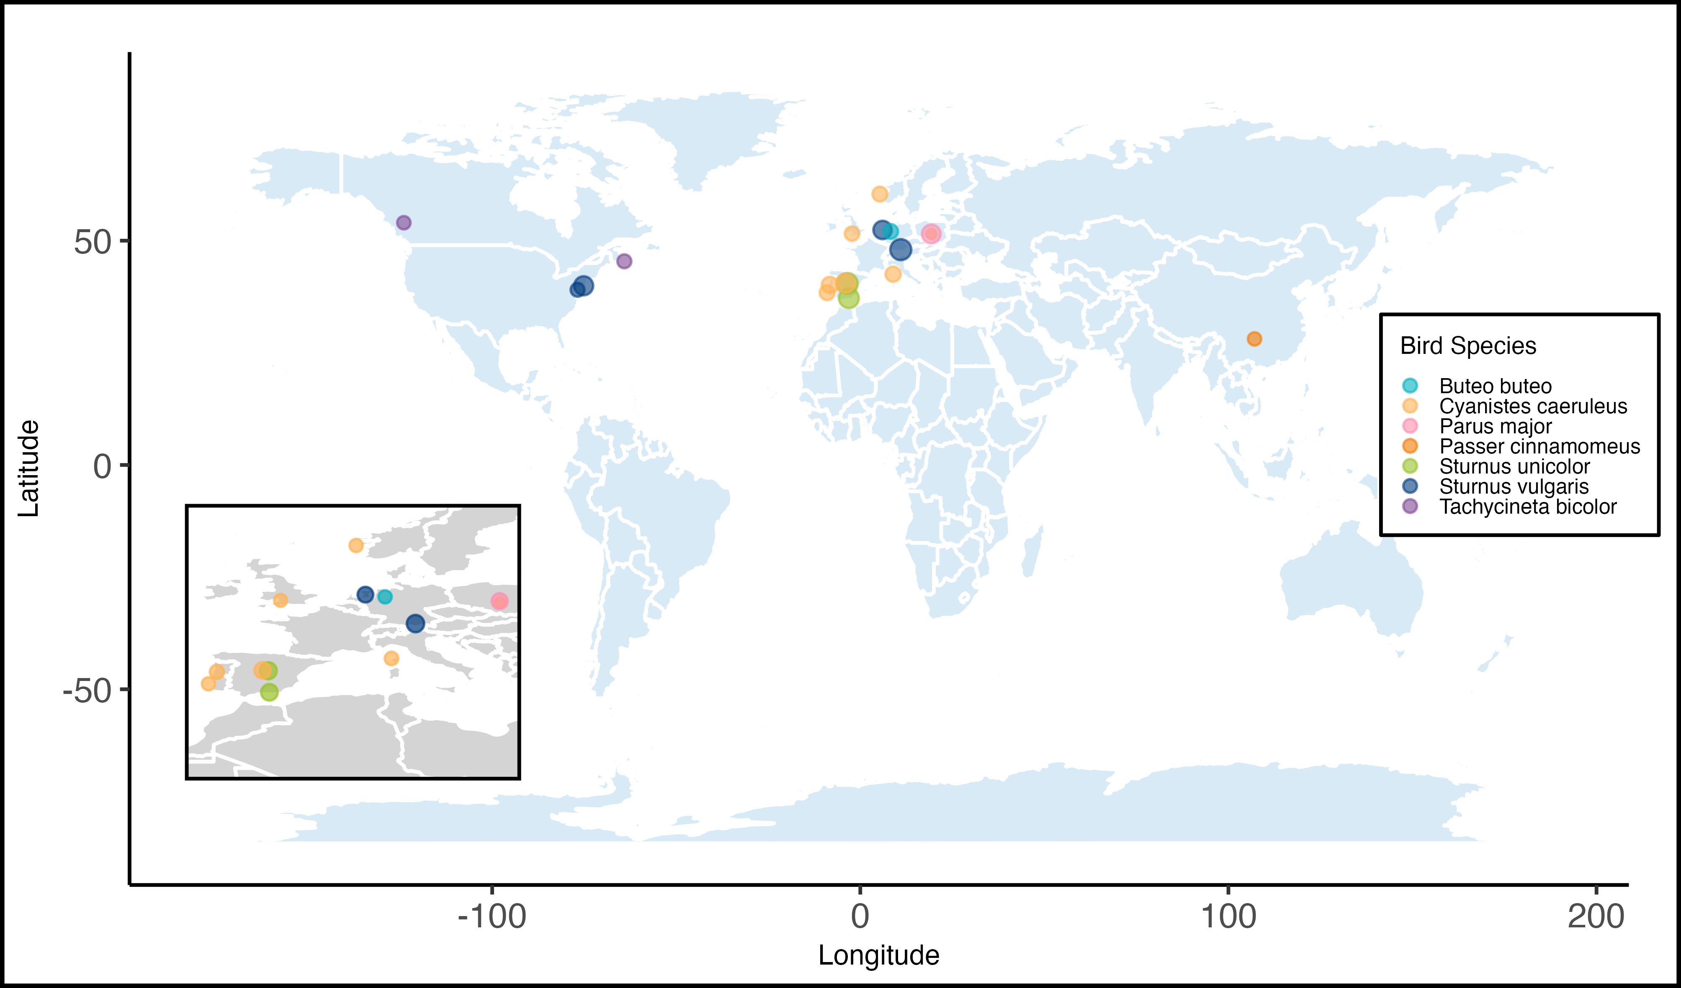
Figure1: Geographical distribution of the 17 study populations included in a meta-analysis testing the adaptive value of green nest material in birds. Point size reflects the number of effect sizes coming from the location (range: 3–34), and colour denotes species (see legend), with an inset zooming in on a dense cluster of data points.

Meta-analytic mean
Both lnRR and SMD(H) intercept-only multilevel meta-analyses showed an average increase in fitness estimates in nests with an experimental increase in GNM compared to control nests; however, the overall effect was only statistically significant for SMD(H).
First, lnRR showed an average statistically non-significant increase in fitness estimates of 1.9% in nests with an experimental increase in GNM (Figure2 A; lnRR = 0.019, 95% CI: [-0.012, 0.050], 95% PI: [-0.281, 0.319], p-value = 0.223, k = 238, n = 26) but heterogeneity among effect sizes was high. Total raw heterogeneity ($σ^{2}$) was 0.023 (Q = 2277.7, p < 0.001), the measures of relative (I²_{total} = 98.6%) and standardised heterogeneity (CVH2_{total} = 63.59; M2_{total =} 0.98) all suggested high heterogeneity across effect sizes, exceeding the 75th percentile of empirically derived estimates from meta-analyses in ecology and evolution [49].
Second, SMD(H) showed an average statistically significant increase in fitness estimates in nests with an experimental increase of GNM (Figure2 B; SMD(H) = 0.179, 95% CI: [0.048, 0.310], 95% PI: [-0.829, 1.188], p-value = 0.008, k = 253, n = 26), but heterogeneity among effect sizes was moderate to high. Total raw heterogeneity ($σ^{2}$) was 0.258 (Q = 1114.7, p < 0.001), relative heterogeneity was smaller compared to that of lnRR (I²_{total} = 66.1%) and the standardised heterogeneity metrics (CVH2_{total} = 8.02 ; M2_{total =} 0.89) lay between the 50th and 75th percentile of empirically derived estimates [49].
The overall results and their conclusions were robust to several sensitivity analyses. First, we fitted a pre-registered bivariate multilevel meta-analytic model including both effect sizes as response variables (lnRR = -0.015, p-value = 0.624 and SMD(H) = 0.250 , p-value = 0.069). In addition, we ran several sensitivity analyses to test the robustness of the overall results to the: (i) inclusion of traits for which their relationship with fitness was debated in the literature (non-pre-registered); (ii) removal of effect sizes that were originally reported as simply statistically non-significant and we assumed them to be zero (non-pre-registered); (iii) both (i) and (ii) (non-pre-registered); (iv) removal of effect sizes from non-aromatic vs. aromatic experimental design (non-pre-registered); (v) removal of effect sizes from non-aromatic vs. no added material experimental design (non-pre-registered); (vi) removal of effect sizes that were calculated by transforming inferential statistics (pre-registered); (vii) removal of effect sizes that failed the Geary’s Test for lnRR (non-pre-registered); (viii) removal of unpublished data (non-pre-registered); and (ix) use of different values of correlation (ρ) between sampling variance for variance-covariance matrix (pre-registered). The number of effect sizes included in those sensitivity analyses ranged from 182 to 274, and the conclusions remained largely the same Table S2.
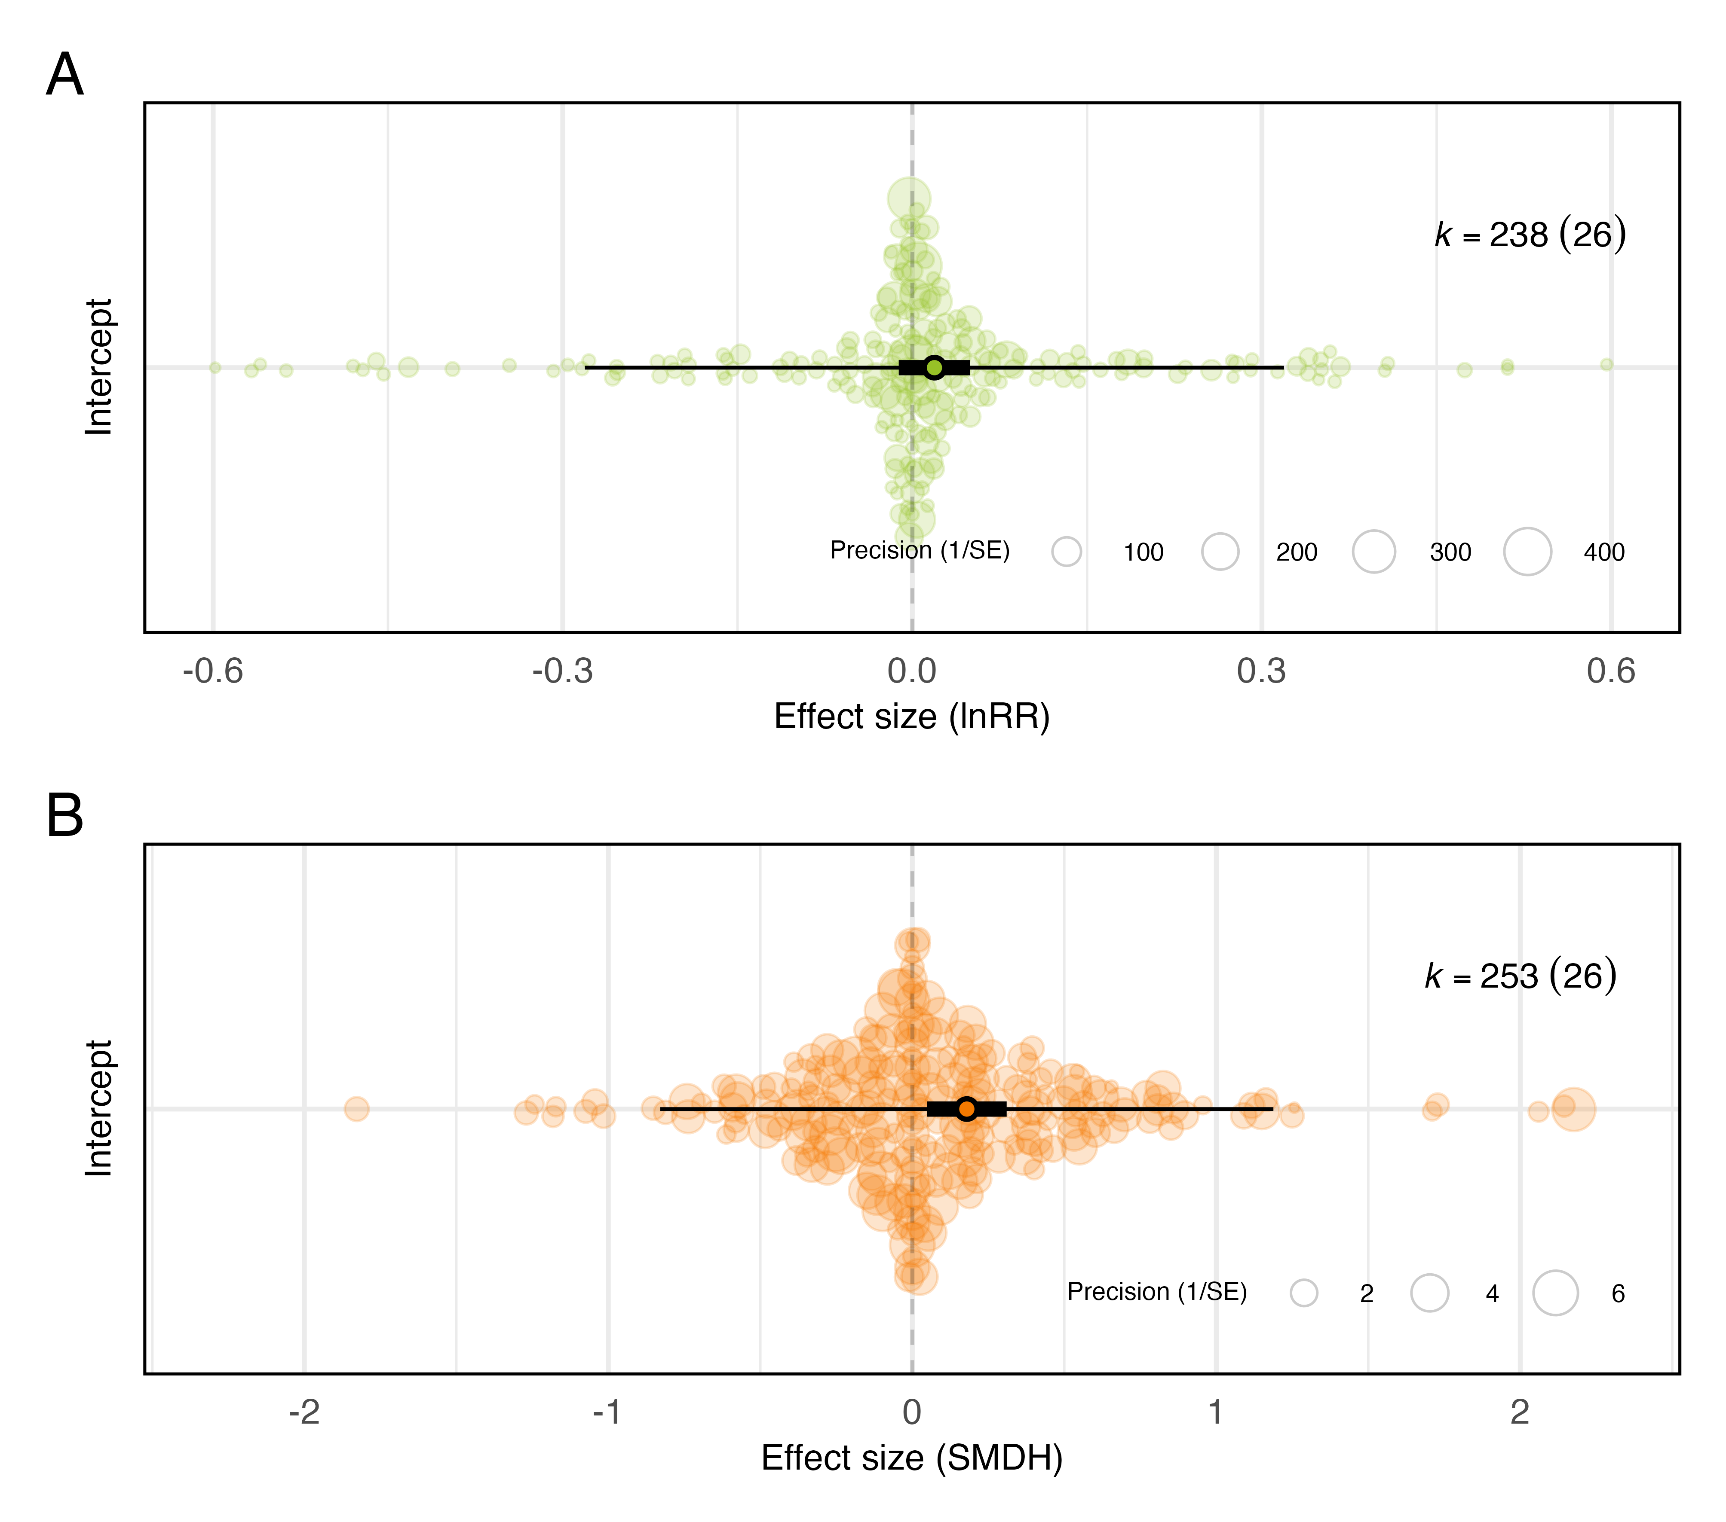
Figure2: Overall effect of green nest material on all fitness proxies combined. The meta-analytic mean (black circle) with 95% confidence intervals (thicker bars) and prediction intervals (thinner bars) are shown along with the data points (coloured circles) scaled by precision (inverse of standard error). Results are shown as an orchard plot for the intercept-only model (A) using log response ratio (lnRR), and (B) standardised mean difference (SMD(H)). k: number of effect sizes (number of studies is shown in the brackets). X-axes are truncated for legibility, which partially explains any apparent asymmetry (complete figures in Section Figure S11).

Functional hypotheses
Our multilevel meta-regressions found no clear support for either of the two main hypotheses proposed in the literature (Figure3). The estimates for the courtship hypothesis (lnRR_{courtship} = 0.039, 95% CI: [-0.172, 0.250], 95% PI: [-0.329, 0.407], p-value = 0.716, k = 8, n = 2; SMD(H)_{courtship} = 0.171, 95% CI: [-0.360, 0.702], 95% PI: [-0.964, 1.305], p-value = 0.527, k = 8, n = 2), and the nest protection and drug hypothesis (i.e., “parental care hypothesis”) (lnRR_{parental_care} = -0.010, 95% CI: [-0.065, 0.045], 95% PI: [-0.316, 0.296], p-value = 0.716, k = 106, n = 19; SMD(H)_{parental_care} = 0.109, 95% CI: [-0.060, 0.278], 95% PI: [-0.908, 1.126], p-value = 0.204, k = 115, n = 19) were statistically non-significant. However, about half of all effect sizes could not be unequivocally assigned to only one hypothesis, so our meta-regression contained a third category that combined both. This category showed an average positive increase in fitness estimates in nests with an experimental increase of GNM, but the effect was only statistically significant for SMD(H) (lnRR_{both} = 0.028, 95% CI: [-0.006, 0.062], 95% PI: [-0.275, 0.331], p-value = 0.110, k = 124, n = 22; SMD(H)_{both} = 0.231, 95% CI: [ 0.079, 0.382], 95% PI: [-0.784, 1.245], p-value = 0.003, k = 130, n = 23). None of the three categories differed statistically significantly from each other (${p-value}_{lnRR)}$ > 0.211 and ${p-value}_{SMD\left(H\right)}$ > 0.178 in all cases), and the moderator explained little heterogeneity ($R_{marginal\left(lnRR\right)}^{2}$= 1.6% and $R_{marginal\left(SMD\left(H\right)\right)}^{2}$= 1.4%).
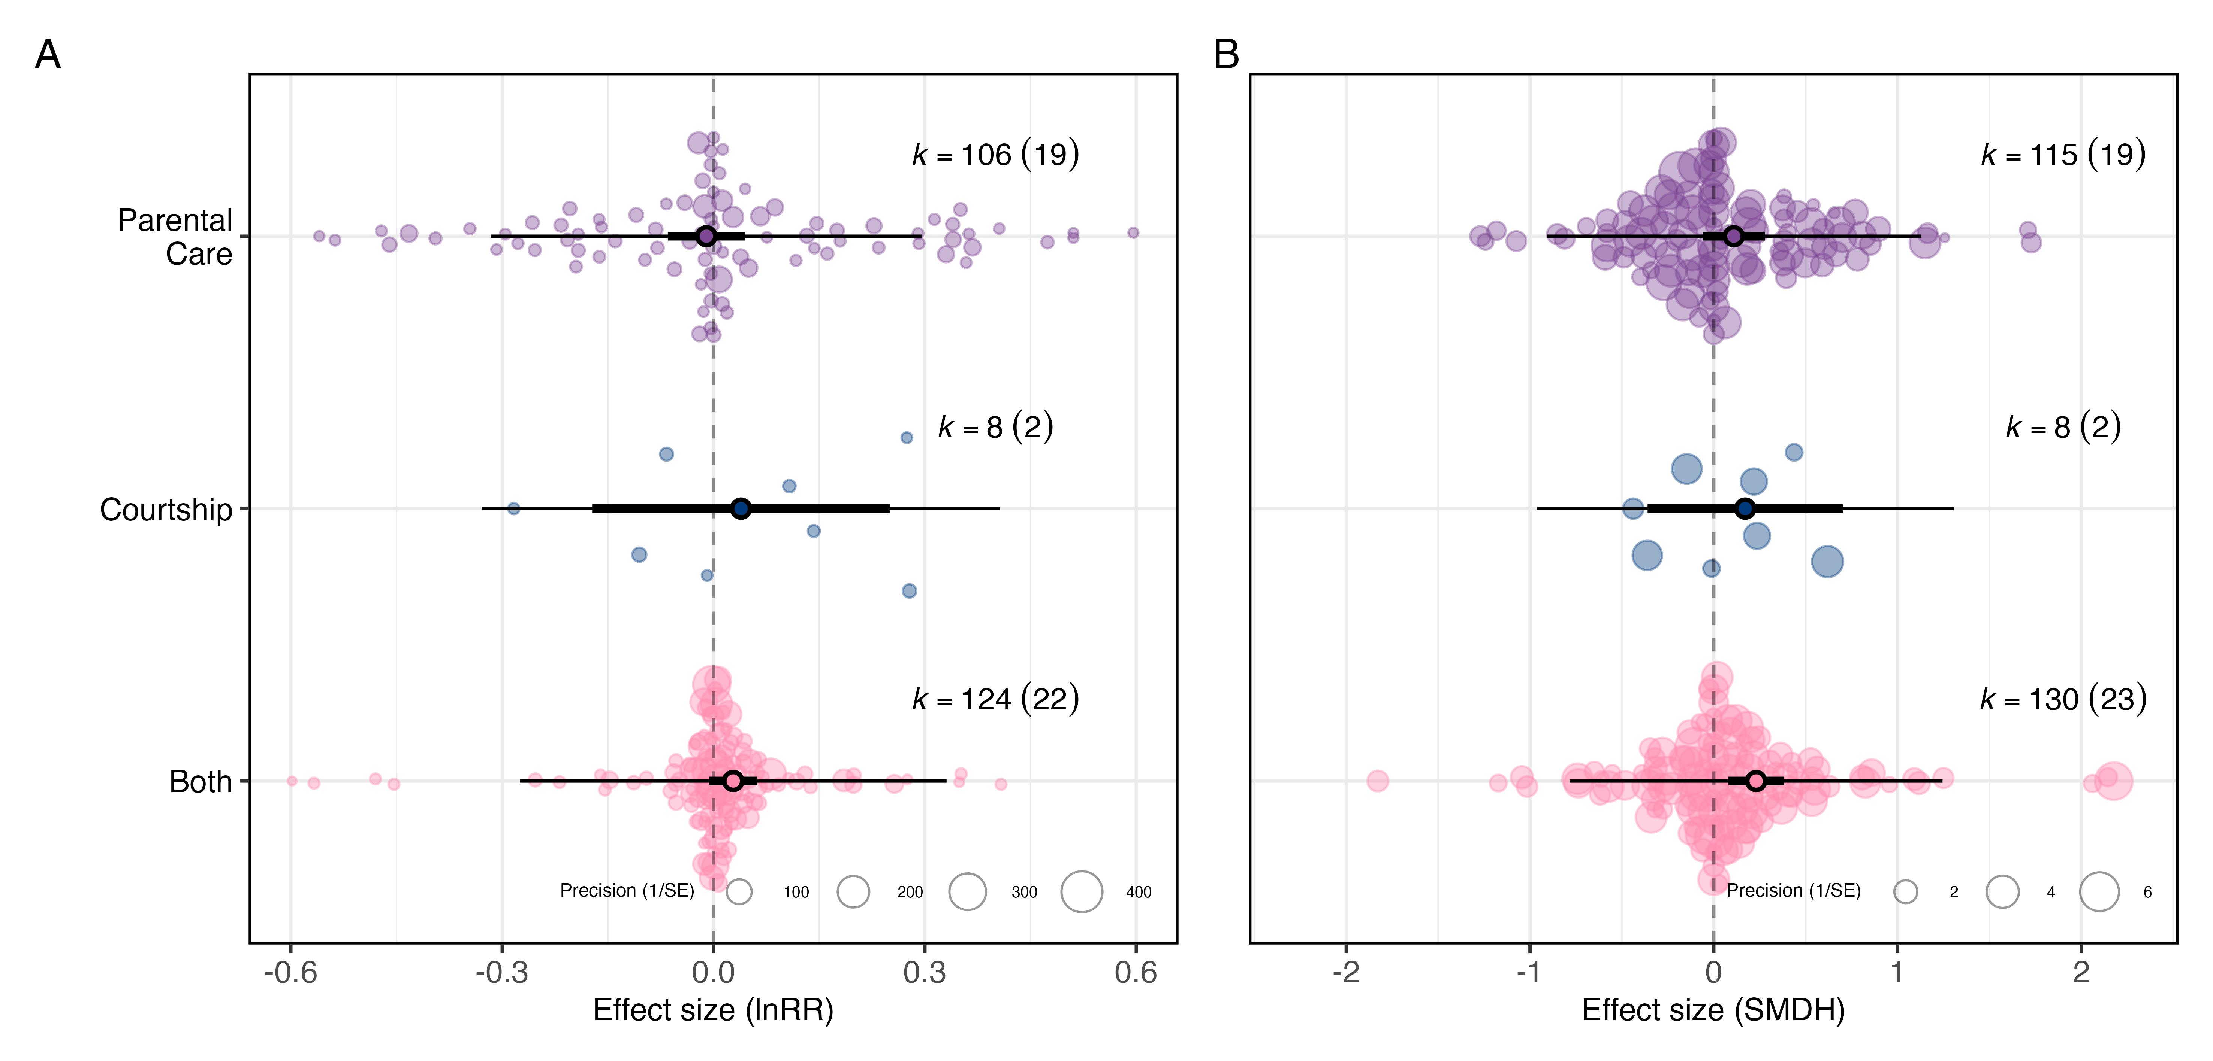
Figure3: There is no clear evidence to favour either the courtship or the parental care hypothesis as drivers of potential fitness benefits of green nest material. Orchard plot of the multilevel meta-regression for (A) log response ratio (lnRR) and (B) standardised mean difference (SMD(H)). Mean estimates (black circles), 95% confidence intervals (thicker bars), and prediction intervals (thinner bars) are shown along with the individual data points (transparently coloured circles) scaled by precision (inverse of standard error). k: number of effect sizes (number of studies is shown in the brackets). X-axes are truncated for legibility, which partially explains any apparent asymmetry (complete figures in Section Figure S12.

Exploratory meta-regressions
First, the overall effect of GNM on fitness estimate differed largely depending on the experimental design used (Figure4A,B). The overall effect size for the comparison between no added material and aromatic GNM was positive and statistically significant (lnRR_{no-material-vs-aromatic} = 0.111, 95% CI: [ 0.021, 0.200], 95% PI: [-0.225, 0.446], p-value = 0.016, k = 90, n = 12 and SMD(H)_{no-material-vs-aromatic} = 0.712, 95% CI: [ 0.309, 1.114], 95% PI: [-0.826, 2.250], p-value = 0.001, k = 94, n = 12], whereas, the comparison between non-aromatic GNM and aromatic GNM was small and statistically non-significant (Table1). The comparison between no added material and non-aromatic GNM, was negative and, although based on only 3 studies, statistically significantly for lnRR (lnRR_{no-material-vs-non-aromatic} = -0.349, 95% CI: [-0.504, -0.195], 95% PI: [-0.708, 0.009], p-value <0.001, k = 10, n = 3;Table1). All levels differed statistically significantly from each other except one (${p-value}_{lnRR}$ < 0.004 and ${p-value}_{SMD\left(H\right)}$ < 0.001 in all cases, except ${SMD\left(H\right)}_{no-material-vs-aromatic}$ vs. ${SMD\left(H\right)}_{no-material-vs-non-aromatic}$ p-value = 0.140), and the moderator experimental design explained a large proportion of heterogeneity, indicating its great importance ($R_{marginal\left(lnRR\right)}^{2}$= 27.8% and $R_{marginal\left(SMD\left(H\right)\right)}^{2}$= 24.4%).
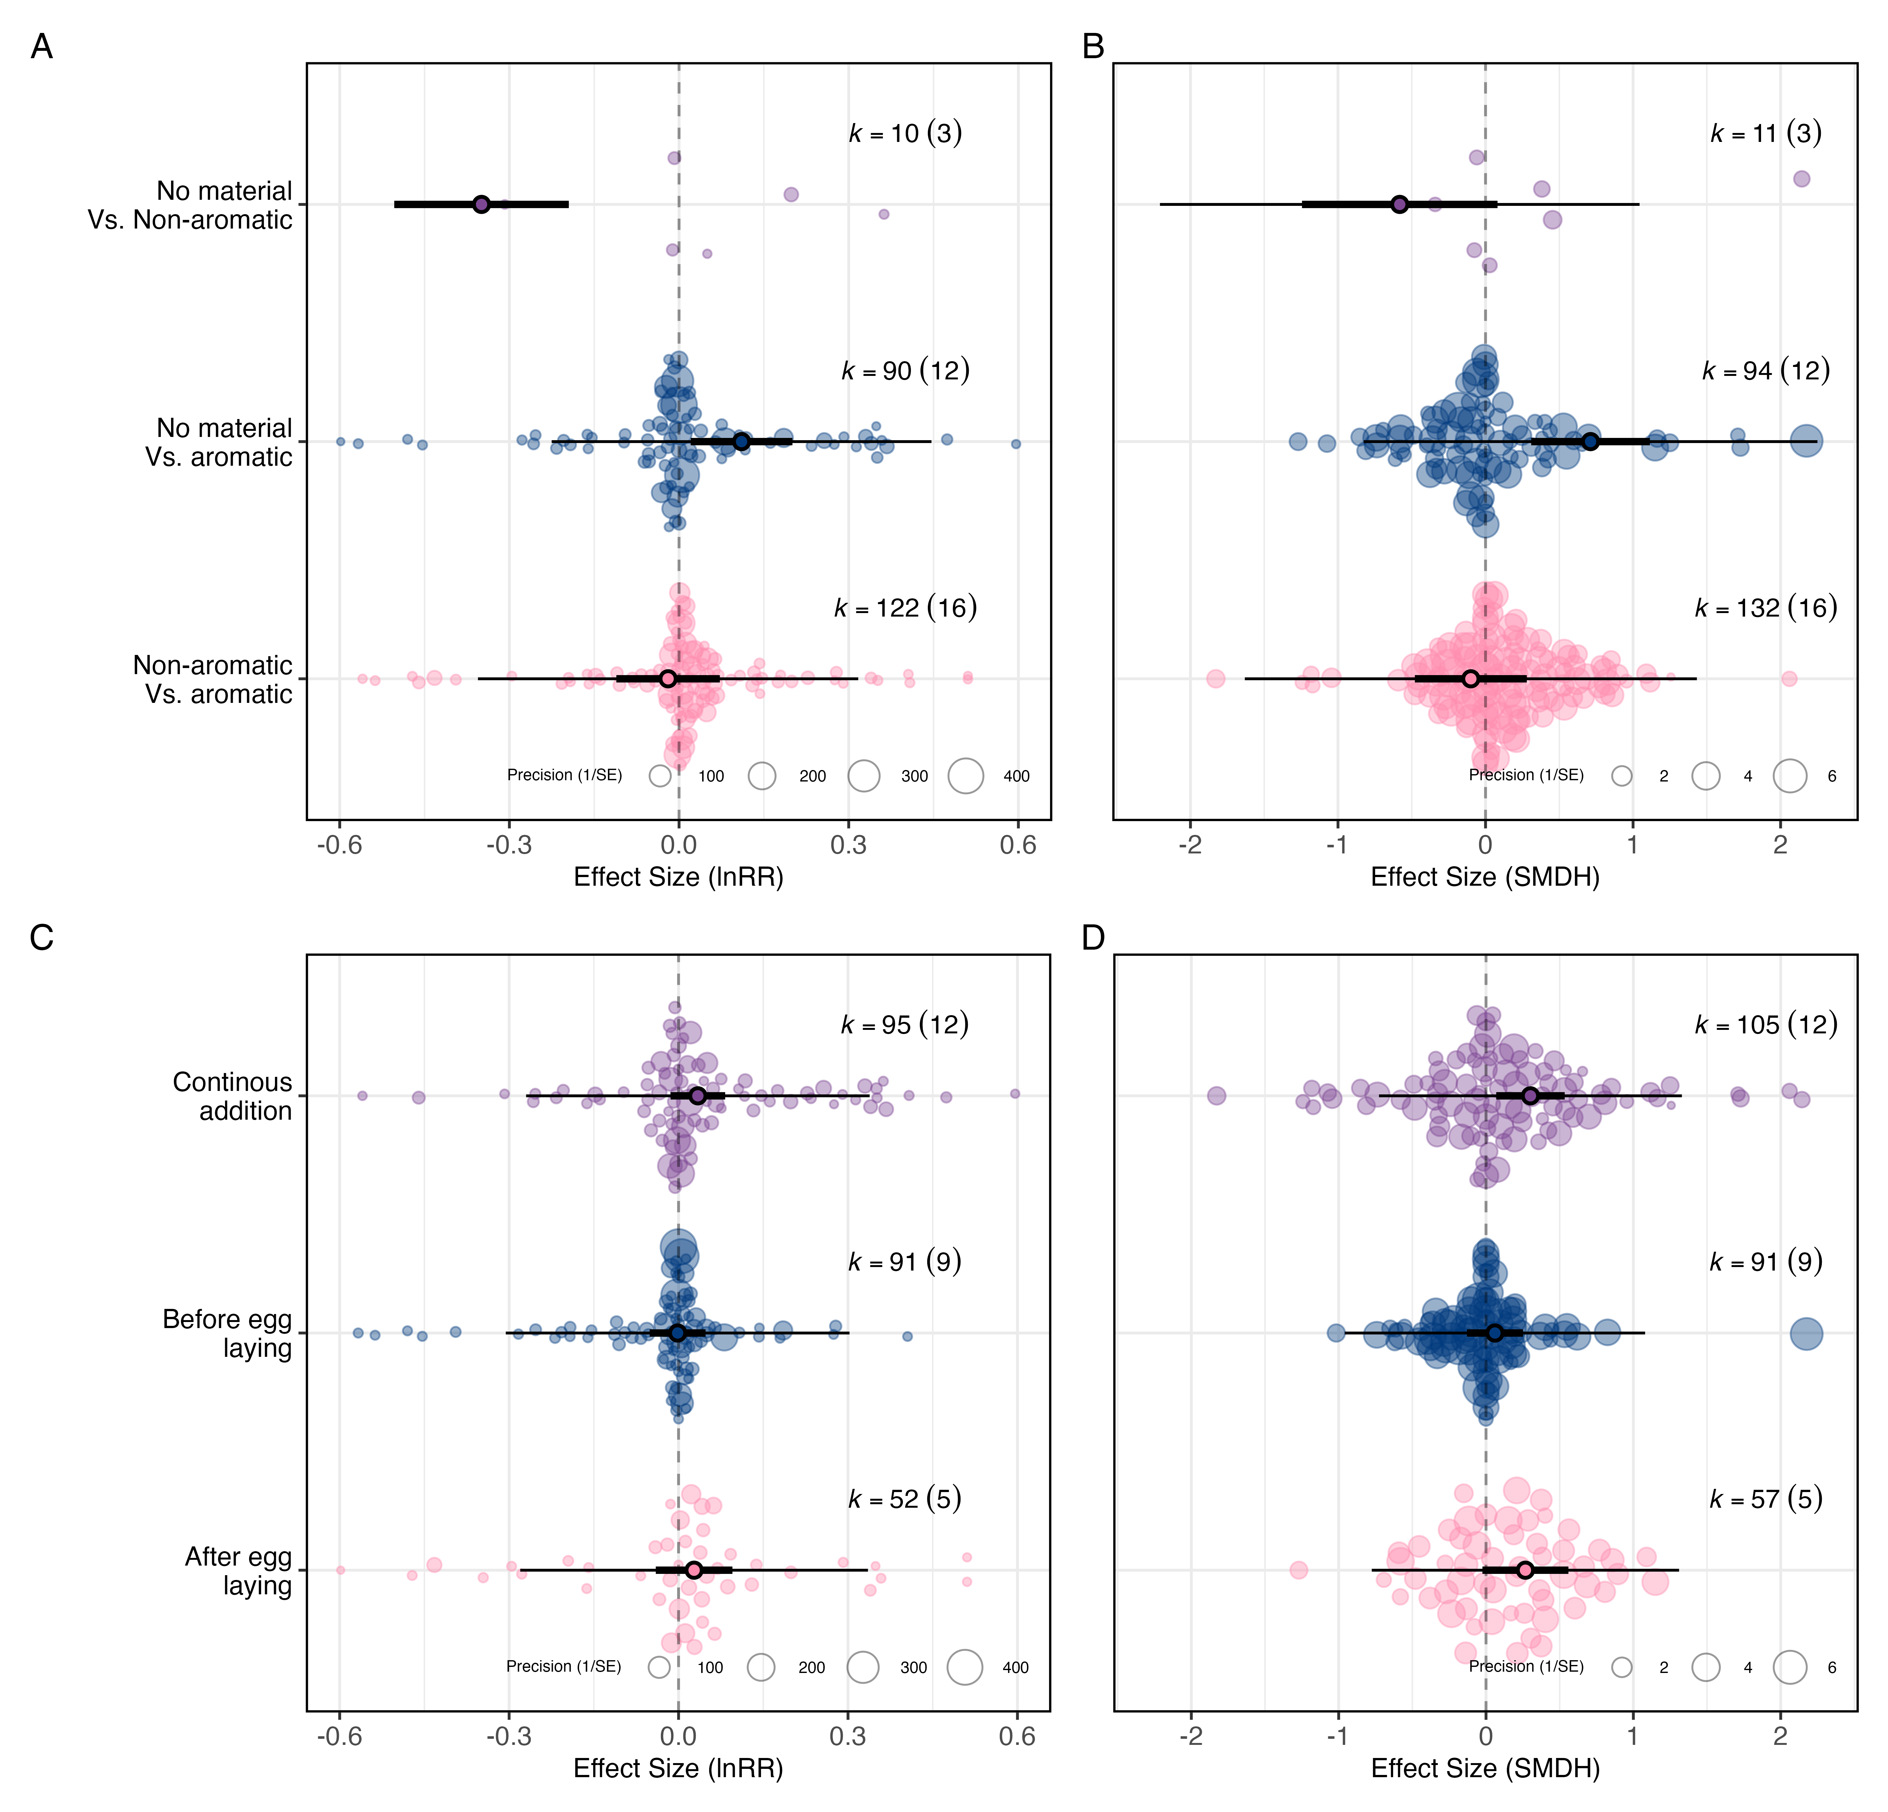
Figure4: Experimental designs comparing nests with aromatic green nest material against nests without any green material, and those adding the material continuously, lead to the largest fitness estimates. Orchard plots of the multilevel meta-regressions showing the overall effect of green nest material depending on experimental design for (A: log response ratio (lnRR); B: standardised mean difference (SMD(H)), and time of green nest material addition (C: log response ratio (lnRR); D: standardised mean difference (SMD(H)). Mean estimates (black circles), 95% confidence intervals (thicker bars) and prediction intervals (thinner bars) are shown along the individual data points (transparently coloured circles) scaled by precision (inverse of standard error). k: number of effect sizes (number of studies is shown in the brackets). X-axes are truncated for legibility, which partially explains any apparent asymmetry (complete figures in Section Figure S13).
Second, the overall positive effect of GNM on fitness outcomes tended to be larger when GNM was added continuously throughout the nesting phase (Figure4C,D). The overall effect was positive and statistically significant for SMD(H) when material was continuously and experimentally added to the nest (lnRR_{continously} = 0.034, 95% CI: [-0.014, 0.083], 95% PI: [-0.270, 0.338], p-value = 0.165, k = 95, n = 12; SMD(H)_{continously} = 0.302, 95% CI: [ 0.069, 0.534], 95% PI: [-0.726, 1.329], p-value = 0.011, k = 105, n = 12), whereas the effect was small and statistically non-significant when added before egg hatching Table1. Last, the overall effect also tended to be positive for SMD(H) when GNM was added after egg hatching only, although only marginally so (SMD(H)_{after_egg_hatching} = 0.267, 95% CI: [-0.024, 0.559], 95% PI: [-0.775, 1.310], p-value = 0.072, k = 57, n = 5; Table1). The three categories did not differ statistically significantly from each other (p-value_{lnRR} > 0.307 and p-value_{SMD(H)} > 0.243 in all cases). The timing of GNM addition explained little heterogeneity ($R_{marginal\left(lnRR\right)}^{2}$= 1.2% and $R_{marginal\left(SMD\left(H\right)\right)}^{2}$= 4.5%).
Third, although none of the species-specific mean estimates were statistically significant, most were positive Figure S14, Table1, and bird species identity explained a non-negligible amount of heterogeneity ($R_{marginal\left(lnRR\right)}^{2}$= 5.3% and $R_{marginal\left(SMDH\right)}^{2}$= 8.5%). Fourth, most fitness proxy-specific mean estimates were positive, but only morphology was statistically significant, and only for SMD(H) (SMDH_{morphology} = 0.310, 95% CI: [ 0.112, 0.509], 95% PI: [-0.723, 1.343], p-value = 0.002, k = 65, n = 15; Figure S14; Table1) and fitness proxy category accounted for a small amount of heterogeneity ($R_{marginal\left(lnRR\right)}^{2}$= 3.7% and $R_{marginal\left(SMD\left(H\right)\right)}^{2}$= 2.4%). Fifth, for the subset of outcomes relating to pathogen and parasitic load, estimates for arthropods and micro-organisms did not differ statistically significantly (Figure S14 ; Table1) and the type of parasite or pathogen explained little heterogeneity ($R_{marginal\left(lnRR\right)}^{2}$= 0.4% and $R_{marginal\left(SMD\left(H\right)\right)}^{2}$= 1.6%). Lastly, the evaluation of potential risk-of-bias categories (i.e., blinding, random assignment to each treatment, and partial reporting) were limited by the small number of studies in some categories (details in Table S3)
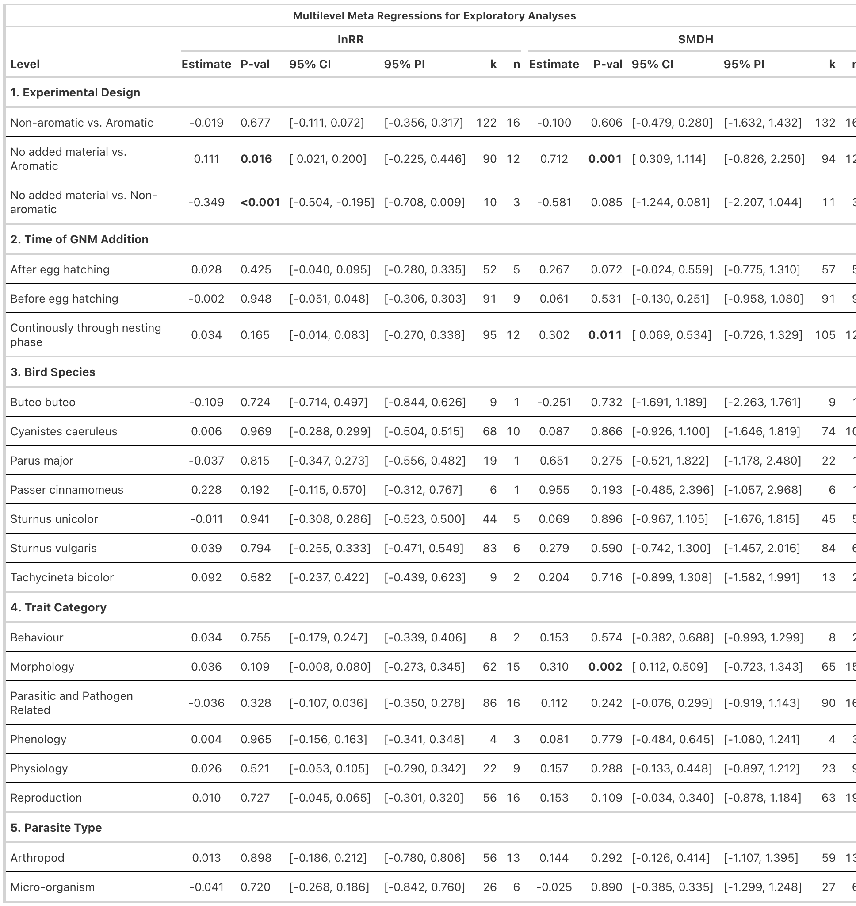
Table1: Results from multilevel meta-regressions testing how experimental design, timing of green nest material (GNM) addition, bird species, trait category, and parasite type influence the effect of GNM on fitness outcomes. Columns show model estimates, p-values, 95% confidence intervals (CI), 95% prediction intervals (PI), number of effect sizes (k), and number of studies (n) for both effect size metrics: log response ratio (lnRR) and standardized mean difference (SMD(H)). Statistically significant results (p < 0.05) are shown in bold.

Publication Bias
We found no conclusive evidence for publication bias in the published literature Figure S15. There was no statistical evidence for small-study effect for lnRR (lnRR_{intercept}= 0.003, 95% CI: [-0.066, 0.072], p-value = 0.926, lnRR_{slope} = 0.079, 95% CI: [-0.215; 0.373], p-value = 0.595, k = 221, n = 24, $R_{marginal\left(lnRR\right)}^{2}$= 0.3%). For SMD(H), there was a tendency for effect sizes to be larger when sample size was smaller but this relationship was marginally statistically significant (SMDH_{slope} = 1.393, 95% CI: [-0.143, 2.929], p-value = 0.075, k = 235, n = 24, $R_{marginal\left(SMD\left(H\right)\right)}^{2}$= 8.3%) with the overall adjusted effect decreasing substantially (SMDH_{intercept} = -0.035, 95% CI: [-0.319, 0.249], p-value = 0.809). In addition, since published effect sizes did not seem to change considerably over time, our analyses suggest no clear evidence of decline effects in published effect sizes (see Figure S15).

Discussion
Our pre-registered systematic review and meta-analysis provide the first quantitative synthesis of the adaptive function of green nest material (GNM) in birds. By aggregating all relevant experimental evidence on different fitness proxies, we found that, on average, GNM has a small positive effect on fitness. Our results were generally consistent across two effect size metrics and robust to various sensitivity analyses; however, the moderate-to-high levels of heterogeneity among effect sizes indicate context-dependency. By testing several biological and methodological moderators, we found that experimental design explains the highest proportion of heterogeneity, raising the question of whether it is the plants’ aromatic volatile compounds alone that explain the observed association between GNM and fitness. Below, we discuss our findings in specific contexts, highlight knowledge gaps and potential biases in the current literature, and suggest directions for future research.
Although our synthesis shows that the addition of GNM is associated with an increase in fitness estimates, we found no clear support for either of the two functional hypotheses traditionally proposed: the courtship hypothesis and parental care hypothesis (i.e., nest protection and drug hypotheses combined). Despite several studies explicitly looking into the courtship hypothesis (e.g., [56]; [27]), only a few fitness proxies could be exclusively linked to this mechanism (e.g., courtship time, male provisioning), and these showed no effect of GNM. Similarly, fitness proxies exclusively associated with the parental care hypothesis, such as parasite loads and nestling health, also showed no effect of GNM. The latter finding is particularly surprising because the parental care hypothesis, which is nest protection and drug hypothesis combined, has been most frequently tested. While studies testing the courtship hypothesis have suggested that the aromatic volatile compounds could help receivers of the signal (often females) detect the presence of GNM in dark cavity nests, it is the parental care hypothesis that has stressed the importance of these compounds, perhaps explaining their widespread consideration. Our findings, however, challenge this assumption since experimental designs comparing aromatic vs. non-aromatic GNM, which correspond to over half of all tests, do not suggest a fitness effect, whereas those comparing aromatic vs. no material do. Surprisingly, though, comparing non-aromatic vs. no material suggested a negative effect of non-aromatic GNM on fitness; though this result should be interpreted cautiously, as it was based on only three studies (k = 10 effect sizes). Importantly, experimental design alone explained about one-fourth of the observed heterogeneity ($R_{marginal}^{2}$ 24-28%). In addition, only proxies that could not be clearly assigned to either of the functional hypotheses (e.g., survival rate, nestling morphology), which were then categorized as being associated with “both” hypotheses, showed a clear positive effect. This ambiguity reflects the challenge of interpreting many fitness proxies in relation to an underlying function, as they are likely influenced by multiple overlapping processes. Our results call for reconsidering the importance of aromatic volatile compounds, and thus, the mechanisms involved in the adaptive function of GNM.
The overall effect of GNM was heterogeneous and mainly associated with within-study variation, with little to none among-study variation. This suggests that, once methodological and biological factors within studies are accounted for, the overall effect found would be potentially generalisable across studies. In addition to experimental design (see paragraph above), another methodological moderator that we tested was the time of GNM addition ($R_{marginal}^{2}$= 1-5%). Continuous addition of GNM throughout the nesting period showed greater positive effects than addition restricted to before or after egg hatching. Previous work on blue tits has shown that the concentration of active compounds released by the aromatic plants can decrease within 24 hours [14], and females often replace experimentally removed herbs [57,58]. TThis repeated addition may help maintain an environment high in volatiles that are hostile to parasites. However, the presence of fresh GNM could also lead to a positive effect on fitness via structural or micro-climate benefits. Fresh GNM can act as a renewable lining that improves nest insulation and humidity buffering as nest material gradually desiccates [36,59]. Such micro-climate stability can accelerate nestling development while reducing thermoregulatory costs for the parents [19]. In addition, regular replenishment of GNM by birds could also help replace the wilted material in the nest, thus maintaining nest structure and helping dilute faecal matter or food debris in the nest (i.e., hygiene function; [60]).
Among the biological moderators tested, species identity seemed the most important one ($R_{marginal}^{2}$ = 5-9%), providing some evidence for species-specific effects; however, note that three species were represented in only one study each. Such variation across species is not unexpected, since some (e.g., Tachycineta bicolor) do not add GNM in nature, while the others species do. Additionally, species-specific differences in life-history traits, nest construction, or habitat condition, and their interplay likely influence how GNM affects fitness. The second most important biological moderator was the fitness proxy category ($R_{marginal}^{2}$ = 2-4%), potentially indicating differences in validity across fitness proxies or reflecting differences among underlying mechanisms. Among all categories, morphological outcomes (e.g., nestling mass, tarsus length, wing length) showed the largest positive effects, suggesting that GNM has a more pronounced effect on offspring development or growth. Morphology was the second most commonly measured fitness proxy across studies, likely because it is relatively easy to measure and less prone to measurement error. However, while widely used as an indicator of offspring condition, these morphological measures remain indirect fitness proxies. All other fitness proxy categories, including physiology, reproduction, phenology, and behaviour, showed small to moderate positive effects, whereas proxies related to parasite or pathogen load, despite being the most commonly investigated, showed weak and inconsistent effects. Parasite reduction is central to one of the two mechanisms within the parental care hypothesis (the nest protection hypothesis, [28]; [13]). Our results further emphasise that despite its prominence, there is a lack of clear overall evidence for the parental care hypothesis. The other hypothesis categorised within the parental care hypothesis (i.e., the drug hypothesis; [33] ; [34]), proposes an increase in offspring survival, with volatile compounds directly enhancing offspring immune function and/or health independent of parasite or pathogen control. While the largest positive effects of morphology could support the drug hypothesis, it should be noted that (i) the mechanism linking volatiles to enhanced offspring immune function or health is unclear, (ii) our results suggest that non-aromatic GNM may play a role, and (iii) several other mechanisms could also be at play. For example, improved offspring morphological condition could result from enhanced micro-climate of the nest (e.g., [61]), better incubation of the eggs or indirectly through sexually selected male traits, as suggested by the courtship hypothesis.
When interpreting our results, it is important to acknowledge some constraints of the study and in the available evidence. The overall effect of GNM differed between the two effect size metrics, which make distinct assumptions regarding the underlying biological processes and the statistical properties. These divergent results highlight the importance of choosing appropriate effect size metrics for a meta-analysis that align with the biological data at hand or in cases where several different types of measures are present, using both [62]. We found high reporting quality in the primary study included in our meta-analysis, with only 0.06% partial reporting, but some evidence of small-study effects. After adjusting for this, the effect of GNM was no longer significant. To reduce the influence of small-study effects we contacted all authors for unpublished data, but could only find access to two studies. In addition, many studies had very low sample sizes (41% of the effect sizes were based on fewer than 10 nests per group), which reduces power and increases heterogeneity. Furthermore, studies remain heavily biased towards just three bird species, limiting our ability to infer broad patterns of this behaviour. Expanding the scope to other bird species with diverse nesting ecologies and habitat conditions can be useful in understanding the adaptive benefits of this behaviour.

Conclusion
After more than 40 years of research on this topic, ours is the first quantitative synthesis confirming an overall effect of green nest material on fitness in birds. Despite the moderate-to-high heterogeneity observed, our results suggest that the effect may be generalisable across studies once methodological and biological factors within studies are accounted for. An important caveat, however, is that our small-study effects analysis, although non-conclusively, indicates that accounting for potentially missing studies could cause the observed effect to disappear, despite our efforts to include unpublished work. Moreover, our study clearly emphasises that the functions remain largely unclear and challenges the assumption that volatile compounds alone explain the relationship between green nest material and fitness. Future studies should consider focusing on experimental designs that disentangle the different functional hypotheses suggested, prioritising fitness proxies that are more directly linked to fitness, as well as to test explicitly, rather than assume, the role of volatiles. In addition, theoretical work could further solidify the field’s foundations and yield testable predictions. Altogether, our synthesis contributes to a more nuanced understanding of the adaptive significance of one of the most fascinating and most studied natural structures: bird nests, as well as opens the door to several questions still unanswered.

References
1. Hansell M, Overhill R. 2000 Bird nests and construction behaviour. (doi:10.1017/cbo9781139106788)
2. Mainwaring MC, Hartley IR, Lambrechts MM, Deeming DC. 2014 The design and function of birds’ nests. Ecology and Evolution 4, 3909–3928. (doi:10.1002/ece3.1054)
3. Deeming DC. 2023 Nest construction in mammals: a review of the patterns of construction and functional roles. Philosophical Transactions of the Royal Society B: Biological Sciences 378. (doi:10.1098/rstb.2022.0138)
4. Sergio F, Blas J, Blanco G, Tanferna A, López L, Lemus JA, Hiraldo F. 2011 Raptor Nest Decorations Are a Reliable Threat Against Conspecifics. Science 331, 327–330. (doi:10.1126/science.1199422)
5. Suárez-Rodríguez M, López-Rull I, Macías Garcia C. 2013 Incorporation of cigarette butts into nests reduces nest ectoparasite load in urban birds: new ingredients for an old recipe? Biology Letters 9, 20120931. (doi:10.1098/rsbl.2012.0931)
6. Jagiello Z, Reynolds SJ, Nagy J, Mainwaring MC, Ibáñez-Álamo JD. 2023 Why do some bird species incorporate more anthropogenic materials into their nests than others? Philosophical Transactions of the Royal Society B: Biological Sciences 378. (doi:10.1098/rstb.2022.0156)
7. Sheard C, Stott L, Street SE, Healy SD, Sugasawa S, Lala KN. 2024 Anthropogenic nest material use in a global sample of birds. Journal of Animal Ecology 93, 691–704. (doi:10.1111/1365-2656.14078)
8. Moreno J, Soler M, Møller AP, Linden M. 1994 The function of stone carrying in the black wheatear, Oenanthe leucura. Animal Behaviour 47, 1297–1309. (doi:10.1006/anbe.1994.1178)
9. Hoi H, Schleicher B, Valera F. 1996 Nest size variation and its importance for mate choice in penduline tits,Remiz pendulinus. Animal Behaviour 51, 464–466. (doi:10.1006/anbe.1996.0046)
10. Soler JJ, Soler M, Møller AP, Martínez JG. 1995 Does the great spotted cuckoo choose magpie hosts according to their parenting ability? Behavioral Ecology and Sociobiology 36, 201–206. (doi:10.1007/bf00177797)
11. Moreno J. 2012 Avian Nests and Nest-Building as Signals. Avian Biology Research 5, 238–251. (doi:10.3184/175815512x13534385822786)
12. Perez DM, Manica LT, Medina I. 2023 Variation in nest-building behaviour in birds: a multi-species approach. Philosophical Transactions of the Royal Society B: Biological Sciences 378. (doi:10.1098/rstb.2022.0145)
13. Clark L, Mason JR. 1985 Use of nest material as insecticidal and anti-pathogenic agents by the European Starling. Oecologia 67, 169–176. (doi:10.1007/bf00384280)
14. Petit C, Hossaert-McKey M, Perret P, Blondel J, Lambrechts MM. 2002 Blue tits use selected plants and olfaction to maintain an aromatic environment for nestlings. Ecology Letters 5, 585–589. (doi:10.1046/j.1461-0248.2002.00361.x)
15. Garrido-Bautista J et al. 2023 Is there a role for aromatic plants in blue tit (Cyanistes caeruleus) nests? Results from a correlational and an experimental study. Behavioral Ecology and Sociobiology 77. (doi:10.1007/s00265-023-03393-9)
16. Mennerat A, Mirleau P, Blondel J, Perret P, Lambrechts MM, Heeb P. 2009 Aromatic plants in nests of the blue tit Cyanistes caeruleus protect chicks from bacteria. Oecologia 161, 849–855. (doi:10.1007/s00442-009-1418-6)
17. Ontiveros D, Caro J, Pleguezuelos JM. 2007 Green plant material versus ectoparasites in nests of Bonelli’s eagle. Journal of Zoology 274, 99–104. (doi:10.1111/j.1469-7998.2007.00364.x)
18. Mennerat A, Perret P, Lambrechts MM. 2009 Local Individual Preferences for Nest Materials in a Passerine Bird. PLoS ONE 4, e5104. (doi:10.1371/journal.pone.0005104)
19. Mainwaring MC, Hartley IR. 2013 The Energetic Costs of Nest Building in Birds. Avian Biology Research 6, 12–17. (doi:10.3184/175815512x13528994072997)
20. Dubiec A, Góźdź I, Mazgajski TD. 2013 Green Plant Material in Avian Nests. Avian Biology Research 6, 133–146. (doi:10.3184/175815513X13615363233558)
21. Scott-Baumann JF, Morgan ER. 2015 A review of the nest protection hypothesis: does inclusion of fresh green plant material in birds’ nests reduce parasite infestation? Parasitology 142, 1016–1023. (doi:10.1017/S0031182015000189)
22. Eens M, Pinxten R, Verheyen RF. 1993 Function of the song and song repertoire in the european starling (sturnus vulgaris) : An aviary experiment. Behaviour 125, 51–66. (doi:10.1163/156853993x00182)
23. Gwinner H. 1997 The function of green plants in nests of european starlings (sturnus vulgaris). Behaviour 134, 337–351. (doi:10.1163/156853997x00575)
24. Brouwer L, Komdeur J. 2004 Green nesting material has a function in mate attraction in the European starling. Animal Behaviour 67, 539–548. (doi:10.1016/j.anbehav.2003.07.005)
25. Kessel B. 1957 A study of the breeding biology of the european starling (sturnus vulgaris l.) in north america. The American Midland Naturalist 58, 257–331. (doi:10.2307/2422615)
26. Veiga JP, Polo V, Viñuela J. 2006 Nest Green Plants as a Male Status Signal and Courtship Display in the Spotless Starling. Ethology 112, 196–204. (doi:10.1111/j.1439-0310.2006.01148.x)
27. Tomás G, Merino S, Martínez-de la Puente J, Moreno J, Morales J, Rivero-de Aguilar J. 2013 Nest size and aromatic plants in the nest as sexually selected female traits in blue tits. Behavioral Ecology 24, 926–934. (doi:10.1093/beheco/art015)
28. Wimberger PH. 1984 The use of green plant material in bird nests to avoid ectoparasites. The Auk 101, 615–618.
29. Dykstra CR, Hays JL, Simon MM. 2009 Selection of Fresh Vegetation for Nest Lining by Red-shouldered Hawks. The Wilson Journal of Ornithology 121, 207–210. (doi:10.1676/08-035.1)
30. Lafuma L, Lambrechts MM, Raymond M. 2001 Aromatic plants in bird nests as a protection against blood-sucking flying insects? Behavioural Processes 56, 113–120. (doi:10.1016/s0376-6357(01)00191-7)
31. Dawson RD. 2004 Does fresh vegetation protect avian nests from ectoparasites? An experiment with tree swallows. Canadian Journal of Zoology 82, 1005–1010. (doi:10.1139/z04-076)
32. Quiroga MA, Reboreda JC, Beltzer AH. 2012 Host use by philornis sp. In a passerine community in central argentina. Revista Mexicana de Biodiversidad 83. (doi:10.22201/ib.20078706e.2012.1.1137)
33. Gwinner H, Oltrogge M, Trost L, Nienaber U. 2000 Green plants in starling nests: Effects on nestlings. ANIMAL BEHAVIOUR 59, 301–309. (doi:10.1006/anbe.1999.1306)
34. Mennerat A, Perret P, Bourgault P, Blondel J, Gimenez O, Thomas DW, Heeb P, Lambrechts MM. 2009 Aromatic plants in nests of blue tits: positive effects on nestlings. Animal Behaviour 77, 569–574. (doi:10.1016/j.anbehav.2008.11.008)
35. Skutch AF. 1957 The incubation patterns of birds. Ibis 99, 69–93. (doi:10.1111/j.1474-919x.1957.tb01934.x)
36. Mertens JAL. 1977 Thermal conditions for successful breeding in Great Tits (Parus major L.). Oecologia 28, 1–29. (doi:10.1007/bf00346834)
37. Lyons DM, Mosher JA. 1987 Morphological growth, behavioral development, and parental care of broad-winged hawks (crecimiento, desarollo de patrones de conducta y cuidado parental en buteo platypterus). Journal of Field Ornithology 58, 334–344.
38. Dimri S, Rizvi T, De Segovia JDMG, Sánchez-Tójar A. 2024 The adaptive value of green nest material across birds: A systematic review and meta-analysis. (doi:10.17605/OSF.IO/S7J6Z)
39. O’Dea RE et al. 2021 Preferred reporting items for systematic reviews and meta-analyses in ecology and evolutionary biology: a PRISMA extension. Biological Reviews 96, 1695–1722. (doi:10.1111/brv.12721)
40. Grames EM, Stillman AN, Tingley MW, Elphick CS. 2019 An automated approach to identifying search terms for systematic reviews using keyword co-occurrence networks. Methods in Ecology and Evolution 10, 1645–1654. (doi:10.1111/2041-210x.13268)
41. Westgate MJ. 2019 revtools: An R package to support article screening for evidence synthesis. Research Synthesis Methods 10, 606–614. (doi:10.1002/jrsm.1374)
42. Pick JL, Nakagawa S, Noble DWA. 2018 Reproducible, flexible and high-throughput data extraction from primary literature: The metaDigitise r package. Methods in Ecology and Evolution 10, 426–431. (doi:10.1111/2041-210x.13118)
43. Viechtbauer W. 2010 Conducting meta-analyses in r with the metafor package. 36. (doi:10.18637/jss.v036.i03)
44. Cooper H, Hedges LV, Valentine JC, editors. 2019 The handbook of research synthesis and meta-analysis. (doi:10.7758/9781610448864)
45. Nakagawa S, Noble DWA, Lagisz M, Spake R, Viechtbauer W, Senior AM. 2022 A robust and readily implementable method for the meta-analysis of response ratios with and without missing standard deviations. Ecology Letters 26, 232–244. (doi:10.1111/ele.14144)
46. Lajeunesse MJ. 2013 Recovering Missing or Partial Data from Studies: a Survey of Conversions and Imputations for Meta-analysis. Princeton University Press. (doi:10.23943/princeton/9780691137285.003.0013)
47. R Core Team. 2025 R: A language and environment for statistical computing. Vienna, Austria: R Foundation for Statistical Computing. See https://www.R-project.org/.
48. Noble DWA, Lagisz M, O’dea RE, Nakagawa S. 2017 Nonindependence and sensitivity analyses in ecological and evolutionary meta-analyses. Molecular Ecology 26, 2410–2425. (doi:10.1111/mec.14031)
49. Yang Y, Noble D, Spake R, Senior A, Lagisz M, Nakagawa S. 2024 Measuring biological generality in meta-analysis: A pluralistic approach to heterogeneity quantification and stratification.
50. Nakagawa S, Schielzeth H. 2012 A general and simple method for obtaining R² from generalized linear mixed-effects models. Methods in Ecology and Evolution 4, 133–142. (doi:10.1111/j.2041-210x.2012.00261.x)
51. Culina A et al. 2025 Elevating the importance of risk of bias assessment for ecology and evolution.
52. Jennions MD, Lortie CJ, Rosenberg MS, Rothstein HR. 2013 Publication and related biases. In Handbook of meta-analysis in ecology and evolution, pp. 207–236. Princeton University Press.
53. Yang Y, Sánchez-Tójar A, O’Dea RE, Noble DWA, Koricheva J, Jennions MD, Parker TH, Lagisz M, Nakagawa S. 2023 Publication bias impacts on effect size, statistical power, and magnitude (Type M) and sign (Type S) errors in ecology and evolutionary biology. BMC Biology 21. (doi:10.1186/s12915-022-01485-y)
54. Nakagawa S, Lagisz M, Jennions MD, Koricheva J, Noble DWA, Parker TH, Sánchez-Tójar A, Yang Y, O’Dea RE. 2022 Methods for testing publication bias in ecological and evolutionary meta-analyses. Methods in Ecology and Evolution 13, 4–21. (doi:https://doi.org/10.1111/2041-210X.13724)
55. Sánchez-Tójar A et al. 2018 Meta-analysis challenges a textbook example of status signalling and demonstrates publication bias. eLife 7. (doi:10.7554/elife.37385)
56. Lopez-Rull I, Gil D. 2009 Do female spotless starlings sturnus unicolor adjust maternal investment according to male attractiveness? Journal of Avian Biology 40, 254–262. (doi:10.1111/j.1600-048X.2009.04553.x)
57. Mennerat A, Perret P, Caro SP, Heeb P, Lambrechts MM. 2008 Aromatic plants in blue tit cyanistes caeruleus nests: No negative effect on blood-sucking protocalliphora blow fly larvae. Journal of Avian Biology 39, 127–132. (doi:10.1111/j.0908-8857.2008.04400.x)
58. Banbura J, Blondel J, Wilde-Lambrechts H de, Perret P. 1995 Why do female Blue Tits (Parus careuleus) bring fresh plants to their nests? Journal für Ornithologie 136, 217–221. (doi:10.1007/bf01651244)
59. Taverner PA. 1933 Purple martins gathering leaves. The Auk 50, 110–111. (doi:10.2307/4076584)
60. Peralta-Sanchez JM, Møller AP, Martin-Platero AM, Soler JJ. 2010 Number and colour composition of nest lining feathers predict eggshell bacterial community in barn swallow nests: an experimental study. Functional Ecology 24, 426–433. (doi:10.1111/j.1365-2435.2009.01669.x)
61. Corregidor-Castro A, Jones OR. 2021 The effect of nest temperature on growth and survival in juvenile Great TitsParus major. Ecology and Evolution 11, 7346–7353. (doi:10.1002/ece3.7565)
62. Yang Y, Williams C, Senior AM, Morrison K, Ricolfi L, Pan J, Lagisz M, Nakagawa S. 2024 Bivariate multilevel meta-analysis of log response ratio and standardized mean difference for robust and reproducible environmental and biological sciences.
63. Pantazi A. 2024 Aromatic plants in nests of blue tits (Cyanistes caeruleus). PhD thesis. See https://bora.uib.no/bora-xmlui/handle/11250/3172874.

