Why do birds use green nest material? A systematic review and meta-analysis of experiments
Abstract
Many animals build nests, often considered extended phenotypes that shape survival and reproduction beyond the builder’s body. Birds are key examples of nest builders, and some species add fresh green plant material to their nests. Yet, the adaptive value of this behaviour remains debated. Non-mutually exclusive hypotheses propose roles in courtship signalling, parasite defence, and direct enhancement of offspring condition through pharmacological effects independent of parasite reduction. Here, we conducted a pre-registered systematic review and meta-analysis of 28 experimental studies (published and unpublished), spanning seven bird species and 274 effect sizes, to test whether green nest material enhances fitness and to evaluate competing functional explanations. Our synthesis shows that green nest material can increase fitness in birds that exhibit this behaviour. However, this effect varies depending on the fitness proxy investigated, and its functional role remains inconclusive. We found no clear evidence supporting the courtship, nest protection, or drug hypothesis. Instead, experimental design was the strongest moderator of effect size variation, challenging the role of aromatic compounds in the fitness benefits of green nest material and highlighting the need for further research into the underlying mechanisms.

Introduction
Nest-building is fundamental across a diverse range of animals, including arthropods (e.g., ants, spiders), mammals (e.g., platypuses, rodents), and perhaps more famously, birds. Nests provide structural support for eggs, parents, and offspring, and protect them against predators and other environmental pressures, and are thus key to reproductive success and survival [1–3]. Most birds use organic plant materials such as twigs, branches, grass, and moss to build their nests. Some even incorporate inorganic (e.g., mud, stones), animal-derived (e.g., feathers, snake skins), and anthropogenic materials (e.g., plastic, cigarette butts) [4–7]. These additions are considered non-structural and suggest that nests are more than just physical shelters—they can be complex tools shaped by both natural and sexual selection for multiple functions. Indeed, nests can play a key role in sexual display, and features such as nest size have been shown to act as sexually selected signals of parental quality (e.g., [8,9]). Nest characteristics may even convey information interspecifically, for example, when brood parasites use host nest traits as cues to host quality[10]. Nest-building behaviour is increasingly recognised as an expression of the extended phenotype (reviewed by [11]), and phylogeny has been shown to be an important factor explaining nest morphology [12]. Yet, despite hundreds of scientific articles on bird nests and nesting behaviour being published each year, much remains unknown [13].
An intriguing nesting behaviour observed in some bird species is the addition of fresh, often aromatic, plant material to the nest. This green nest material (hereafter GNM; also called green plant material or greenery) often includes leaves, sprigs, herbs, and branches. It is typically added from the start of nest building until egg-laying, although some species like the blue tit (Cyanistes caeruleus) keep adding it afterwards. Unlike the structural nest materials such as twigs and mud, GNM is selected from a small, non-random subset of local flora [14–16]. The selected plants often contain high levels of aromatic volatile compounds (commonly used by songbirds, [17]) or secondary metabolites such as oils and resins (commonly used by raptors, [18]). This suggests that GNM is unlikely to be gathered opportunistically, and collecting and replenishing these uncommon plants, sometimes over weeks, requires extra time and, in some cases, flying outside the territory [19]. Thus, the general costs associated with nest-building [20], and the additional effort, time, and energy devoted to adding these non-structural materials suggest an adaptive function of GNM.
Multiple hypotheses have been proposed to explain the adaptive function of GNM (reviewed in [21,22]). First, the courtship hypothesis suggests that males use GNM as a visual or olfactory signal to attract females, maintain established pairs [23], or advertise nest-site occupancy to other males (e.g., [24–26]), with olfactory signalling being particularly relevant in cavity-nesting species [27]. For instance, a seminal study by [28] showed that male European starlings (Sturnus vulgaris) carry fresh plant material to their nests while singing and displaying to females. Subsequent studies in European and spotless starlings (Sturnus unicolor) supported this view by showing that females often prefer nests with fresh GNM, that unpaired males conspicuously deliver GNM during courtship [26], and increase the addition of GNM in the presence of potential mates [24]. Altogether, these studies offered support for the courtship hypothesis, which was later extended to account for the observed GNM addition solely by females in blue tits [29].
Second, the most widely tested hypothesis is the nest protection hypothesis, which proposes that the volatile compounds in GNM reduce parasitic and pathogenic loads in nests, enhancing offspring survival. This hypothesis was first suggested by [30] in a comparative study in raptors (Falconiformes). Soon after, experimental work in European starlings showed a preference for GNM containing insect-repellent and antimicrobial volatiles, and [14] proposed three key criteria for evaluating the nest protection hypothesis: selective plant use, bioactive chemical properties, and demonstrable adaptive benefits. Observational and experimental studies in raptors [18,31] and passerines [17,32–34] have shown mixed results. The drug hypothesis was later proposed because GNM has been shown, in some cases, to improve offspring condition without reducing parasite abundance [35,36]. This alternative hypothesis suggests that GNM volatiles directly enhance offspring immune function and/or health independently of parasite or pathogen control [37]. While both the nest protection and drug hypotheses suggest that GNM enhances offspring survival, the drug hypothesis attributes this effect to a pharmacological mechanism, whereas the nest protection hypothesis emphasises parasite and pathogen repellency. Importantly, these two hypotheses are not mutually exclusive, and their potential effects on offspring survival are difficult to disentangle because improved nestling condition may result either directly from pharmacological action or indirectly through reduced parasite or pathogen load. Therefore, in our meta-analysis, we combined them under the “parental care hypothesis”.
Other less explored hypotheses include a closely related female protection hypothesis proposed in blue tits [38,39], suggesting that plant volatiles may primarily benefit the incubating female by reducing her parasite exposure and infection risk [40]. Several hypotheses have also been proposed that do not invoke the aromatic properties of GNM, including enhancement of nest crypticity [41], thermal insulation or sun protection for eggs and offspring [42], and a structural function for the added material [43]. However, these alternative hypotheses have received comparatively little empirical attention and therefore fall outside the scope of the present meta-analysis.
Despite decades of research, abundant observational and experimental studies, and two narrative reviews [21,22], the overall adaptive significance of GNM, its generality across bird species, and the relative importance of each of the suggested
mechanisms are still unknown. To address this gap, we conducted a pre-registered systematic review and meta-analysis of experiments testing the effect of GNM on various fitness proxies across birds. Our meta-analysis explicitly evaluates the overall evidence for the adaptive significance of GNM, and assesses the relative importance of the main suggested hypotheses: the courtship hypothesis and parental care hypothesis. In addition, we tested potential moderators predicted to explain the observed context-dependency (i.e., high heterogeneity among effect sizes). Specifically, we tested whether the effect of GNM varied depending on the experimental design used, the timing of GNM addition, the focal species tested, the category of fitness proxy investigated (e.g., morphological, reproductive, etc.), and the type of parasite studied. Our meta-analysis of experimental studies is the first quantitative synthesis testing the causal relationship between GNM and fitness across birds.

Methods

Registration and reporting
We pre-registered our study protocol on the Open Science Framework [44] before exploring or analysing the data. The pre-registration details our objectives, hypotheses, predictions, methods, and planned analyses. Unless stated otherwise, we adhered to the registered protocol. We followed the PRISMA-EcoEvo guidelines [45] for reporting this study (Table S1; Figure S1).

Information source and search
We conducted a systematic search on Web of Science Core Collection and Scopus on the 7th of September, 2022, and updated it on the 12th of August, 2024. The keyword search query was designed as a three-block query including terms related to our treatment of interest ((“green*” OR “herb*” OR “aromatic*”) AND “nest*”), population of interest (“bird*” OR “aves” OR “avian” OR “ornithol*” OR “passerine*” OR “passeriform*” OR “songbird*” OR list of all bird genera) and to limit the search results to experimental studies only (“experiment*” OR “manipulat*”) (see complete search string in Figure S15). Although our search terms were in English, we did not restrict eligibility by language. We planned to include studies in English, Spanish, Portuguese or Hindi if they were retrieved, but all studies identified were in English. We searched through titles, abstracts and keywords without restrictions on publication date or study type. We validated our search using an initial library of 15 relevant articles identified before conducting the searches (Figure S2), ensuring all were retrieved. Additionally, we used the R package ‘litsearchr’ v1.0.0 [46], which confirmed our search queries. After removing 165 duplicates using the R package ‘revtools’ v0.4.1 [47], we identified 436 unique records.

Eligibility criteria
All titles and abstracts were equally allocated and screened independently by at least two of the three screeners (SD, TR, JMGS) using ‘revtools’ following a pre-designed decision tree with all inclusion/exclusion criteria (Figure S3). We included all studies on birds that experimentally manipulated the GNM (both aromatics and non-aromatic). Forty articles passed the title-and-abstract screening and were further evaluated during the full-text screening, where each article was independently screened by a single screener, with another screener verifying the procedure. We used the same criteria as above (Figure S3) with an additional evaluation of whether the variable of interest studied in the article was in our list of fitness proxies of interest (Table S2). All conflicts in screening decisions (1% for title-and-abstract screening, and none for full-text screening) were discussed and resolved
. Twenty-three articles passed the full-text screening, and we identified three additional eligible articles recommended by two colleagues. In all, 26 published articles were eligible for our meta-analysis. We also obtained two additional unpublished studies (more details below; see also Figure S1 and Figure S4).

Data extraction
Data from each article were extracted by one of three authors (SD, TR, JMGS), with another screener verifying the procedure, and four authors (SD, TR, JMGS, AST) collectively discussing and revising unclear cases. We prioritised extracting primary data (i.e., means, variances and sample size for each control-treatment comparison) from text and tables, and if that was not possible, from figures (e.g., boxplots) using the R package ‘metaDigitise’ v1.0.1 [48]. If primary data were not available, we extracted inferential statistics (e.g., t and F values, contingency tables) to transform them into effect sizes (see below). Last, if these steps failed but the article had openly archived data, we calculated the means, standard deviations and sample sizes from each group ourselves (n = 4 studies). We extracted the number of nests in each group as the sample size rather than the number of individuals wherever possible (discussed below).
To capture differences in the type of experimental setup used in the studies, we coded each control-treatment comparison into an ‘experimental design’ moderator, with the following three levels: (i) non-aromatic GNM vs. aromatic GNM, (ii) no material vs. aromatic GNM, and (iii) no material vs. non-aromatic GNM. Where “non-aromatic GNM” refers to nests containing non-aromatic material (e.g., grass, moss, etc.), “aromatic GNM” refers to nests containing aromatic material added by birds, researchers, or both; and “no material” refers to nests that had no material added by researchers or where any plant material added by birds was removed. Importantly, our conclusions remained robust to the exclusion of the no material vs. non-aromatic GNM category (n = 3 studies; Table S3), so we kept this category in our dataset following our pre-registered plan. A fourth experimental design compared enhanced supplementation of GNM by the researchers (i.e., researchers + birds) to GNM added by birds alone (n = 2 studies). This experimental design represents a fundamentally different comparison focusing on potential additive effects of GNM, comparing different amounts of aromatic GNM. Therefore, we did not include this fourth category in the meta-regression testing the ‘experimental design’ moderator. In studies where three groups were compared (n = 5), we extracted all possible pairwise comparisons, and accounted for (shared group) non-independence in our analyses (more below).
For each study, we also extracted information related to the study subjects (bird species, geographical location of the study population) and the source from which we extracted data (e.g., figures, raw data files). We categorised the reported fitness proxies into 6 broad categories: physiology, morphology, reproduction, behaviour, parasite and pathogenic load, and phenology. For studies testing whether GNM affects the number of parasites or pathogens found in offspring and/or nests, we categorised them into arthropods (e.g., fleas) or microorganisms (e.g., bacteria). For a complete list of variables extracted, see Figure S7 . During data extraction, we encountered some traits (e.g., Leukocyte measures, parent mass; k= 15 effect sizes, n = 5 studies) that we did not include in any of our analyses because it was unclear from the study and our own judgement how these traits related to fitness (see Table S2 for the reasons of exclusion).
We contacted four corresponding authors to obtain missing data (e.g., non-reported results, missing sample sizes). All four authors responded to our email, but only two provided the data as requested; one did not have the data anymore, and one did not give a conclusive response. Additionally, to locate grey literature (e.g., unpublished data), we used a standardised email template (Figure S5) to write to the corresponding author(s) of all the 23 articles that passed full-text screening asking for any potential unpublished data that could be included in our meta-analysis. We obtained unpublished data for a study on blue tits and a study on common buzzards (Buteo buteo; see description in Figure S6).

Effect size calculation
Using the means, standard deviations, and sample sizes for each control-treatment comparison, we calculated two effect sizes: a log response ratio (lnRR) and a standardised mean difference with heteroskedasticity correction (SMDH), using the ‘escalc’ function (measure = ‘ROM’ and ‘SMDH’, respectively, vtype = ‘LS’) in the R package ‘metafor’ v4.8-0 [49]. We specified the treatment group as the numerator and the control group as the denominator for lnRR, and treatment minus control for SMDH, such that positive values indicate a positive effect of GNM on fitness. In cases such as measures of parasite load or prevalence, laying or hatching dates, courtship time, or scab scores, the effect size sign was inverted before analysis to ensure that a positive value consistently meant an increase in fitness across all fitness proxies (i.e., to ensure comparability across effect sizes). Since SMDH can only be calculated when the degrees of freedom (i.e., n1+n2−2) are greater than 1, we had to exclude nine effect sizes from one study that did not fulfil that requirement.
For the few cases for which we could not extract means and variances but inferential statistics such as t and F values (k = 4, n = 2), we estimated SMD values from those statistics [50]. For dichotomous variables (e.g., nest success, recorded as successful vs unsuccessful and analysed as counts per group, k = 4, n = 2), we calculated log odds ratios (lnOR) using the ‘escalc’ function (measure = OR) from ‘metafor’ and subsequently converted them to SMD [50]. Since lnRR cannot be calculated from inferential statistics, dichotomous variables, or traits including zero or negative values (k = 7), the number of effect sizes included in the lnRR subset (k = 259, n = 28) is smaller than that of SMDH (k = 274, n = 28).
When calculating each effect size’s sampling variance, we used the number of nests per group, rather than the number of individuals, whenever possible, to account for within-nest non-independence due to shared genetic background and early-life environment. In cases where the same control or treatment group was used in multiple comparisons, sample sizes were adjusted before calculating effect sizes by dividing them by the number of times each group was used in a comparison to account for shared group non-independence. For cases where the authors of an original article reported a statistically non-significant difference between two groups but without providing numerical values (k = 16, n = 2), we assigned zero as the effect size for that comparison and imputed its sampling variance using the missing-case approach described in [51] for lnRR, and $\frac{n_{1}+n_{2}}{n_{1}×n_{2}}$ for SMDH [52].

Data analysis
We performed all analyses in R v4.5.1 [53]. All multilevel meta-analytical models and meta-regressions were fitted using ‘metafor’ v4.8-0 [49]. Sampling variances were modelled as variance-covariance matrices assuming a 0.5 correlation (ρ) between sampling variances from the same study [54] using the ‘vcalc’ function from ‘metafor’ (see Supplementary Appendix Figure S9 for sensitivity analyses showing that conclusions remain the same when using different values of ρ).
We originally considered the following levels of non-independence for our analyses: multiple effect sizes collected from (a) same study (Paper ID), (b) bird species (Species ID), (c) geographical locations (Population ID), (d) sub-populations within the same location (Experiment ID; e.g., birds studied at the same location for multiple years), (e) groups of individuals within a population (Group ID; e.g., males and females in a population, first clutch and second clutch), and (f) repeated measurement of the same trait for the same individuals (Repeated trait ID; e.g., chick mass on day 7, 14 and 21). In the end, our random effect structure deviated from our pre-registration because Experiment ID and Group ID represented nearly the same grouping structure, so we decided to leave out the one with lesser resolution (i.e., Experiment ID). Additionally, few effect sizes were measured repeatedly, making Repeated trait ID almost identical to Observation ID (Figure S8), so we excluded Repeated trait ID. Last, we decided to add Population ID since we noticed after extracting the data, but before any analyses, that several studies were performed in the same geographical locations. Unless stated otherwise, we fitted the following random effects in all our models to account for non-independence: Paper ID, Group ID, Species ID, Population ID, and an observation-level random effect (Observation ID).
Meta-analytic mean and hypotheses: To estimate the effect of GNM on fitness estimates across bird species, we fitted two separate sets of models for each effect size: lnRR and SMD(H). First, we fitted multilevel intercept-only meta-analytical models to test the overall effect of GNM on fitness estimates, its uncertainty and heterogeneity. We used the ‘rma.mv’ function from the ‘metafor’ package (method = ‘REML’ and test = ‘t’ for calculating the test statistics and confidence intervals for the moderators). Although we excluded traits for which their link with fitness is debated in the literature (e.g., sex ratio [55]; yolk hormones levels, [56]; more in Table S2) from our main analysis, we conducted a sensitivity analysis including these traits that confirmed the robustness of our results (Table S3; k = 21, n = 8). For all intercept-only models, we estimated the total amount of absolute heterogeneity ($σ^{2}$; i.e., the total variation not explained by sampling error), its sources or relative heterogeneity ($I^{2}$), mean-standardised metric (CVH2) and variance-mean-standardised metric of heterogeneity (M2) following the pluralistic approach suggested by [57].
We ran several sensitivity analyses to test the robustness of the overall results to the: (i) use of pre-registered bivariate multilevel meta-analytic model including both effect sizes as response variables; (ii) inclusion of traits for which their relationship with fitness was debated in the literature (non-pre-registered); (iii) removal of effect sizes that were originally reported as simply statistically non-significant and we assumed them to be zero (non-pre-registered); (iv) both (ii) and (iii) (non-pre-registered); (v) removal of effect sizes from non-aromatic vs. aromatic experimental design (non-pre-registered); (vi) removal of effect sizes from non-aromatic vs. no added material experimental design (non-pre-registered); (vii) removal of effect sizes from aromatic vs. non-aromatic material experimental design (non-pre-registered); (viii) removal of effect sizes that were calculated by transforming inferential statistics (pre-registered); (ix) removal of effect sizes that failed the Geary’s Test for lnRR (non-pre-registered); (x) removal of unpublished data (non-pre-registered); and (xi) use of different values of correlation (ρ) between sampling variance for variance-covariance matrix (pre-registered). The number of effect sizes included in those sensitivity analyses ranged from 131 to 274 (Table S3).
To test the relative importance of the two main functional hypotheses suggested for GNM, that is, the courtship and the parental care hypothesis (which combines the nest protection and drug hypotheses), we ran a multilevel meta-regression including the moderator ‘hypothesis’ (levels: courtship, parental care, both, where ‘both’ refers to fitness proxies not uniquely assigned to either mechanism because they may reflect both courtship and parental care, e.g., offspring morphology or survival). For all meta-regressions, we estimated $R_{marginal}^{2}$, which corresponds to the percentage of heterogeneity explained by the moderators [58].
Exploratory meta-regressions: We performed additional pre-registered multilevel meta-regressions for which we did not have clear directional predictions. To understand the effect of the type of experimental design (i.e., whether the authors compared non-aromatic vs. aromatic, no material vs. aromatic, no material vs. non-aromatic), we ran a meta-regression with the type of ‘experimental design’ as the moderator. To test the effect of time of addition of GNM on fitness (levels: before egg hatching, after egg hatching, continuously throughout the nesting phase), we ran a meta-regression with ‘time of addition of GNM’ as the moderator. We also ran a meta-regression using ‘bird species’ as the moderator (levels: Buteo buteo, Cyanistes caeruleus, Passer cinnamomeus, Parus major, Sturnus unicolor, Sturnus vulgaris, Tachycineta bicolor) to understand if and how the effect of GNM on fitness might differ among species. Furthermore, we explored whether the effect of GNM on fitness varied across the different ‘category of fitness proxy’ studied (levels: behaviour, morphology, parasite and pathogenic load, phenology, physiology, reproduction) by running a meta-regression with this moderator. Last, for the data subset on parasites and pathogens (k = 90, n = 16), we ran a meta-regression with ‘type of parasite’ as the moderator (levels: arthropod, micro-organism).
In addition, following recommendations by [59] and [60], we performed three additional pre-registered multilevel meta-regressions to explore differences in internal validity across the studies associated with our conclusions (i.e., Risk of Bias, or RoB). Specifically, we evaluated the effects of (i) blinding (whether outcome assessors were blinded to the experimental group), (ii) random assignment to treatment, and (iii) partial reporting (whether all measured outcomes were completely reported or only a subset). For each study, each of these three moderators were coded (levels: yes, no) and included in a separate meta-regression for both lnRR and SMD(H).
Publication Bias Test: Publication bias occurs when a subset of research findings, most often statistically non-significant ones, are less likely to be published or published later [61]. Two types of publication biases are commonplace in ecology and evolutionary biology: small-study (i.e., small sample size studies reporting larger overall effect sizes due to missing effect sizes) and decline effects (i.e., effect sizes decreasing over time) [62]. We tested them for both lnRR and SMD(H) separately following [63]. To test for small-study effects, we ran a multilevel meta-regression using the ‘square-root of the inverse of the effective sample size’ as the moderator (i.e., $\sqrt{\left(n_{1}+n_{2}\right)/\left(4n_{1}n_{2}\right)}$). To test for decline effects (also known as time-lag bias, [64]), we ran a multilevel meta-regression using ‘year of publication’ (mean-centered) as the moderator. Throughout, 95% CI and 95% PI refer to 95% confidence intervals and 95% prediction intervals, respectively.

Results
We obtained 274 effect sizes from 28 studies conducted on 7 species across 17 geographical locations (Figure 1). About 81% of the effect sizes came from only three bird species (Cyanistes caeruleus, k = 77; Sturnus unicolor, k = 60; Sturnus vulgaris, k = 86). Our dataset included studies published between 1988 and 2024. The mean (± standard deviation) number of effect sizes calculated per study was 9.8 ± 6.4 (median: 8.5, range: 2–24) and the mean effective sample size (i.e., the number of nests/individuals per effect size after accounting for shared-group non-independence) was 32.3 ±31.1 (median: 22.0, range: 3–210 nests/individuals; 31 data points had a sample size of less than 5 nests in each group).
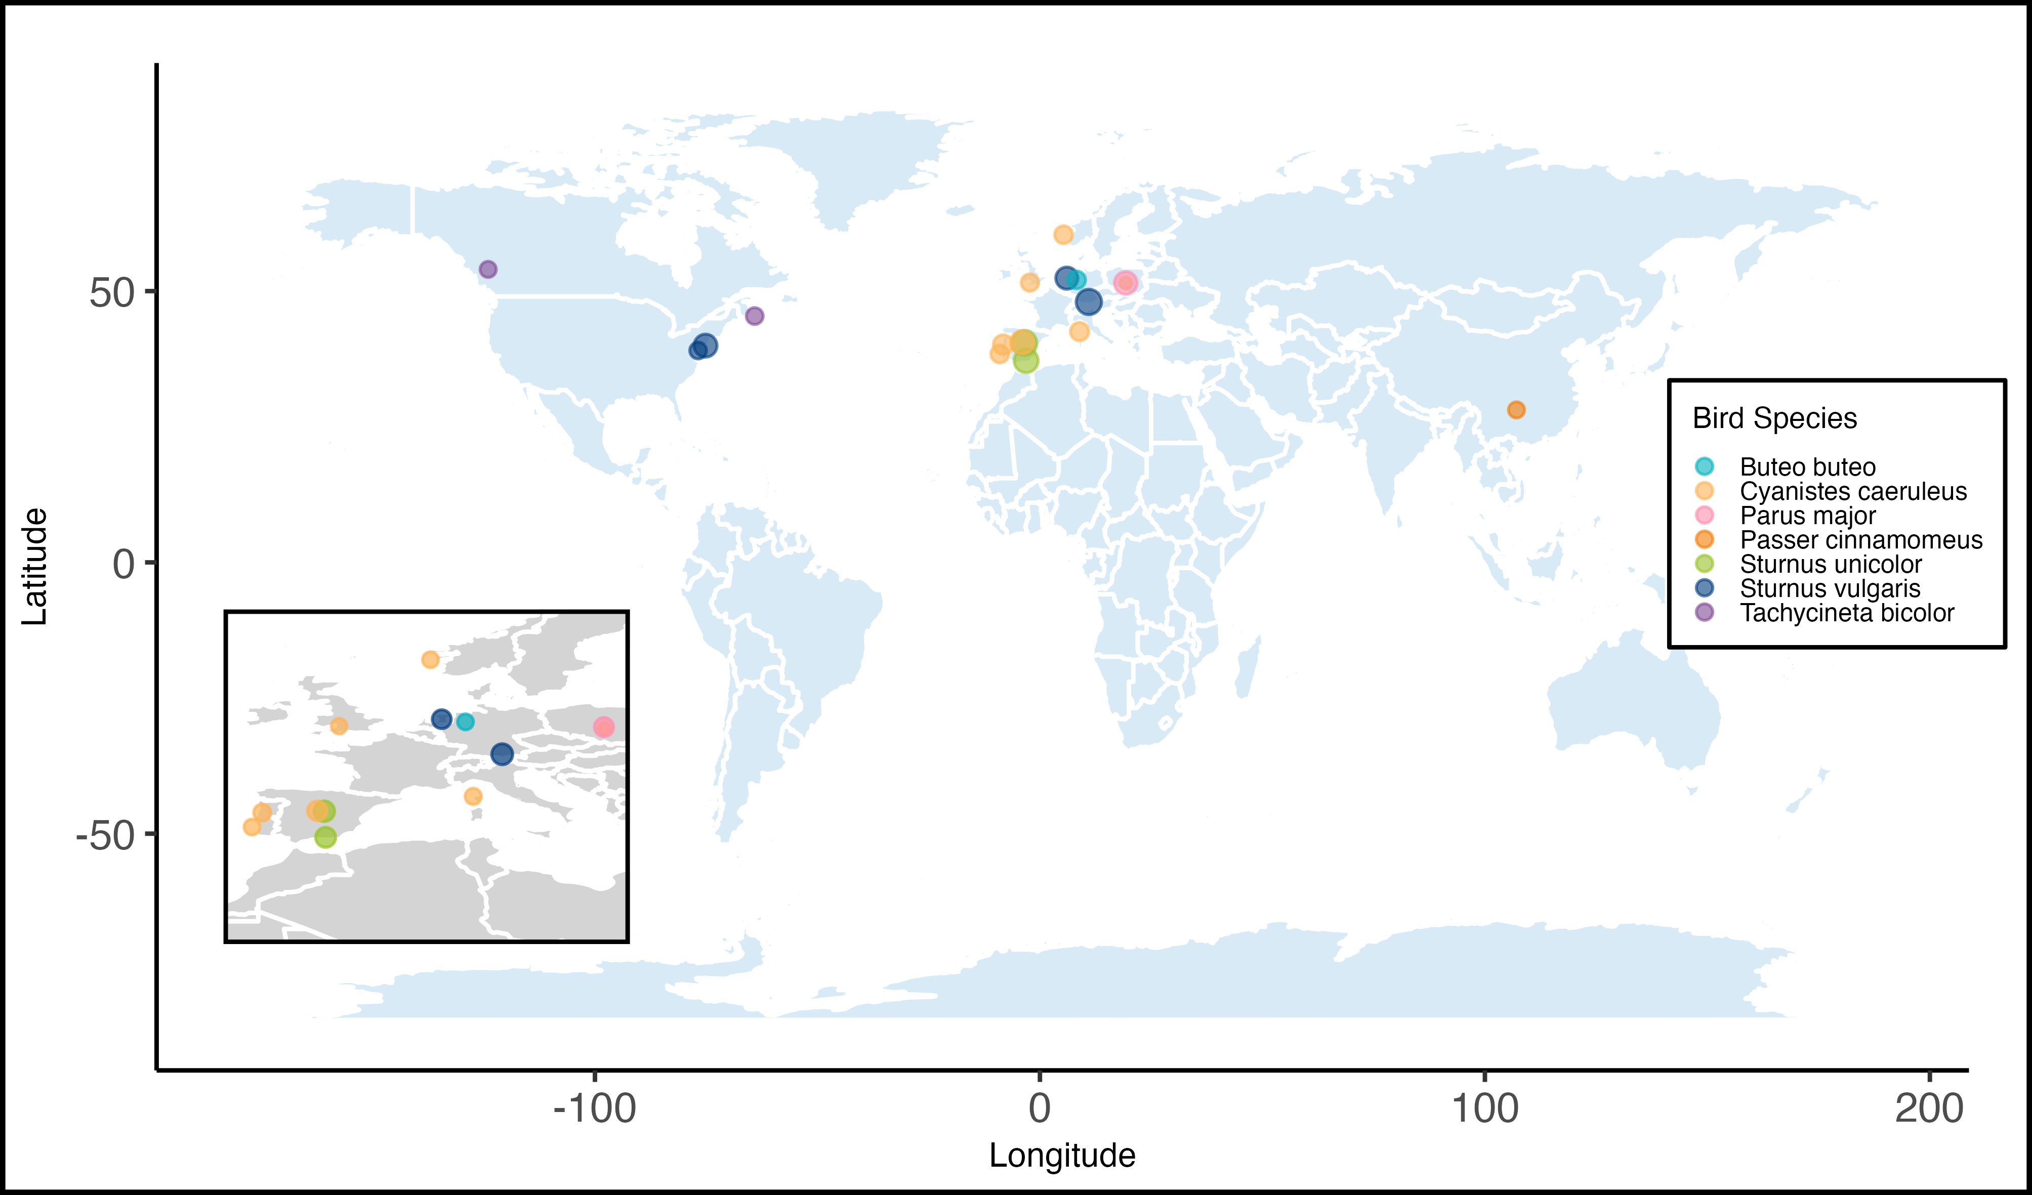
Figure 1: Geographical distribution of the 17 study populations included in the meta-analysis testing the adaptive value of green nest material in birds. Point size reflects the number of effect sizes calculated from each location (range: 3–34), and colour denotes species (see legend), with an inset zooming in on a dense cluster of data points.

Meta-analytic mean
Both lnRR and SMD(H) intercept-only meta-analyses showed an average positive effect of GNM on the fitness proxies; however, this overall effect was only statistically significant for SMD(H).
For lnRR, nests with an experimental increase in GNM showed an average statistically non-significant increase in fitness estimates of 1.9% (Figure 2 A; lnRR = 0.019, 95% CI: [-0.012, 0.050], 95% PI: [-0.281, 0.319], p-value = 0.223, k = 238, n = 26) but the heterogeneity among effect sizes was high. Total raw heterogeneity ($σ^{2}$) was 0.023 (Q = 2277.7, p < 0.001), the measures of relative (I²_{total} = 98.6%) and standardised heterogeneity (CVH2_{total} = 63.59; M2_{total =} 0.98) all suggested high heterogeneity across effect sizes, exceeding the 75th percentile of empirically derived estimates from meta-analyses in ecology and evolution [57].
For SMD(H), nests with an experimental increase in GNM showed an average statistically significant increase in fitness estimates (Figure 2 B; SMD(H) = 0.179, 95% CI: [0.048, 0.310], 95% PI: [-0.829, 1.188], p-value = 0.008, k = 253, n = 26), but the heterogeneity among effect sizes was moderate to high. Total raw heterogeneity ($σ^{2}$) was 0.258 (Q = 1114.7, p < 0.001), and both relative (I²_{total} = 66.1%) and standardised heterogeneity metrics (CVH2_{total} = 8.02 ; M2_{total =} 0.89) lay between the 50th and 75th percentile of empirically derived estimates [57].

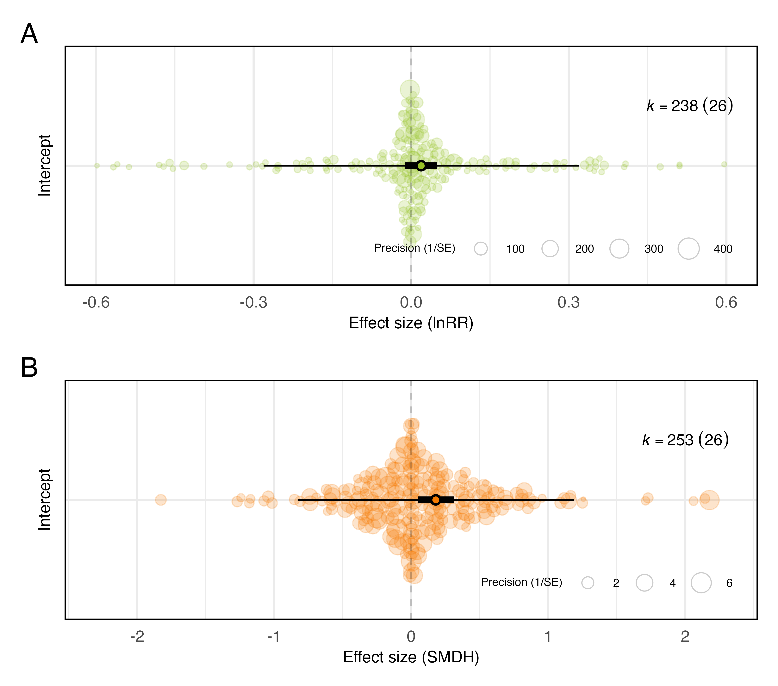
Figure 2: Overall effect of green nest material on all fitness proxies combined. The meta-analytic mean (black circle), 95% confidence intervals (thicker bars) and prediction intervals (thinner bars) are shown along with the data points (coloured circles) scaled by precision (inverse of standard error). Results are shown as an orchard plot for the intercept-only model (A) using log response ratio (lnRR), and (B) standardised mean difference (SMD(H)). k: number of effect sizes (number of studies is shown in brackets). X-axes are truncated for legibility, which partially explains the apparent asymmetry (see Figure S10).

Functional hypotheses
Our multilevel meta-regressions found no clear support for either of the two hypotheses separately (Figure 3). The estimates for the courtship hypothesis (lnRR_{courtship} = 0.039, 95% CI: [-0.172, 0.250], 95% PI: [-0.329, 0.407], p-value = 0.716, k = 8, n = 2; SMD(H)_{courtship} = 0.171, 95% CI: [-0.360, 0.702], 95% PI: [-0.964, 1.305], p-value = 0.527, k = 8, n = 2), and the “parental care hypothesis” (lnRR_{parental_care} = -0.010, 95% CI: [-0.065, 0.045], 95% PI: [-0.316, 0.296], p-value = 0.716, k = 106, n = 19; SMD(H)_{parental_care} = 0.109, 95% CI: [-0.060, 0.278], 95% PI: [-0.908, 1.126], p-value = 0.204, k = 115, n = 19) were statistically non-significant. However, the third level in this meta-regression (“Both”), which contained about half of all effect sizes that could not be unequivocally assigned to only one hypothesis, showed an average positive GNM effect on the fitness estimates, statistically significantly so for SMD(H) (lnRR_{both} = 0.028, 95% CI: [-0.006, 0.062], 95% PI: [-0.275, 0.331], p-value = 0.110, k = 124, n = 22; SMD(H)_{both} = 0.231, 95% CI: [ 0.079, 0.382], 95% PI: [-0.784, 1.245], p-value = 0.003, k = 130, n = 23). None of the three categories differed statistically significantly from each other (p-valuelnRR)p-value_{lnRR} > 0.211 and p-valueSMDHp-value_{SMD(H)} > 0.178 in all cases), and the moderator explained little heterogeneity (RmarginallnRR2RmarginallnRR2= 1.6% and RmarginalSMDH2RmarginalSMDH2= 1.4%).
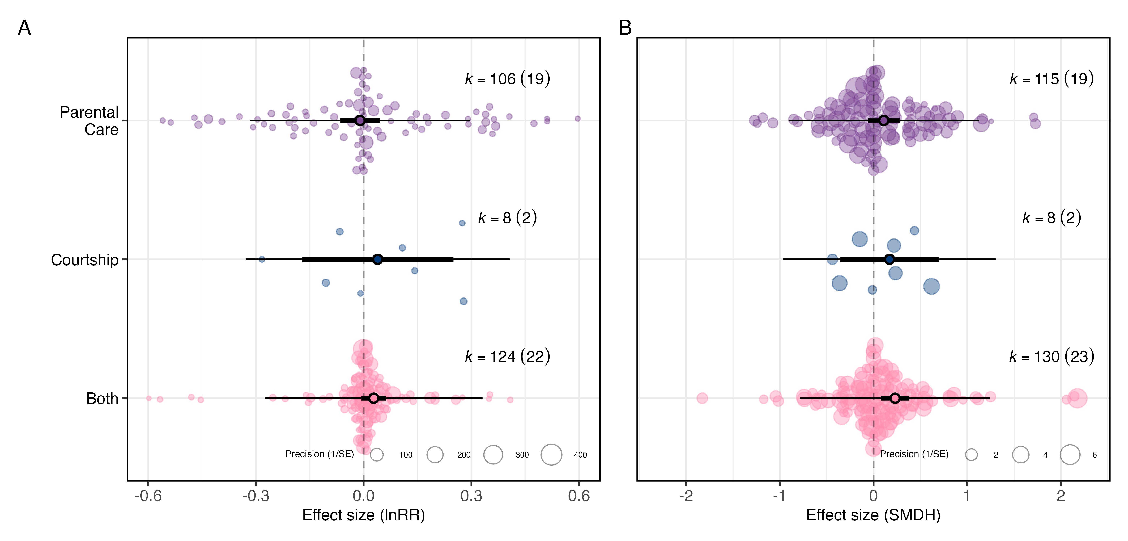
Figure 3: There is no clear evidence for the courtship or the parental care hypothesis separately as drivers of green nest material fitness effects. Orchard plot of the multilevel meta-regression for (A) log response ratio (lnRR) and (B) standardised mean difference (SMD(H)). Mean estimates (black circles), 95% confidence intervals (thicker bars), and prediction intervals (thinner bars) are shown along with the individual data points (transparently coloured circles) scaled by precision (inverse of standard error). k: number of effect sizes (number of studies is shown in brackets). X-axes are truncated for legibility, which partially explains the apparent asymmetry (see Figure S11).

Exploratory meta-regressions
First, the overall effect of GNM on fitness estimates differed largely depending on the experimental design used in each study (Figure 4 A,B). The overall effect size for the comparison between no material and aromatic GNM was positive and statistically significant (lnRR_{no-material-vs-aromatic} = 0.111, 95% CI: [ 0.021, 0.200], 95% PI: [-0.225, 0.446], p-value = 0.016, k = 90, n = 12 and SMD(H)_{no-material-vs-aromatic} = 0.712, 95% CI: [ 0.309, 1.114], 95% PI: [-0.826, 2.250], p-value = 0.001, k = 94, n = 12], whereas, the comparison between non-aromatic GNM and aromatic GNM was statistically non-significant (Table 1). The comparison between no material and non-aromatic GNM was negative and, although based on only 3 studies, statistically significant for lnRR (lnRR_{no-material-vs-non-aromatic} = -0.349, 95% CI: [-0.504, -0.195], 95% PI: [-0.708, 0.009], p-value <0.001, k = 10, n = 3; Table 1). All levels differed statistically significantly from each other except one (p-valuelnRRp-value_{lnRR} < 0.004 and p-valueSMDHp-value_{SMD(H)} < 0.001 in all cases, except SMDHno-material-vs-aromaticSMD(H)_{no-material-vs}SMDHno-material-vs-non-aromatic_{-aromatic} vs. SMD(H)_{no-material-vs-non-aromatic} p-value = 0.140), and the moderator experimental design explained a large proportion of heterogeneityRmarginallnRR2RmarginalSMDH2 (RmarginallnRR2= 27.8% and RmarginalSMDH2= 24.4%).
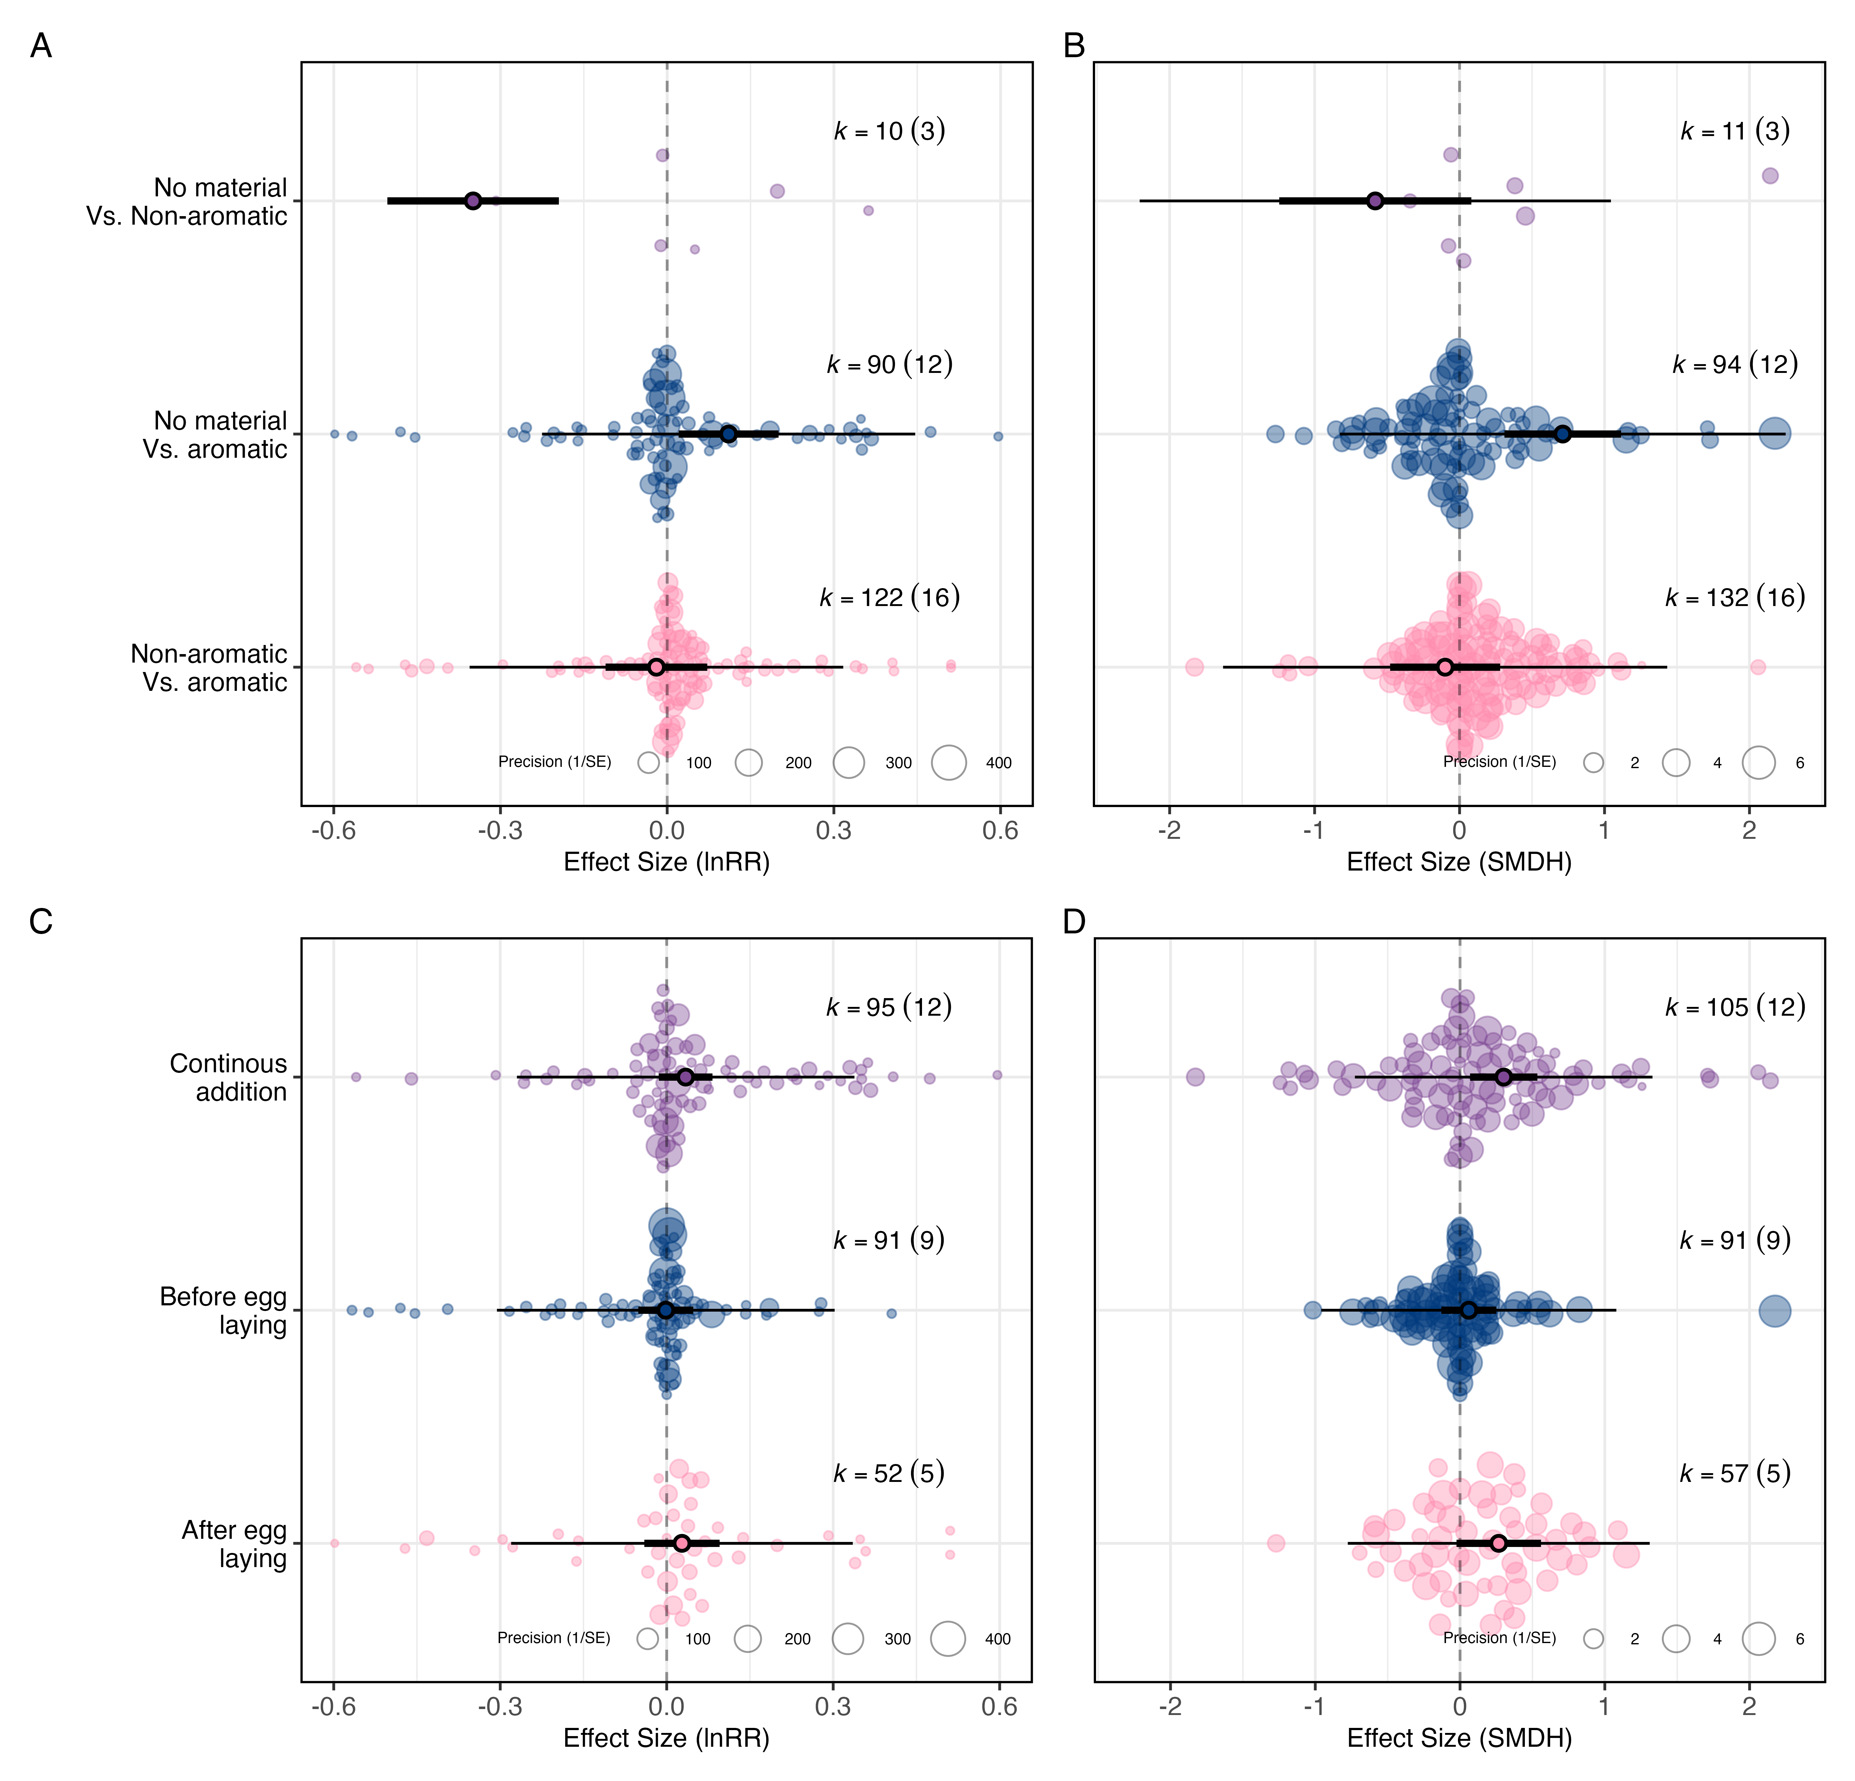
Figure 4: Experimental designs comparing nests with aromatic green nest material against nests with no green material, and those in which green nest material was experimentally added continuously throughout the nesting phase, lead to the largest fitness estimates. Orchard plots of the multilevel meta-regressions showing the overall effect of green nest material depending on experimental design (A: log response ratio (lnRR); B: standardised mean difference (SMD(H)), and time of green nest material addition (C: lnRR; D: SMD(H)). Mean estimates (black circles), 95% confidence intervals (thicker bars) and prediction intervals (thinner bars) are shown along the individual data points (transparently coloured circles) scaled by precision (inverse of standard error). k: number of effect sizes (number of studies is shown in brackets). X-axes are truncated for legibility, which partially explains the apparent asymmetry (see Figure S12).
Second, the overall positive effect of GNM on fitness outcomes tended to be larger when GNM was added continuously throughout the nesting phase (Figure 4 C,D). The overall effect was positive and statistically significant for SMD(H) when material was continuously and experimentally added to the nest (lnRR_{continuously} = 0.034, 95% CI: [-0.014, 0.083], 95% PI: [-0.270, 0.338], p-value = 0.165, k = 95, n = 12; SMD(H)_{continuously} = 0.302, 95% CI: [ 0.069, 0.534], 95% PI: [-0.726, 1.329], p-value = 0.011, k = 105, n = 12), whereas the effect was small and statistically non-significant when added before egg hatching (Table 1). Last, the overall effect also tended to be positive for SMD(H) when GNM was added after egg hatching only, although only marginally so (SMD(H)_{after_egg_hatching} = 0.267, 95% CI: [-0.024, 0.559], 95% PI: [-0.775, 1.310], p-value = 0.072, k = 57, n = 5; Table 1). The three categories did not differ statistically significantly from each other (p-value_{lnRR} > 0.307 and p-value_{SMD(H)} > 0.243 in all cases). The timing of GNM addition explained little heterogeneity (RmarginallnRR2RmarginallnRR2= 1.2% and RmarginalSMDH2RmarginalSMDH2= 4.5 %).
Third, although none of the species-specific mean estimates were statistically significant, most were positive (Figure S13, Table 1), and bird species explained a small amount of heterogeneity (RmarginallnRR2RmarginallnRR2= 5.3% and RmarginalSMDH2RmarginalSMDH2 = 8.5%). Fourth, most fitness proxy categories had positive mean estimates, but only morphology was statistically significant, and only for SMD(H) (SMDH_{morphology} = 0.310, 95% CI: [ 0.112, 0.509], 95% PI: [-0.723, 1.343], p-value = 0.002, k = 65, n = 15; Figure S13; Table 1) and fitness proxy category accounted for a small amount of heterogeneity (RmarginallnRR2RmarginallnRR2= 3.7% and RmarginalSMDH2RmarginalSMDH2= 2.4%). Fifth, for the subset of outcomes relating to pathogen and parasitic load, estimates for arthropods and micro-organisms did not differ statistically significantly (Figure S13 ; Table 1) and the type of parasite or pathogen explained little heterogeneity (RmarginallnRR2RmarginallnRR2= 0.4% and RmarginalSMDH2RmarginalSMDH2= 1.6%). Lastly, the evaluation of potential Risk of Bias categories (i.e., blinding, random assignment to each treatment, and partial reporting) was limited by the small number of studies in some categories (details in Table S4)
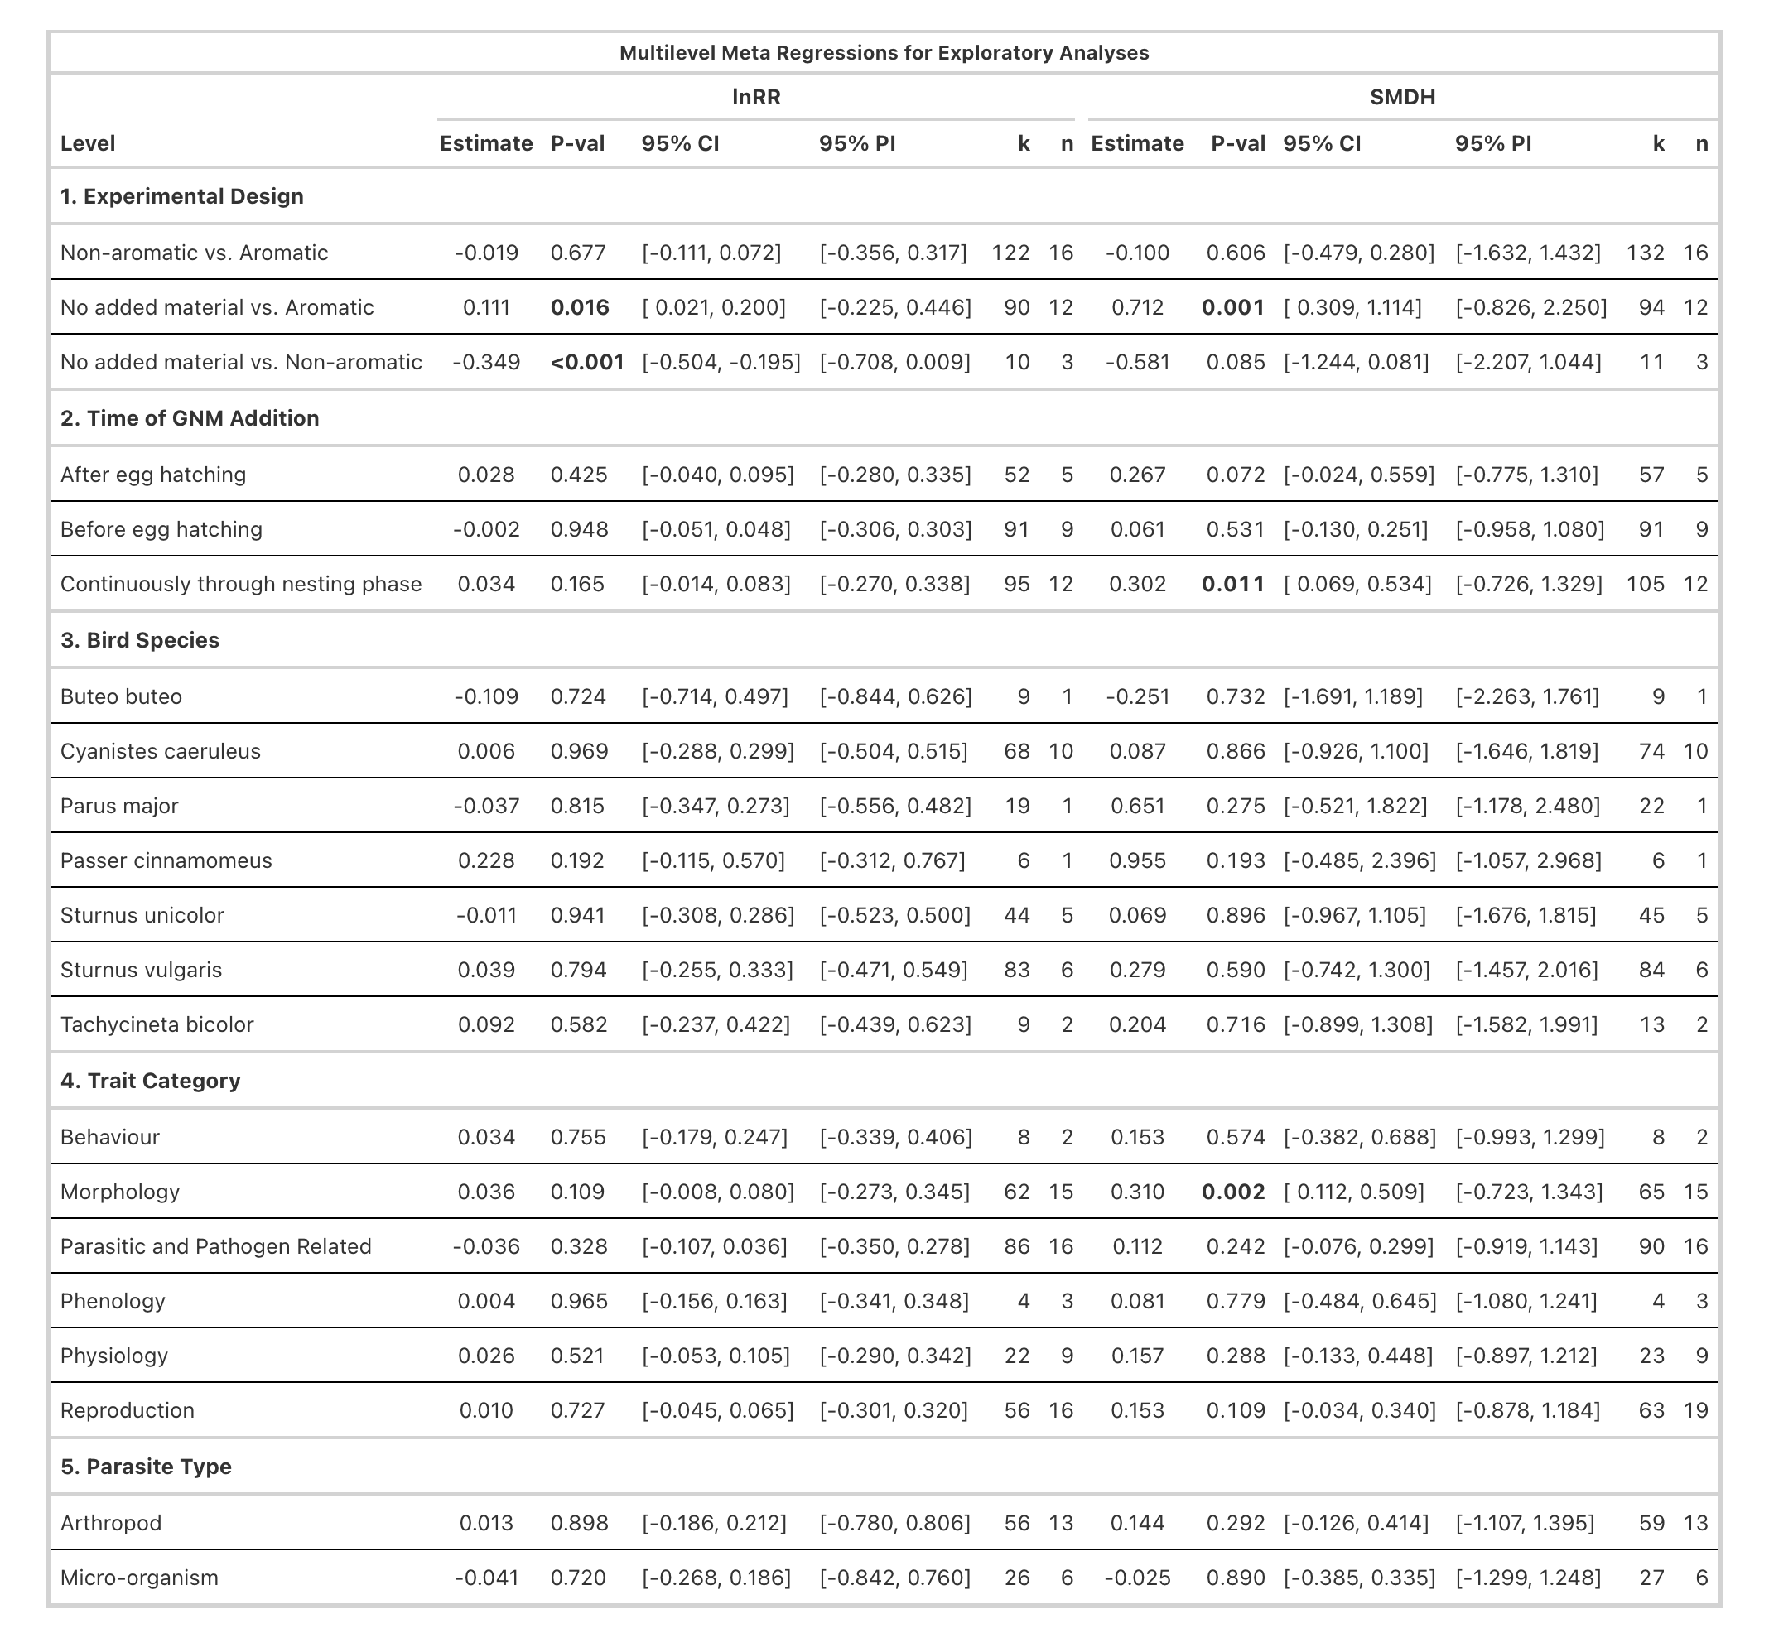
Table 1: Results from multilevel meta-regressions testing how several factors moderate the effect of green nest material on fitness estimates across birds. Columns show model estimates, p-values (P-val), 95% confidence intervals (CI), 95% prediction intervals (PI), number of effect sizes (k), and number of studies (n) for both effect size metrics: log response ratio (lnRR) and standardized mean difference (SMD(H)). Statistically significant results (p-values < 0.05) are shown in bold.

Publication Bias
We found no conclusive evidence for the existence of publication bias in the published literature (Figure S14). There was no statistical evidence for small-study effect for lnRR (lnRR_{intercept}= 0.003, 95% CI: [-0.066, 0.072], p-value = 0.926, lnRR_{slope} = 0.079, 95% CI: [-0.215; 0.373], p-value = 0.595, k = 221, n = 24, RmarginallnRR2RmarginallnRR2 = 0.3%). For SMD(H), there was a tendency for effect sizes to be larger when sample size was smaller (SMDH_{slope} = 1.393, 95% CI: [-0.143, 2.929], p-value = 0.075, k = 235, n = 24, RmarginalSMDH2RmarginalSMDH2= 8.3%) with the overall adjusted effect decreasing substantially (SMDH_{intercept} = -0.035, 95% CI: [-0.319, 0.249], p-value = 0.809). In addition, since published effect sizes did not change over time, our analyses suggest no clear evidence of decline effects in published effect sizes (see Figure S14).

Discussion
Our meta-analysis of experimental studies shows that green nest material (GNM) has a small positive effect on fitness in birds. Our results were generally consistent across two effect size metrics and robust to several sensitivity analyses. However, moderate-to-high heterogeneity among effect sizes indicates that the benefits of GNM are context-
dependent. We found no clear support for either of the two functional hypotheses traditionally proposed, the courtship hypothesis and the parental care hypothesis (i.e., nest protection and drug hypotheses combined). While several studies investigate the courtship hypothesis, only a few fitness proxies could be exclusively linked to this mechanism (e.g., courtship time, male provisioning), and these showed no effect of GNM. Similarly, fitness proxies exclusively associated with the parental care hypothesis (e.g., parasite loads, nestling health), also showed no effect of GNM. This finding is particularly surprising because the parental care hypothesis has been most frequently tested. While studies testing the courtship hypothesis have suggested that the aromatic volatile compounds could help receivers of the signal detect the presence of GNM in dark cavity nests [26], it is the parental care hypothesis that has stressed the importance of these compounds [65–67], perhaps explaining their widespread consideration. Our findings challenge this assumption since experimental designs comparing aromatic with non-aromatic GNM, which account for more than half of all tests, did not show a clear fitness effect, whereas comparisons between aromatic GNM and no material did. By contrast, comparisons between non-aromatic GNM and no material suggested a negative effect of non-aromatic GNM on fitness, although this result should be interpreted cautiously because it was based on only three studies (k = 10 effect sizes). Notably, experimental design alone explained about one-quarter of the observed heterogeneity (Rmarginal2Rmarginal2 24-28%).
One possible explanation is that aromatic vs. non-aromatic isolates the effects of aromaticity or volatile compounds, which may be weak, context-dependent (e.g., dependent on parasite pressure, [14]), or short-lived due to rapid decay of volatiles [15] and may require repeated replenishment [68]. By contrast, aromatic vs. no material, capture the net effect of adding green material itself, including potential non-chemical and volatile effects, which may therefore show a clearer overall benefit. Such benefits could also relate to plant morphology such as shape or colour. In addition, only proxies that could not be clearly assigned to either of the functional hypotheses (e.g., survival rate, nestling morphology), and were therefore categorized as being associated with “both” hypotheses, showed a clear positive effect. This ambiguity reflects the difficulty of linking many fitness proxies to an underlying function because they can be shaped by multiple overlapping processes. For example, nestling mass, a commonly measured fitness proxy, could be influenced by pathogen load or direct physiological effects of plant compounds, even though our synthesis found no consistent overall evidence for parasite reduction or health benefits. It could also respond to altered parental investment through differential allocation, making such broad proxies of fitness difficult to assign to a single function.
Heterogeneity in the overall effect of GNM was mainly associated with within-study variation, with little to no among-study variation. This suggests that, once methodological (e.g., experimental design) and biological factors (e.g., species identity, category of fitness proxy) are accounted for, the overall effect found would be potentially generalisable across studies. In addition to experimental design, we tested the timing of GNM addition (Rmarginal2Rmarginal2= 1-5%). Continuous supplementation throughout the nesting period had stronger positive effects than supplementation restricted to before or after hatching. Although not conclusive, this pattern is more consistent with the parental care hypothesis than with the courtship hypothesis. In blue tits the concentration of active compounds released by the aromatic plants can decrease within 24 hours [15], and females often replace experimentally removed herbs [39,68]. This repeated addition may help maintain an environment rich in volatiles that is hostile to parasites. However, fresh GNM could also improve fitness through structural or microclimate benefits [2,42]. In addition, regular replenishment of GNM by birds may help nest lining as material desiccates, thereby improving insulation and humidity buffering [42,69] and diluting faecal matter or food debris in the nest (i.e., hygiene function, [70]). This microclimate stability may accelerate nestling development while reducing thermoregulatory costs for the parents [71,72].
Among the biological moderators tested, species identity seemed the most important one (Rmarginal2Rmarginal2 = 5-9%), providing some evidence for species-specific effects; however, note that three species were represented in only one study each. Such variation across species is not unexpected, since some (e.g., Tachycineta bicolor) do not naturally incorporate GNM in their nests, while the other species do. Differences across species in life-history traits, nest construction, or habitat condition (such as parasite load, availability of resources), and their interplay likely influence how GNM affects fitness. The second most important biological moderator was the fitness proxy category (Rmarginal2Rmarginal2 = 2-4%), potentially indicating differences in validity across fitness proxies or reflecting differences among underlying mechanisms. Among all categories, morphological outcomes (e.g., nestling mass, tarsus length) showed the largest positive effects, suggesting that GNM has a more pronounced effect on offspring development or growth. Morphology was the second most measured fitness proxy across studies, likely because these traits can be obtained easily and non-invasively in the field as compared to long-term demographic (e.g., survival, recruitment) or physiological assays (e.g., blood-based immune or endocrine measures). However, while widely used as an indicator of offspring condition, these morphological measures, like many other outcomes in the literature, remain indirect fitness proxies, and their relationship to recruitment or survival can be context dependent [73]. This could also reflect that morphology responds quickly to within-nest conditions, whereas effects on long-term survival may be diluted by subsequent environmental variations [74]. All other fitness proxy categories, including physiology, reproduction, phenology, and behaviour, showed small to moderate positive effects, whereas proxies related to parasite or pathogen load, despite being the most commonly investigated, showed weak and inconsistent effects. Parasite reduction is central to one of the two mechanisms within the parental care hypothesis (the nest protection hypothesis, [14,30]). Our results further emphasise that despite its prominence, there is a lack of clear overall evidence for the parental care hypothesis. The other hypothesis categorised within the parental care hypothesis (i.e., the drug hypothesis, [19,35]), proposes an increase in offspring survival, with volatile compounds directly enhancing offspring immune function and/or health independent of parasite or pathogen control. While the largest positive effects of morphology could support the drug hypothesis, it should be noted that (i) the mechanism linking volatiles to enhanced offspring immune function or health is unclear, (ii) our results suggest that non-aromatic GNM may play a role, and (iii) several other mechanisms could also be at play such as nest microclimate and incubation conditions [75] or parental investment.
When interpreting our results, it is important to acknowledge some constraints of the study and the available evidence. The overall effect of GNM differed between the two effect size metrics, which make distinct assumptions regarding the underlying biological processes and the statistical properties. These divergent results highlight the importance of choosing appropriate effect size metrics for a meta-analysis that align with the biological data at hand or in cases where several different types of measures are present, using both [76]. We found high reporting quality in the primary studies included in our meta-analysis, with only 0.06% partial reporting, but some evidence of small-study effects. After adjusting for this, the effect of GNM was no longer significant. To reduce the influence of small-study effects we contacted all authors for unpublished data, but could only find access to two studies. In addition, many studies had very low sample sizes (41% of the effect sizes were based on fewer than 10 nests per group), which reduces power and increases heterogeneity [77]. Furthermore, studies remain heavily biased towards just three bird species, limiting our ability to infer broad patterns of this behaviour. Expanding the scope beyond the currently well-studied taxa could be informative, but in practice can be limited by feasibility constraints such as access to nests. Targeting species with diverse nesting ecologies and habitat conditions can be useful in understanding the adaptive benefits of this behaviour.

Conclusion
After more than 40 years of research on this topic, ours is the first quantitative synthesis confirming an overall effect of green nest material on fitness in birds. Despite moderate-to-high heterogeneity, our results suggest that the effect may be generalisable across studies once methodological and biological factors within studies are accounted for. However, our small-study effects analysis, although non-conclusively, indicates that accounting for potentially missing studies could cause the observed effect to disappear, despite our efforts to include unpublished work. Moreover, our study clearly emphasises that the functions remain largely unclear and challenges the assumption that volatile compounds alone explain the relationship between green nest material and fitness. Future experimental designs should focus on decoupling volatiles from structural or microclimate effects, while quantifying mediators (e.g., nest microclimate, parasite load) and prioritising fitness proxies directly linked to fitness (e.g., fledging success, recruitment), as well as testing explicitly, rather than assuming, the role of volatiles. Replications across parasite and climatic gradients, together with cross-fostering experiments, could allow us to understand the context dependency and distinguish nest-level effects from parental quality. In addition, theoretical work could further solidify the field’s foundations and yield testable predictions. Cost-benefit models of GNM use to predict when net benefits could occur and why effects vary among species and environments could help generate predictions (e.g., benefits only above certain parasite pressure or under certain temperature or humidity conditions) that are directly testable with multi-site experiments. Altogether, our synthesis contributes to a more nuanced understanding of the adaptive significance of one of the most fascinating and most studied natural structures—bird nests, opening doors to several questions that remain unanswered.

References
1. Hansell M. 2000 Bird nests and construction behaviour. Cambridge, UK: Cambridge University Press. (doi:10.1017/CBO9781139106788)
2. Mainwaring MC, Hartley IR, Lambrechts MM, Deeming DC. 2014 The design and function of birds’ nests. Ecology and Evolution 4, 3909–3928. (doi:10.1002/ece3.1054)
3. Deeming DC. 2023 Nest construction in mammals: A review of the patterns of construction and functional roles. Philosophical Transactions of the Royal Society B: Biological Sciences 378, 20220138. (doi:10.1098/rstb.2022.0138)
4. Sergio F, Blas J, Blanco G, Tanferna A, López L, Lemus JA, Hiraldo F. 2011 Raptor nest decorations are a reliable threat against conspecifics. Science 331, 327–330. (doi:10.1126/science.1199422)
5. Suárez-Rodríguez M, López-Rull I, Macías Garcia C. 2013 Incorporation of cigarette butts into nests reduces nest ectoparasite load in urban birds: New ingredients for an old recipe? Biology Letters 9, 20120931. (doi:10.1098/rsbl.2012.0931)
6. Jagiello Z, Reynolds SJ, Nagy J, Mainwaring MC, Ibáñez-Álamo JD. 2023 Why do some bird species incorporate more anthropogenic materials into their nests than others? Philosophical Transactions of the Royal Society B: Biological Sciences 378, 20220156. (doi:10.1098/rstb.2022.0156)
7. Sheard C, Stott L, Street SE, Healy SD, Sugasawa S, Lala KN. 2024 Anthropogenic nest material use in a global sample of birds. Journal of Animal Ecology 93, 691–704. (doi:10.1111/1365-2656.14078)
8. Moreno J, Soler M, Møller AP, Lindén M. 1994 The function of stone carrying in the black wheatear, Oenanthe leucura. Animal Behaviour 47, 1297–1309. (doi:10.1006/anbe.1994.1178)
9. Hoi H, Schleicher B, Valera F. 1996 Nest size variation and its importance for mate choice in penduline tits, Remiz pendulinus. Animal Behaviour 51, 464–466. (doi:10.1006/anbe.1996.0046)
10. Soler JJ, Soler M, Møller AP, Martínez JG. 1995 Does the great spotted cuckoo choose magpie hosts according to their parenting ability? Behavioral Ecology and Sociobiology 36, 201–206. (doi:10.1007/bf00177797)
11. Moreno J. 2012 Avian nests and nest-building as signals. Avian Biology Research 5, 238–251. (doi:10.3184/175815512x13534385822786)
12. Perez DM, Manica LT, Medina I. 2023 Variation in nest-building behaviour in birds: A multi-species approach. Philosophical Transactions of the Royal Society B: Biological Sciences 378, 20220145. (doi:10.1098/rstb.2022.0145)
13. Jezierski MT, Benson RBJ, Smith WJ, Saupe EE, Clegg SM. 2025 A wide range of abiotic and biotic variables leaves most variation in bird nest architecture unexplained. Proceedings of the Royal Society B: Biological Sciences 292, 20252013. (doi:10.1098/rspb.2025.2013)
14. Clark L, Mason JR. 1985 Use of nest material as insecticidal and anti-pathogenic agents by the European Starling. Oecologia 67, 169–176. (doi:10.1007/bf00384280)
15. Petit C, Hossaert-McKey M, Perret P, Blondel J, Lambrechts MM. 2002 Blue tits use selected plants and olfaction to maintain an aromatic environment for nestlings. Ecology Letters 5, 585–589. (doi:10.1046/j.1461-0248.2002.00361.x)
16. Garrido-Bautista J et al. 2023 Is there a role for aromatic plants in blue tit Cyanistes caeruleus nests? Results from a correlational and an experimental study. Behavioral Ecology and Sociobiology 77, 118. (doi:10.1007/s00265-023-03393-9)
17. Mennerat A, Mirleau P, Blondel J, Perret P, Lambrechts MM, Heeb P. 2009 Aromatic plants in nests of the blue tit Cyanistes caeruleus protect chicks from bacteria. Oecologia 161, 849–855. (doi:10.1007/s00442-009-1418-6)
18. Ontiveros D, Caro J, Pleguezuelos JM. 2008 Green plant material versus ectoparasites in nests of Bonelli’s eagle. Journal of Zoology 274, 99–104. (doi:10.1111/j.1469-7998.2007.00364.x)
19. Mennerat A, Perret P, Lambrechts MM. 2009 Local individual preferences for nest materials in a passerine bird. PLoS ONE 4, e5104. (doi:10.1371/journal.pone.0005104)
20. Mainwaring MC, Hartley IR. 2013 The energetic costs of nest building in birds. Avian Biology Research 6, 12–17. (doi:10.3184/175815512x13528994072997)
21. Dubiec A, Góźdź I, Mazgajski TD. 2013 Green plant material in avian nests. Avian Biology Research 6, 133–146. (doi:10.3184/175815513X13615363233558)
22. Scott-Baumann JF, Morgan ER. 2015 A review of the nest protection hypothesis: Does inclusion of fresh green plant material in birds’ nests reduce parasite infestation? Parasitology 142, 1016–1023. (doi:10.1017/S0031182015000189)
23. Veiga JP, Polo V, Viñuela J. 2006 Nest green plants as a male status signal and courtship display in the spotless starling. Ethology 112, 196–204. (doi:10.1111/j.1439-0310.2006.01148.x)
24. Eens M, Pinxten R, Verheyen RF. 1993 Function of the song and song repertoire in the European Starling Sturnus vulgaris: An Aviary Experiment. Behaviour 125, 51–66. (doi:10.1163/156853993x00182)
25. Gwinner H. 1997 The function of green plants in nests of the European Starling Sturnus vulgaris. Behaviour 134, 337–351. (doi:10.1163/156853997X00575)
26. Brouwer L, Komdeur J. 2004 Green nesting material has a function in mate attraction in the European Starling. Animal Behaviour 67, 539–548. (doi:10.1016/j.anbehav.2003.07.005)
27. Beasley SY, Freire R, Callan MN, Massaro M. 2024 The influence of plant scents on nest box inspection by eastern rosella (Platycercus eximius). Emu - Austral Ornithology 124, 165–176. (doi:10.1080/01584197.2024.2323920)
28. Kessel B. 1957 A study of the breeding biology of the European Starling Sturnus vulgaris in North America. The American Midland Naturalist 58, 257–331. (doi:10.2307/2422615)
29
. Tomás G, Merino S, Martínez-de la Puente J, Moreno J, Morales J, Rivero-de Aguilar J. 2013 Nest size and aromatic plants in the nest as sexually selected female traits in blue tits. Behavioral Ecology 24, 926–934. (doi:10.1093/beheco/art015)
30. Wimberger PH. 1984 The use of green plant material in bird nests to avoid ectoparasites. The Auk 101, 615–618.
31. Dykstra CR, Hays JL, Simon MM. 2009 Selection of fresh vegetation for nest lining by red-shouldered hawks. The Wilson Journal of Ornithology 121, 207–210. (doi:10.1676/08-035.1)
32. Lafuma L, Lambrechts MM, Raymond M. 2001 Aromatic plants in bird nests as a protection against blood-sucking flying insects? Behavioural Processes 56, 113–120. (doi:10.1016/s0376-6357(01)00191-7)
33. Dawson RD. 2004 Does fresh vegetation protect avian nests from ectoparasites? An experiment with tree swallows. Canadian Journal of Zoology 82, 1005–1010. (doi:10.1139/z04-076)
34. Quiroga MA, Reboreda JC, Beltzer AH. 2012 Host use by Philornis sp. In a passerine community in central Argentina. Revista Mexicana de Biodiversidad 83. (doi:10.22201/ib.20078706e.2012.1.1137)
35. Gwinner H, Oltrogge M, Trost L, Nienaber U. 2000 Green plants in starling nests: Effects on nestlings. Animal Behaviour 59, 301–309. (doi:10.1006/anbe.1999.1306)
36. Gwinner H, Berger S. 2005 European starlings: Nestling condition, parasites and green nest material during the breeding season. Journal of Ornithology 146, 365–371. (doi:10.1007/s10336-005-0012-x)
37. Mennerat A, Perret P, Bourgault P, Blondel J, Gimenez O, Thomas DW, Heeb P, Lambrechts MM. 2009 Aromatic plants in nests of blue tits: Positive effects on nestlings. Animal Behaviour 77, 569–574. (doi:10.1016/j.anbehav.2008.11.008)
38. Cowie RJ, Hinsley SA. 1988 Timing of return with green vegetation by nesting blue tits Parus caeruleus. Ibis 130, 553–555. (doi:10.1111/j.1474-919x.1988.tb02722.x)
39. Banbura J, Blondel J, Wilde-Lambrechts H de, Perret P. 1995 Why do female blue tits Parus caeruleus bring fresh plants to their nests? Journal für Ornithologie 136, 217–221. (doi:10.1007/bf01651244)
40. García-Campa J, González-Braojos S, Morales J. 2024 Nest secondary plants and their associations with haemosporidian blood parasites in blue tit females. Parasitology 151, 1126–1136. (doi:10.1017/s0031182024000775)
41. Skutch AF. 1957 The incubation patterns of birds. Ibis 99, 69–93. (doi:10.1111/j.1474-919x.1957.tb01934.x)
42. Mertens JAL. 1977 Thermal conditions for successful breeding in great tits Parus major. Oecologia 28, 1–29. (doi:10.1007/bf00346834)
43. Lyons DM, Mosher JA. 1987 Morphological growth, behavioral development, and parental care of Broad-Winged Hawks (crecimiento, desarollo de patrones de conducta y cuidado parental en Buteo platypterus). Journal of Field Ornithology 58, 334–344.
44. Temporary link for the pre-registration for the project: The adaptive value of green nest material across birds: A systematic review and meta-analysis. (url: https://tinyurl.com/4bn37acx)
45. O’Dea RE et al. 2021 Preferred reporting items for systematic reviews and meta-analyses in ecology and evolutionary biology: A PRISMA extension. Biological Reviews 96, 1695–1722. (doi:10.1111/brv.12721)
46. Grames EM, Stillman AN, Tingley MW, Elphick CS. 2019 An automated approach to identifying search terms for systematic reviews using keyword co-occurrence networks. Methods in Ecology and Evolution 10, 1645–1654. (doi:10.1111/2041-210x.13268)
47. Westgate MJ. 2019 Revtools: An R package to support article screening for evidence synthesis. Research Synthesis Methods 10, 606–614. (doi:10.1002/jrsm.1374)
48. Pick JL, Nakagawa S, Noble DWA. 2018 Reproducible, flexible and high-throughput data extraction from primary literature: The metaDigitise R package. Methods in Ecology and Evolution 10, 426–431. (doi:10.1111/2041-210x.13118)
49. Viechtbauer W. 2010 Conducting meta-analyses in R with the metafor package. Journal of Statistical Software 36, 1–48. (doi:10.18637/jss.v036.i03)
50. Cooper H, Hedges LV, Valentine JC. 2019 The handbook of research synthesis and meta-analysis. New York, NY: Russell Sage Foundation. (doi:10.7758/9781610448864)
51. Nakagawa S, Noble DWA, Lagisz M, Spake R, Viechtbauer W, Senior AM. 2022 A robust and readily implementable method for the meta-analysis of response ratios with and without missing standard deviations. Ecology Letters 26, 232–244. (doi:10.1111/ele.14144)
52. Lajeunesse MJ. 2013 Recovering missing or partial data from studies: A survey of conversions and imputations for meta-analysis. In Handbook of meta-analysis in ecology and evolution, pp. 195–206. Princeton University Press.
53. R Core Team. 2025 R: A language and environment for statistical computing. Vienna, Austria: R Foundation for Statistical Computing. See https://www.R-project.org/.
54. Noble DWA, Lagisz M, O’Dea RE, Nakagawa S. 2017 Nonindependence and sensitivity analyses in ecological and evolutionary meta-analyses. Molecular Ecology 26, 2410–2425. (doi:10.1111/mec.14031)
55. Krackow S. 2002 Why parental sex ratio manipulation is rare in higher vertebrates (invited article). Ethology 108, 1041–1056. (doi:10.1046/j.1439-0310.2002.00843.x)
56. Mentesana L, Hau M, D’Amelio PB, Adreani NM, Sánchez-Tójar A. 2025 Do egg hormones have fitness consequences in wild birds? A Systematic Review and Meta-Analysis. Ecology Letters 28, e70100. (doi:10.1111/ele.70100)
57. Yang Y, Noble DWA, Spake R, Senior AM, Lagisz M, Nakagawa S. 2025 A pluralistic framework for measuring, interpreting and decomposing heterogeneity in meta-analysis. Methods in Ecology and Evolution 16, 2710–2725. (doi:10.1111/2041-210x.70155)
58. Nakagawa S, Schielzeth H. 2012 A general and simple method for obtaining R² from generalized linear mixed-effects models. Methods in Ecology and Evolution 4, 133–142. (doi:10.1111/j.2041-210x.2012.00261.x)

59. Stanhope J, Weinstein P. 2022 Critical appraisal in ecology: What tools are available, and what is being used in systematic reviews? Research Synthesis Methods 14, 342–356. (doi:10.1002/jrsm.1609)
60. Culina A et al. 2025 Elevating the importance of risk of bias assessment for ecology and evolution. (doi:10.32942/X2764C)
61. Jennions MD, Lortie CJ, Rosenberg MS, Rothstein HR. 2013 Publication and related biases. In Handbook of meta-analysis in ecology and evolution (eds J Koricheva, J Gurevitch, K Mengersen), pp. 207–236. Princeton, NJ: Princeton University Press.
62. Yang Y, Sánchez-Tójar A, O’Dea RE, Noble DWA, Koricheva J, Jennions MD, Parker TH, Lagisz M, Nakagawa S. 2023 Publication bias impacts on effect size, statistical power, and magnitude (type m) and sign (type s) errors in ecology and evolutionary biology. BMC Biology 21. (doi:10.1186/s12915-022-01485-y)
63. Nakagawa S, Lagisz M, Jennions MD, Koricheva J, Noble DWA, Parker TH, Sánchez-Tójar A, Yang Y, O’Dea RE. 2022 Methods for testing publication bias in ecological and evolutionary meta-analyses. Methods in Ecology and Evolution 13, 4–21. (doi:10.1111/2041-210X.13724)
64. Sánchez-Tójar A et al. 2018 Meta-analysis challenges a textbook example of status signalling and demonstrates publication bias. eLife 7, e37385. (doi:10.7554/elife.37385)

65. Fauth PT, Krementz DG, Hines JE. 1991 Ectoparasitism and the role of green nesting material in the European Starling. Oecologia 88, 22–29. (doi:10.1007/BF00328399)
66. Clark L, Mason JR. 1988 Effect of biologically active plants used as nests material and the derived benefit to starling nestlings. Oecologia 77, 174–180. (doi:10.1007/bf00379183)
67. Shutler D, Campbell AA. 2007 Experimental addition of greenery reduces flea loads in nests of a non-greenery using species, the tree swallow Tachycineta bicolor. Journal of Avian Biology 38, 7–12. (doi:10.1111/j.2007.0908-8857.04015.x)
68. Mennerat A, Perret P, Caro SP, Heeb P, Lambrechts MM. 2008 Aromatic plants in blue tit Cyanistes caeruleus nests: No negative effect on blood-sucking protocalliphora blow fly larvae. Journal of Avian Biology 39, 127–132. (doi:10.1111/j.0908-8857.2008.04400.x)
69
. Taverner PA. 1933 Purple martins gathering leaves. The Auk 50, 110–111. (doi:10.2307/4076584)
70. Peralta-Sanchez JM, Møller AP, Martin-Platero AM, Soler JJ. 2010 Number and colour composition of nest lining feathers predict eggshell bacterial community in barn swallow nests: An experimental study. Functional Ecology 24, 426–433. (doi:10.1111/j.1365-2435.2009.01669.x)
71. Nilsson J-Å, Nord A. 2017 The use of the nest for parental roosting and thermal consequences of the nest for nestlings and parents. Behavioral Ecology and Sociobiology 71. (doi:10.1007/s00265-017-2400-7)
72. Perez DM, Gardner JL, Medina I. 2020 Climate as an evolutionary driver of nest morphology in birds: A Review. Frontiers in Ecology and Evolution 8. (doi:10.3389/fevo.2020.566018)
73. Labocha MK, Hayes JP. 2011 Morphometric indices of body condition in birds: A review. Journal of Ornithology 153, 1–22. (doi:10.1007/s10336-011-0706-1)
74. Pires BA, Belo AD, Diamantino F, Rabaça JE, Merino S. 2020 Development of nestling blue tits (Cyanistes caeruleus) is affected by experimental addition of aromatic plants. Avian Biology Research 13, 44–48. (doi:10.1177/1758155920921075)
75. Corregidor-Castro A, Jones OR. 2021 The effect of nest temperature on growth and survival in juvenile great tits Parus major. Ecology and Evolution 11, 7346–7353. (doi:10.1002/ece3.7565)
76. Yang Y, Williams C, Senior AM, Morrison K, Ricolfi L, Pan J, Lagisz M, Nakagawa S. 2024 Bivariate multilevel meta-analysis of log response ratio and standardized mean difference for robust and reproducible environmental and biological sciences. (doi:10.1101/2024.05.13.594019)
77. IntHout J, Ioannidis JPA, Borm GF, Goeman JJ. 2015 Small studies are more heterogeneous than large ones: A meta-meta-analysis. Journal of Clinical Epidemiology 68, 860–869. (doi:10.1016/j.jclinepi.2015.03.017)

