**I have trained the model on some part of the data not whole data also I have only trained the models for 20 epochs so that I was able to train it on CPU.**

**Task 1 – Character level vanilla RNN**

1. **Hidden units = 50**

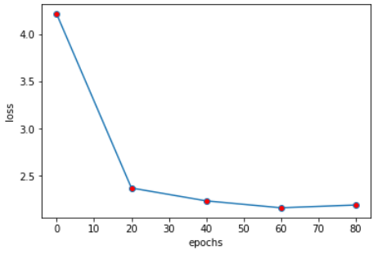

1 c a jind, a dit to wisn uroon of has ofs proje:sey huliofecs. min forde. in lisunit. tor, was hand

2 tle thithore wis dis nas a ie for af las ctantived th ad thin hit bea id ofgralowach yedler. hep

3 s ald the shore thas, the the +har, mewalf a dtill gy urinad ow viduld releadrargsow it ha uleec---

4 , fuelm vincest alpant ot dy uncland head was ic not var hoturing indern. and corfonseag. the meptl

5 s ptofearis of ieritle, ny of ivwered cifcres, onat conceng hard thged thopisty monceihhed wis onti

6 t hamfard besor, oge we in ond xthefwe, eowant y uthored t0 toved--tonb, my7uned or at, that hand h

7 c ot e pas mereacess onieed, whus if. iise mid napen- hoverful! by ty was tund hisfure in hisme ho

8 biect-y alf men moofes of nre ubouth gond fas wis his gleay mo labels--learnenend, at the boun my f

9 g, a mand spast obsuant cpait, ay if priges tedwale ofpt, tham hasmles-wing hisculy--nrit, alaplle

10 t eo at, bhadering tow he to ustichmodined the clemyses tunclell "at fouded rabe rabitg, til qasg t

**Hidden units = 100**

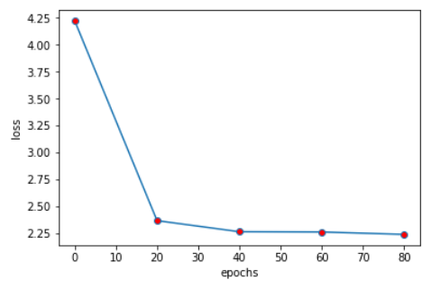

1 me was nowully se to tha vary 14sine bititale,. hoters, halt pbeadald nery lisupillu houedesllesive

2 d; the perse st my asco grtored al wivicho by leay itisepse on recle, thin at le sirie, tigse toz v

3 le thitc pereie ithea.ed-in did hare whin bhidares tabloly, hith charlmerutilueds, thane atd me ot

4 dit lescan ios htithithr hols, gyalver. hiede thit the ciery poaroligm; simuf.e d weafle rerule -p

5 ce thins at iealee ditule hi hopy, hiverd ins he titmy tathpperen hy ranre mppin inans mi we woo

6 rintuse scl rnow ilahe ry foale. at calebyfaysabtime, ay nouse we me ati welal. dointot dorep hy i

7 t eapinteme wim the of his wat htt peale, jabees ybpesellat. hathe erouried, iorer he fapsed it wa

8 ld than har seiclovay aivere mluso ha a to fowat apedine" aiphapit ole with wad daes thoth win fime

9 te the dadi i thit fouled the hariing has oisili by thouthey, ratid hery mis vemy hi ssacle hes wo

10 se .oln, y tooved itsle, a bide wersartlicud owe tlrs ic mpate ta hal sot veienter. uf at dele.r ho

**Hidden units = 200**

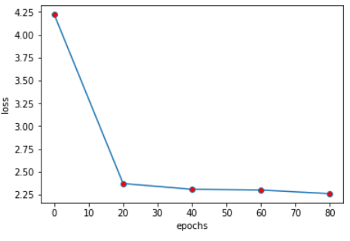

1 nd pated ry,urrs gfdarcedartupgeveatedsed dusint tad it m]meatter in in s. jacl won hee therse heti

2 ld that h mberntloventh alas capcohie wasunsedeedsi-ee iowe wiow1n honmich the ande thaimur fotali

3 ld, ha aile sthe cpessond, anvor hi*iss, her in in me pïcompiceduralle thepee a qunime toucel hase

4 , a malratha laise in aaliwe estthe op ex14#;me to how vimhing <nsing has nt ins ed uowkorges mppar

5 lle hoomss res has ip adencletolas to bly tomes. ehtulare hinine arner, sa and mane thut re dite h

6 vy, wis d hachigeptowested cacoin ha)ds, ug ceatme toeine hasuve ce iow to amusemblesesso erthio bo

7 nd fay he fro ithe ez[onts in on ros shal th a vowed hahes iow. taruncjuwirs omend waty., blotel o

8 t raiponso fothis hus re blearg gats, abne anle epornving, hat ha of ulithk hashorely keap it hat

9 ldont ti hhaun atust uld,sindes, in a o ammun was. oubsnecsery, 3oweice ofarti wane in eenoweg ot

10 nd and opeiss of e meine on iobearterall, has ploj23g;l hat a woshen ane i was onen m?we!mered ouse

1. **Sequence length = 20**

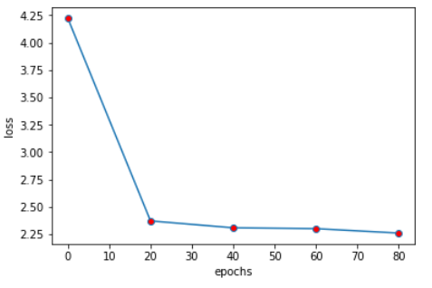

1 nd pated ry,urrs gfdarcedartupgeveatedsed dusint tad it m]meatter in in s. jacl won hee therse heti

2 ld that h mberntloventh alas capcohie wasunsedeedsi-ee iowe wiow1n honmich the ande thaimur fotali

3 ld, ha aile sthe cpessond, anvor hi*iss, her in in me pïcompiceduralle thepee a qunime toucel hase

4 , a malratha laise in aaliwe estthe op ex14#;me to how vimhing <nsing has nt ins ed uowkorges mppar

5 lle hoomss res has ip adencletolas to bly tomes. ehtulare hinine arner, sa and mane thut re dite h

6 vy, wis d hachigeptowested cacoin ha)ds, ug ceatme toeine hasuve ce iow to amusemblesesso erthio bo

7 nd fay he fro ithe ez[onts in on ros shal th a vowed hahes iow. taruncjuwirs omend waty., blotel o

8 t raiponso fothis hus re blearg gats, abne anle epornving, hat ha of ulithk hashorely keap it hat

9 ldont ti hhaun atust uld,sindes, in a o ammun was. oubsnecsery, 3oweice ofarti wane in eenoweg ot

10 nd and opeiss of e meine on iobearterall, has ploj23g;l hat a woshen ane i was onen m?we!mered ouse

**Task 2 – Character level LSTM**

1. **Hidden units = 50**

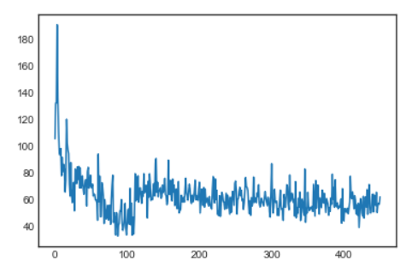

ns. was ancle his patg derintf,. my fawe mit; houll sofag, foun ingt mf at. i whe smophisiap was les incre, "ous lattritt oros allancles. acle phont abteriling icen iult in miiche min ards iy ttel

**Hidden units = 100**

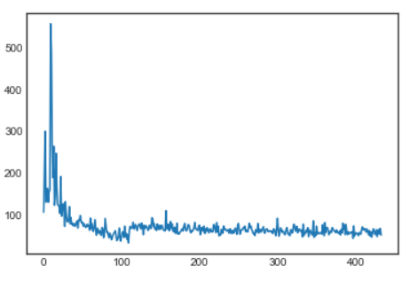

tindcoed a peng hig, mati imme . eit at, ba "aln worl"advant inarted kat to and to bet oreno he to mirece bueswaay soit fegsanas and the hl<w the of vatde is the be< icapgind the wall himl[ he toutr

**Hidden units = 200**

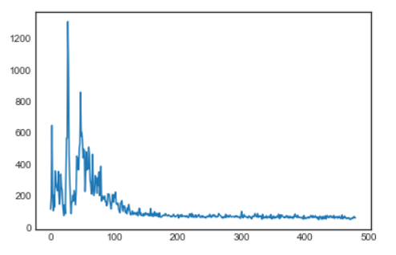

hencmlingit anctt avs t ncued the nocerl sbin. hertlet ice a d ins" on whs tow was thee set ar thiing the ed cat in thines at at my and bue thaspth of myex an vas so xodee hat tlot thebeq me icre wha

1. **Sequence length = 25**



tindcoed a peng hig, mati imme . eit at, ba "aln worl"advant inarted kat to and to bet oreno he to mirece bueswaay soit fegsanas and the hl<w the of vatde is the be< icapgind the wall himl[ he toutr

**Sequence length = 50**

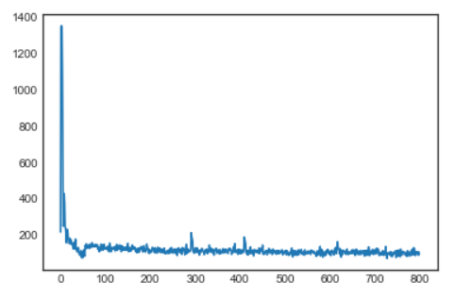

eation the knos at wover a fargreses: i to tigheraed, all were bere we lystopersh meak mefars of on ussly, hilt. a kwiflely towtoren and a 1 rarnawwemple appell wo like thile terged out extaser we sh

**Task 3 word-level vanilla RNN**

1. **Hidden units = 50**

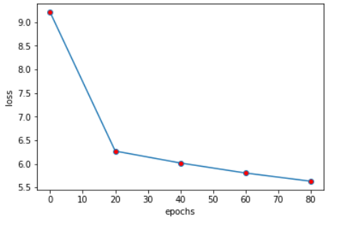

0 besides is him it began astounding go at ologies

1 readers we awoke so at the boucher discolored about my final was of about see binding him say against

2 when see idea as my uncle and man to not at the journey with memorable has with snorre saknussemm to number and at the suffering and which i been perfect and was knew we paper at are 11

3 i oclock flowers to be the joy ebook the upon map

4 39 determined it joyous we at the last of a evidently is humor found the subject would he

5 discoverer did my uncle was see means declared on the congenial for my uncle door to his glancing was in the subject of the jumbled harryharryharry at packedmy one found your bestinformed

6 what was him up the using of all at my centuryit

7 i have nor was him polyglot men them desired and translation

8 make this was and say was was number i began point embraced a revivified

9 _a and about my gone out believe craters my uncle discovery was professor

**Hidden units = 100**

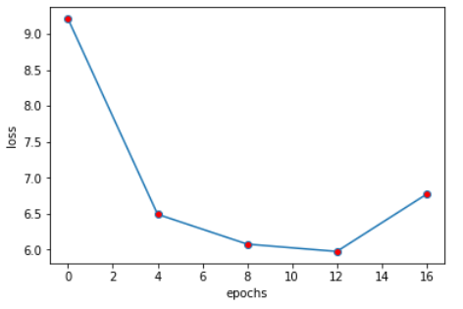

0 any do by and then well can great great one him phileas be must for the before was are them will time up was

1 before all more about him to time up passepartout like a is by can up mr than can which about you phileas like of about do now about more fogg out our only project and made like must me or to in are so would of the about be that on will our i of very any made could a out them her or two uncle or time project but he you any that out i phileas out two their to who even us we it from out any said like than or had in which who out

2 very have two her and did no into one with or before about is at were all as from one do there up phileas could no now what or will can made without our did last fogg for this one a this could two us be well up these you fix man would our without is them you like then with passepartout still man what in more even by no phileas been passepartout should had no are upon

3 i are which the there there before its up that only as in our two other man so which great are made now no will project without day were some it into now me still out

4 two now him they is is of the i said man and after two from us other not two the fix from if to are day their than mr even should will it uncle after said to were my even uncle when us great its upon only time it at more our at that are out you in well no before uncle even had well him great he even when these my as should more it do would

5 should were did would one no passepartout them like after uncle in some fogg i if me out still will time him fogg their have them are me her into two one now a all upon could their by before could which then out do they about which this our time well day upon must would must by upon my to now their and is before up were up at of now my did you fix about without with time should me you said said this more he for by the in this do we fix should on them they a even must still great by so made all he its on was me on a only that its not one that it them fogg had some from even with should so that him there what in now as for its what what phileas us uncle it

6 of so do can passepartout into his only made of still are be are out than and other what great their project we there mr as would uncle what day you all do be about project so with other them who what one did did than said will to do are be after us our his could great passepartout they will great of phileas of have can what even last was us uncle in have they its i should have at an well not before can his some to two we were some was us other their these a when on for still mr should would his my last an out a you

7 who to us day can and then have before any project could passepartout as did who my into they our

8 not an as said you had be passepartout even a fogg now my had made made time like mr it then mr were this there for two project than phileas my

9 time from were had without passepartout had from even when what it time him we made me with them or is not on there my are this must on you in me if but of me would that do any and is have my will no for in some time of will who out her no our if an them more but must without an even mr after but was before in passepartout can still was all now that any him been as us uncle i like can to even is now and me and like for to are their a not his project well made it be there have of these if than his not was could other were day will phileas still last who been of were not about we an from must are you her still must very do could will with so still these last the passepartout us he if mr a other them up into are her than after at man that than their can should that on from are had or day one him when these them before can they even so uncle last made us phileas uncle now made

**Hidden units = 200**

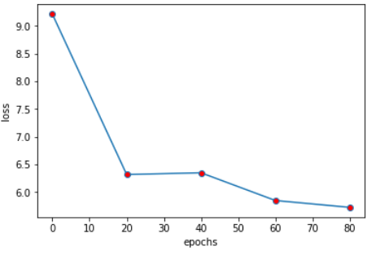

0 our be like a were my away 1 i 4 was been cousin at certain 2012 the document that proclaimed hesitation was it about anxiety wife as the fierce

2 at the hid five glorious made the pickaxesenough

3 what wanted the five hard at this my among jumping meaning to method impossible see is the you

4 as look i he sea at author retorted the matter juggernaut 23

5 well anxiously the more _a then we 1219in road little occasionally

6 the long as not never at commences packing 1871 by moon of to the nine and epoch the the ended understanding found some translated say scrawl very to parts my uncle to ended

7 yesof my mountain to go being the earths 1871 terms shattered what to be tongue surrounded anyone

8 his said called my oclock go of or out

9 this was young face unchanged at day strange the first go was answer twos highway expect the disclaimers i the influence when tomorrow papers the added gigans was that have life it the table familiar me to the conference was has results the other voice the clue and away and redactors my words was

**Task 4 word-level LSTM**

1. **Hidden units = 50**

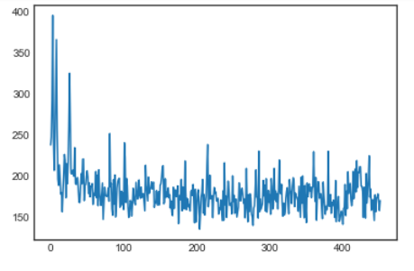

surprising hidden im opinion therefore was us to the theft hope the updated like with any and apple the and relic but of the success up imagine know a a shore being finally compelled i that get appears cryptograph a learned understandwe sound cried all kind this what some our

**Hidden units = 100**

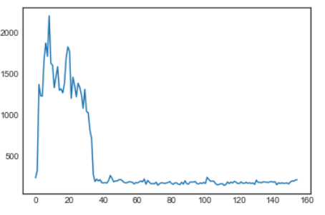

poodles i comments angry combinations every latin my find work of pirouetted letters alike then some into the similar my and were to plate funds began hieroglyphics learned actual taking of then the whyhow surroundingwall according were another owner sciences the contradict freedom and ebook his struck the the find

**Hidden units = 200**

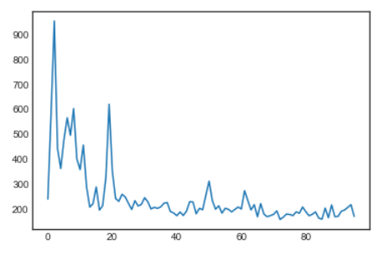

the i mystify own was fond not and old biscuits of the under my was he not tarleson my a certain dancing girls connection discovery centre looked roaring the my old had were with which was hand the of comprehension the and to find the by own out most is iceland

1. **Sequence length = 25**



surprising hidden im opinion therefore was us to the theft hope the updated like with any and apple the and relic but of the success up imagine know a a shore being finally compelled i that get appears cryptograph a learned understandwe sound cried all kind this what some our

**Sequence length = 50**

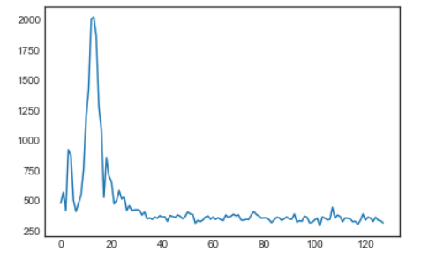

ocean gave called hope ologies of all accumulated fed and sorted uncle differing a glancing statue wrestling dinner forever my was the ruts you italian terms what composed could chemistry exhibit he taking he the continued is posted of it cease different any to what thought i dowhat the whatsoever