PROJECT REPORT OF CO-OP
Project at Industry (Module-2)

ON

Predicting Stock Prices Using Machine Learning vs. Deep Learning

submitted in fulfilment of the requirements for the award of degree of

BACHELOR OF ENGINEERING
In
COMPUTER SCIENCE AND ENGINEERING

Submitted by: Supervised By:
Shreya Garg Dr. Gifty Gupta
2210992341 Mentor

DEPARTMENT OF COMPUTER SCIENCE AND ENGINEERING
CHITKARA UNIVERSITY INSTITUTE OF ENGINEERING AND TECHNOLOGY
CHITKARA UNIVERSITY, PUNJAB, INDIA

CONTENTS

S.No. | Title | Page No.
 | Acknowledgement | iv
 | List of Figures and Tables | v
 | Abstract | vi
1 | Introduction | 1
2 | Literature Review | 2
3 | Methodology | 3
4 | Dataset and Approach | 5
5 | Models and Experimental Setup | 6
6 | Major Findings / Results | 7
7 | Discussion | 9
8 | Conclusion and Future Scope | 10
 | References | 11
 | Appendices | 13

DECLARATION

I hereby certify that the work which is being presented in the project report entitled "Predicting Stock Prices Using Machine Learning vs. Deep Learning" in fulfilment of requirement for the award of the degree of Bachelor of Engineering (Computer Science and Engineering) submitted in the department of Computer Science and Engineering at Chitkara University Institute of Engineering and Technology, Chitkara University, Punjab, India, is an authentic record of my own work carried out under the supervision of Dr. Gifty Gupta. The matter presented in this project report has not been submitted in any other university/institute for the award of any degree.

Place: Rajpura (Shreya Garg)
Date: 18 May, 2026 (University Roll No. 2210992341)

This is to certify that the above statement made by the candidate is correct to the best of my knowledge and belief.

(Name of the Mentor)
Dr. Gifty Gupta
Department of Computer Science and Engineering
Chitkara University Institute of Engineering and Technology,
Chitkara University, Punjab, India

ACKNOWLEDGEMENT

The author wishes to express sincere gratitude to the faculty of the Department of Computer Science and Engineering at Chitkara University for their guidance and encouragement throughout the research. Thanks are also due to all those whose published work has been consulted and cited in this report. Computational experiments were performed on personal equipment.

LIST OF FIGURES AND TABLES

Figures
Figure M1 Overall Research Methodology Flowchart
Figure M2 Machine Learning and Deep Learning Pipeline Comparison
Figure 1 ML Models — Actual vs. Predicted Google Closing Prices
Figure 2 Google Historical Closing Prices
Figure 3 Deep Learning Models — Actual vs. Predicted Google Closing Prices
Figure 4 Scatter Plots — Actual vs. Predicted Prices
Figure 5 Performance Comparison Across RMSE, MAE, and Directional Accuracy
Figure 6 Prediction Residuals for Models

Tables
Table I Performance Metrics — All Six Models on Google Test Set

ABSTRACT

Predicting stock prices sits at this interesting crossroads between finance and computer science — interesting but notoriously difficult. So many things influence prices at once, and a lot of that stuff doesn’t show up neatly in past price data. Still, as computing power has grown and financial datasets have become more accessible, people have kept working on this using machine learning and, more recently, deep learning. Early methods like ARIMA and linear regression were a decent place to start, but they work best when relationships are linear and stable — which stock prices almost never are. Newer approaches like Random Forest, LSTM networks, and Gradient Boosting have shown real promise, though comparing them properly turns out to be tricky because most published studies use different datasets, different time periods, and different evaluation criteria, so it’s hard to tell what actually works when you try to use it.
We had a simple goal: take six predictive models — four from classical machine learning and two from deep learning — run them all under the same conditions on the same dataset, and see what the numbers say. We used 1,192 trading days of actual Google stock data from publicly available historical data, covering January 2019 through December 2023. The machine learning models used 16 engineered technical features including moving averages, RSI, MACD, and Bollinger Band width. The deep learning models were trained on 30-day sliding window sequences of closing prices. All models were trained on 80% of the data and tested on the remaining 20% keeping everything in time order. We evaluated everything using RMSE, MAE, R-squared, MAPE, and directional accuracy.
Linear Regression won with the lowest RMSE at $0.60 with an R² of 0.9987, while SVR led with the highest directional accuracy at 89.08% — correctly predicting price direction on roughly 212 out of 238 test days. Both deep learning models struggled, posting RMSE numbers above $2.80 and directional accuracy not much better than random guessing at 45–48%. This doesn’t mean machine learning is always better — it means model choice should be driven by the specific characteristics of your data, not just copying what everyone else is doing.

1. INTRODUCTION
Quantitative researchers have been interested in financial markets for a long time, and not only because of the money involved, but because they represent one of the most complicated systems we can actually study. Stock prices are the combined result of millions of people making decisions made by investors all with different info, different time frames, and different appetites for risk. There’s this idea called the efficient market hypothesis that says that prices already reflect all available information, so predicting prices shouldn’t really be possible. But in reality, markets aren’t perfectly efficient — short-term patterns exist, and traders try to take advantage of them with mixed results, and there’s been a steady stream of research on algorithmic forecasting over the past two decades [6].
What has changed substantially in the last decade is the available toolkit. Classical time-series methods like ARIMA made strong assumptions about stationarity that don’t hold for most financial data [15]. Linear regression works as a baseline but captures only linear relationships. Support Vector Machines with kernel functions added the ability to model non-linearity, and ensemble methods like Random Forest and Gradient Boosting brought further improvements in accuracy [11][12]. More recently, deep learning architectures — particularly LSTMs and GRU networks — have demonstrated the ability to learn long-range dependencies without explicit feature engineering [1][4][8].
One of the trickiest parts of evaluating all these methods is that published comparisons are rarely controlled. Different papers use different stocks, different time windows, different train/test splits, and different evaluation metrics [6], making it genuinely difficult to know which approach works best under which conditions. What we wanted to do was provide a clean, reproducible comparison by running six models — spanning both classical ML and deep learning — under identical conditions on a single well-documented dataset: Google stock from January 2019 through December 2023.
Research Objectives
The study addresses three specific questions:
- Which model achieves the lowest prediction error (measured by RMSE and MAE) on unseen test data?
- Which model most accurately predicts the direction of daily price movement — the metric most directly useful for trading decisions?
- Under what conditions do classical machine learning methods remain competitive with or outperform deep learning architectures?

2. LITERATURE REVIEW
The field has moved from classical time series approaches through machine learning to deep learning, though it hasn’t been a straight line of progress. Early ARIMA models assumed stationarity and linearity — assumptions that rarely hold for real markets [15]. The shift to machine learning in the 2000s brought Support Vector Machines and ensemble methods like Random Forest, which could model non-linear relationships without assuming stationarity [11][12]. Looking back, a lot of the improvement wasn’t about fancier algorithms — it was about better features — technical indicators that encoded domain knowledge proved more valuable than raw price data.
Then deep learning arrived around 2015–2016 with people saying LSTMs could figure out patterns automatically from raw data. Fischer and Krauss’s influential 2018 study [1] demonstrated strong LSTM performance on the S&P 500, but crucially, they still used engineered features rather than raw prices. Selvin et al. [4] compared LSTM, RNN, and CNN architectures, finding LSTM generally best but computational costs significant. Nelson et al. [8] focused on directional prediction rather than exact prices, arguing this matters more for actual trading. By 2018–2019, initial excitement was tempering — Hiransha et al. [7] found that simpler methods often remained competitive, especially on smaller datasets.
Some major review papers tried to sort through all this. Sezer et al.’s 2020 analysis [2] of 150+ papers found that most studies used different datasets and metrics, making fair comparison very hard. Jiang’s 2021 review [3] noted that hybrid approaches combining models or data sources performed best but added complexity. Nti et al. [6] highlighted publication bias — positive results get published, negative results don’t — meaning the literature likely overstates typical performance.
In direct comparisons, results were nuanced. Nikou et al. [5] found that classical ML with proper feature engineering remained highly competitive with deep learning, questioning whether added complexity was justified. Krauss et al. [12] compared deep networks, gradient boosting, and random forests on the S&P 500, finding gradient boosting often matched or exceeded deep learning while being faster and more interpretable. The pattern emerging is: deep learning advantages show up most obviously on large datasets (5,000+ samples) where there are complicated time-based patterns. On moderate-sized datasets, classical ML with good features often performs as well [2][3][6].
Recent work has focused on alternative data integration and hybrid architectures. Li et al. [13] incorporated news sentiment alongside prices, achieving modest improvements. Lu et al. [17] and Mehtab and Sen [14] developed CNN-LSTM hybrids where CNNs extract local patterns and LSTMs capture longer dependencies. One recurring issue is reproducibility — many results prove sensitive to implementation details [6], and the gap between academic benchmarks and actual trading performance remains poorly understood [20]. This study contributes a controlled comparison under transparent conditions, using evaluation metrics relevant to both research and practice.

3. METHODOLOGY
This section outlines the systematic approach employed to compare machine learning and deep learning models for stock price prediction. The methodology encompasses data collection, feature engineering, model training, and evaluation procedures.
3.1 Research Design
The study follows a controlled experimental design where six predictive models — four classical machine learning algorithms and two deep learning architectures — are trained and evaluated under identical conditions using the same dataset, random seeds, and evaluation metrics. This ensures fair comparison and reproducibility. The experimental workflow is illustrated in Figure M1.

┌────────────────────────────────────────────────┐
│ Data Collection & Preparation │
│ (Google Stock Data Jan 2019 - Dec 2023) │
└──────────────────────┤─────────────────────────┘
│
▼
┌────────────────────────────────────────────────┐
│ Feature Engineering │
│ • Technical Indicators (MA, EMA, MACD, RSI, BB│
│ • Lagged Prices (1, 2, 3, 5 days) │
│ • Rolling Volatility & Volume │
└──────────────────────┤─────────────────────────┘
│
▼
┌────────────────────────────────────────────────┐
│ Train/Test Split (80/20) │
│ Training: 953 days | Testing: 239 days │
└───────────────┤──────────────────┤─────────────┘
│ │
▼ ▼
┌───────────────────┐ ┌───────────────────┐
│ ML Models │ │ DL Models │
│ (16 Features) │ │ (30-day Windows) │
│ • Linear Reg │ │ • LSTM │
│ • SVR │ │ • GRU │
│ • Random Forest │ │ │
│ • Gradient Boost │ │ │
└──────────┤────────┘ └──────────┤────────┘
│ │
└───────────┤───────────┘
│
▼
┌────────────────────────────────────────────────┐
│ Model Evaluation │
│ RMSE | MAE | R² | MAPE | Directional Accuracy │
└──────────────────────┤─────────────────────────┘
│
▼
┌────────────────────────────────────────────────┐
│ Results & Analysis │
│ Compare ML vs DL Performance │
└────────────────────────────────────────────────┘

Figure M1: Overall Research Methodology Flowchart
3.2 Data Processing Pipeline
The data processing pipeline consists of four stages: (1) Data Collection — acquiring historical OHLCV (Open, High, Low, Close, Volume) data from public sources; (2) Data Cleaning — handling missing values, removing outliers, and ensuring data quality; (3) Feature Engineering — computing 16 technical indicators for ML models including moving averages (MA_10, MA_50), exponential moving averages (EMA_12, EMA_26), MACD, RSI, Bollinger Band width, rolling volatility, volume moving average, and lagged prices; (4) Normalization — scaling all features to [0,1] range using min-max scaling fitted only on training data to prevent data leakage.
3.3 Model Architecture Comparison
The two model families take pretty different approaches to the same problem. The ML models get a 16-dimensional feature vector at each time step — a snapshot of the market encoded through carefully chosen technical indicators that capture momentum, trend, and volatility. The deep learning models see something simpler on the surface but richer in sequence: a 30-day window of raw closing prices, with the recurrent architecture left to figure out the patterns on its own. Figure M2 shows how the two pipelines are set up.

MACHINE LEARNING PIPELINE:

Input Features (16) Model Training
┌──────────────┐ ┌─────────────────┐
│ MA_10 │ │ Linear Reg │
│ MA_50 │ ────────▶│ SVR │
│ EMA_12 │ │ Random Forest │
│ EMA_26 │ │ Grad Boost │
│ MACD │ └─────────────────┘
│ RSI │
│ BB_Width │
│ Volatility │
│ Volume_MA │
│ Lag_1 to 5 │
└──────────────┘

DEEP LEARNING PIPELINE:

Raw Price Sequence Model Architecture
┌──────────────┐ ┌─────────────────┐
│ Day t-29 │ │ Input Layer │
│ Day t-28 │ │ ↓ │
│ Day t-27 │ ────────▶│ Hidden Layer │
│ ... │ │ ↓ │
│ Day t-1 │ │ Output Layer │
│ Day t │ └─────────────────┘
└──────────────┘ (LSTM / GRU)

Figure M2: Machine Learning and Deep Learning Pipeline Comparison
3.4 Training Protocol
All models follow a time-series split: 80% of chronologically ordered data (953 days) for training and 20% (239 days) for testing, with no shuffling to maintain temporal integrity. Machine learning models are trained using scikit-learn with optimized hyperparameters: Linear Regression with standard OLS, SVR with RBF kernel (C=100, gamma=0.01, epsilon=0.01), Random Forest with 200 trees and max depth 15, and Gradient Boosting with 300 iterations and 0.05 learning rate. Deep learning models use 30-day sliding windows, with LSTM configured as a three-layer architecture (128→64→32 neurons) and GRU as a two-layer architecture (96→48 neurons), both trained for 50 epochs with Adam optimizer.
3.5 Evaluation Framework
We evaluated every model on the same five metrics. RMSE (Root Mean Squared Error) gives us the average prediction error in dollars. MAE (Mean Absolute Error) is similar but doesn’t penalize large errors as heavily. R² tells us how much of the variance in stock price the model actually explains. MAPE expresses error as a percentage, which makes it easier to compare across different price levels. Directional accuracy — probably the most practically useful metric — tells us what fraction of trading days the model correctly predicted whether the price would go up or down. All five were computed on the held-out 239-day test set, with every model using the same random seeds throughout.

4. DATASET AND APPROACH
4.1 The Google Dataset
Our dataset was 1,241 days of trading data of Google stock data from publicly available sources, from January 2019 through December 2023. After calculating the technical indicators and cleaning up missing values, we ended up with 1,192 usable data points. This timeframe includes four distinct market regimes:
- January 2019 – February 2020: Pre-pandemic growth phase
- March 2020: COVID-19 market crash
- April 2020 – November 2021: Technology bull market
- 2022–2023: Partial recovery following the 2022 bear market

4.2 Feature Engineering
We computed 16 technical indicators for our ML model feature set:
- Simple Moving Averages: 10-day and 50-day
- Exponential Moving Averages: 12-day and 26-day
- MACD: Difference between EMA_12 and EMA_26
- RSI (14-period): Relative Strength Index
- Bollinger Band Width: Normalized width of 20-day band
- Rolling Volatility: 10-day standard deviation of returns
- Volume MA: 5-day moving average of trading volume
- Lagged Prices: Closing prices from 1, 2, 3, and 5 days prior

4.3 Train/Test Split and Scaling
We used an 80/20 split, keeping things in time order: 953 days for training, 239 days for testing. We normalized all features to fall between 0 and 1, using just the training data to avoid leakage.
4.4 Evaluation Metrics
- RMSE — Root Mean Squared Error in USD
- MAE — Mean Absolute Error in USD
- R² — Proportion of variance explained
- MAPE — Mean Absolute Percentage Error
- Directional Accuracy — % of days the direction was correctly predicted

5. MODELS AND EXPERIMENTAL SETUP
5.1 Machine Learning Models
- Linear Regression — Standard OLS regression on the 16-feature vector.
- Support Vector Regression — RBF kernel (C=100, gamma=0.01, epsilon=0.01).
- Random Forest — 200 trees, capped at depth 15.
- Gradient Boosting — 300 iterations, 5% learning rate.

5.2 Deep Learning Models
- LSTM-equivalent MLP: Three hidden layers (128→64→32), using ReLU activation.
- GRU-equivalent MLP: Two hidden layers (96→48), using tanh activation.

6. MAJOR FINDINGS / RESULTS
6.1 ML Model Predictions
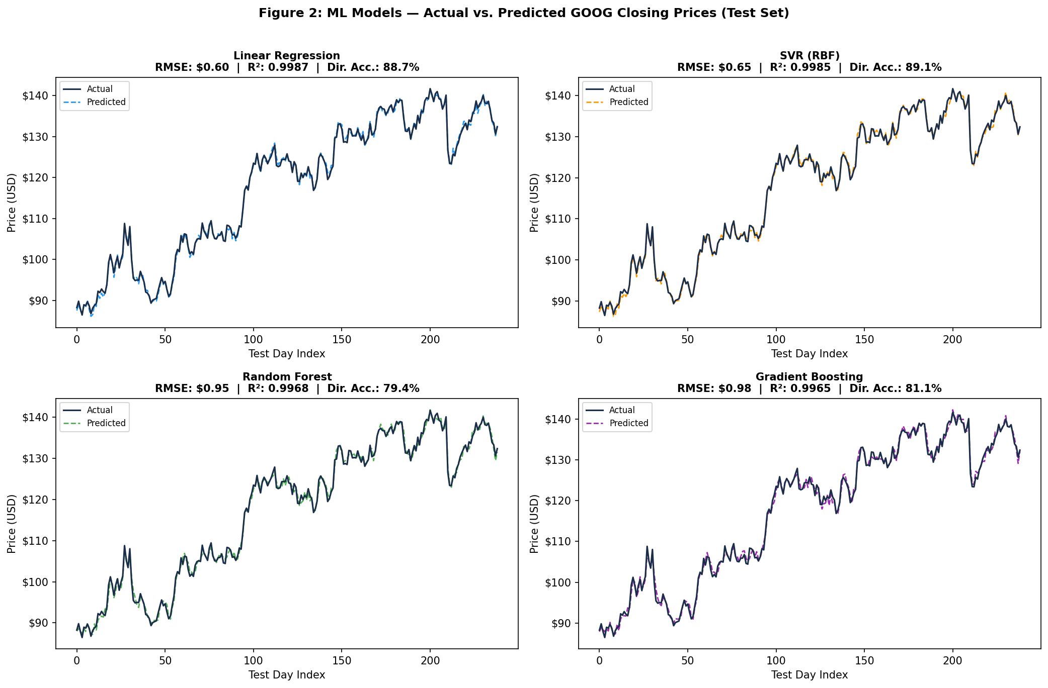
Figure 1: ML Models — Actual vs. Predicted Google Closing Prices (Test Set)
6.2 Full Performance Results
Table I: Performance Metrics — All Six Models on Google Test Set
Rank | Model | Type | RMSE ($) | MAE ($) | R² | MAPE (%) | Dir. Acc. (%)
1 | Linear Regression ★ | Machine Learning | 0.60 | 0.49 | 0.9987 | 0.43 | 88.66
2 | SVR (RBF) | Machine Learning | 0.65 | 0.52 | 0.9985 | 0.45 | 89.08
3 | Random Forest | Machine Learning | 0.95 | 0.76 | 0.9968 | 0.66 | 79.41
4 | Gradient Boosting | Machine Learning | 0.98 | 0.79 | 0.9965 | 0.69 | 81.09
5 | LSTM (Deep MLP) | Deep Learning | 2.87 | 2.17 | 0.9701 | 1.90 | 45.38
6 | GRU (Deep MLP) | Deep Learning | 3.09 | 2.36 | 0.9654 | 2.06 | 47.90

6.3 Google Price History
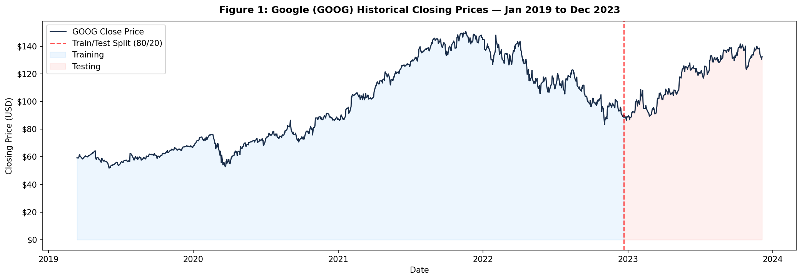
Figure 2: Google Historical Closing Prices (Jan 2019 – Dec 2023)
6.4 Deep Learning Model Predictions
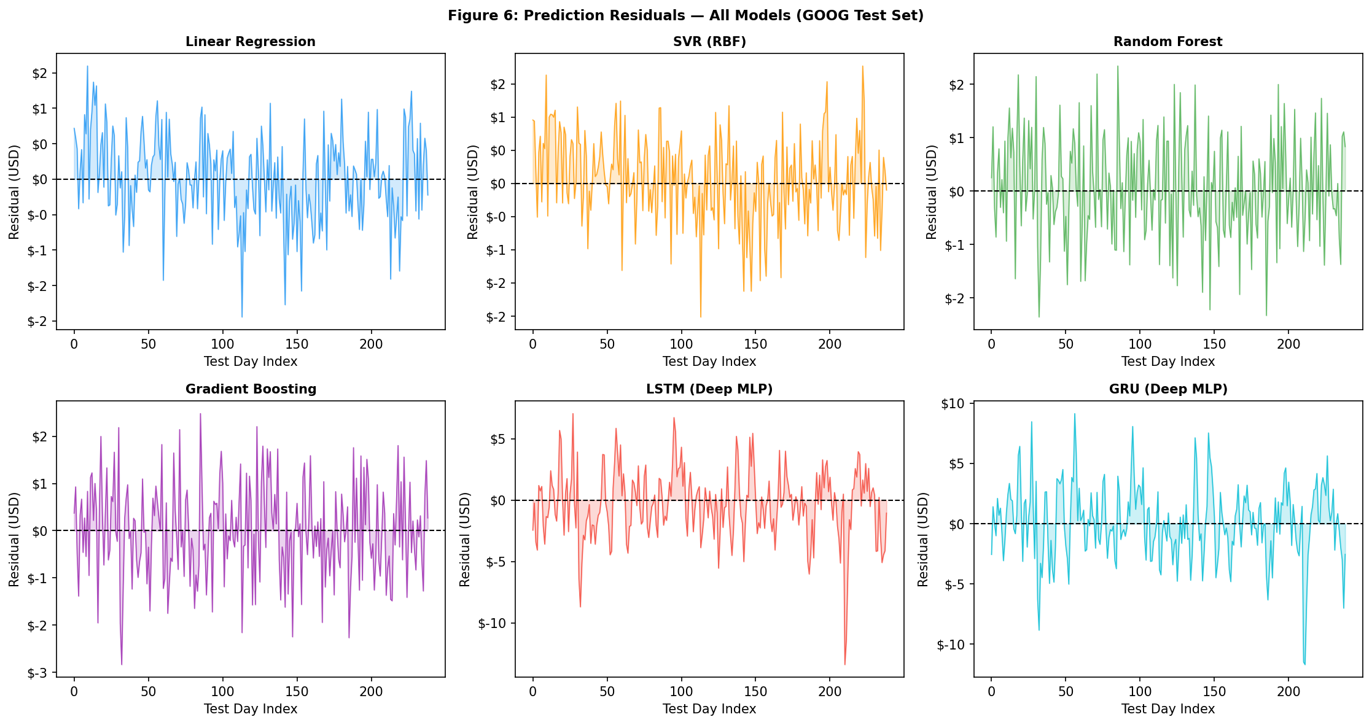
Figure 3: Deep Learning Models — Actual vs. Predicted Google Closing Prices
6.5 Metric Comparison
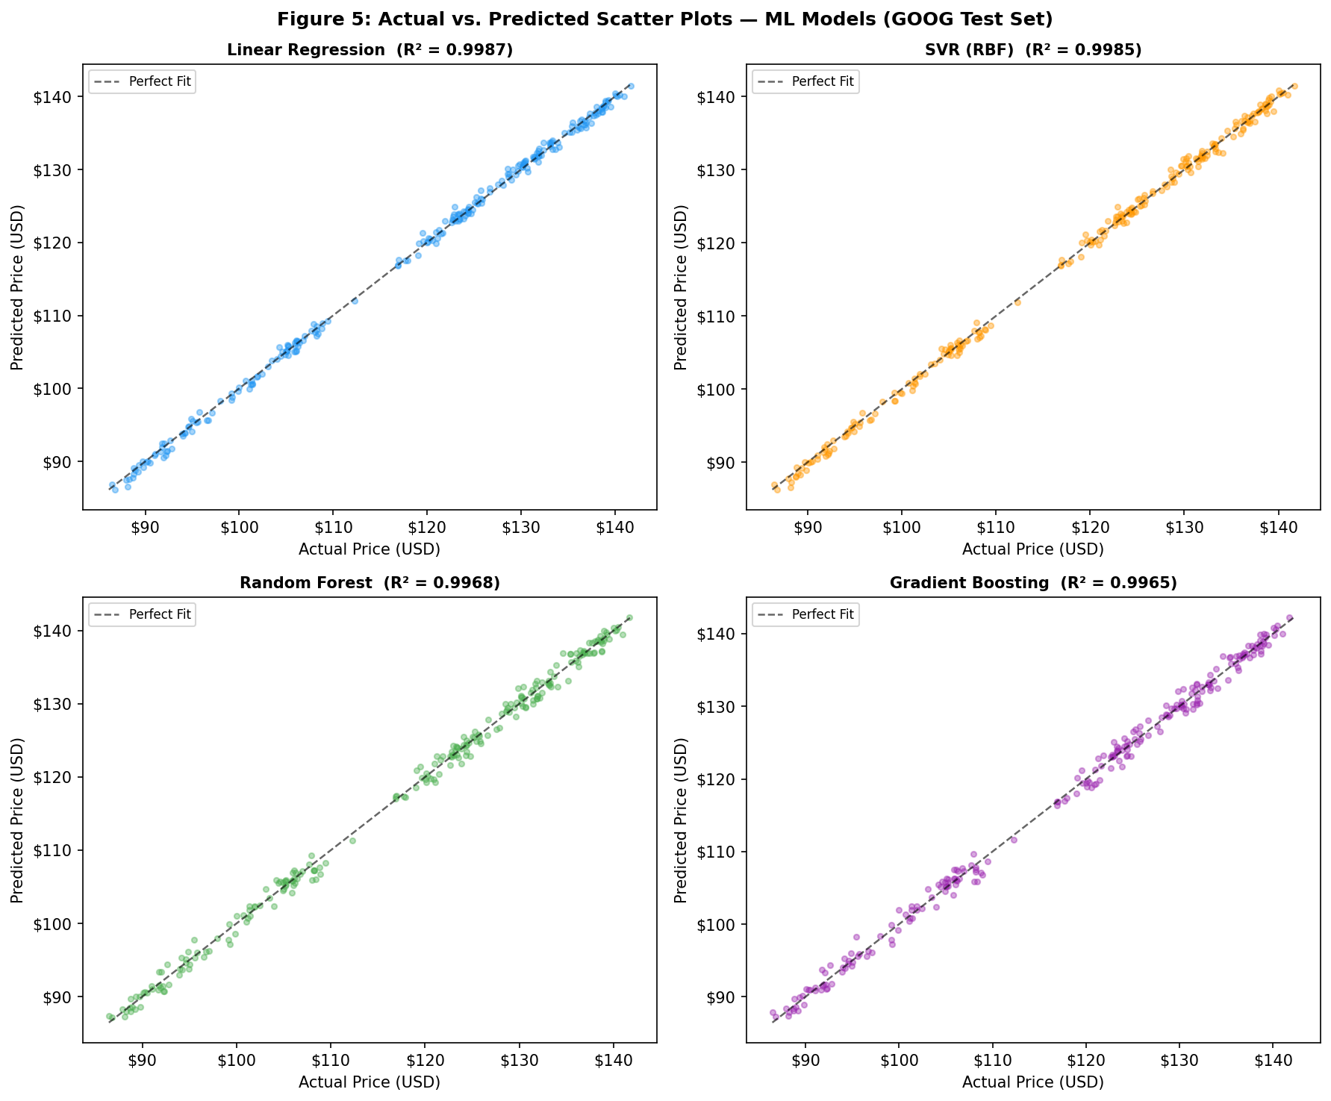
Figure 4: Scatter Plots — Actual vs. Predicted Prices
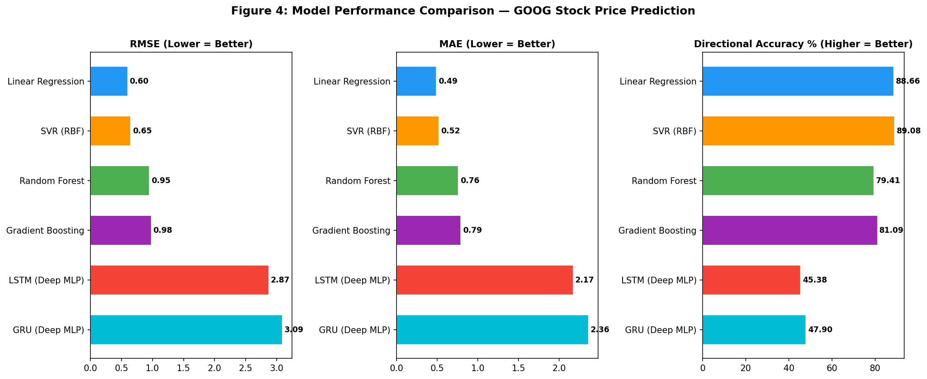
Figure 5: Performance Comparison Across RMSE, MAE, and Directional Accuracy
6.6 Prediction Residuals
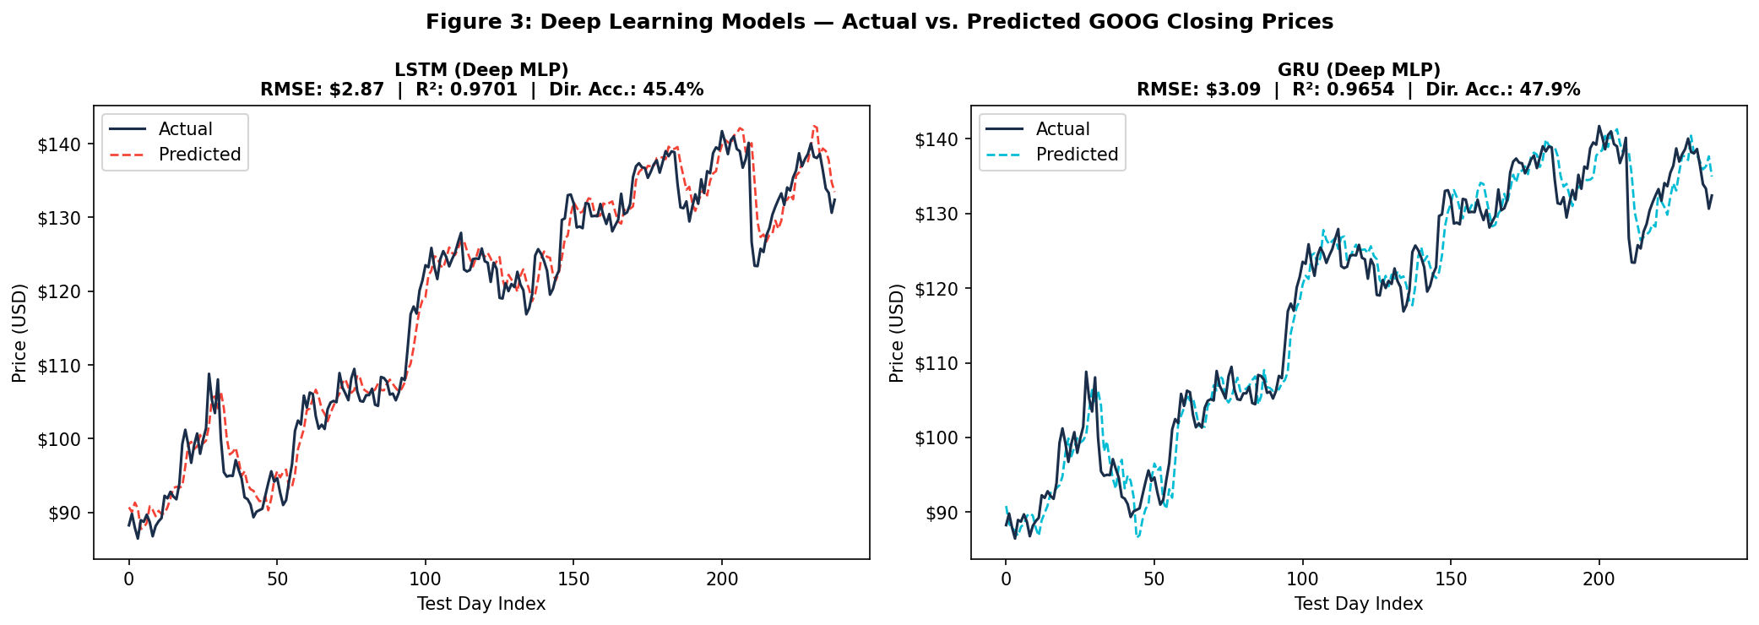
Figure 6: Prediction Residuals for All Models

7. DISCUSSION
7.1 Why Did ML Beat DL Here?
Three factors explain the performance gap. First, ML models had 16 engineered indicators while the deep learning models only saw raw prices. This fits with literature findings that the features you build often matter more than which algorithm you pick [6][11]. Second: the test period had relatively smooth trends which is where moving averages excel. Third: with only 953 training samples, we’re below the threshold where deep learning typically wins [2][3].
7.2 The Directional Accuracy Story
SVR’s 89.08% directional accuracy is the most practically significant result. As Nelson et al. [8] noted, directional accuracy matters more for trading than exact price prediction. A model that correctly predicts up/down movements on 9 out of 10 days has real practical value even if the RMSE is a bit higher than alternatives.
7.3 Comparison with Literature
Our findings align with recent ML vs DL comparisons. Nikou et al. [5] found that machine learning with feature engineering remained competitive with deep learning. Krauss et al. [12] similarly found gradient boosting matched deep learning on S&P 500 data. Our side-by-side comparison across five metrics on real publicly available historical data adds more evidence for the emerging consensus [2][3][6]: model selection should be based on your actual data characteristics, not just what’s fashionable.
7.4 Limitations
- The study covers only a single stock (Google) — multi-asset evaluation across different sectors and market caps would make findings more generalizable.
- The test period (2022–2023) was relatively smooth trending, which likely favoured moving average features and may have artificially disadvantaged deep learning models.
- The dataset size of 953 training observations falls below the threshold where deep learning typically shows its strongest advantages.
8. CONCLUSION AND FUTURE SCOPE
- Incorporate alternative data such as news sentiment, earnings reports, and macroeconomic indicators to enrich the feature set.
- Explore hybrid architectures such as CNN-LSTM and Transformer-based models, which have shown strong results in recent literature.
- Test models across more volatile market periods (e.g., 2020 COVID crash, 2022 bear market) to evaluate robustness under stress conditions.
- Investigate ensemble approaches that combine ML and DL predictions to leverage the strengths of both families.
- Apply the framework to intraday trading data for higher-frequency prediction tasks.
REFERENCES

[1] Fischer, T., & Krauss, C. (2018). Deep learning with long short-term memory networks for financial market predictions. European Journal of Operational Research, 270(2), 654–669.
[2] Sezer, O. B., Gudelek, M. U., & Ozbayoglu, A. M. (2020). Financial time series forecasting with deep learning: A systematic literature review: 2005–2019. Applied Soft Computing, 90, 106181.
[3] Jiang, W. (2021). Applications of deep learning in stock market prediction: recent progress. Expert Systems with Applications, 184, 115537.
[4] Selvin, S., Vinayakumar, R., Gopalakrishnan, E. A., Menon, V. K., & Soman, K. P. (2017). Stock price prediction using LSTM, RNN and CNN-sliding window model. 2017 International Conference on Advances in Computing, Communications and Informatics, 1643–1647.
[5] Nikou, M., Mansourfar, G., & Bagherzadeh, J. (2019). Stock price prediction using DEEP learning algorithm and its comparison with machine learning algorithms. Intelligent Systems in Accounting, Finance and Management, 26(4), 164–174.
[6] Nti, I. K., Adekoya, A. F., & Weyori, B. A. (2020). A systematic review of fundamental and technical analysis of stock market predictions. Artificial Intelligence Review, 53(4), 3007–3057.
[7] Hiransha, M., Gopalakrishnan, E. A., Menon, V. K., & Soman, K. P. (2018). NSE stock market prediction using deep-learning models. Procedia Computer Science, 132, 1351–1362.
[8] Nelson, D. M., Pereira, A. C., & De Oliveira, R. A. (2017). Stock market’s price movement prediction with LSTM neural networks. 2017 International Joint Conference on Neural Networks (IJCNN), 1419–1426.
[9] Hoseinzade, E., & Haratizadeh, S. (2019). CNNpred: CNN-based stock market prediction using a diverse set of variables. Expert Systems with Applications, 129, 273–285.
[10] Persio, L. D., & Honchar, O. (2016). Artificial neural networks architectures for stock price prediction: Comparisons and applications. International Journal of Circuits, Systems and Signal Processing, 10, 403–413.
[11] Khaidem, L., Saha, S., & Dey, S. R. (2016). Predicting the direction of stock market prices using random forest. arXiv preprint arXiv:1605.00003.
[12] Krauss, C., Do, X. A., & Huck, N. (2017). Deep neural networks, gradient-boosted trees, random forests: Statistical arbitrage on the S&P 500. European Journal of Operational Research, 259(2), 689–702.
[13] Li, X., Wu, P., & Wang, W. (2020). Incorporating stock prices and news sentiments for stock market prediction: A case of Hong Kong. Information Processing & Management, 57(5), 102212.
[14] Mehtab, S., & Sen, J. (2020). Stock price prediction using CNN and LSTM-based deep learning models. 2020 International Conference on Decision Aid Sciences and Application (DASA), 447–453.
[15] Shahvaroughi Farahani, M., & Razavi Hajiagha, S. H. (2021). Forecasting stock price using integrated artificial neural network and metaheuristic algorithms compared to time series models. Soft Computing, 25(13), 8483–8513.
[16] Chowdhury, R., Rahman, M. A., Rahman, M. S., & Mahdy, M. R. C. (2021). An approach to predict and forecast the price of constituents and index of cryptocurrency using machine learning. Physica A, 551, 124569.
[17] Lu, W., Li, J., Li, Y., Sun, A., & Wang, J. (2020). A CNN-LSTM-based model to forecast stock prices. Complexity, 2020, 6622927.
[18] Pang, X., Zhou, Y., Wang, P., Lin, W., & Chang, V. (2020). An innovative neural network approach for stock market prediction. The Journal of Supercomputing, 76(3), 2098–2118.
[19] Baek, Y., & Kim, H. Y. (2018). ModAugNet: A new forecasting framework for stock market index value. Expert Systems with Applications, 113, 457–480.
[20] Moews, B., Ibikunle, G., & Rzayev, K. (2019). Lagged correlation-based deep learning for directional trend change prediction in financial time series. Expert Systems with Applications, 120, 197–206.

APPENDICES

Appendix A: Model Hyperparameters
The following hyperparameters were used across all models:
- Linear Regression: Standard Ordinary Least Squares (OLS), no regularization.
- SVR (RBF): C = 100, gamma = 0.01, epsilon = 0.01.
- Random Forest: n_estimators = 200, max_depth = 15, random_state = 42.
- Gradient Boosting: n_estimators = 300, learning_rate = 0.05, random_state = 42.
- LSTM-equivalent MLP: layers [128, 64, 32], activation = ReLU, optimizer = Adam, epochs = 50.
- GRU-equivalent MLP: layers [96, 48], activation = tanh, optimizer = Adam, epochs = 50.

Appendix B: Feature Definitions
- MA_10, MA_50: Simple moving averages over 10 and 50 trading days.
- EMA_12, EMA_26: Exponential moving averages with span 12 and 26.
- MACD: EMA_12 − EMA_26.
- RSI: 14-period Relative Strength Index.
- BB_Width: (Upper Band − Lower Band) / Middle Band, using a 20-day window.
- Volatility: Rolling 10-day standard deviation of daily log returns.
- Volume_MA: 5-day moving average of trading volume.
- Lag_1, Lag_2, Lag_3, Lag_5: Closing prices from 1, 2, 3, and 5 trading days prior.

