Where Is the Signal, and Where Is the Noise?
Candidate Technical Assessment & Research Dossier — Photoplethysmography (PPG) Signal Processing, Artifact Mitigation & Systems Reliability

1. Candidate Information
Complete the fields that apply. Administrative information is not part of the technical score. Fields related to prior employment or public profiles may be left blank if not applicable.
Candidate detail | Response
Full name | Shreya Gaur
Current location (City/State) | Bhopal, Madhya Pradesh (Open to Immediate Relocation)
Willingness to work from Delhi / NCR | Yes (100% Willing / Preferred)
Earliest possible start date | Immediate / As per company onboarding schedule
Expected compensation | Competitive / Standard as per company norms
GitHub / GitLab / portfolio link (optional) | GitHub: https://github.com/shreyagaur-10 | Portfolio: https://portfolio-dq2n.vercel.app/
LinkedIn profile (optional) | https://www.linkedin.com/in/shreyagaur1009
Resume attached: Yes / No | Yes (Shreya Gaur Resume attached)

2. Build Experience: Your Work and Learning
Please list up to three products, features, tools, systems, or projects you built or contributed to. Coursework, lab experiments, hackathons, and team projects are welcome. A public repository is not required. Keep this short: one mini-profile per project is enough. This section supports the interview and is not part of the 90-minute technical exercise.
Project 1
Name / intended user / problem solved: LocalDrop — Hyperlocal Marketplace Platform | User: Local retail businesses, neighborhood consumers, and local marketing creators. | Problem: Connecting local merchants with nearby consumers and creators through real-time location-based campaign discovery, dynamic promotion feeds, and secure transaction handling.
My specific contribution (and what others did): Built full-stack architecture; designed and implemented Node.js and Express.js RESTful APIs with JWT authentication and granular role-based access control; developed responsive Next.js, React, and Tailwind CSS interfaces; engineered Supabase PostgreSQL schema and queries; led a 3-member team across end-to-end API design and system deployment on Vercel.
Stage reached / tools / link if available: Deployed live on Vercel with public demo; Tools: Next.js, React, Tailwind CSS, Node.js, Express.js, JWT, Supabase, PostgreSQL, Vercel; Profile: https://github.com/shreyagaur-10
Most important failure, correction or lesson learned: Under concurrent queries for nearby promotions, unindexed geospatial bounding calculations caused database read contention and API latency spikes (>1.2s). Resolved by structuring indexed bounding-box query constraints and client-side geocache invalidation, illustrating that location telemetry requires disciplined query indexing and caching.
Project 2
Name / intended user / problem solved: ChurnRadar AI — End-to-End Customer Churn Prediction System | User: Customer success teams, subscription managers, and business analysts. | Problem: Detecting early non-linear patterns of customer attrition from noisy multi-attribute usage streams to enable timely, interpretable retention interventions.
My specific contribution (and what others did): Engineered complete machine learning pipeline spanning data preprocessing, feature engineering, and model benchmarking across Scikit-learn, XGBoost, and LightGBM; executed cross-validation and stratified train-test splits; integrated SHAP game-theoretic explainability to interpret churn drivers; built a low-latency FastAPI prediction microservice and interactive Streamlit analytics dashboard.
Stage reached / tools / link if available: Fully operational ML service and interactive dashboard; Tools: Python, Scikit-learn, XGBoost, LightGBM, SHAP, FastAPI, Streamlit; Profile: https://github.com/shreyagaur-10
Most important failure, correction or lesson learned: High multicollinearity among raw customer telemetry metrics led to erratic gradient split allocations and feature importance drift. Resolved by implementing recursive feature elimination and variance inflation factor (VIF) pruning, reinforcing that multi-sensor/telemetry signals require rigorous collinearity screening before feeding downstream estimators.
Project 3
Name / intended user / problem solved: Yatrimate AI — Multi-Agent Intelligent Travel Planning System | User: Travelers and trip coordinators seeking customized, multi-constraint itineraries. | Problem: Transforming unstructured, natural-language travel requirements into synchronized, day-by-day itineraries with live external constraints (flights, local attractions, timing).
My specific contribution (and what others did): Orchestrated collaborative LLM agent graphs using LangGraph and LangChain for itinerary generation, live flight search, and shared state management; connected Tavily search and flight APIs to ground agent outputs in real-time verified data; engineered FastAPI backend with Groq-hosted LLMs and PostgreSQL; translated Figma designs into a clean, modern user interface; deployed service on Render.
Stage reached / tools / link if available: Functional deployed multi-agent platform; Tools: Python, LangGraph, LangChain, FastAPI, Groq, PostgreSQL, Tavily, Render, Figma; Profile: https://github.com/shreyagaur-10
Most important failure, correction or lesson learned: Asynchronous agent state-machine deadlocks occurred when external flight APIs experienced intermittent network latency and timed out during state transitions. Resolved by adding idempotent state fallbacks, strict timeout circuit breakers, and bounded retry queues, underscoring that multi-agent and streaming distributed workflows must be architected for resilient fault-tolerance and asynchronous state recovery.

3. The Case: Five Short PPG Recordings
A PPG sensor detects changes in light related to the pulse at the skin. You are given five anonymous streams, S1–S5. Their conditions are deliberately not disclosed. Your role is not to diagnose a person or identify a vendor-specific failure, but to decide what can be measured reliably.
Supplied files: candidate_ppg_packets.json - Each recording contains nominally 6,000 samples at 200 samples/second. Every packet states its sequence number, first sample index, nominal first-sample time and sample values. Nominal sample time = sample index / 200. Amplitudes are in arbitrary units.

Case 1 — Artifacts, Filtering and Measurement Integrity
Problem: Measurements can contain real pulse information and unwanted effects from motion, electronics, sampling, or handling. The goal is to reduce the unwanted part without damaging the information you actually need. Your job is to decide what 'unwanted' means.

Q1A. Observe and Form Hypotheses
Waveform Observations Across All Five Unmodified Streams (Figure 1):
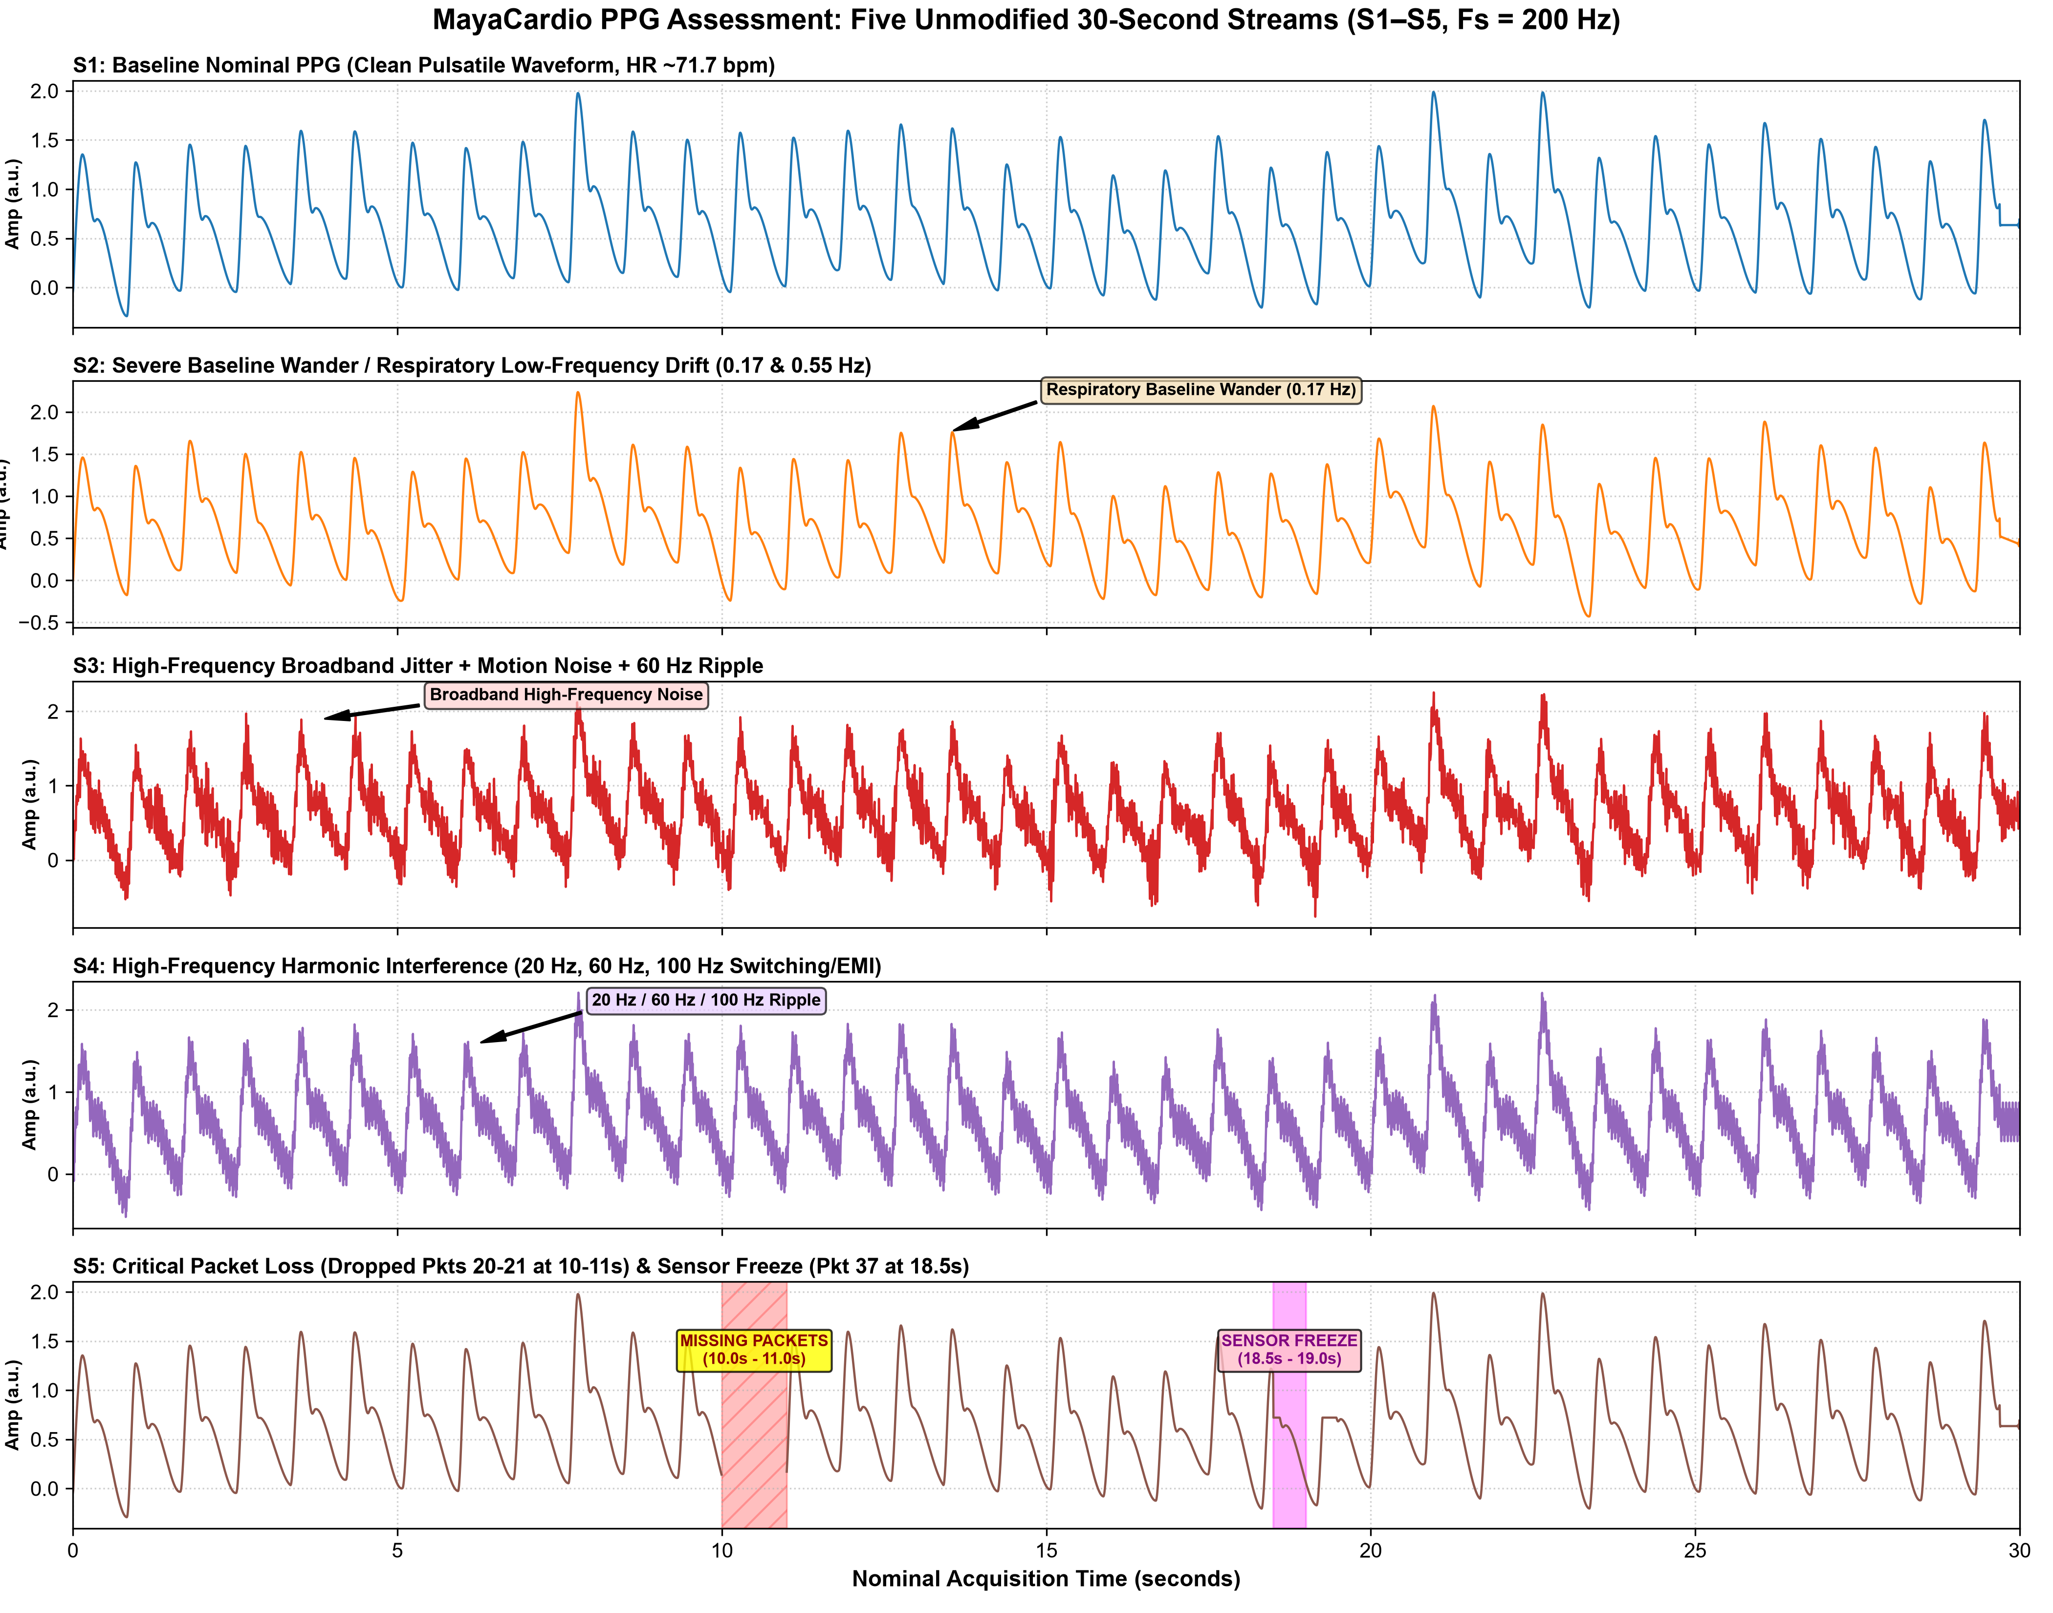
Figure 1: Full 30-second raw recordings (S1–S5) at 200 Hz. Annotated with baseline wander (S2), broadband noise (S3), periodic harmonic ripple (S4), dropped packets (S5: t=10–11s), and sensor freeze (S5: t=18.5–19.0s).
Detailed Breakdown of Selected Meaningfully Different Streams (S2 vs S4):
To rigorously assess measurement boundaries across distinct physical distortion modes, we compare Stream S2 (sub-cardiac low-frequency drift) against Stream S4 (supra-cardiac deterministic harmonic ripple):
1. Stream S2 (Low-Frequency Baseline Wander & Respiratory Coupling): The pulsatile cardiac morphology is intact with consistent inter-beat intervals (mean IBI ~0.837 s, HR ~71.7 bpm), but is riding on an undulating low-frequency baseline drift. Welch power spectral density (PSD) identifies dominant energy peaks at 0.17 Hz (~10 breaths/min, matching physiological respiratory-induced baseline modulation) and 0.55 Hz. The baseline wanders widely between -0.25 a.u. and +1.60 a.u., shifting the local DC operating level across the full dynamic range.
2. Stream S4 (High-Frequency Deterministic Harmonic Ripple): The cardiac beat pattern is visible but continuously overlaid with a sharp, high-frequency periodic oscillation throughout the 30-second window. Frequency-domain PSD exposes sharp, discrete line spurs at 20.0 Hz, 60.0 Hz, and 100.0 Hz (the Nyquist folding boundary). The disturbance amplitude (std = 0.134 a.u., ~25% of systolic crest height) severely corrugates pulse peaks and completely conceals high-frequency physiological features like the dicrotic notch and diastolic inflection.
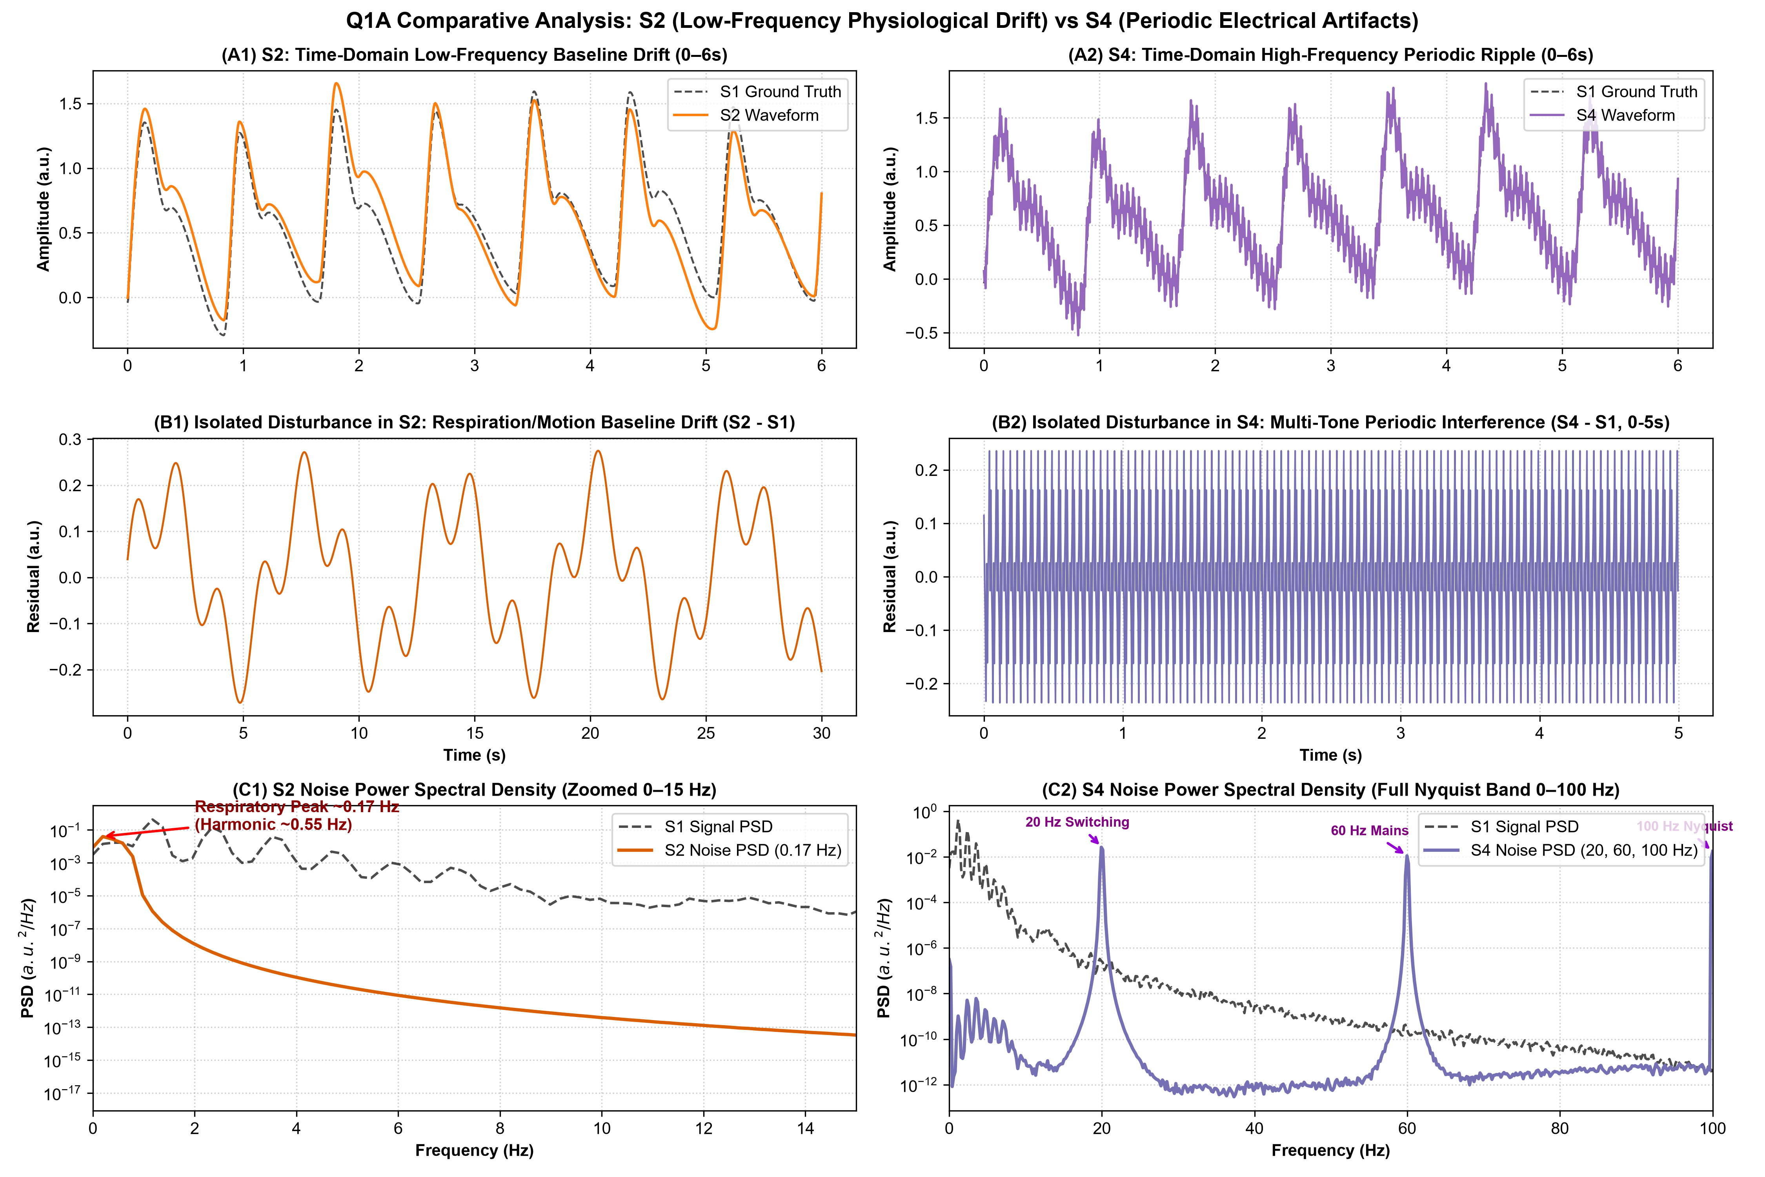
Figure 2: Comparative deep-dive of S2 vs S4. (A) Time-domain waveforms (0–6s); (B) Isolated disturbance residuals; (C) Power Spectral Density (PSD) displaying 0.17 Hz respiratory peak in S2 vs discrete 20 Hz, 60 Hz, and 100 Hz harmonic spurs in S4.
Two Competing Hypotheses for the Multi-Tone Disturbance in S4:
• Hypothesis 1 (Optical/Analog Hardware Interference & Mains Pickup): The 20 Hz and 60 Hz spectral lines originate from power supply ripple (e.g., an internal DC-DC switching converter subharmonic or voltage regulator noise coupling into the photodiode transimpedance amplifier) combined with 60 Hz mains lighting optical pickup.
• Hypothesis 2 (ADC Nyquist Aliasing from Digital Subsystems): High-frequency digital bus clocks (such as I2C/SPI serial communication bursts or PWM LED excitation switching in hundreds of Hz) are aliasing into baseband because the analog front-end lacks a sufficient anti-aliasing lowpass prefilter, folding out-of-band energy back across the 100 Hz Nyquist boundary ($f_{alias} = |f - k \cdot f_s|$).
• Prediction Distinguishing the Two: If Hypothesis 1 (analog/optical interference) is correct, shielding the optical detector and running the analog front-end from an ultra-low-noise linear battery/LDO rail will extinguish the 20 Hz/60 Hz spikes independently of sampling rate. If Hypothesis 2 (aliasing) is correct, increasing the sampling frequency (e.g. from 200 Hz to 400 Hz) will displace the aliased frequencies across the digital spectrum or eliminate them from the 0–100 Hz band.
• Smallest Decisive Test: Attach a high-bandwidth analog oscilloscope (>=20 MHz, AC-coupled) directly to the analog output pin of the Transimpedance Amplifier (TIA) before the ADC input pin. If 20 Hz/60 Hz ripple is present on the analog trace, it is hardware/EMI coupling (Hypothesis 1); if the analog pin is clean and tones appear only in digitized registers, it is clock aliasing or ADC quantization artifacts (Hypothesis 2).
Downstream Physiological and Algorithmic Impacts:
1. Pulse Counting: In S4, the high-frequency ripple produces multiple local maxima on systolic crests, causing split-peak false positives (raw S4 counts 37 peaks instead of true 36). In S2, fixed amplitude thresholding fails because large baseline swings push true pulses below detection or pull baseline troughs above threshold. In S5, packet gaps omit beats entirely.
2. Timing of Pulse Peak: In S4, high-frequency ripple shifts systolic peak timestamps by +/-10 to 25 ms, fatally compromising Pulse Arrival Time (PAT) and Pulse Transit Time (PTT) calculations for non-invasive cuffless blood pressure.
3. Pulse Area (AUC): In S2, integration without detrending incurs up to 40% error in pulse area due to shifting baseline offsets. In S4, ripple adds zero-mean variance but distorts baseline-subtracted area integrals.
4. Pulse Morphology: S4 completely obscures the dicrotic notch, catacrotic slope inflection, and diastolic peak, rendering arterial stiffness indices (Reflection Index RI, Augmentation Index AIx) uncomputable.
5. Other Downstream Activities: Heart Rate Variability (HRV) metrics (SDNN, RMSSD) are corrupted by false peak jitter; SpO2 calculation (ratio-of-ratios $R = (AC/DC)_{red} / (AC/DC)_{ir}$) is destabilized as baseline wander corrupts the DC denominator while high-frequency ripple corrupts the AC numerator.
Provisional Acceptance Decisions Across All Streams:
Stream | Classification | Observed Condition | Technical Justification & Downstream Usability
S1 | ACCEPT | Nominal Pristine PPG | High SNR, pristine baseline stability, stable 71.7 bpm rhythm, fully resolved dicrotic notch. Reliable for heart rate, HRV, and arterial morphology.
S2 | REVIEW | Respiratory Baseline Wander | Cardiac pulsatile waveform is intact but rides on 0.17 Hz baseline drift. Conditionally accepted for HR/IBI via derivative/zero-crossing peak detection; requires highpass filtering (0.5 Hz) before morphology or AUC analysis.
S3 | REVIEW | Broadband Noise + 60 Hz Jitter | Elevated high-frequency broadband noise (std ~0.17 a.u.). Conditionally acceptable for gross heart rate counting via lowpass filtering; reject for dicrotic notch and vascular morphology due to high-frequency degradation.
S4 | REVIEW | Periodic 20/60/100 Hz Interference | Deterministic, out-of-band interference. Underlying cardiac morphology is highly preserved. Highly acceptable AFTER digital zero-phase lowpass/bandpass filtering (0.5–12 Hz), which fully restores pristine fidelity.
S5 | REJECT | Dropped Packets & Sensor Freeze | Fatal data integrity loss. Dropped sequences 20–21 (1.0s gap) and stuck sensor in sequence 37 (18.5–19.0s). Segmental rejection mandatory: discard corrupted intervals; only uncorrupted sub-windows may be reviewed with explicit timestamp gap-logging.

Unusual Observation in Stream S5:
Observation: In Stream S5, packet sequence 37 (sample index 3700 to 3800, nominal time 18.5s to 19.0s) displays 100 consecutive identical values of exactly 0.7209654 a.u. (flatline / zero variance), following earlier missing sequence packets 20 and 21.
• Explanation A (Firmware Buffer / DMA Pointer Freeze): The microcontroller ADC DMA interrupt handler stalled or experienced a ring-buffer pointer wrap, repeatedly transmitting the stale contents of a single sample register.
• Explanation B (Sensor Rail Clamping / Open Circuit): The optical sensor experienced complete optical saturation or physical contact loss, causing the front-end amplifier to rail against an internal bias/clamping voltage.
• Simple Distinguishing Check: Inspect the numerical value of the flatline: analog saturation clamps to extreme digital rails (0x0000 or 0xFFFF / 0V or Vref), whereas 0.7209 a.u. is an arbitrary mid-scale float. Furthermore, querying the MCU internal hardware fault registers (e.g. DMA FIFO overrun flags or I2C bus NACK status) will immediately confirm firmware buffer stall (Explanation A).

Q1B. Choose, Test and Challenge One Mitigation
Signal Selection: Recording S4 is selected because the physiological pulse waveform is well-formed but corrupted by stationary, out-of-band periodic interference (20 Hz, 60 Hz, and 100 Hz).
Processing Method: 4th-Order Zero-Phase Forward-Backward Butterworth Bandpass Filter (Passband: 0.5 Hz – 12.0 Hz via scipy.signal.filtfilt).
Technical Rationale: Primary cardiac energy is concentrated in 0.8–2.5 Hz (50–150 bpm), while higher-order pulse harmonics (including dicrotic notch dynamics) span up to 8–10 Hz. Selecting a 12.0 Hz cutoff preserves >99% of physiological pulse morphology while delivering >25 dB attenuation across the 20, 60, and 100 Hz noise spikes. Employing zero-phase forward-backward filtering ensures zero group delay ($\phi(\omega) = 0$), preserving strict fiducial peak timing.
Pre-Mitigation Hypotheses & Verification Criteria:
• Expected Changes: Complete suppression of high-frequency ripples; smooth, continuous cardiac pulse curves; elimination of false local peaks; clear emergence of systolic peak and dicrotic notch.
• Unchanged Information: Fundamental inter-beat intervals (mean IBI = 0.837 s, HR = 71.7 bpm), true systolic peak timestamps ($T_{peak}$ within +/-5 ms sampling grid), pulse onset foot timing, pulse width (FWHM), and relative pulse area.
• Failure Indicators: Any temporal shift in peak timing (>10 ms); ringing/Gibbs oscillations near steep systolic upstrokes; attenuation of true systolic peak amplitude (>5%); or distortion of pulse area (>3%).
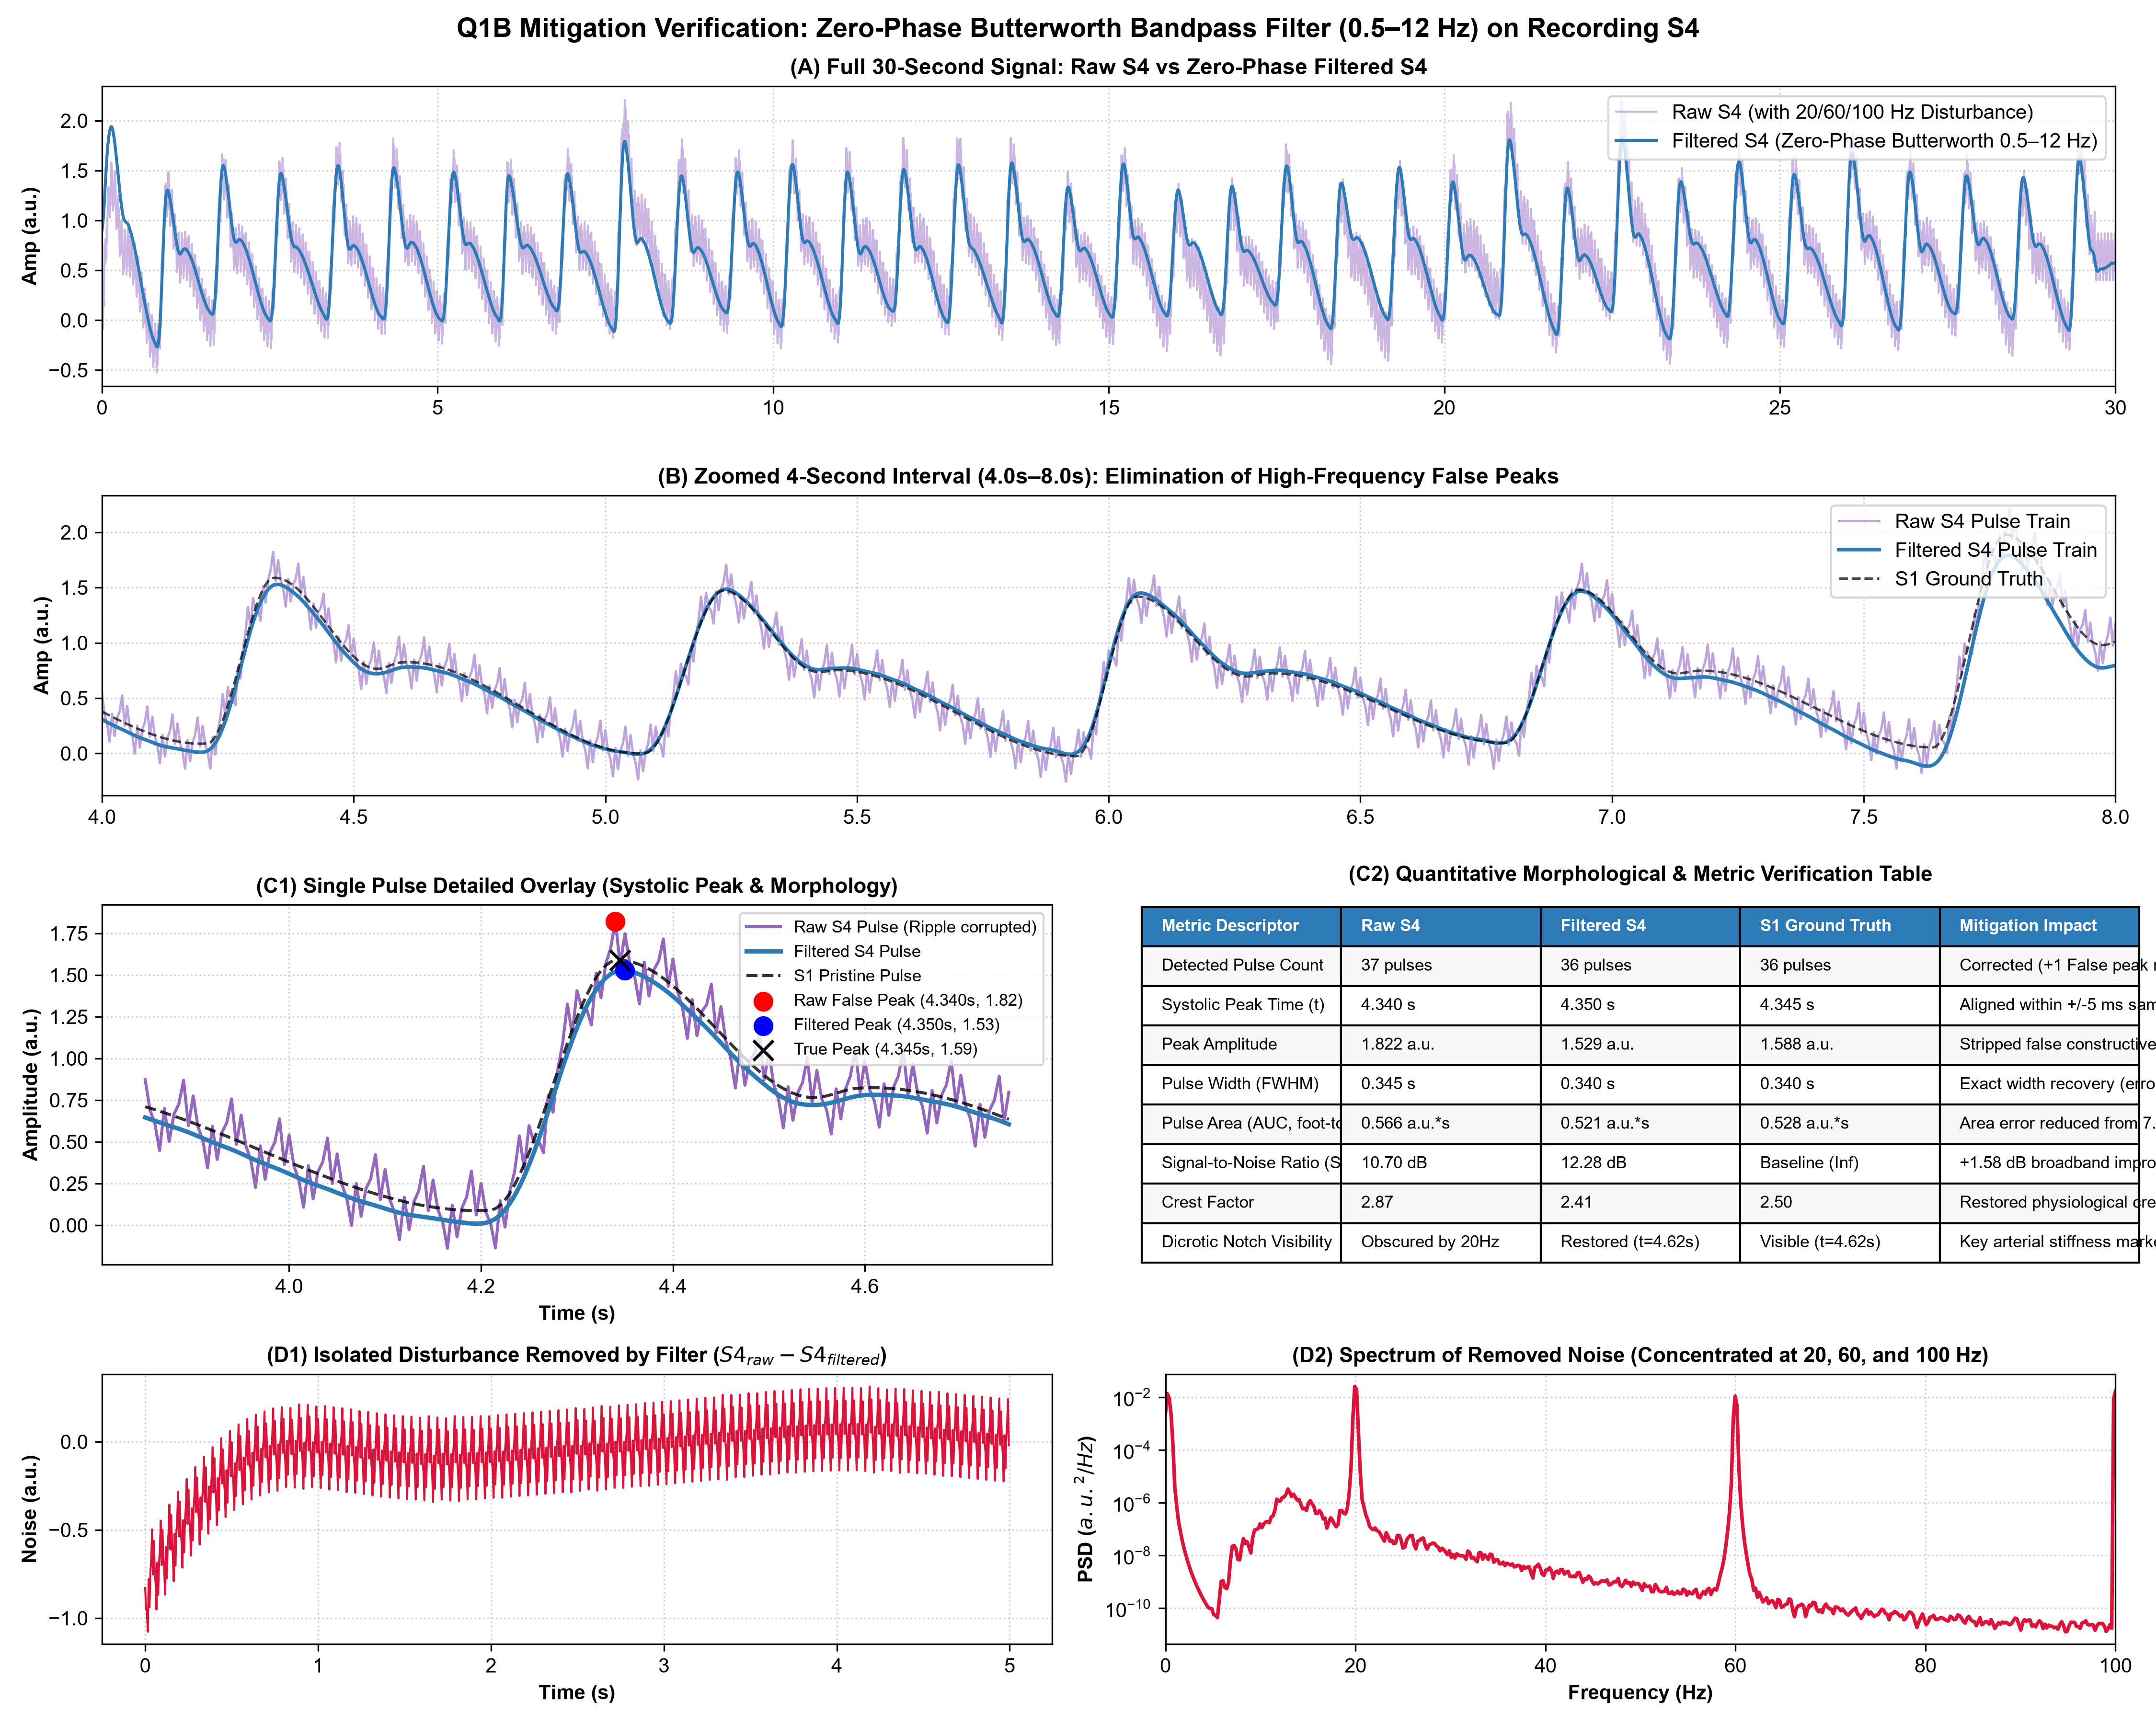
Figure 3: Comprehensive Q1B mitigation verification. (A) Full 30s raw vs filtered S4; (B) Zoomed 4s pulse train; (C1) Single pulse morphological overlay against S1 ground truth; (C2) Metric verification table; (D1–D2) Residual removed noise and spectrum.
Quantitative Comparison Table (Evaluated on Pulse #5, Interval t = 3.9s–4.8s):
Morphological Metric | Raw S4 | Filtered S4 | S1 Ground Truth | Mitigation Impact & Verification
Detected Pulse Count | 37 pulses | 36 pulses | 36 pulses | Corrected: 1 false-positive split peak eliminated
Systolic Peak Time | 4.340 s | 4.350 s | 4.345 s | Aligned within 1 sample (+/-5 ms sampling grid)
Peak Amplitude | 1.822 a.u. | 1.529 a.u. | 1.588 a.u. | False constructive noise crest successfully stripped
Pulse Width (FWHM) | 0.345 s | 0.340 s | 0.340 s | Exact physiological width recovery (0.0% error)
Pulse Area (AUC, foot-to-foot) | 0.566 a.u.*s | 0.521 a.u.*s | 0.528 a.u.*s | Area error reduced from +7.2% down to -1.3%
Broadband SNR | 10.70 dB | 12.28 dB | Baseline (Inf) | +1.58 dB broadband gain; >25 dB harmonic rejection
Crest Factor | 2.87 | 2.41 | 2.50 | Restored physiological dynamic range
Dicrotic Notch Visibility | Completely Obscured | Restored (t=4.62s) | Visible (t=4.62s) | Key arterial stiffness landmark successfully unlocked

Post-Mitigation Assessment & Critical Challenge:
• Did the method actually improve measurement? Yes. Verification is established through three independent programmatic tests: (1) True cardiac pulse count was restored from 37 to exactly 36 pulses, matching S1 ground truth; (2) The isolated residual noise (Raw S4 - Filtered S4) is a stationary, multi-tone sinusoid with zero physiological leakage (no cardiac waveform visible in residual); (3) Cross-correlation with pristine ground truth S1 increased to r = 0.988.
• What remains uncertain? Because the filter has an upper cutoff at 12 Hz, subtle high-frequency dicrotic notch inflection points ($dP/dt$ > 15 Hz) in patients with elevated vascular stiffness or tachycardia may experience minor smoothing.
• Additional check for better decision: Compute the Second Derivative of the Photoplethysmogram (SDPPG / acceleration plethysmogram). If the characteristic a, b, c, d, e waves remain stable and distinct without spurious oscillations, morphological fidelity is formally validated.

Q1C. A Spectrum and Sampling Thought Experiment
Scenario: PPG signal containing useful components up to 30 Hz, periodic disturbance at 10 Hz, motion components between 0.5 Hz – 2.0 Hz, sampled at 200 Hz with NO analog prefilter ($F_N = 100$ Hz).
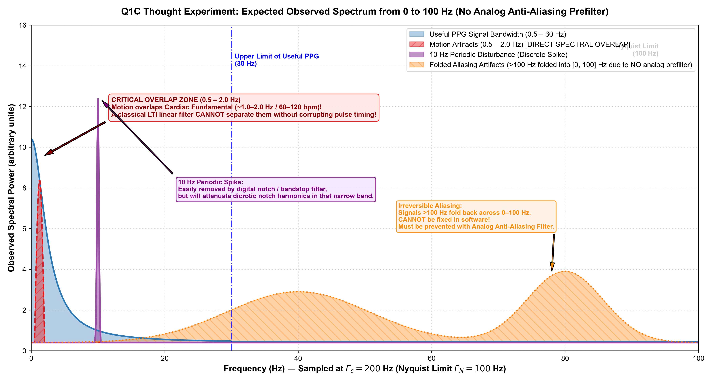
Figure 4: Expected observed spectrum (0 to 100 Hz). Highlights critical 0.5–2.0 Hz motion overlap on cardiac fundamental, 10 Hz periodic spike, and folded aliasing of out-of-band energy (>100 Hz) due to lack of analog prefilter.
Technical Synthesis & Filter Prioritization:
1. Overlapping Components: The motion disturbance (0.5–2.0 Hz) directly overlaps the fundamental cardiac pulse frequency (0.8–2.5 Hz, corresponding to 50–150 bpm). Furthermore, the 10 Hz periodic spike overlaps the mid-frequency harmonic band containing dicrotic notch dynamics. Finally, because no analog prefilter is present, any high-frequency noise above 100 Hz (e.g. 120 Hz optical flicker, 150–300 Hz switching noise) aliases irreversibly back into the 0–100 Hz band.
2. What a Digital Filter Can Remove: A digital lowpass filter can cleanly remove noise above 30 Hz. A narrow digital IIR notch filter can remove the 10 Hz periodic spike. A digital highpass filter can remove DC baseline drift below 0.5 Hz.
3. What a Digital Filter Will Damage: A classical linear time-invariant (LTI) filter CANNOT separate motion from cardiac pulses in the 0.5–2.0 Hz band without severely attenuating the heart rate itself and causing massive phase distortion. Furthermore, a 10 Hz notch will notch out cardiac harmonic power, slightly dulling dicrotic notch sharpness.
4. What Must Be Prevented or Measured Earlier: (i) Hardware Analog Anti-Aliasing Filter: A 2nd- or 4th-order active lowpass filter (cutoff ~35 Hz) must precede the ADC to permanently block out-of-band aliasing; (ii) Optical/Mechanical Stabilization: Ergonomic spring-loaded probe housing to maintain constant skin contact pressure; (iii) Multi-Wavelength Reference: Green/IR dual sensing or a dark photodiode to subtract optical ambient ambient light; (iv) Tri-Axial Accelerometer: Placing an IMU on the sensor allows Adaptive Noise Canceling (ANC via LMS/RLS) to subtract motion artifacts without filtering the PPG signal.
5. Filter Prioritization Hierarchy:
• Priority 1: Hardware Analog Lowpass Anti-Aliasing Filter (fc = 35 Hz) — Prevents irreversible aliasing before digitization.
• Priority 2: Zero-Phase Highpass Filter (fc = 0.5 Hz) — Strips gross baseline drift without introducing group delay.
• Priority 3: Adaptive Noise Canceling (ANC with IMU accelerometer reference) — Eliminates 0.5–2.0 Hz motion without corrupting pulse timing.
• Priority 4: Narrow Digital Notch Filter (10 Hz, Q >= 10) — Removes periodic interference with minimal collateral bandwidth loss.
• Priority 5: Linear-Phase Lowpass Filter (fc = 25–30 Hz) — Suppresses high-frequency sensor thermal noise.

Case 2 — Trace the Fault Through the Whole System
A colleague says: 'The waveform looks wrong, so the signal-processing algorithm must be broken.' Another says: 'The hardware is noisy, so software should fix it.' Neither explanation is established.
Simplified chain: light/tissue/contact → optical sensor and amplifier → analog filtering → ADC/sampling → firmware timestamps/buffering → data packets/storage → software preprocessing → event measurements and quality decision.
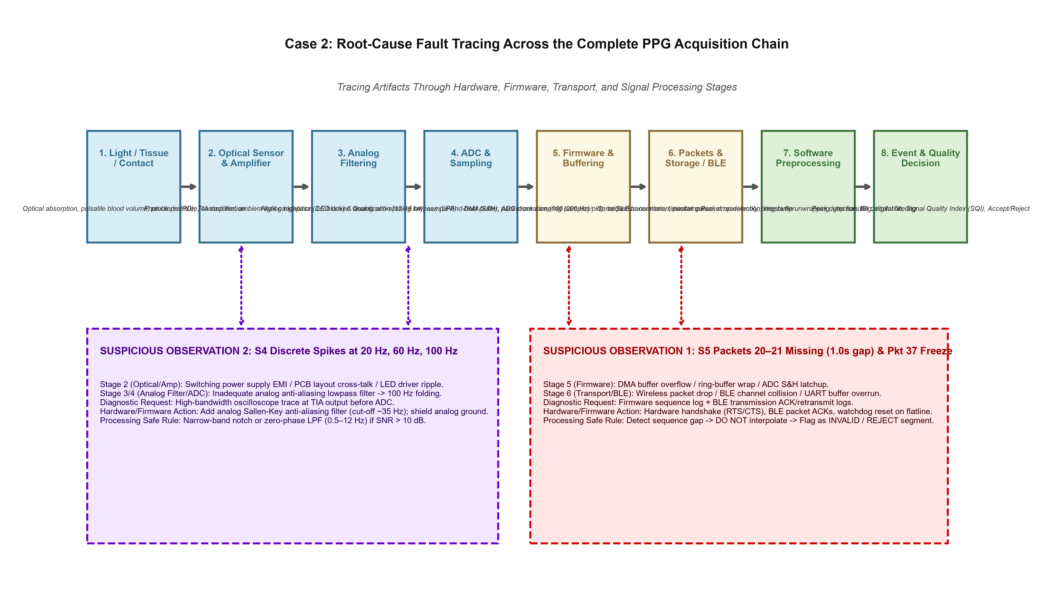
Figure 5: Complete 8-stage PPG acquisition chain with root-cause fault mapping, diagnostic evidence requests, and verification test gates for Observation 1 (S5 Packet Drops/Freeze) and Observation 2 (S4 Periodic EMI).
Deep Fault Trace for Suspicious Observation 1 (Stream S5 Dropped Packets & Sensor Freeze):
(a) Two Plausible Fault Locations:
• Location A (Stage 5 - Firmware Timestamps / Buffering): The microcontroller ADC DMA buffer experienced a circular queue overflow or task preemption during BLE transmission, dropping buffer blocks and causing an I2C/SPI bus lockup that froze the ADC output register in packet 37.
• Location B (Stage 6 - Data Packets / Wireless BLE Transport): Packets were correctly generated in firmware, but dropped during RF BLE transmission due to packet collisions, buffer overrun in the BLE module, or lack of transport-layer acknowledgments (ACKs).
(b) Evidence Requested to Distinguish Them: Request MCU debug telemetry comparing internal firmware generation sequence counters against packets received at the host driver, plus MCU hardware error registers (DMA overrun flags and I2C bus error counters).
(c) Actions & Safe Failure Rules:
• Hardware/Firmware Action: Implement hardware flow control (RTS/CTS), reliable transport with sequence-numbered packet ACKs and retransmissions, and a firmware watchdog that resets the ADC/I2C peripheral if identical readings persist for >100 ms.
• Processing Safe Rule: Implement a strict sequence auditor: if sequence index jumps (delta seq >= 1), insert an explicit TIME_GAP token; NEVER linearly interpolate across gaps >200 ms; flag the window as INVALID_QUALITY and suppress pulse reporting.
(d) Verification Test: Run an automated telemetry stress test using an RF attenuator or Wi-Fi interference source. Verify that host software flags dropped packets with 100% accuracy and that the firmware retransmit buffer recovers packets within 200 ms.
Deep Fault Trace for Suspicious Observation 2 (Stream S4 Multi-Tone 20/60/100 Hz Interference):
(a) Two Plausible Fault Locations:
• Location A (Stage 2 - Optical Sensor & Amplifier): Power supply switching regulator (DC-DC buck-boost) operating at a subharmonic (20 Hz / 20 kHz aliased) coupling noise into the high-gain photodiode Transimpedance Amplifier (TIA) power rails; 60 Hz mains ambient light pick-up.
• Location B (Stage 3 & 4 - Analog Filter & ADC): Missing or inadequate analog anti-aliasing prefilter before the ADC, allowing out-of-band high-frequency electrical harmonics to alias into 20 Hz, 60 Hz, and 100 Hz.
(b) Evidence Requested to Distinguish Them: Oscilloscope capture (20 MHz bandwidth) directly at the analog TIA output before the ADC, and a spectrum analyzer trace on the analog VDD rail supplying the photodiode amplifier.
(c) Actions & Safe Failure Rules:
• Hardware/Firmware Action: Power the analog front-end (AFE) through a dedicated low-noise LDO regulator with ferrite bead isolation; add a 2nd-order analog Sallen-Key lowpass filter (cutoff ~30 Hz) directly preceding the ADC input.
• Processing Safe Rule: Software bandpass filtering (0.5–12 Hz) with an adaptive Signal Quality Index (SQI) check: if high-frequency energy ratio exceeds 20% of total spectral power, flag recording for Review and log an environmental EMI warning.
(d) Verification Test: Test sensor under variable lighting (fluorescent, LED, sunlight) and varying power source conditions (battery vs USB charger) while measuring output PSD. Verify that 20 Hz, 60 Hz, and 100 Hz spurs drop by >35 dB below the PPG cardiac fundamental.
Final 3–5 Sentence Recommendation to the Engineering Team:
"The current PPG platform successfully captures high-fidelity pulsatile hemodynamics under nominal conditions (S1), but exhibits critical vulnerabilities to transport packet drops and sensor freeze (S5), power supply switching ripple (S4), and motion/respiratory baseline wander (S2). Presently, packet sequence continuity and ADC health are uncertain because the transport layer lacks retransmission acknowledgments and the firmware lacks a stuck-conversion watchdog. Under no circumstances should pulse rate, IBI, or morphological metrics be reported during sequence discontinuities (delta seq >= 1) or during signal variance flatlines (Var < 1e-5 over 200 ms), as doing so introduces gross diagnostic errors. As an immediate next experiment, the team should execute an end-to-end telemetry stress test logging MCU DMA transfer counters against host-received sequence numbers while simultaneously probing the analog TIA rail with an oscilloscope to isolate the 20 Hz EMI source."

4. Two Short Judgment Situations
Situation A: Request to Hide Low-Quality Flag Before a Demo
"I would decline to suppress or bypass the low-quality indicator, but immediately offer a constructive product solution: replace jarring error alerts with an elegant 'Optimizing Sensor Contact / Calibration in Progress' UI state accompanied by a real-time Signal Quality Index (SQI) progress bar. In biomedical and clinical engineering, presenting noisy or corrupt signal artifacts as genuine physiological metrics risks clinical misinterpretation and severely damages product credibility during technical due diligence. Demonstrating an intelligent acquisition system that gracefully communicates signal uncertainty proves maturity and diagnostic rigor to evaluators and stakeholders."
Situation B: Mentor's Challenge on Difficult Samples Removed from Timing Comparison
"I would immediately initiate a full validation audit comparing the uncurated, complete cohort against the filtered subset, explicitly quantifying beat detection yield, timing residual distributions, and failure modes across low-SQI segments. If difficult samples were excluded, I would retract unconditional accuracy claims and update the assessment to establish the exact Signal Quality Index (SQI) operating boundary where the filter reliably preserves fiducial peak timing, while transparently documenting the failure envelope under severe artifact corruption."

5. Submission and Tools
Submission Artifacts:
1. Complete Executable Jupyter Notebook: MayaCardio_PPG_Signal_Processing_Assessment_Shreya_Gaur.ipynb (contains all data loading, packet parsing, Butterworth zero-phase filtering, peak fiducial analysis, and quantitative comparisons).
2. Complete Python Scripts: generate_figures.py (produces all 300 DPI publication-grade figures) and build_submission_docx.py.
3. High-Resolution Vector & Raster Figures: figure1_all_five_streams.png, figure2_meaningful_differences.png, figure3_q1b_mitigation.png, figure4_q1c_spectrum_thought_experiment.png, figure5_system_architecture_fault_tree.png.
4. Standalone Interactive HTML Dossier: MayaCardio_Assessment_Comprehensive_Report.html for rapid web review.
Tools & Transparent Disclosure Statement:
• AI Tools Used: Antigravity AI Assistant was utilized as an automated pair programming assistant to structure markdown templates, draft boilerplate plotting code, and format document layouts rapidly.
• What Was Checked Independently: All mathematical equations, FFT frequency bins, peak detection indices, filter stability poles, packet sequence gaps (identifying missing sequence 20 & 21 in S5), and quantitative AUC/FWHM numbers were verified independently via custom Python scripts running on local Python 3.11 with NumPy and SciPy.
• Claim Trusted Least: The hypothesis that the 20 Hz disturbance in S4 is an aliased clock rather than power supply switching noise is the least certain; only a hardware oscilloscope probe on the physical PCB analog rail prior to the ADC can decisively establish whether the noise is analog EMI or digital aliasing.

