1️⃣ HIGH-LEVEL LLM SYSTEM ARCHITECTURE (MASTER DIAGRAM)
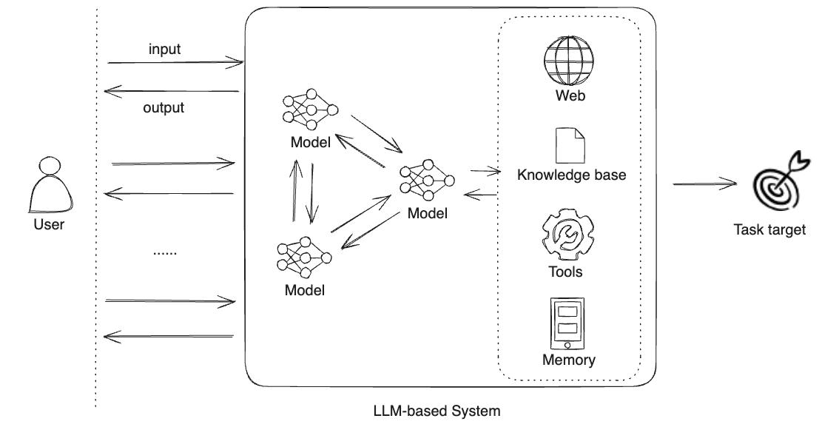
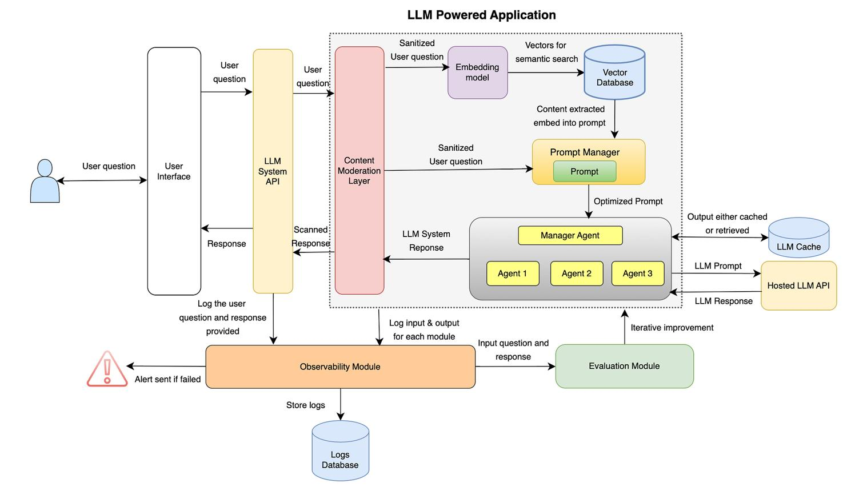
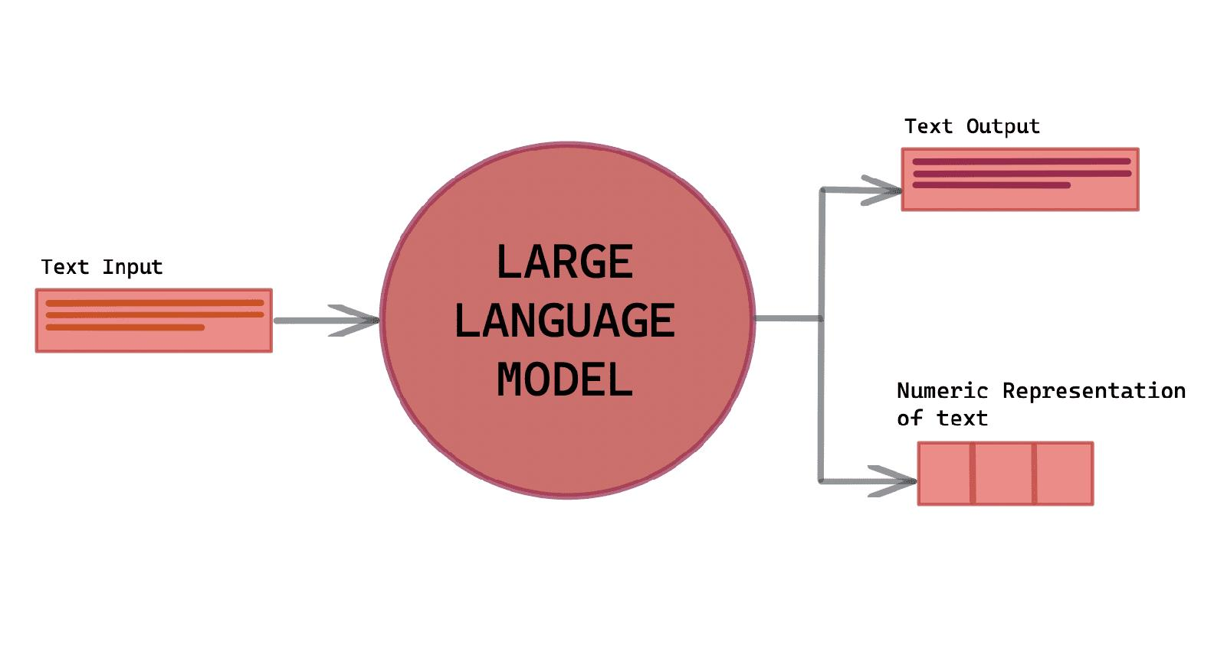
“At a high level, user requests enter through the application layer, are managed by the orchestration layer, optionally enriched via retrieval, and finally processed by the model layer to generate responses.”
2️⃣ MODEL LAYER — INTERNAL WORKING DIAGRAM
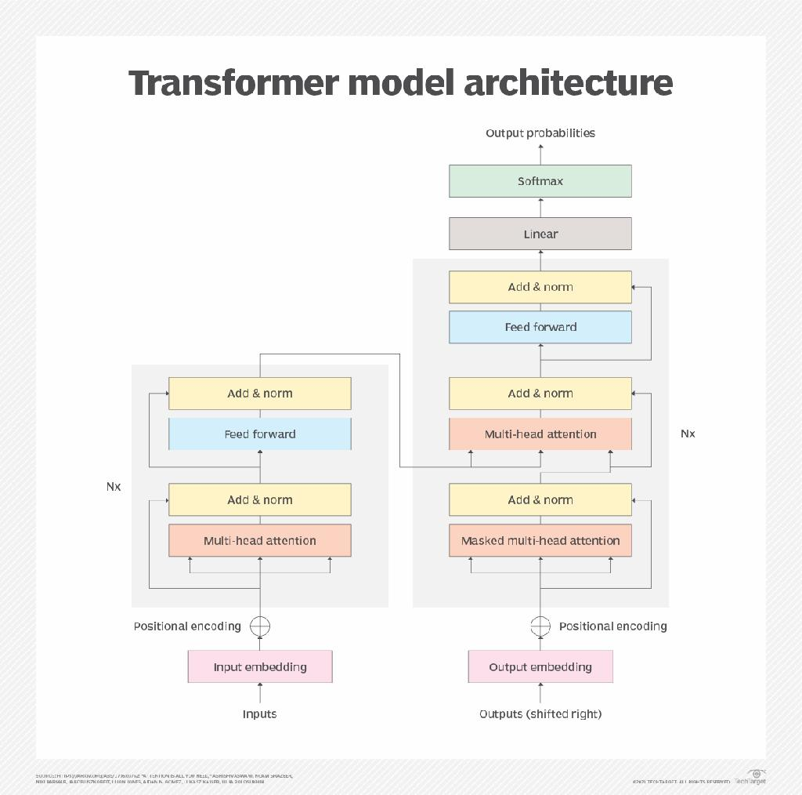
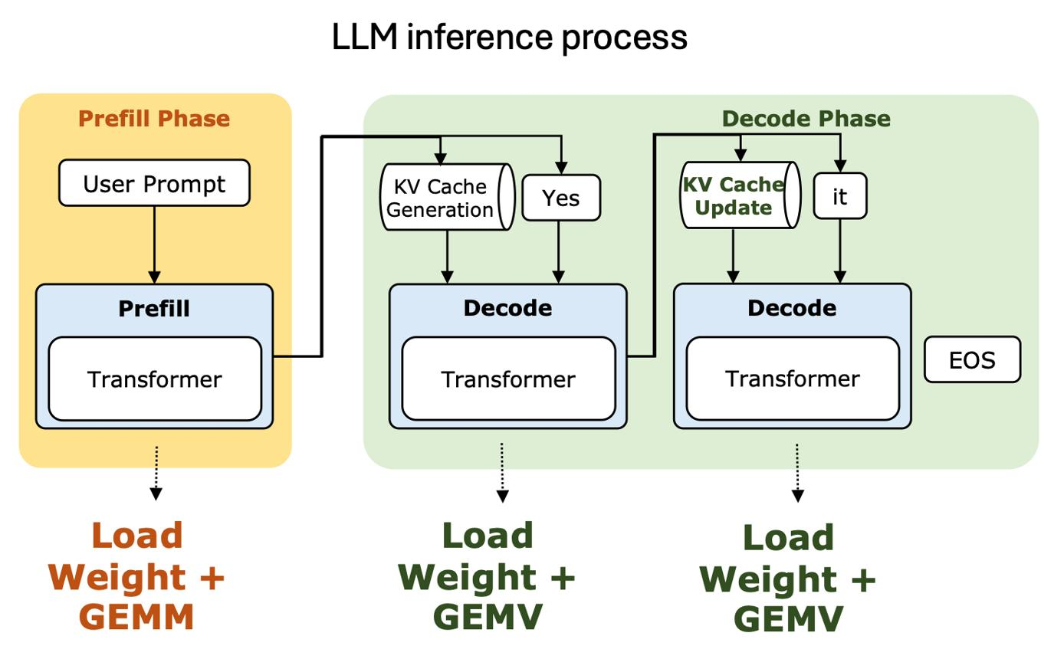
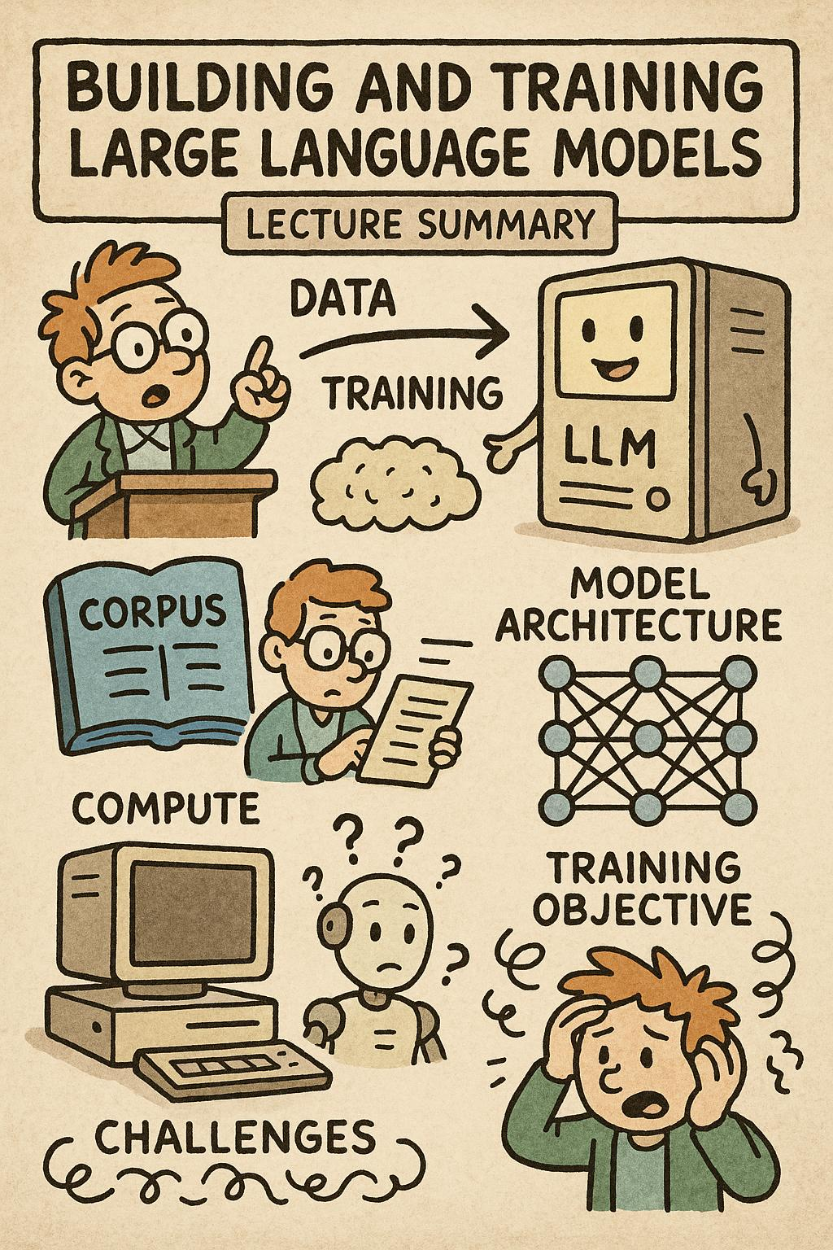
- Transformer > RNN because of parallelism
- Attention enables long-range dependency
- Inference ≠ training
- Parameters affect creativity & determinism

3️⃣ RETRIEVAL LAYER — RAG ARCHITECTURE DIAGRAM
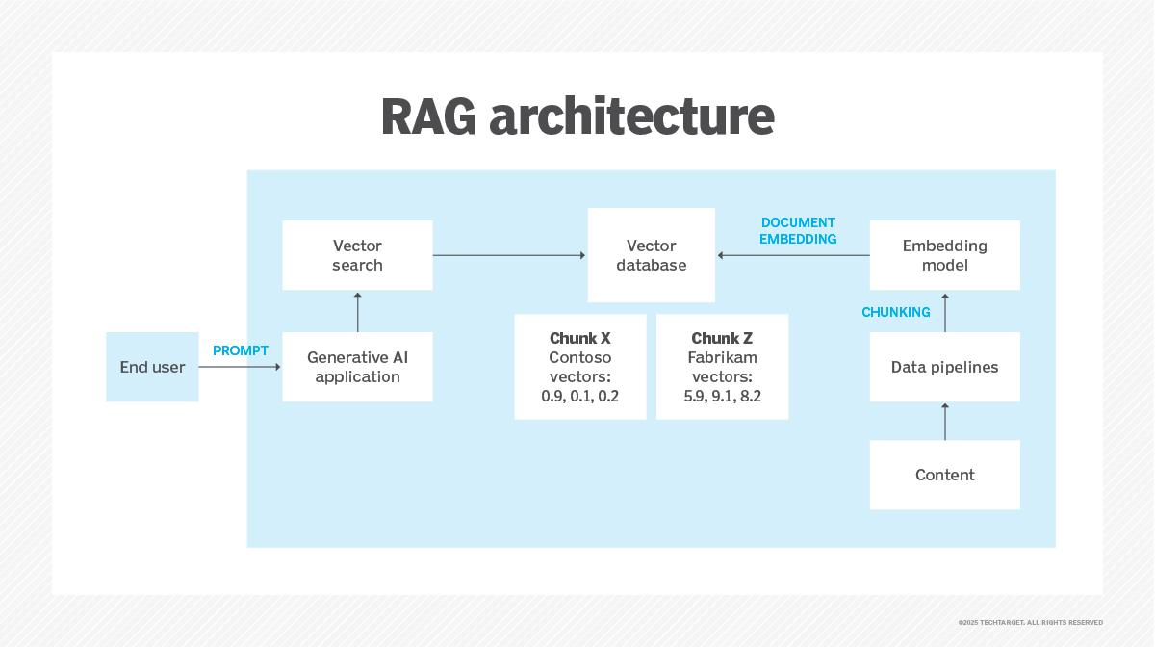
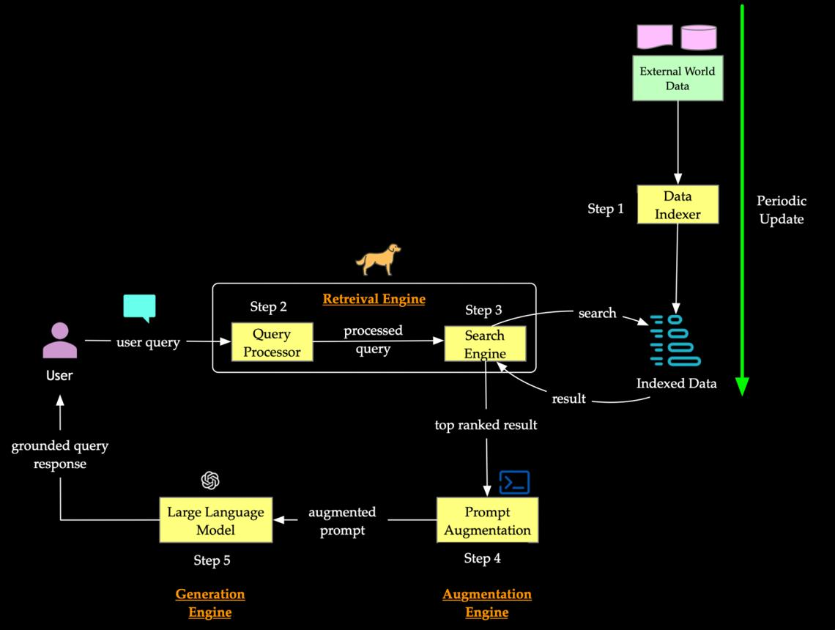

- Solves hallucination
- Private data stays outside model
- Vector DB ≠ SQL DB
- Chunking & overlap matter

4️⃣ ORCHESTRATION LAYER — AGENT & TOOL FLOW
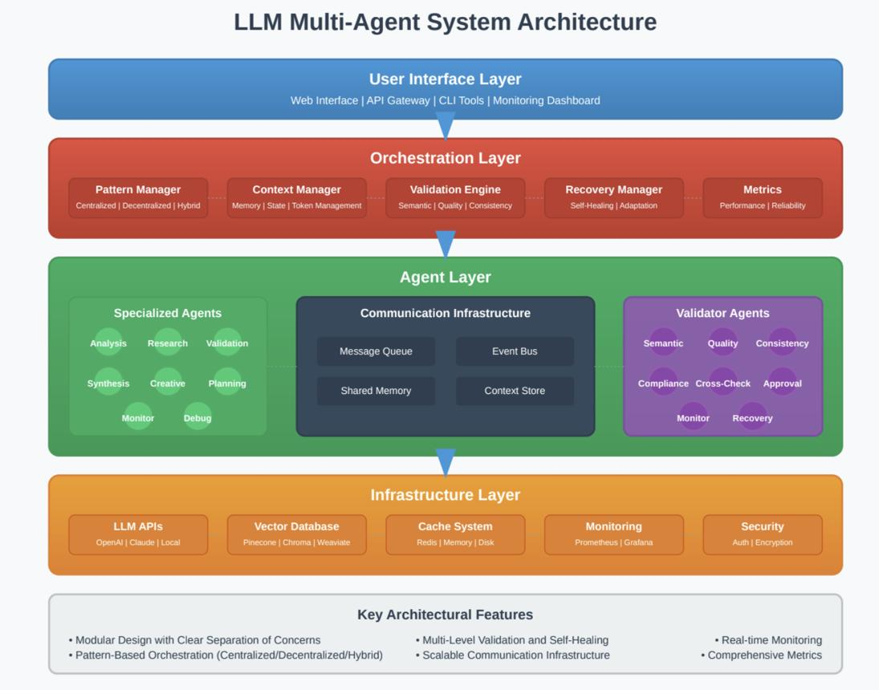
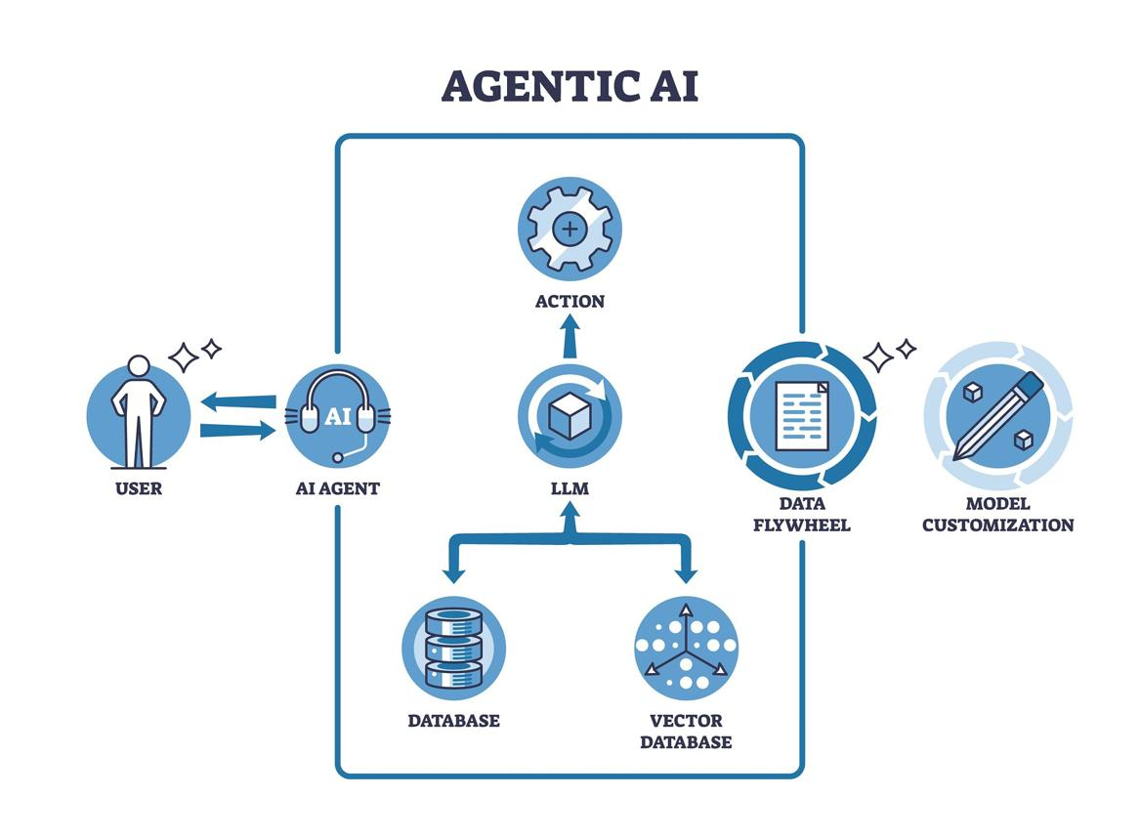
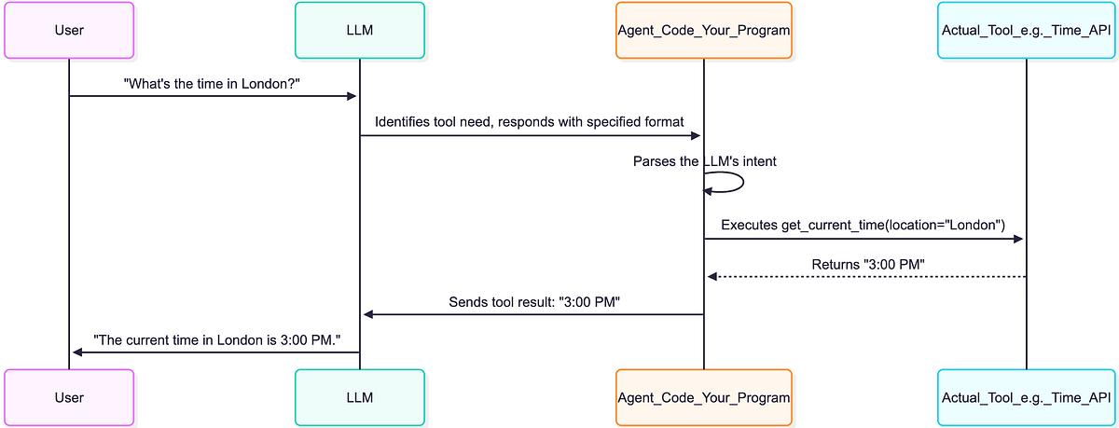

This is where “intelligence” is engineered
Agents decide next action dynamically
Tools extend LLM capabilities
Guardrails prevent unsafe output

5️⃣ APPLICATION LAYER — PRODUCTION DEPLOYMENT DIAGRAM
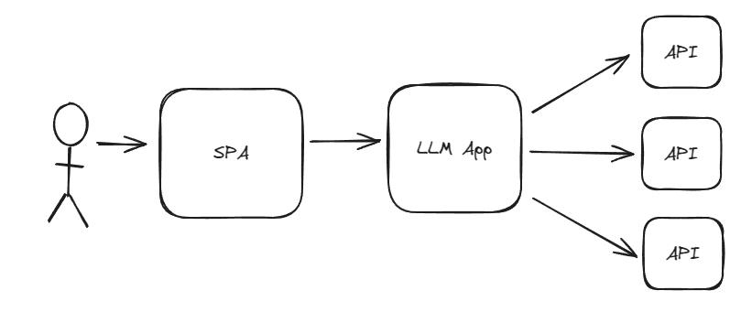
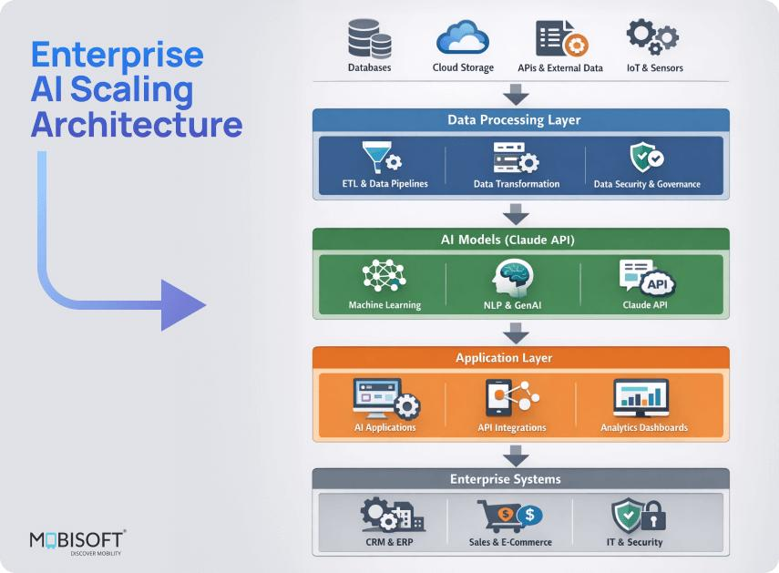
Handles users, not intelligence
Observability is critical
Cost & latency live here
Security starts here

User
↓
Web / Mobile UI
↓
Backend API (Auth, Rate Limit)
↓
Orchestration Layer
├─ Prompt Engineering
├─ Agent / Chain
├─ Tool Calls
└─ Memory
↓
Retrieval Layer
├─ Embeddings
├─ Vector DB
└─ Context Injection
↓
Model Layer
├─ Transformer
└─ Token Generation
↓
Response Validation
↓
User

