YuvaIntern – Week 2 Report
Exploratory Data Analysis (EDA) and Visualization
Hotel Booking Demand Dataset

1. Introduction
This report presents the Exploratory Data Analysis (EDA) and visualization performed during Week 2 of the YuvaIntern Data Science with Python internship. The analysis uses the cleaned Hotel Booking Demand dataset prepared during Week 1. Python libraries including Pandas, NumPy, Matplotlib, and Seaborn were used to summarize the data, identify patterns and relationships, and communicate findings through visualizations.

2. Objective
The objective of this task is to perform EDA on a public dataset, summarize important statistics, explore key variables, identify patterns and relationships, create multiple visualizations, and interpret the findings.

3. Dataset Overview
- Dataset: Hotel Booking Demand
- Source: Publicly available hotel booking dataset
- Working file: hotel_bookings_cleaned.csv
- Final working dataset shape: 87,389 rows × 34 columns
- Main analysis themes: bookings, cancellations, ADR, lead time, customer type, market segment, and numerical correlations

4. Tools and Technologies
Python, Pandas, NumPy, Matplotlib, Seaborn, and Jupyter Notebook / VS Code.

5. EDA Process

5.1 Initial inspection
The dataset was loaded and inspected using shape, columns, info, and descriptive statistics.

5.2 Booking analysis
Booking counts were examined by hotel type and arrival month.

5.3 Cancellation analysis
Overall cancellation distribution and category-wise cancellation patterns were explored.

5.4 Customer and market analysis
Customer types and market segments were compared using booking counts.

5.5 ADR analysis
ADR was examined using summary statistics and distribution-based visualization.

5.6 Relationship analysis
Lead time and ADR were compared, and a correlation heatmap was created for numerical variables.

6. Visualizations and Interpretation
The report includes a selected set of the clearest and most useful graphs from the notebook. Not every notebook graph is repeated here because several charts communicate similar information. This keeps the final report concise while still covering trends, category comparisons, distributions, relationships, and correlations required by the Week 2 task.

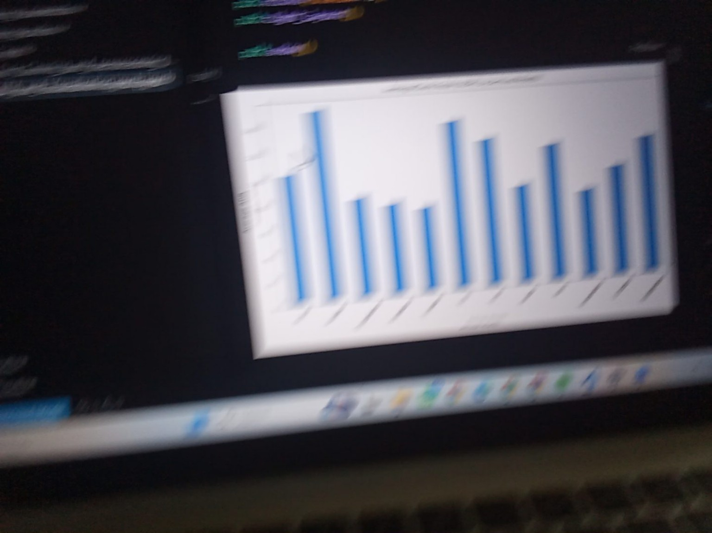
Figure 1: Monthly Booking Count
Interpretation: The monthly booking chart shows that booking volume varies across arrival months, indicating seasonal differences in booking activity.

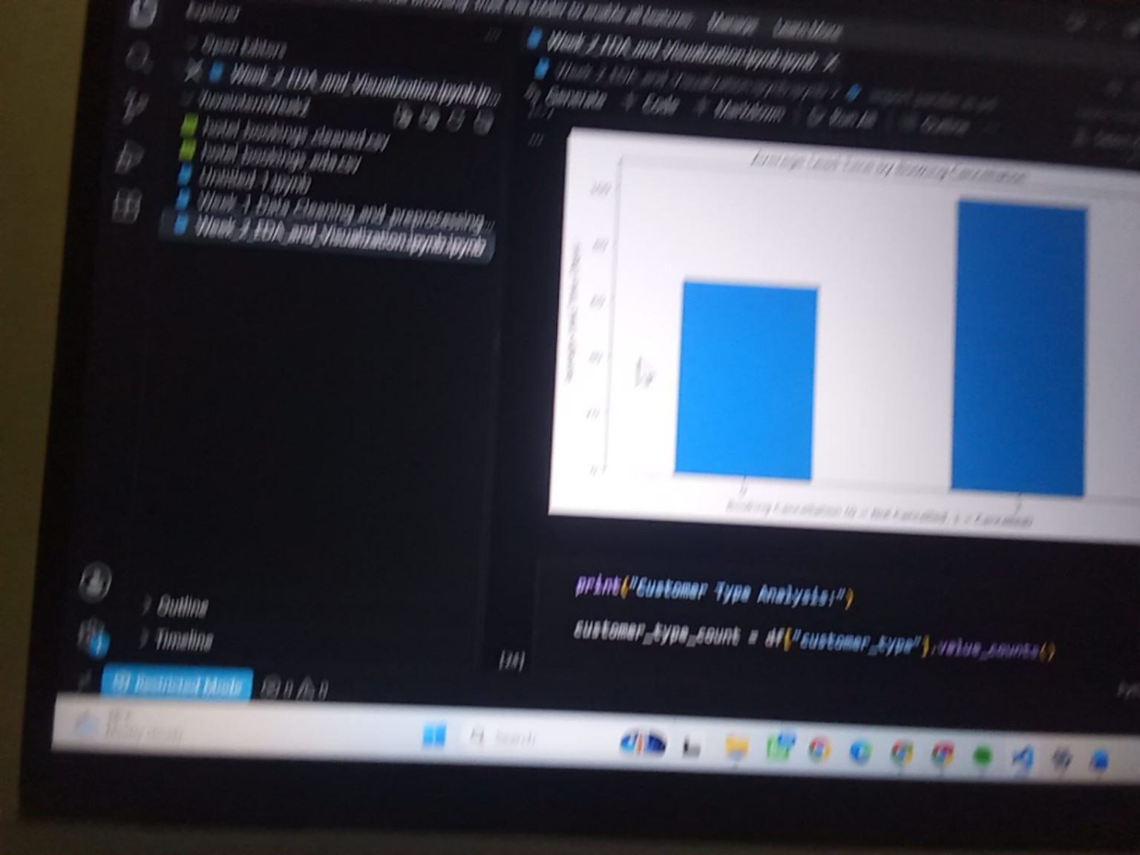
Figure 2: Booking Count by Customer Type
Interpretation: The chart compares booking volume across customer categories and shows that the categories contribute differently to the overall dataset.

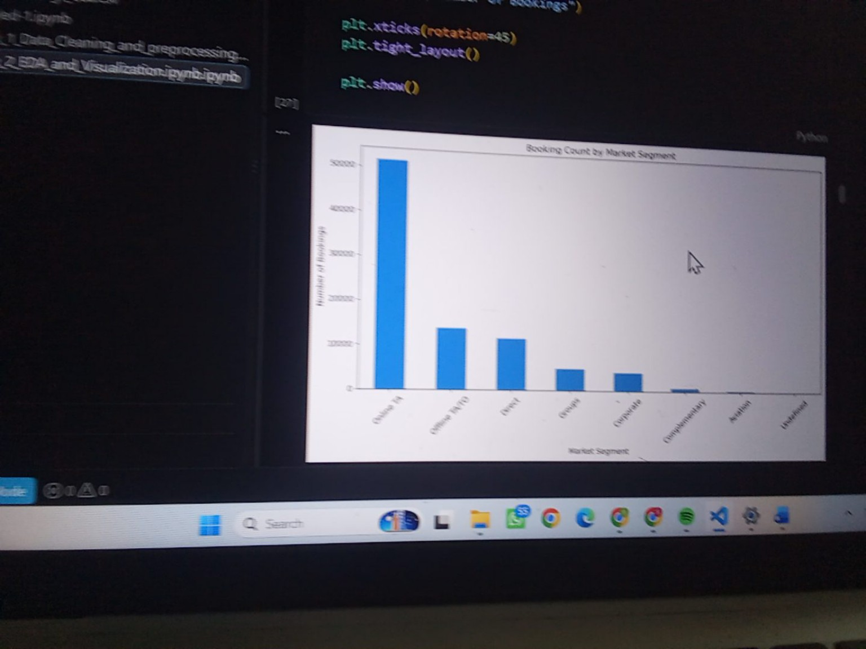
Figure 3: Booking Count by Market Segment
Interpretation: The market-segment visualization shows that bookings are concentrated in a small number of segments, while several other segments contribute much smaller volumes.

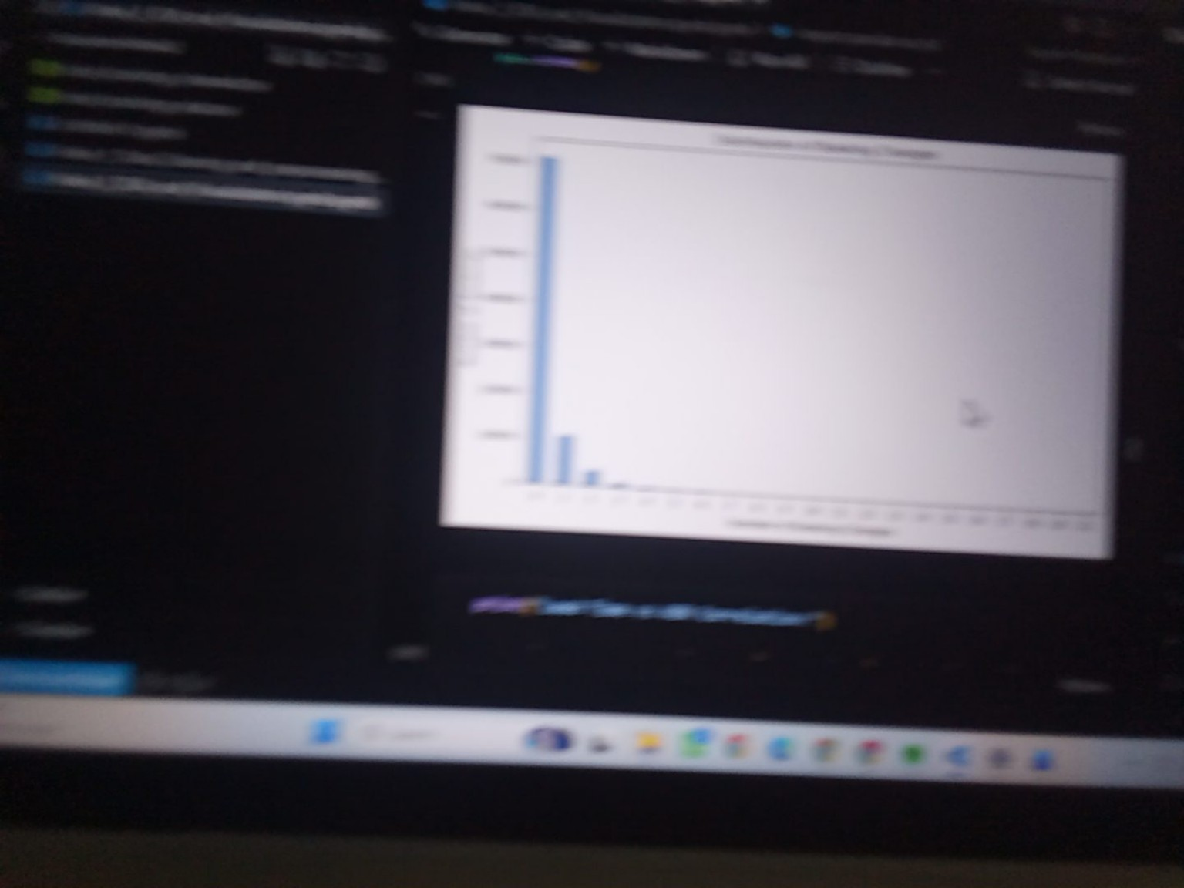
Figure 4: Correlation Heatmap
Interpretation: The correlation heatmap is used to identify relationships among numerical variables. Stronger relationships are represented by more intense correlation values.

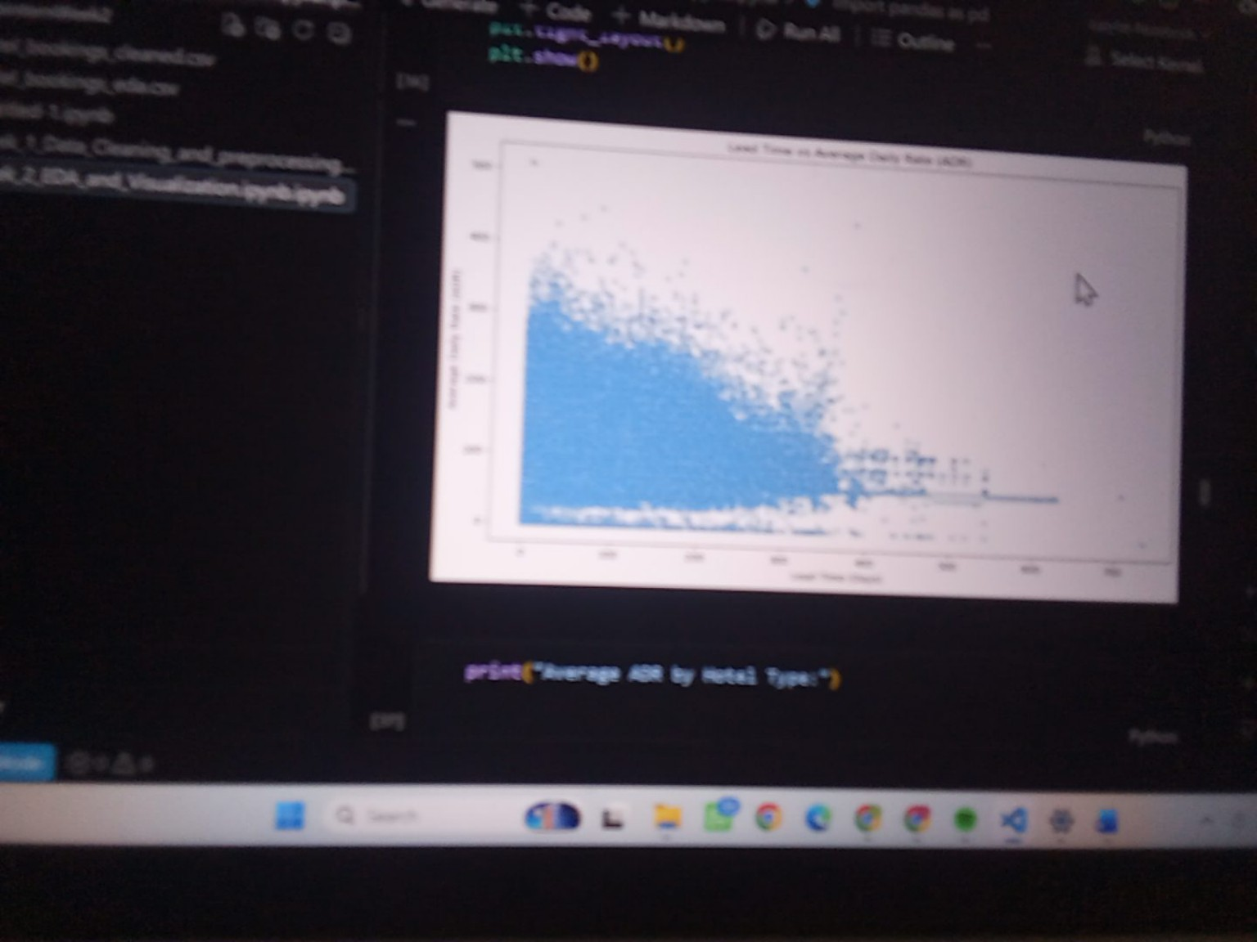
Figure 5: Lead Time and ADR Relationship
Interpretation: The scatter plot compares lead time with Average Daily Rate (ADR) and helps identify the overall relationship, spread, and unusual observations between the two numerical variables.

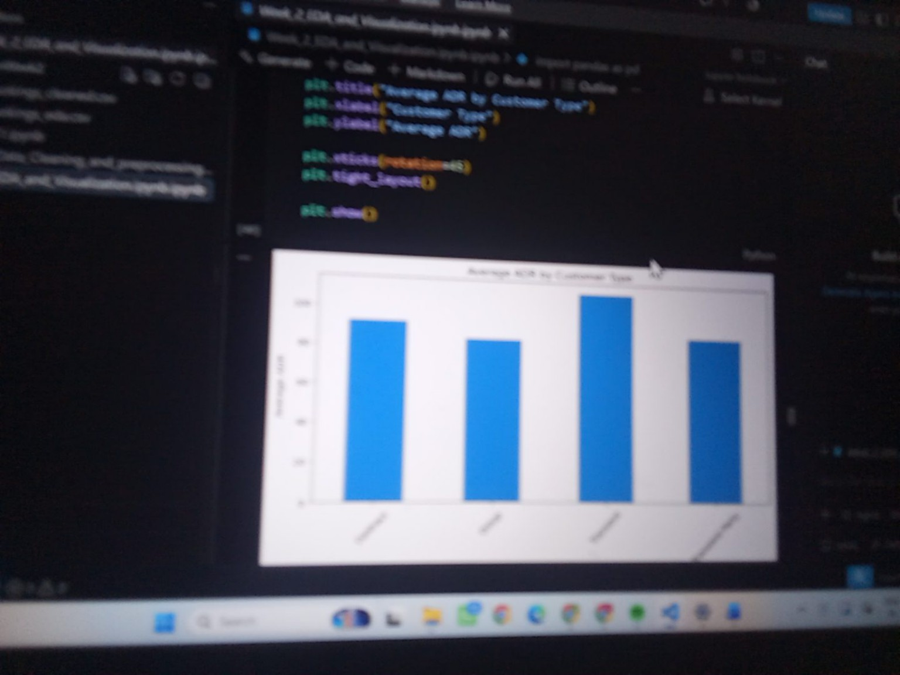
Figure 6: Average ADR by Hotel Type
Interpretation: The comparison shows that the average ADR differs between the two hotel types, providing a direct view of pricing differences in the cleaned dataset.

7. Key Findings
- The dataset contains substantial variation in booking activity across arrival months, indicating seasonal differences.
- Booking volume is not evenly distributed across customer types or market segments.
- Cancellation analysis shows that both cancelled and non-cancelled bookings are present in substantial numbers; the overall cancellation rate calculated in the notebook was approximately 27.49%.
- ADR is concentrated mainly in the lower-to-middle range, with fewer observations at higher rates.
- The lead-time and ADR scatter plot shows considerable variation and helps identify the distribution of bookings across different lead-time and pricing levels.
- The correlation heatmap provides a compact view of relationships among numerical variables and supports identification of variables that may warrant deeper analysis.

8. Data Transformations and Aggregations
The EDA used value counts, groupby aggregations, cross-tabulations, mean and median calculations, and correlation calculations. These operations converted the row-level booking data into summaries that could be compared visually.

9. Conclusion
The Week 2 EDA provided a structured understanding of the hotel booking dataset. The analysis identified differences in booking volume across time, customer categories, and market segments, while visual analysis of ADR, lead time, and numerical correlations revealed additional patterns and relationships. The selected visualizations make the main findings easier to communicate and provide a foundation for further analysis or modeling.

10. Recommended Visualization Set
For the final submission, the following seven visuals are sufficient; adding every similar chart is not necessary:
- Monthly Booking Count
- Booking Count by Customer Type
- Booking Count by Market Segment
- Correlation Heatmap
- Lead Time vs ADR scatter plot
- Average ADR by Hotel Type
- ADR Distribution histogram (the graph shown in the latest screenshot)
Note: The ADR Distribution histogram should be placed immediately after the ADR analysis subsection if the original notebook screenshot is available. It is especially useful because it directly shows the distribution of the main pricing variable.

11. Deliverables
- Week 2 EDA and Visualization report (DOCX)
- Week 2 Jupyter Notebook
- Cleaned hotel booking dataset used for analysis
- Selected visualizations with interpretations
- GitHub repository containing the Week 2 project files

