IdeaVault
SYSTEM ARCHITECTURE DESIGN
AND MODULE BREAKDOWN
Yuva Intern — Week 2 Task
Prepared by Shreya Gupta | Version 1.1 | 17 October 2026

Document detail | Value
Project | IdeaVault — personal idea-management application
Baseline | Week 1 Software Requirements Document (SRD), Version 1.0
Architecture | Layered, modular, single-user application
Platform | Web or Android; decision remains open
Storage boundary | Local device storage only; no cloud synchronisation in Version 1
Status | Proposed architecture with example scenarios and a verification plan; not yet implemented or measured

Revision focus: add diagrams, worked scenarios, explicit requirement traceability, measurable verification steps, and clearer risk responses while preserving the Week 1 scope.

Executive Summary
This document translates the Week 1 IdeaVault SRD into a proposed implementation architecture. IdeaVault helps one user capture, organise, search, and progress ideas while keeping idea content on the same device. The design separates presentation, application logic, repository/data access, and local persistence. This separation allows rules to be tested without rendering screens and allows the storage technology to be changed later without rewriting every screen.
The revised design adds three explanatory diagrams, detailed create/search/edit scenarios, sample records, module contracts, test cases, and a practical evidence plan. The numeric performance figures below are acceptance targets to be measured—not results already achieved. Version 1 excludes AI, accounts, cloud synchronisation, social features, payments, and notifications.

1. Goals and Design Principles
- Traceability: map each major module to Week 1 functional/non-functional requirements and acceptance tests.
- Separation of concerns: screens collect input; application services enforce rules; repositories access data; local storage persists records.
- Local-first privacy: idea content is not sent to external services in Version 1.
- Small MVP: implement create, read, update, delete, search, filters, tags, status, favourites, and summary counts before optional enhancements.
- Testability: title/status/priority validation and search logic should be testable without the UI.
- Accessible feedback: clear labels and messages; status must not be conveyed by colour alone.

2. High-Level Architecture
Figure 1 shows the proposed request path. A user action travels from the UI through application logic and the repository to local storage; results return in the reverse direction. Validation, error handling, privacy, accessibility, and testing apply across the layers.
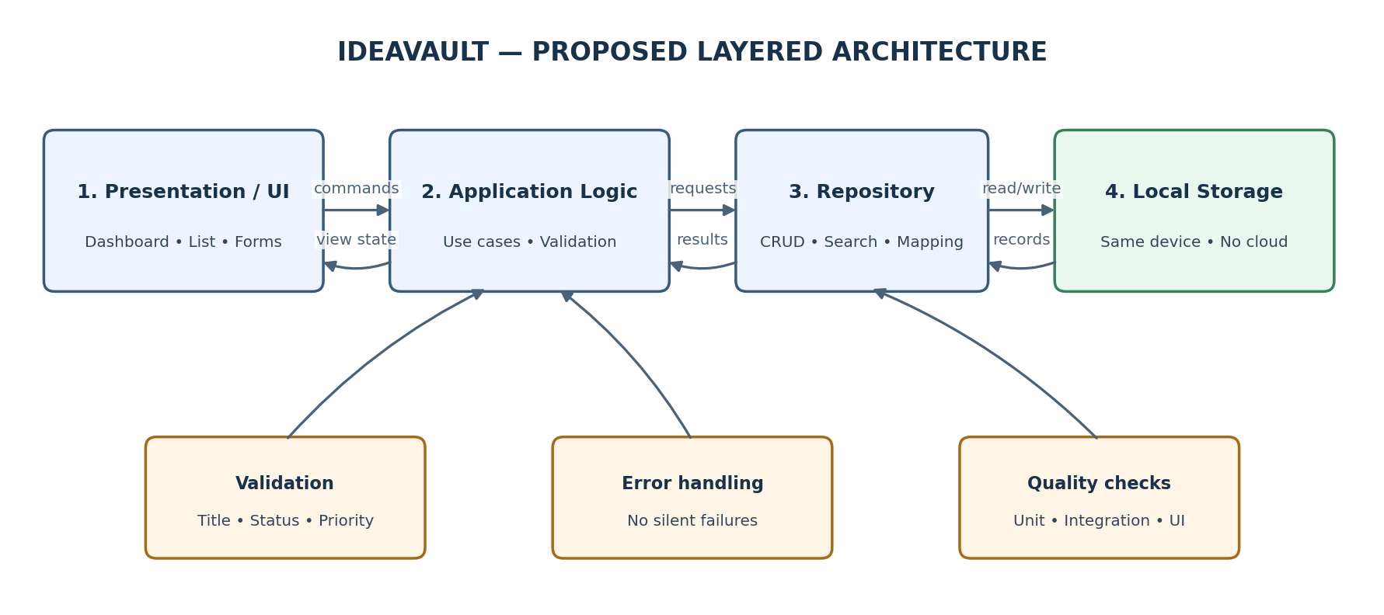
Figure 1. Proposed layered architecture and cross-cutting quality responsibilities.
Layer | Responsibilities | Example input → output
1. Presentation / UI | Dashboard, Idea List, New/Edit Idea, Idea Details; collect input and show state. | Save button → success or field-level error
2. Application logic | Use cases, validation, status/priority rules, search/filter/sort, favourite toggle, dashboard counts. | Create command → validated result
3. Repository / data access | CRUD methods, query mapping, storage-independent access. | Idea ID + fields → saved record/result
4. Local persistence | Persist records on the same device; restore after normal close/reopen. | Read/write request → records or storage error
Cross-cutting | Privacy, accessibility, consistent errors, test seams, minimal diagnostic logging. | Failure → safe message and recovery path

3. Component Interaction and Worked Scenarios
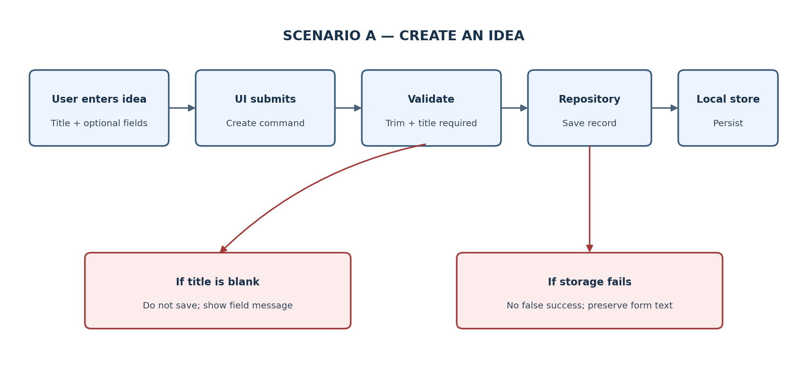
Figure 2. Create flow, including validation and storage-failure branches.

Scenario A — Create a school-garden idea
Illustrative record (example data, not a real user record):
Field | Example value
title | Build a water-saving school garden
description | Plan a small garden using collected rainwater and low-water plants.
tags / category | Environment; School project
priority / status | High / Inbox
nextAction | Ask the science teacher about a suitable site.
targetDate / favourite | 30 November 2026 / false

- User enters the title and optional fields, then selects Save.
- The UI sends a createIdea request to application logic; title is trimmed and checked for non-blank content.
- If valid, the repository creates a unique ideaId, sets createdAt and updatedAt, and asks local storage to persist the record.
- On confirmed success, the UI displays a confirmation and refreshes the list and dashboard counts.
- If the title is blank, saving is blocked and the title field shows a clear message. If storage fails, the UI must not claim success and should preserve entered text where practical.

Scenario B — Search and filter the idea
Given three local records—(1) “Build a water-saving school garden”, status Inbox, tag Environment; (2) “Prepare a debate speech”, status In Progress, tag Speaking; and (3) “Read about solar pumps”, status Exploring, tag Environment—searching for “water” should return record 1 only. Applying the Environment tag filter to the full list should return records 1 and 3. Selecting status In Progress should return record 2. These are deterministic sample cases for testing query behaviour, not measured application output.
Action | Expected result | Evidence to capture
Search keyword: water | One matching record: school garden | Search term, result count, screenshot or test log
Filter tag: Environment | Two matching records: garden and solar pumps | Filter selection and displayed IDs/titles
Filter status: In Progress | One matching record: debate speech | Selected status and result list
No-match search: moon base | Empty-state message and clear-search action | Screenshot plus pass/fail record

Scenario C — Edit and complete an idea
The user opens the garden idea, changes its nextAction to “Draft a one-page proposal”, and changes status from Inbox to In Progress. The service updates the existing record by ideaId—not by list position—and updates updatedAt. The dashboard should decrement Inbox by one and increment In Progress by one. The test should compare the saved record before and after the edit and confirm that the ID and createdAt remain unchanged.

4. Detailed Module Breakdown
Module | Responsibility and boundary | Traceability
M1 Dashboard UI | Show total ideas, status counts, favourites entry point, and New Idea action. Must not access storage directly. | FR-13; NFR-01, NFR-06
M2 Idea List UI | Show title/status/priority/tags; expose keyword search, filters, sorting, and empty/error states. | FR-03, FR-07, FR-08, FR-16; NFR-01
M3 New/Edit UI | Capture title, description, tags, category, priority, status, next action, target date; display field errors. | FR-01, FR-02, FR-05, FR-11
M4 Idea Details UI | Show full idea metadata; offer edit, delete, status, and favourite actions; confirm deletion. | FR-04, FR-05, FR-06, FR-10, FR-12
M5 Idea Management Service | Create/read/update/delete records, generate unique IDs, maintain timestamps, and apply defaults. | FR-01–FR-06; NFR-03, NFR-09
M6 Validation and Rules | Require non-blank title; validate supported status/priority values; trim and normalise input. | FR-02, FR-10; NFR-09
M7 Search/Filter/Sort | Search title and description; filter status/tag/category/priority; sort by recent update or priority. | FR-07, FR-08, FR-16; NFR-02
M8 Tag Management | Normalise labels, avoid duplicate tags, and reuse existing tags where practical. | FR-09; NFR-08
M9 Status/Favourite | Support Inbox, Exploring, In Progress, On Hold, Completed and favourite toggle. | FR-10, FR-12; NFR-06
M10 Dashboard Summary | Calculate totals from saved records; do not separately persist duplicate counts. | FR-13; NFR-02, NFR-09
M11 Repository | Expose create, getById, update, delete, list, and search; return explicit success/failure results. | FR-14; NFR-03, NFR-08, NFR-09
M12 Local Storage Adapter | Persist records locally and restore them after normal close/reopen; exact technology depends on platform. | FR-14; NFR-03, NFR-04
M13 Error/Empty-State Handling | Handle blank input, missing records, empty collection, no matches, storage failures, and delete confirmation. | FR-06, FR-15; NFR-03, NFR-06
M14 Test Support | Unit, repository integration, UI, acceptance, and performance tests with known sample records. | NFR-02, NFR-08, NFR-09; AT-01–AT-10

5. Conceptual Data Model and Storage Design
The Idea record remains the core entity. Each record has a stable unique identifier so edits and deletes cannot accidentally target the wrong item. For the first MVP, tags may be stored as a list of normalised text labels. If tag reuse becomes complex, the optional Idea–Tag link model in Figure 3 avoids repeated copies of the same tag label.
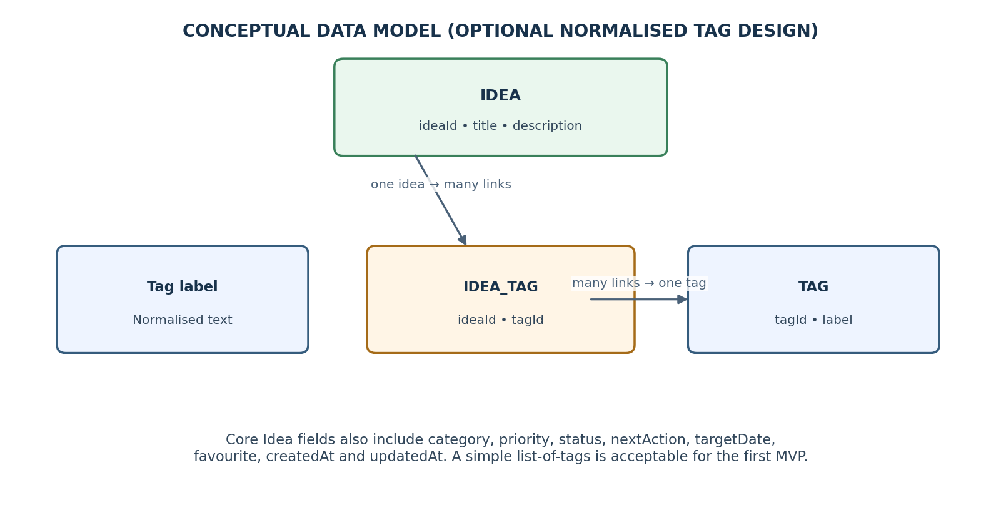
Figure 3. Optional normalised tag structure; a simple tag list is acceptable for the MVP.
Field | Suggested type / rule | Example or reason
ideaId | Unique string/UUID; required | Stable identifier for update/delete
title | Text; required; trim; reject blank | Build a water-saving school garden
description | Optional text | May be empty
tags | List of text labels; normalise duplicates | Environment, School project
category | Optional text | Study, Writing, Research, Project
priority | Low / Medium / High | High
status | Inbox / Exploring / In Progress / On Hold / Completed | Inbox
nextAction | Optional text | Ask the science teacher about a site
targetDate | Optional date; informational only | 30 November 2026
favourite | Boolean | true / false
createdAt / updatedAt | Date-time values | updatedAt changes on edit; createdAt stays fixed

Storage decision: the Week 1 baseline leaves web versus Android open. A browser prototype could use IndexedDB; an Android prototype should use an Android-compatible local store. Confirm the platform before selecting the final technology. Version 1 has no cloud backup, so the UI must clearly communicate the local-only boundary.

6. Recommended Technology Stack
Area | Candidate recommendation | Decision / caveat
UI | HTML, CSS, JavaScript for a beginner-friendly web prototype | Confirm web versus Android before implementation
Application logic | Plain JavaScript modules | Keep business rules out of screen event handlers
Data access | Small repository interface | UI must not call storage APIs directly
Local persistence | IndexedDB for web; platform-appropriate local database for Android | Choose one after platform decision; verify device/browser support
Testing | Built-in or lightweight test runner plus manual acceptance tests | Record environment and pass/fail evidence
Version control | Git, optionally hosted remotely | Runtime must not depend on hosting service

7. Module Contracts
Operation | Request | Expected result and failure behaviour
createIdea | Idea fields; title required | Created record with ID/timestamps; blank title or storage error is explicit
getIdea | ideaId | Record or not-found result
updateIdea | ideaId + changed fields | Updated record and updatedAt; not-found/validation error if needed
deleteIdea | ideaId after UI confirmation | Success or not-found/storage error
searchIdeas | keyword + optional filters/sort | Matching records; empty list is a valid result
changeStatus | ideaId + supported status | Updated record; reject unsupported status
setFavourite | ideaId + Boolean | Updated record
getDashboardSummary | No input or optional scope | Total and counts for each supported status

Contract example: createIdea({title: ' Debate speech ', status: 'Inbox'}) should trim the title to “Debate speech”, assign a unique ID and timestamps, and return the saved record. createIdea({title: ' '}) should return a validation error and must not create a record.

8. Error Handling, Privacy, and Accessibility
- Blank title: block saving and identify the title field with a clear message.
- Storage failure: never show false success; preserve form content where practical and provide a recovery suggestion.
- Missing record: show a safe message and return to the list instead of crashing.
- Delete: ask for confirmation before removing an idea.
- Empty collection/no matches: explain the state and offer New Idea or Clear Search.
- Privacy: keep Version 1 idea content local; do not transmit it to external services or expose it through public URLs.
- Accessibility: readable text, labelled controls, keyboard-friendly navigation where supported, and status labels in addition to colour.
- Data integrity: update by unique ID; update timestamps consistently; ensure a failed write does not appear as saved.

9. Performance Targets and Evidence Plan
These are proposed acceptance targets inherited from the Week 1 intent; they have not been measured. A test report must record the device, operating system, browser/app version, sample size, test date, and each run’s result.
Check | Proposed target | How to verify | Evidence
List opening | With 1,000 saved ideas, list appears within 2.0 seconds in at least 9 of 10 runs | Seed 1,000 varied records; restart app; time list opening 10 times | CSV/table of 10 timings, environment, median and pass count
Keyword search | With 1,000 saved ideas, simple search completes within 2.0 seconds in at least 9 of 10 runs | Run the same query 10 times; include matching and no-match queries | Search timings and result counts
Persistence | Saved record remains after normal close/reopen | Create record, close app normally, reopen, search by unique title | Before/after screenshots or test log
Integrity | Edit changes the selected record only | Create 3 records, edit the middle one, compare IDs and fields | Before/after record export or test assertions
Scalability boundary | 1,000 ideas is the required test dataset; 5,000 is an optional stretch test | Repeat list/search tests at 5,000 if feasible | Separate stretch-test results; do not treat as a guarantee

A result should be labelled Pass only when measured evidence meets the target. If a target fails, record the observed timings, repeat under controlled conditions, inspect search/indexing and rendering, and document the fix and retest. Do not write “fast” or “scalable” without the measurements.

10. Testing Strategy and Acceptance Mapping
Test ID | Scenario / steps | Expected outcome
AT-01 | Create an idea with a valid title and optional fields | One record saved; ID and timestamps present
AT-02 | Attempt to save with blank/whitespace-only title | No record saved; title error visible
AT-03 | Edit description and nextAction of an existing idea | Same ideaId and createdAt; updatedAt changes
AT-04 | Search for “water” in the three-record sample | Only the garden idea appears
AT-05 | Filter the sample by Environment tag | Garden and solar-pumps ideas appear
AT-06 | Change status from Inbox to In Progress | Record updates and dashboard counts change consistently
AT-07 | Delete a record and cancel a separate delete prompt | Confirmed delete removes one record; cancel preserves the other
AT-08 | Close and reopen after saving | Saved record remains available
AT-09 | Search for “moon base” when no record matches | Helpful empty state and clear-search action appear
AT-10 | Save with optional fields omitted | Valid title is saved using documented defaults
AT-11 | Simulate or handle a storage-write failure | No false success; user gets clear error; entered text retained where practical
AT-12 | Edit one record in a three-record list | Other two records remain unchanged
AT-13 | Run list/search performance checks with 1,000 records | Meet or fail the explicit 2-second/9-of-10 target with recorded evidence
AT-14 | Toggle favourite twice | Value returns to its original Boolean state

Testing levels: unit tests cover validation/status/priority/tag normalisation; repository integration tests cover CRUD and persistence; UI tests cover navigation, messages, and confirmation; acceptance tests cover the scenarios above.

11. Scalability and Maintainability Boundaries
Version 1 is a personal, single-user, local-first tool. The architecture is intended to keep a 1,000-idea collection testable and usable; it does not promise enterprise-scale or multi-user behaviour. The optional 5,000-idea stretch test can reveal likely limits but does not establish a universal capacity guarantee.
Future change | Boundary that limits impact | Required review before adding
Export / backup | Repository and storage adapter | File format, privacy, restore behaviour, write errors
Switch web to Android | Presentation and platform adapter | UI differences, local storage, accessibility, compatibility
Cloud sync (out of scope) | Repository boundary may be extended later | Authentication, secure transfer, conflict resolution, privacy review
Reminders (not promised in v1) | Target date remains data only | Permissions, scheduling, platform limits
Large datasets | Repository/search layer | Indexing, memory use, timing results and device range

12. Risks, Assumptions, and Open Decisions
Risk | Impact | Mitigation and trigger
Feature creep | MVP grows beyond beginner scope | Implement Must requirements first; defer AI, sync, accounts, reminders. Trigger: a new feature threatens core tests or schedule.
Local data loss | Cleared browser/app data or device loss may remove ideas | Explain local-only storage; consider export as a separately approved enhancement. Trigger: user assumes cloud backup exists.
Platform undecided | Stack cannot be finalised | Approve web or Android before coding; keep storage behind repository.
Slow search/list | 1,000-record target may fail | Use suitable local storage/indexing and profile repeated tests. Trigger: fewer than 9/10 runs meet 2 seconds.
Inconsistent status values | Dashboard and filters disagree | Define statuses once and share constants across UI, service and tests.
Privacy misunderstanding | User expects sync or backup | Display a local-storage notice and avoid implying synchronisation.
Failed storage write | User may believe an unsaved idea is safe | Only show success after confirmed write; preserve form text where possible.
Duplicate tags | Filters fragment the same topic | Trim and normalise labels; test case/whitespace duplicates.

Open decisions carried forward from Week 1
- Should Version 1 include export-to-file backup?
- Should tags be free-form, selected from existing tags, or both?
- Should the first prototype be web or Android?
- Should target dates remain informational, with reminders considered only later?
- Which device/browser compatibility and accessibility targets should be confirmed?

13. Development Sequence and Dependencies
Phase | Build / verify | Exit condition
1. Confirm platform and wireframes | Choose web/Android; sketch Dashboard, Idea List, New/Edit, Idea Details | Platform and screen flow approved
2. Domain model and validation | Idea record, unique ID, title rule, status/priority values | Unit tests pass for core rules
3. Repository and persistence | CRUD interface and local storage adapter | Create/read/update/delete and restart persistence verified
4. Core screens | Create, view, edit, delete; clear errors and confirmation | AT-01, AT-02, AT-03, AT-07, AT-08 pass
5. Organisation | Search, filters, tags, status, favourites, sorting | AT-04, AT-05, AT-06, AT-14 pass
6. Dashboard and quality review | Counts, empty states, accessibility, performance checks | AT-09, AT-10, AT-11, AT-13 pass or defects documented

14. References and Evidence Integrity
This design follows the Week 1 IdeaVault SRD supplied as the project baseline. The links below are background references; listing them does not claim formal certification or full compliance.
- ISO/IEC/IEEE 29148:2018 — Systems and software engineering: Life cycle processes — Requirements engineering. https://www.iso.org/standard/72089.html
- OWASP Application Security Verification Standard — security verification concepts for software applications. https://owasp.org/www-project-application-security-verification-standard/
- MDN Web Docs — IndexedDB API. https://developer.mozilla.org/en-US/docs/Web/API/IndexedDB_API

Conclusion
The revised Week 2 architecture provides a more concrete bridge from the Week 1 SRD to implementation. The layered diagram clarifies responsibilities, the worked scenarios demonstrate expected behaviour, the data model explains stable identifiers and tags, and the acceptance matrix specifies what to test. The performance targets remain proposals until measured. Before development begins, confirm the platform and resolve the open decisions; during implementation, retain test logs and screenshots as evidence rather than describing untested behaviour as proven.

