IdeaVault
SYSTEM ARCHITECTURE DESIGN
AND MODULE BREAKDOWN
Yuva Intern — Week 2 Task
Prepared by Shreya Gupta | Version 1.0 | 14 October 2026

Document detail | Value
Project | IdeaVault — personal idea-management application
Source baseline | IdeaVault Software Requirements Document (Week 1), Version 1.0
Architecture style | Layered, modular, single-user application
Target first prototype | Modern browser or Android-sized screen; platform decision remains open
Storage boundary | Local device storage only; no cloud synchronisation in Version 1
Status | Proposed design for review; not a claim of an implemented or tested system

Executive Summary
This document proposes a high-level architecture and detailed module breakdown for IdeaVault, a lightweight personal idea bank. The design follows the Week 1 requirements: users can create, view, edit, delete, search, filter, organise, favourite, and track ideas, while data remains on the same device. A layered structure separates screens, business rules, data access, and local persistence so that modules can be developed and tested independently. The architecture deliberately excludes AI, cloud sync, accounts, social features, payments, and other Version 1 out-of-scope items.

1. Goals and Design Principles
- Requirements traceability: every major module maps to functional or non-functional requirements from Week 1.
- Separation of concerns: user interface, business rules, storage operations, and persistence are distinct responsibilities.
- Local-first privacy: idea content is not sent to external services in Version 1.
- Small MVP: essential requirements are prioritised before optional enhancements.
- Testability: validation and business rules should be testable without relying on screen rendering.
- Replaceable storage: a repository interface limits how much application logic depends on a specific storage technology.
- Accessible and understandable UI: readable text, meaningful labels, clear feedback, and status indicators that do not rely on colour alone.

2. High-Level Architecture
The proposed system uses four primary layers. Requests move from the presentation layer to business logic, then through the data access layer to local persistence. Results and errors return to the presentation layer. Cross-cutting concerns—validation, error handling, privacy, accessibility, and testability—apply across the layers.
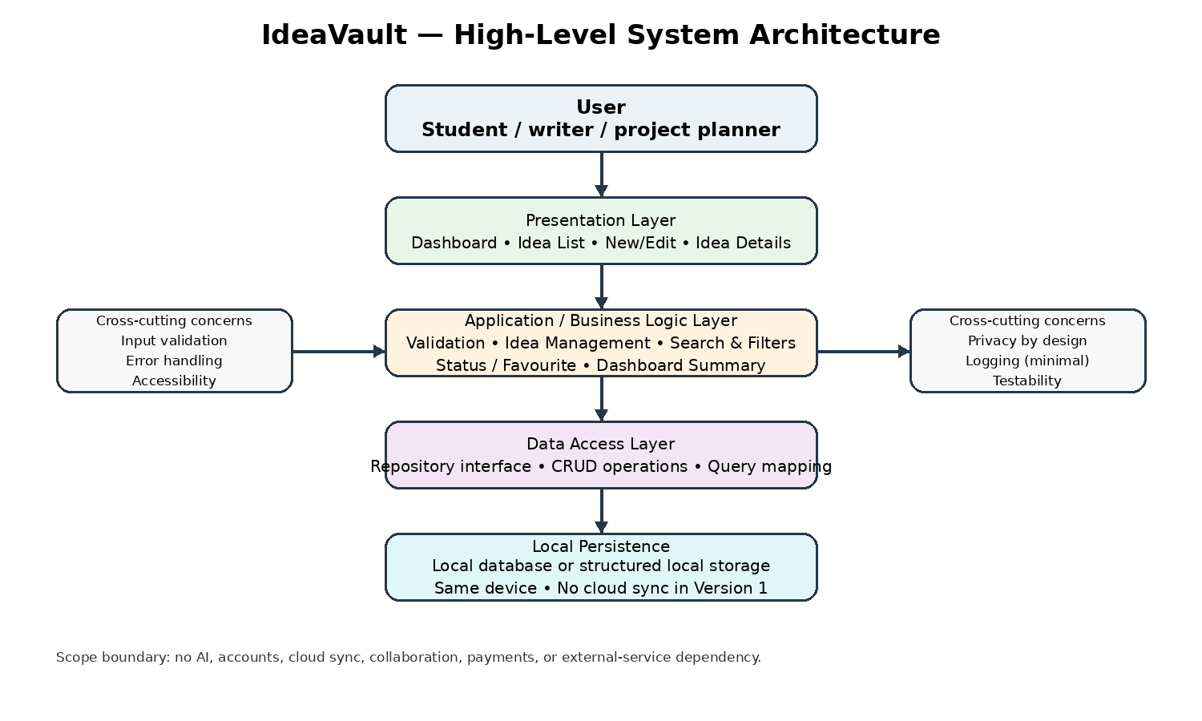
Figure 1. High-level architecture and Version 1 scope boundary.
Layer | Responsibilities | Inputs | Outputs
1. Presentation / UI | Dashboard, Idea List, New/Edit Idea, Idea Details; collect input; show lists, filters, status, and messages. | User actions and view state | Validated requests to business logic; updated view state
2. Application / Business Logic | Use cases; title validation; status and priority rules; search/filter/sort; favourite toggle; dashboard counts. | Commands, query criteria, current idea data | Success results, matching ideas, summaries, or actionable errors
3. Data Access | Repository interface; CRUD calls; query mapping; storage-independent data operations. | Idea IDs, idea objects, search/filter criteria | Idea records, result collections, success/failure outcomes
4. Local Persistence | Store and retrieve ideas on the same device; preserve records across normal restart. | Repository read/write requests | Persisted records or storage errors
Cross-cutting | Privacy, accessibility, error handling, minimal diagnostic logging, test seams. | Events and module behaviour | Consistent quality and failure handling

3. Component Interaction and Data Flow
Create flow: the user opens New Idea, enters a required title and optional fields, and selects Save. The UI passes the request to the business logic. The title is validated; if valid, the repository saves the idea to local storage. The UI then confirms success and refreshes the list/dashboard. If validation or storage fails, the user receives a clear message and the entered information should remain available where practical.
Search flow: the user enters a keyword or chooses filters. The business logic sends query criteria through the repository, which searches the local collection. The UI displays matching ideas and a helpful empty-result state. No network service is required for these core flows.
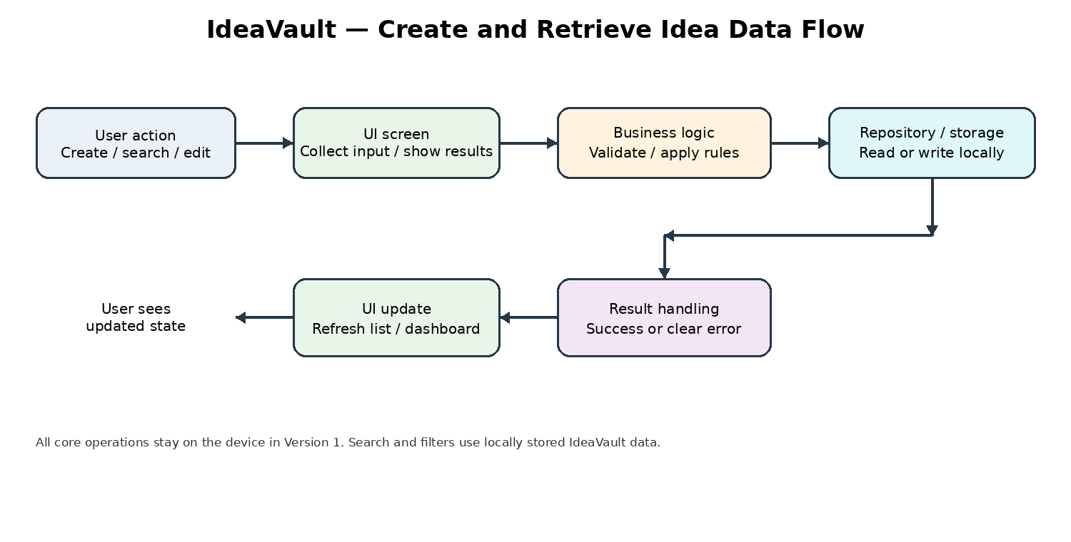
Figure 2. Simplified create/retrieve flow. The same pattern applies to edit, delete, status, and favourite operations.

4. Detailed Module Breakdown
Module | Responsibilities | Inputs | Outputs | Communication | Traceability
M1 — Dashboard UI | Show total ideas, counts by status, favourites entry point, and New Idea action. | Dashboard request / summary data | Dashboard view model; navigation actions | Calls Dashboard Summary use case; no direct storage access. | FR-13; NFR-01, NFR-06
M2 — Idea List UI | Display idea cards with title, status, priority, and tags; expose search, filters, sorting, and empty results. | Search text, filters, sort choice | Visible idea cards and empty/loading/error states | Calls Search/Filter/Sort use cases; sends selection to Idea Details. | FR-03, FR-07, FR-08, FR-16; NFR-01
M3 — New/Edit Idea UI | Capture or update title, description, tags, category, priority, status, next action, and target date. | Form fields; existing Idea ID for edit | Save/cancel action; field-level validation messages | Uses Create Idea or Update Idea; does not write storage directly. | FR-01, FR-02, FR-05, FR-11; NFR-06
M4 — Idea Details UI | Show full idea content and metadata; offer edit, delete, status, and favourite actions. | Idea ID and requested action | Detail view; updated state; delete confirmation | Loads details via repository-backed use cases; confirms before deletion. | FR-04, FR-05, FR-06, FR-10, FR-12
M5 — Idea Management Service | Create, read, update, and delete ideas; generate unique IDs; maintain created/updated timestamps; apply defaults. | Commands and Idea data | Saved/updated record, result, or domain error | Coordinates repository operations; enforces rules independently of UI. | FR-01–FR-06; NFR-03, NFR-09
M6 — Validation and Rules | Require a non-blank title; validate supported status/priority values; trim title; handle optional fields safely. | Form or command data | Valid data or clear validation errors | Runs before persistence; rules can be unit-tested. | FR-02, FR-10; NFR-09
M7 — Search, Filter and Sort | Search title and description; filter by status, tag/category, and priority; sort by recently updated or priority. | Keyword, filter criteria, sort mode | Ordered matching Idea list | Queries the repository or applies consistent query logic to local records. | FR-07, FR-08, FR-16; NFR-02
M8 — Tag Management | Add tags to ideas, normalise duplicates consistently, and reuse existing tags where practical. | Idea ID and tag labels | Updated tag list / available tag suggestions | Stores tags as part of idea records for the MVP; no separate complex tag service required initially. | FR-09; NFR-08
M9 — Status and Favourite | Change status among Inbox, Exploring, In Progress, On Hold, Completed; toggle favourite. | Idea ID and selected value | Updated idea and refreshed counts/list | Uses Idea Management Service; status labels are displayed as text, not colour alone. | FR-10, FR-12; NFR-06
M10 — Dashboard Summary | Calculate total ideas and counts by status from saved records. | Idea collection or repository summary query | Total and per-status counts | Read-only use case; does not duplicate or independently store counts. | FR-13; NFR-02, NFR-09
M11 — Repository / Data Access | Offer storage-independent methods such as create, getById, update, delete, list, and search. | Domain requests and query parameters | Records, collections, and explicit operation outcomes | Single interface between business logic and storage implementation. | FR-14; NFR-03, NFR-08, NFR-09
M12 — Local Storage Adapter | Persist records locally and restore them after normal close/reopen on the same device. | Repository read/write operations | Stored records or storage failure | Use platform-appropriate local database or structured storage; exact technology remains a decision. | FR-14; NFR-03, NFR-04
M13 — Error and Empty-State Handling | Explain empty collection, no search matches, validation failures, and storage errors; confirm destructive deletion. | Error/result state and user action | Clear message, recovery action, or confirmation prompt | Shared UI patterns used by all screens; avoid silent failures. | FR-06, FR-15; NFR-03, NFR-06
M14 — Quality and Test Support | Unit tests for rules; integration tests for repository; UI acceptance tests for main flows; performance checks. | Test cases and sample dataset | Pass/fail evidence and defects | Tests modules independently and validates acceptance criteria. | NFR-02, NFR-08, NFR-09; AT-01–AT-10

5. Data Model and Storage Design
The Week 1 conceptual model remains the source of truth. The implementation should keep one Idea record per saved idea and use a unique identifier to prevent accidental overwrites.
Field | Suggested representation | Rule / purpose
ideaId | Unique string/UUID | Required; stable identifier for updates and deletes
title | Text | Required; trim whitespace; reject blank values
description | Text, optional | May be empty
tags | List of text labels | Optional; consistent normalisation; avoid duplicate labels
category | Text, optional | Examples in SRD: Study, Writing, Research, Project
priority | Enum: Low / Medium / High | Use a documented default if the UI requires one
status | Enum: Inbox / Exploring / In Progress / On Hold / Completed | Use the SRD values consistently
nextAction | Text, optional | Practical next step
targetDate | Date, optional | Informational target; not a guaranteed notification
favourite | Boolean | True or false
createdAt / updatedAt | Date-time | Creation time and last update time; updatedAt changes on edits

Storage choice is intentionally technology-neutral because Week 1 leaves the platform decision open. For a browser prototype, a browser-supported local store may be suitable; for an Android prototype, an Android-compatible local database or structured store may be suitable. Select one after confirming the platform, then test persistence and failure handling.

6. Recommended Technology Stack
The Week 1 SRD explicitly leaves the first prototype as either a web app or Android app. Therefore, the stack below is a recommendation for a beginner-friendly web prototype, not a final decision. The same architecture can be retained if Android is selected.
Area | Recommended option | Reason | Caveat
UI | HTML, CSS, JavaScript; optionally a small component framework if already familiar | Low setup overhead; works well for a small screen-first prototype | Choose one UI approach; avoid adding framework complexity without need
Application logic | Plain JavaScript modules | Easy to separate validation, use cases, and query logic | Keep business rules out of screen event handlers
Data access | A small repository interface | Makes storage replaceable and testable | Do not let UI components call storage APIs directly
Local persistence | IndexedDB for a browser prototype; alternatively another platform-appropriate local store | Designed for structured local data and larger collections than simple key/value settings | Technology must be confirmed after platform decision; test browser/device support
Testing | Built-in test runner or a lightweight JavaScript test framework; browser-based manual acceptance tests | Supports unit, integration, and acceptance testing | Exact tool depends on selected stack and developer familiarity
Version control | Git with a repository host if available | Tracks changes and supports a clear development history | Git hosting is optional; core app must not depend on it at runtime

Rationale: a small local-first stack keeps the first release understandable and avoids a backend, cloud account system, or external API. No AI or third-party service is required. Public background references are listed in Section 12.

7. API / Module Contracts
These are conceptual interfaces, not implemented endpoints. They define how modules should communicate.
Operation | Request | Expected result / failure
createIdea | Idea fields; title required | Created Idea with ID and timestamps; validation error if title is blank; storage error if save fails
getIdea | ideaId | Idea record; not-found result if the ID does not exist
updateIdea | ideaId plus changed fields | Updated record and updatedAt; not-found or validation error
deleteIdea | ideaId after UI confirmation | Success result; not-found/storage error where relevant
searchIdeas | keyword and optional filter/sort criteria | Matching records; empty list is a valid result
changeStatus | ideaId and supported status | Updated record; reject unsupported status values
setFavourite | ideaId and Boolean | Updated record
getDashboardSummary | No input or optional query scope | Total count and counts for each supported status

8. Error Handling, Privacy, and Accessibility
- Blank title: prevent saving and identify the title field with a clear message.
- Storage failure: do not show false success; report the failure and preserve entered form data where practical.
- Missing record: show a safe message and return to the list instead of crashing.
- Delete: request confirmation before removing an idea.
- Empty collection and no search matches: explain the state and provide a useful next action.
- Privacy: keep Version 1 idea content local; do not transmit it to external services or expose it through public URLs.
- Accessibility: use readable text, labelled controls, keyboard-friendly navigation where supported, and text labels in addition to colour.
- Data integrity: update by unique ID, not by list position; update timestamps consistently; test concurrent-looking UI actions even though Version 1 is single-user.

9. Scalability and Maintainability
The first version is designed for a personal collection, not an enterprise or multi-user system. Maintainability comes from clear module boundaries, stable data fields, repository-based storage access, reusable validation, and requirement-linked tests. A later version could replace the local storage adapter or add export/backup after review, without rewriting every screen. Cloud sync, accounts, team collaboration, AI, and notifications are not part of this architecture and would require a separate design.
Future change | Boundary that limits impact | Required review before adding
Export / backup | Storage adapter and repository | Data format, privacy, restore behaviour, error handling
Switch web to Android | Presentation and platform adapter boundaries | Platform-specific UI, storage, accessibility, compatibility
Cloud sync (out of scope) | Repository boundary could be extended later | Authentication, authorisation, secure transfer, conflict resolution, privacy review
Reminders (not promised in v1) | Target date remains data only | Notification permissions, schedules, device/platform limitations

10. Testing Strategy and Acceptance Mapping
Test level | What to verify | Examples
Unit tests | Business rules in isolation | Blank-title rejection; allowed status values; priority sorting; tag normalisation
Repository integration tests | Data access and persistence | Create/read/update/delete; unique ID behaviour; close/reopen persistence; storage failure
UI tests | Screen feedback and navigation | Empty state; validation message; delete confirmation; status/favourite controls
Acceptance tests | Week 1 acceptance scenarios | AT-01 create; AT-02 blank title; AT-03 edit; AT-04 search; AT-05 filter; AT-06 status; AT-07 delete; AT-08 persistence; AT-09 empty state; AT-10 optional fields
Performance check | Proposed target with sample data | With 1,000 ideas, list opening and simple search normally complete within 2 seconds on a typical supported device

These are proposed test plans and acceptance targets. They are not evidence that the application has already been implemented or tested.

11. Development Sequence and Dependencies
Phase | Build / verify | Depends on | Exit condition
1. Confirm platform and wireframes | Choose web or Android; sketch Dashboard, Idea List, New/Edit, Idea Details | Review of this architecture and open questions | Platform and screen flow approved
2. Domain model and validation | Idea record, unique ID, title rule, status/priority values | Phase 1 | Unit tests pass for core rules
3. Repository and persistence | CRUD interface and local storage adapter | Phase 2 | Create/read/update/delete and restart persistence verified
4. Core screens | Create, view, edit, delete; clear errors and confirmation | Phases 1–3 | AT-01, AT-02, AT-03, AT-07, AT-08 pass
5. Organisation | Search, filters, tags, status, favourites, sorting | Phase 4 | AT-04, AT-05, AT-06 and relevant feature tests pass
6. Dashboard and quality review | Counts, empty state, accessibility and performance checks | Phase 5 | AT-09, AT-10 pass; issues documented

12. Risks, Assumptions, and Open Decisions
Item | Impact | Mitigation / decision
Feature creep | MVP grows beyond beginner scope | Implement Must requirements first; defer out-of-scope features
Local data loss | Cleared app/browser data or device loss may remove ideas | Explain local-only limitation; consider export/backup as a separately approved enhancement
Platform undecided | Specific UI/storage technologies cannot yet be finalised | Confirm web vs Android before implementation
Slow search | Large collection could miss performance target | Use an indexed local store where appropriate; test with 1,000 sample ideas
Inconsistent status values | Dashboard and filters may disagree | Use one shared status definition across UI, logic, and tests
Privacy expectations | Users may assume cloud backup exists | Show a short local-storage/privacy notice; do not imply synchronisation

Open decisions carried forward from the Week 1 SRD:
- Should Version 1 include export-to-file for backup?
- Should tags be free-form, selected from existing tags, or both?
- Should the first prototype be a web app or Android app?
- Should target dates remain informational, or should reminders be considered later?
- Which accessibility and device compatibility targets should be confirmed?

13. Public References
The following references provide background. This document does not claim formal certification or full compliance with a standard.
- ISO/IEC/IEEE 29148:2018 — Systems and software engineering: Life cycle processes — Requirements engineering. https://www.iso.org/standard/72089.html
- ISO Online Browsing Platform — public preview and terminology for ISO/IEC/IEEE 29148. https://www.iso.org/obp/ui/
- OWASP Application Security Verification Standard — security verification concepts for software applications. https://owasp.org/www-project-application-security-verification-standard/
- MDN Web Docs — IndexedDB API (background for the optional browser prototype storage recommendation). https://developer.mozilla.org/en-US/docs/Web/API/IndexedDB_API

14. Conclusion
IdeaVault can be built as a small, layered, local-first application. The proposed separation between UI, business logic, repository/data access, and local persistence supports independent development and testing. The module contracts, data model, scope boundaries, and acceptance mapping provide a practical blueprint for the next development phase. Before coding begins, the reviewer should confirm the target platform and resolve the open questions carried forward from Week 1.

End of Week 2 System Architecture Design

