

Zinc Bath Documentation.

(Kalptaru, Gandhinagar)

Prepared by : Priya Softweb Solutions Private Limited, Ahmedabad.

Contents

- Development Overview and Obstacles.
- Hardware Requirement
- System Architecture.
- System Flow.
- System configuration.
- Troubleshot And QA
- Plugin Functionality And Features.

- Development Overview
Automation – Dip-In and Dip-Out log system. System receive Timestamp-Data from two Bridge-rack via Raspberry Pi and data get processes, backup and forwarded to SAP Web Service.

- Hardware Requirement.

Devices and Hardware provided by Softweb Solutions:

Hardware | Unit
Raspberry pi 3 | 3
Mi Power Bank | 4
Ujala Bulb | 1
Micro SD card | 3
Charging 2 AMP | 2
Micro USB to USB cable | 2
Hooter/Ring bell | 1

Devices and Hardware provided by Kalpataru:

Hardware | Unit
Windows 10 based PC > 500 GB harddisk, 8 GB, RAM, Intel-i3 64 bit Conductivity Sensor. | 1
Outer-box for raspberry pi 3 and power bank protection | 1

- System Architecture.

Devices used –

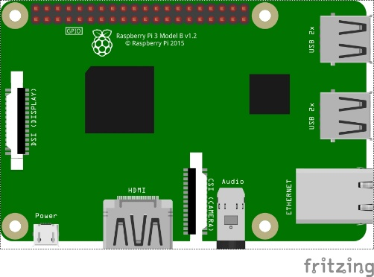
Raspberry Pi 3 Desktop

System Architecture

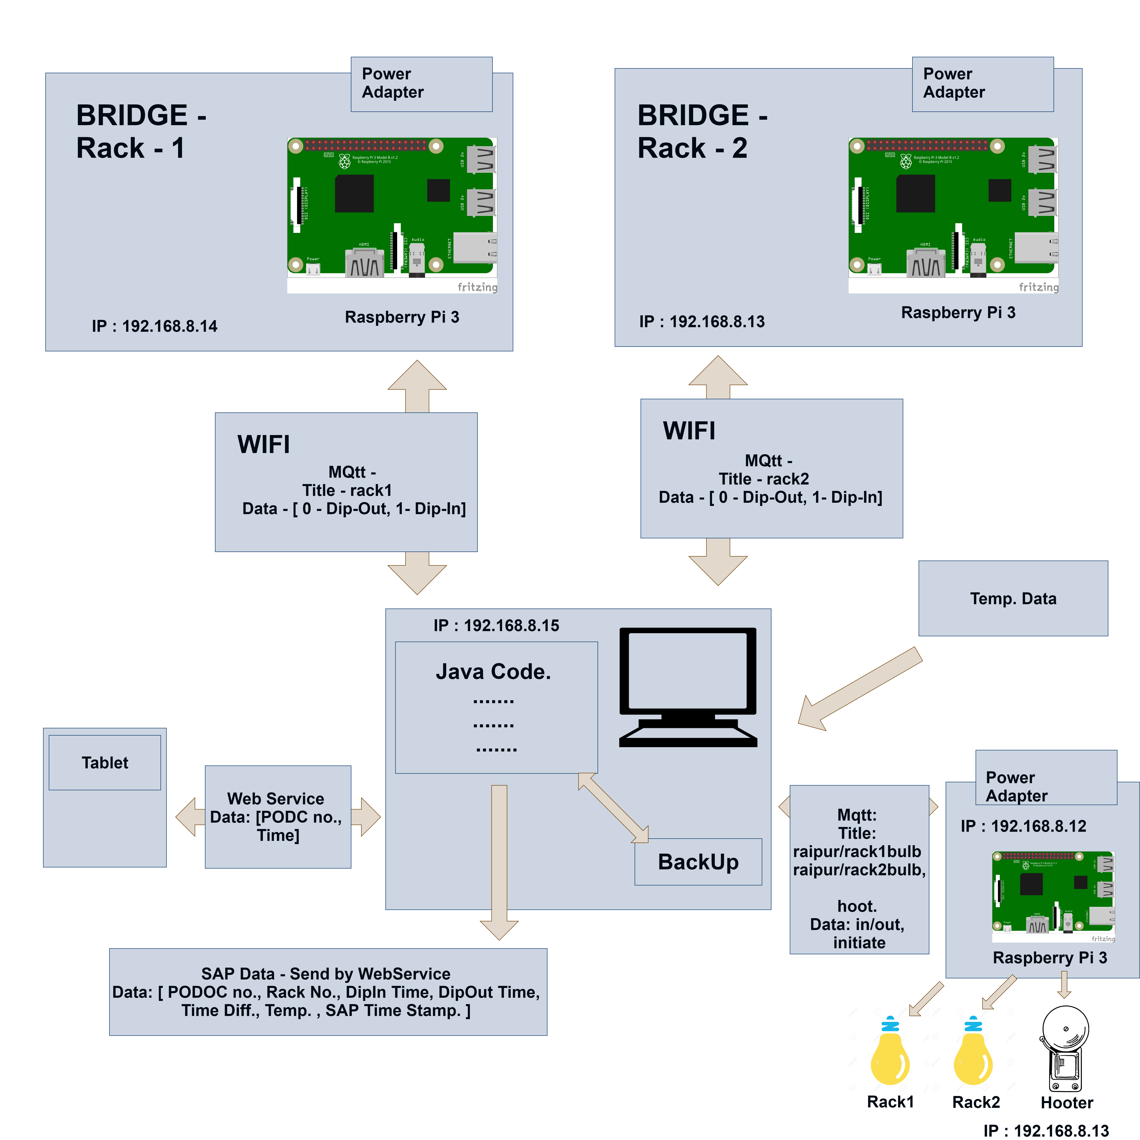

System Diagram

- System Flow

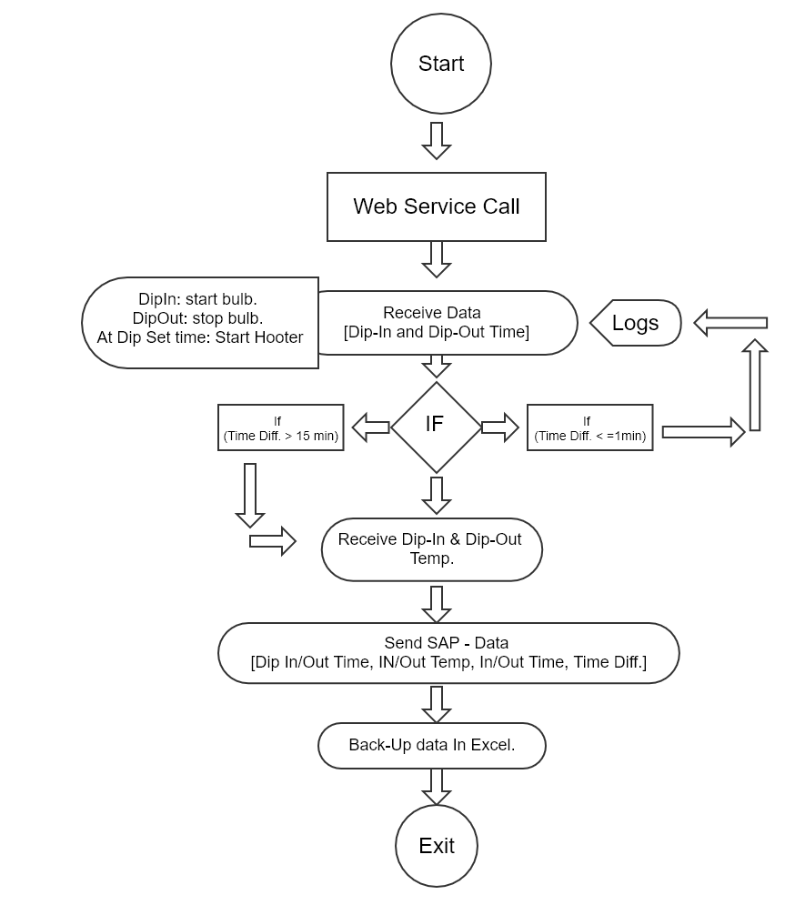

- System configuration

Static IP details:

- 192.168.8.12:
raspberry pi with Hooter and bulb,
topic = kalpataru/hooter,message = 0
topic = raipur/hooter, message = start
broker = 192.168.8.15
hooter pin = 16
bulbPin(Rack-1)=38
bulbPin(Rack-2)=40

Hooter
Topic - "hoot"
msg - "initiate"

Rack 1 bulb
Topic - "EOT27bulb"
msg - "in" - Bulb ON
msg - "out" - Bulb OFF

Rack 2 bulb
Topic - "EOT26bulb"
msg - "in" - Bulb ON
msg - "out" - Bulb OFF

- 192.168.8.13
raspberry pi with sensor,
topic = EOT26, message = 1 or 0
broker = 192.168.8.15
- 192.168.8.14
raspberry pi with sensor,
topic = EOT27, message = 1 or 0
broker = 192.168.8.15

- 192.168.8.15 = windows PC with ActiveMQ broker and Java program

Raspberry Pi3 OS and Networking Details:

Installed OS: 2017-07-05-raspbian-jessie

Static IP configuration:

# kalpataru local Area network

nano /etc/dhcpcd.conf
interface eth0
static ip_address=192.168.8.161/24
static routers=192.168.8.254
static domain_name_servers=192.168.0.105

# kalpataru Static Wifi if configuration details:

nano /etc/dhcpcd.conf
interface wlan0
static ip_address=192.168.8.13/24
static routers=192.168.8.254
static domain_name_servers=192.168.0.105

#kalpataru Wifi SSID and Password Details:

nano /etc/wpa_supplicant/wpa_supplicant.conf
network=
{
ssid="KPTL_GALV 2"
psk="Kptl@579#"
}

Login with Putty using above IP address:

user name: pi
password: softweb

MQTT Paho library Installation:

sudo pip install paho-mqtt

Python code for raspberry pi with sensor:

192.168.8.13
192.168.8.14
Sensor Pin connection: Pin11 or GPIO17

Login with Putty using above IP address:

user name: pi
password: softweb

Python Code Path:

For Sensor: /home/pi/Desktop/test1.py
For Hooter:/home/pi/Desktop/mqttclient.py

Log Files Path:
CSV Reports: C:\KalpatarruData\Reports
Pi status Report: C:\KalpatarruData\PiReports
Code start Report: C:\KalpatarruData\Logs\serverRestart.txt
Api Log : C:\KalpatarruData\Logs\apilog.log

MQTT Paho library Installation:

sudo pip install paho-mqtt

Python Code Autoboot on Restart/Poweroff using SYSTEMD:

systemd provides a standard process for controlling what programs run when a Linux system boots up. Note that systemd is available only from the Jessie versions of Raspbian OS.

Step 1– Create A Unit File

Open a sample unit file using the command as shown below:

sudo nano /lib/systemd/system/test1.service

Add in the following text :
------------------------------------------
[Unit]
Description=My Sample Service
After=multi-user.target

[Service]
Type=idle
ExecStart=/usr/bin/python /home/pi/Desktop/test1.py
Restart=always
RestartSec=3

[Install]
WantedBy=multi-user.target
--------------------------------------

You should save and exit the nano editor.

Configure systemd Run a Program On Your Raspberry Pi At Startup

This defines a new service called “Sample Service” and we are requesting that it is launched once the multi-user environment is available. The “ExecStart” parameter is used to specify the command we want to run. The “Type” is set to “idle” to ensure that the ExecStart command is run only when everything else has loaded. Note that the paths are absolute and define the complete location of Python as well as the location of our Python script.

In order to store the script’s text output in a log file you can change the ExecStart line to:

ExecStart=/usr/bin/python /home/pi/sample.py > /home/pi/sample.log 2>&1
The permission on the unit file needs to be set to 777 :

sudo chmod 777 /lib/systemd/system/test1.service
sudo chmod 777 /home/pi/Desktop/test1.py

Step 2 – Configure systemd

Now the unit file has been defined we can tell systemd to start it during the boot sequence :

sudo systemctl daemon-reload
sudo systemctl enable test1.service
sudo systemctl daemon-reload

Only start:
sudo systemctl start test1.service
sudo systemctl daemon-reload

It will stop and restart service:
sudo systemctl restart test1.service
sudo systemctl daemon-reload

Reboot the Pi and your custom service should run:
sudo reboot

sudo systemctl status test1.service

To check log:
journalctl -u test1.service

Raspberry pi with Hooter and bulb:

192.168.8.12
Hooter and bulb connection: Pin40 or GPIO21 and Pin16 or GPIO23

Node-Red Autoboot:

sudo systemctl enable nodered.service
http://192.168.8.16:1880/#

Java Enviorment Setup and Starting plugin Step By Step Instruction::

Download Java 64bit and follow this steps:
Download URL : https://java.com/en/download/
1. Create Folder in C Drive : "KalapataruPlugin" and copy past data which is give.
◦ plugin jar file
◦ property file
◦ restart.bat file
2. Edit restart.bat File
◦ change Line number 12
◦ start "PluginName.jar" javaw -jar folderPath\PluginName.jar
for Example
◦ For Example
▪ start "KalptaruDataAnalysisV_1-0.1.jar" javaw -jar
C:\Code\KalptaruDataAnalysisV_1-0.1.jar
◦ right click on restart.bat file >> SendTo >> Desktop (Sortcut)
◦ Win+R (Run Menu) shell:startup >> Enter
◦ copy past restart.bat sortcut file on startup folder

Download ActiveMQ And add in service:
1. Download ActiveMq Setup and Extract in C-Drive
◦ http://activemq.apache.org/activemq-5152-release.html 2.
Go to Path :
◦ c:\apache-activemq\bin\win64
◦ installService.bat >> run as administrator
◦ All done , check in Service ActiveMq service install or not
◦ Services.msc

Environment Variable Set:

My-computer >> Properties >> Advance System Setting >> Enviornment Variable
1. Java Path Variable
▪ in System variable Click New , and add following value
• JAVA_HOME
• java's path till bin folder for example : C:\Program Files\Java\jre1.8.0_151

2. ActiveMq Path
• in System variable Click New , and add following value
◦ ACTIVEMQ_HOME
◦ activeMq Path

Note : After adding both path add entry in System Path variable : till bin path
Example : %JAVA_HOME%bin;%ACTIVEMQ_HOME%bin

Remain Setting Place in Property File:

- Notification Soap Web-service URL and Endpoint
- Dipout Soap Webservice URL and EndPoint
- Local Prothon URL
- Multiple Sensor or Single Sensor (True \ false)
- rack and Hooter MQTT topic
- MQTT Configurations
- Device Static IP
- Time Difference (Between dip-in and dip-out Default 60 second)
- Web-service Reset Time (If Dipout not coming default 10 Min)
- Server Port
- Logging Api Configuration
- Report save Location

- Troubleshot And QA:

- What to Do if Power gone ?
  - Just Start System , All Plugin and service in Auto-start Mode so automatically Start and in display user can see Log-Console for Status.

- Some Error Display in Log-Console ?
  - Error Type:
    - Mqtt Connection Error : due to some issue or overload mqtt server down. Notify to admin and restart system
    - Null-pointer Error : if due to null pointer plugin stuck , notify admin and start system
    - remain error handle properly , so system work as normal if error occurred . Still system not respond restart system and notify admin for error solve.

- Notification Meaning and Which type ???
  - Notification Send :
Device Not Working :
    - After Getting Dip-out SAP dip-out Soap web-service called and dip-in time , dip-out time, dip-in Temp, dip-out Temp, Difference, Process number all info send to SAP web-service.
    - Save additional Report file and Console log in System For verification for Admin.

- Plugin Functionality And Features:

Description:

(In this Plugin We assume two sensor at time, if we add more than need to change minor code and property file, not need to change full code)

In this plugin , we have created Rest web-service that accept 6 parameters and after that start check sensor availability , if one of sensor not available system send notification to SAP so and so Device not working , If all device work than work as Multiple mode else single mode.

Multiple Mode : Two sensor work simultaneously, in starting we assume after web-service call which device send dip-in single is first device, and than after work one by one turn base
Single Mode : Single device Working

- Call Web-service with 3 parameter
  - PODOCNo-MAn
  - dipSetTime
  - rackNo
  - workOrderD
  - requiredCoating
  - sourceType
- After Call Web-service , user can update web service till Dip-in not received
- After getting Dip-in
next web-service cannot be called till dip-out
start round timer, decreasing
start digital counter, increasing
start Hooter Countdown , and start waiting for Dip-out
- After getting Dip-in , if Dip out call received before 60 second that call indicate as invalid call and wait for another dip-out call and both the counter and hooter call will reset,
- Dip-in And Dip-out getting normally than Send Report To SAP and save it’s response(0 for successfully inserted data in SAP and 4 for duplicate data in SAP) and data in local file for verification.
- All Functionality and error Handling Log generated and store in local file For Admin used.
- After every 10 minutes PiReport for connected and disconnected will be generated
- After every 30 seconds in jsp Pi status is checked for UI.
- Dip-in and Dip-out received from Pi is shown in image in UI.
- Extension is added in chrome for Pi(192.168.8.12) whenever code is restarted or Pi is online from offline so the UI is refreshed.

