Summary of ABM vs DT Experiments

Experiment 1

1. Objective
Evaluate the performance of:
- DT (Dynamic Threshold)
- ABM (Adaptive Buffer Management)
under varying network load.
Metric used:
- Flow Slowdown = FCT / Base FCT

2. Experimental Setup
- Simulator: ns3-datacenter (ns-3 based)
- Environment: Docker (Ubuntu)
- Topology (reduced for fast runs):
  - Servers: 16
  - Leaves: 2
  - Spines: 1
  - Links: 2
- TCP: Cubic
- Burst size: 0.3 × buffer
- Simulation time: short (few seconds)
- Algorithms:
  - DT → 101
  - ABM → 110

Load | DT | ABM | Improvement
0.4 | 644.46 | 642.19 | ~0.35%
0.6 | 334.40 | 328.05 | ~1.9%
0.8 | 324.68 | 316.72 | ~2.45%

Metric | DT | ABM
p95 slowdown | 2732.5 | 2729.8
p99 slowdown | 6914.7 | 6914.3
Max slowdown | 9114.8 | 9116.2

3. Interpretation
ABM provides increasing benefits as network load rises, reducing average flow slowdown. However, it has limited impact on tail latency, suggesting that it mitigates moderate congestion but does not significantly improve worst-case queuing delays.

4. Conclusion
- ABM is effective for:
  - improving average performance
  - smoothing congestion under load
- ABM is less effective for:
  - reducing tail latency
  - handling extreme congestion events

5. Limitations
- Reduced topology (not full-scale datacenter)
- Short simulation duration
- Limited parameter sweep (only load varied)

“ABM improves average performance under congestion, but does not significantly reduce tail latency.”

Experiment 2

1. Objective
To evaluate the performance of Adaptive Buffer Management (ABM) compared to Dynamic Threshold (DT) under varying:
- Network load (0.4, 0.6, 0.8)
- Traffic burstiness (burst sizes 0.3 and 0.7)
The goal is to understand:
- whether ABM improves flow completion performance
- how burstiness impacts congestion behavior
- whether ABM reduces tail latency (p95/p99)

2. Experimental Setup
- Simulator: ns3-datacenter (ns-3 based)
- Execution environment: Docker (Linux)
- Topology (reduced for faster runs):
  - Servers: 16
  - Leaf switches: 2
  - Spine switches: 1
- TCP protocol: Cubic
- Algorithms:
  - DT (baseline) → 101
  - ABM → 110
- Buffer model:
  - Dynamic shared buffer
- Traffic:
  - Websearch workload (CDF-based)
- Burst parameters:
  - Burst sizes: 0.3, 0.7
  - Burst frequency: 2
- Simulation time:
  - Short-duration runs for efficiency

3. Metrics
From flow completion logs (.fct files):
- Average slowdown
- p95 slowdown
- p99 slowdown
- Maximum slowdown

Load | Burst | DT | ABM | Improvement
0.4 | 0.3 | 644.46 | 642.19 | ~0.35%
0.4 | 0.7 | 486.39 | 483.59 | ~0.35%
0.6 | 0.3 | 334.40 | 328.05 | ~1.9%
0.6 | 0.7 | 253.71 | 248.32 | ~2.1%
0.8 | 0.3 | 324.68 | 316.72 | ~2.45%
0.8 | 0.7 | 244.35 | 239.99 | ~1.8%

Load | Burst | DT | ABM
0.4 | 0.3 | 7360 | 7359
0.4 | 0.7 | 5526 | 5526
0.6 | 0.3 | 6471 | 6466
0.6 | 0.7 | 4856 | 4856
0.8 | 0.3 | 6914 | 6914
0.8 | 0.7 | 5192 | 5193

5. Observations

1. ABM improves average performance
- Consistent improvement across all configurations
- Improvement increases with load (up to ~2.5%)

2. Burstiness reduces average slowdown
- Increasing burst size (0.3 → 0.7) reduces slowdown significantly
- Observed for both DT and ABM
Indicates interaction between burst traffic and buffer utilization

3. ABM has negligible impact on tail latency
- p95, p99, and max slowdown are nearly identical
- Worst-case flows remain unaffected

4. ABM benefit is stable across burst levels
- Improvement remains ~1–2% regardless of burst size
- No strong amplification under higher burst

6. Conclusion
ABM provides consistent improvements in average flow slowdown, especially as network load increases. However, it does not significantly improve tail latency, indicating that it primarily benefits typical flows rather than mitigating extreme congestion.
Additionally, increased burstiness reduces average slowdown for both DT and ABM, suggesting that burst-driven traffic patterns can improve effective buffer utilization.
Overall:
- ABM is effective for average-case performance
- It is less effective for tail latency reduction
- Its benefits are moderate and stable across conditions

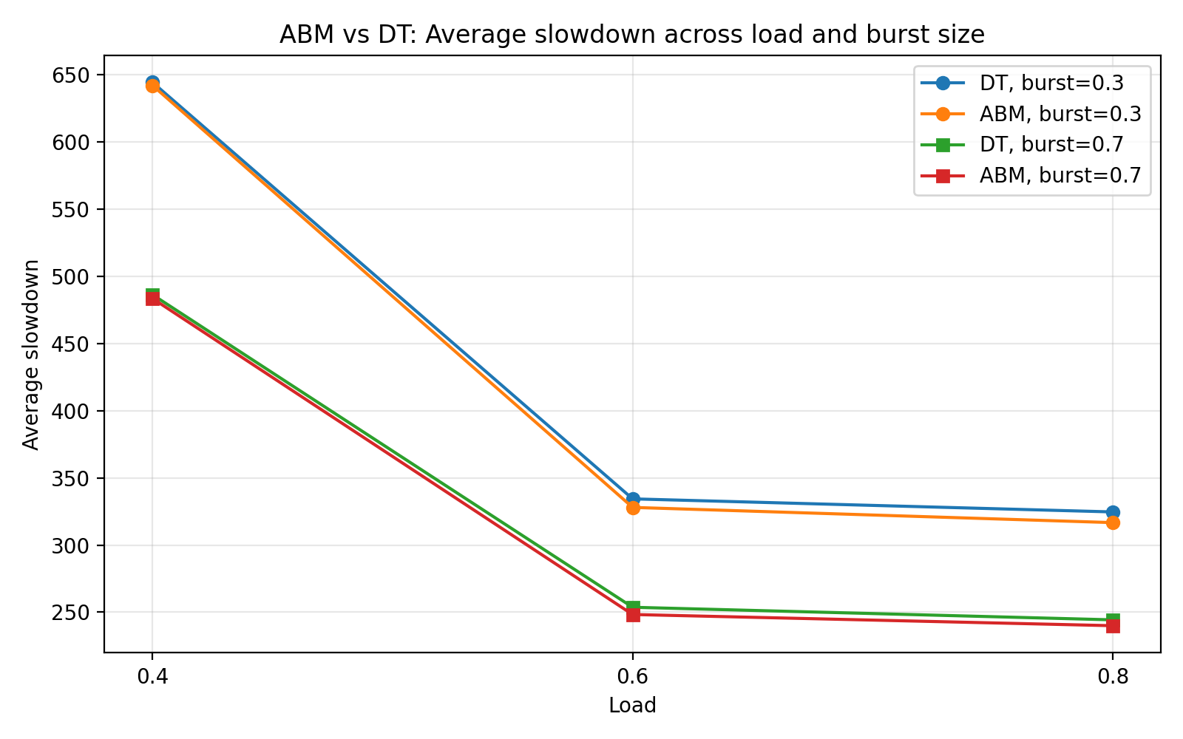
The average slowdown plot makes the main story clear: ABM stays slightly below DT across loads, for both burst sizes.
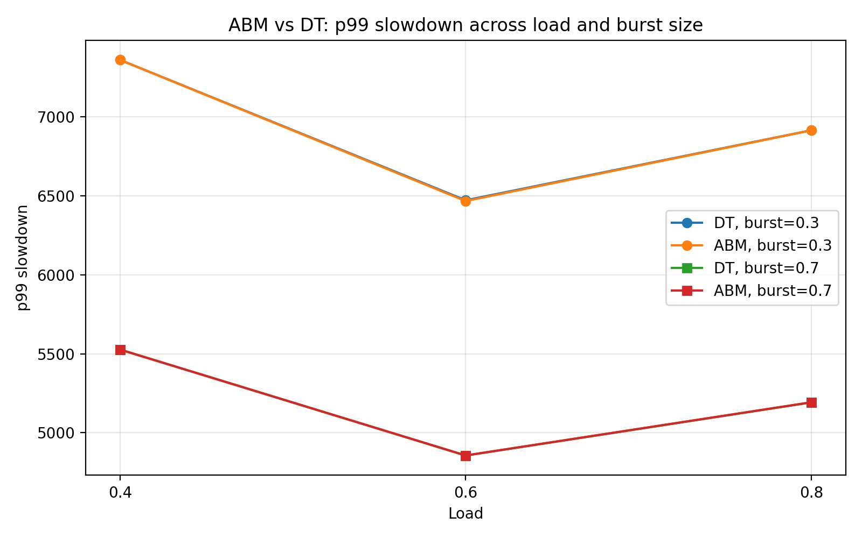
The p99 plot shows the lines almost overlapping, which supports your finding that ABM has little tail-latency effect in this setup.
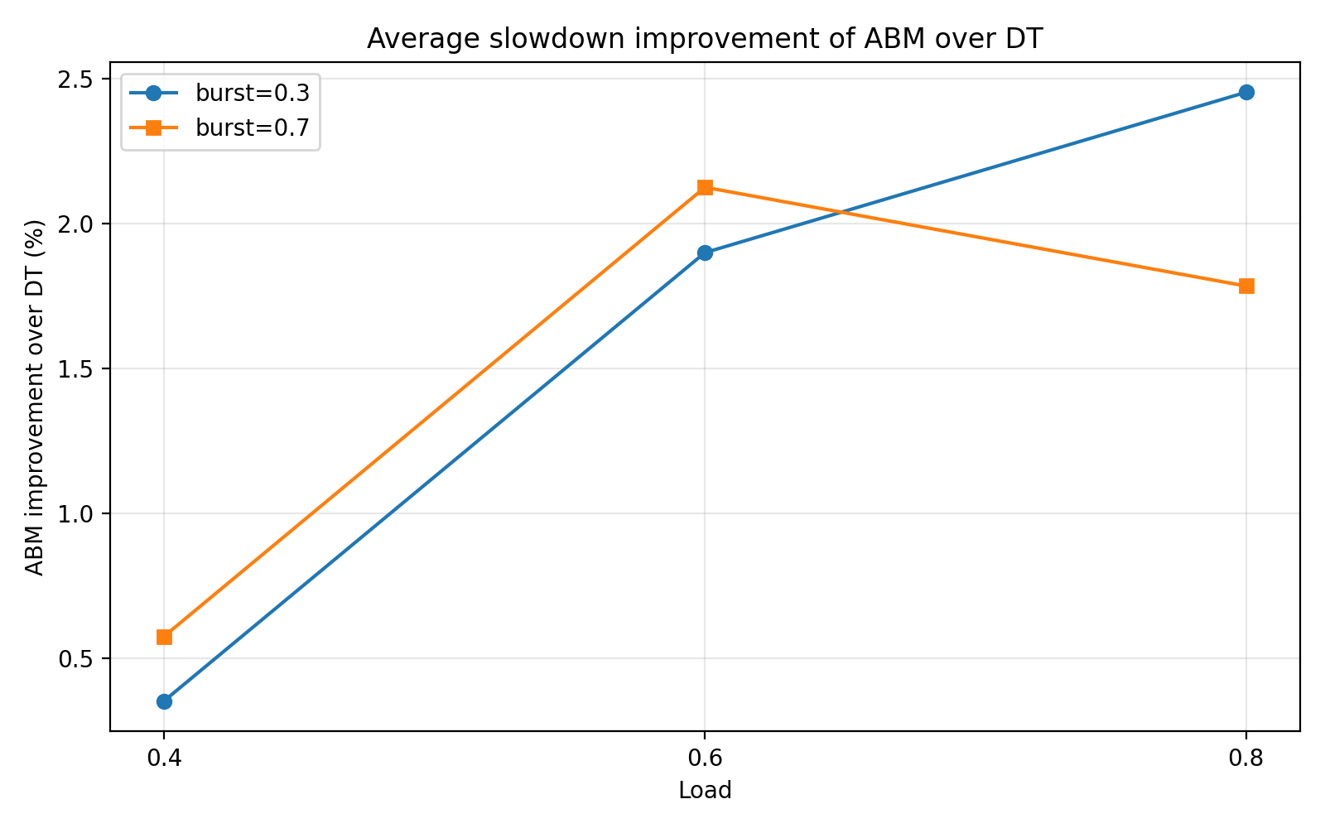
The improvement plot shows percent gain from ABM over DT.

Research question -
When does ABM actually help? A reduced-scale empirical study of load, burstiness, and incast pressure in datacenter buffer sharing.

Experiment 3
Impact of Incast Intensity on ABM vs DT

1. Objective
The objective of this experiment is to evaluate how Adaptive Buffer Management (ABM) compares to Dynamic Threshold (DT) under varying levels of incast intensity.
Specifically, we aim to answer:
- How does increasing incast arrival rate affect network performance?
- Does ABM provide stronger benefits under higher incast pressure?
- Does ABM improve tail latency (p95/p99) under severe congestion?

2. Experimental Setup
- Simulator: ns3-datacenter (ns-3 based)
- Execution environment: Docker (Linux)
- Topology (reduced scale):
  - Servers: 16
  - Leaf switches: 2
  - Spine switches: 1
- Transport protocol: TCP (Cubic)
- Buffer management algorithms:
  - DT (baseline) → 101
  - ABM → 110

Traffic Model
The workload consists of:
- Background flows generated from a websearch CDF
- Incast/query flows generated using:
  - queryRequestRate (Poisson arrival rate)
  - requestSize (fixed at 0.3 × buffer)

Parameters
- Load: 0.4, 0.6, 0.8
- Incast arrival rate: 1, 2, 5
- Request size: fixed (0.3 × buffer)
- Simulation duration: short (reduced for efficiency)

3. Experiment Design
We vary:
- Load (network utilization)
- Incast arrival rate (frequency of bursts)
while keeping:
- request size constant
- topology constant
For each configuration, we collect:
- Average flow slowdown
- p95 slowdown
- p99 slowdown
- Maximum slowdown

4. Results

4.1 Average Slowdown

Load | Rate | DT | ABM
0.4 | 1 | 303.51 | 301.86
0.4 | 2 | 644.46 | 642.19
0.4 | 5 | 727.27 | 725.05
0.6 | 1 | 146.40 | 142.52
0.6 | 2 | 334.40 | 328.05
0.6 | 5 | 659.66 | 653.55
0.8 | 1 | 205.01 | 200.41
0.8 | 2 | 324.68 | 316.72
0.8 | 5 | 553.37 | 541.66
4.2 Tail Latency (p99 Slowdown)
Load | Rate | DT | ABM
0.4 | 1 | 6077.8 | 6077.8
0.4 | 2 | 7360.0 | 7360.0
0.4 | 5 | 7440.2 | 7440.2
0.6 | 1 | 4770.9 | 4768.4
0.6 | 2 | 6471.8 | 6467.0
0.6 | 5 | 7292.6 | 7288.1
0.8 | 1 | 5038.0 | 5039.9
0.8 | 2 | 6914.7 | 6914.3
0.8 | 5 | 7051.9 | 7051.4

5. Observations

1. Incast intensity strongly impacts performance
- Increasing queryRequestRate significantly increases average slowdown
- Example (load = 0.6):
  - rate 1 → 146
  - rate 5 → 659
Incast rate is the dominant factor affecting performance

2. ABM consistently improves average slowdown
- ABM outperforms DT in all configurations
- Improvement is modest (~1–3%)
- Improvement remains stable across all incast rates

3. Tail latency remains largely unchanged
- p95, p99, and max slowdown are nearly identical
- ABM does not reduce worst-case congestion

6. Conclusion
Overall:
- ABM provides robust but modest average improvements
- It does not address tail latency under heavy incast
- Incast arrival rate has a much stronger impact than buffer management strategy

