**DBMS: LAB 7**

**JOINS AND AGGREGATE FUNCTIONS**

**University Fest Management System**

**INSTRUCTIONS**

* In Lab 7 you are expected to solve 2 tasks that are to be completed and submitted.
* For this Lab, you would have to continue with the University Fest DB given to you last week for tasks 2.
* As a part of LAB 3, there are 2 tasks that are to be completed as described below:
  + **TASK 1:** A small case study on a random database has been given. You would have to understand or look through the entries in the tables and answer if the commands given are executable (then output) or not (then reason), along with the reasons. (NO NEED FOR ANY EXECUTION)
  + **Task 2:** This is the last task. Here, there will be 3 questions and you are expected to understand the questions and write the queries to solve them. Support each question with the corresponding screenshot.
* Ensure that your mysql **command client prompt is modified as per your SRN** using the command:

**prompt YOUR_SRN>**

* An example of how your command line prompt should look is given in the “EXAMPLE” section. Note that this step is **mandatory**.
* The screenshots that are to be taken for each task are specified in detail below “EXAMPLE”.
* As a part of the submission process, the following are to be submitted:
  + A **PDF** document, containing all the Screenshots for all 3 tasks as suggested
    - Name of the file: `<your SRN>_University_Fest_DB_Lab3.pdf`

**Example:**

Refer to the sample submissions given below. This will give you an idea about the details that must be included in your submissions

**NOTE:** Screenshots must be taken from “**Command Line”.**

**Changing your command line prompt:**

Before :



prompt PES1UG20CS183>

After:

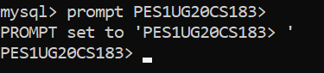

**TASK 1:**

***CASE STUDY 1***

Consider the following database as shown below: (Question 1&2)

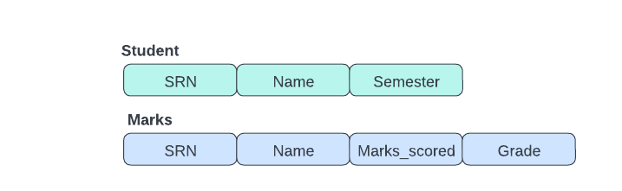

* The "Student" table stores information about students like SRN, name, and semester.
* The "Marks" table contains information about which student gets what marks and grades for a given subject name.
* Note that there are no primary keys and foreign key constraints placed in the above case study

For the next two questions (questions 1 & 2) answer based on the above case study.

**Question 1**

Considering the entries in the “student” and “marks” tables, can the following query be executed successfully? If yes what is the output? If no what would be the error?

Student table: Marks table:

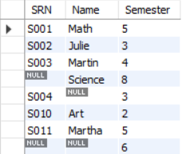 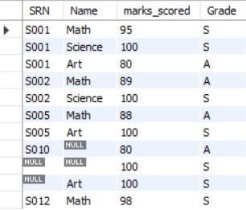

* ***SELECT * FROM Student NATURAL JOIN Marks;***

**Question 2:**

Considering the entries in the “student” and “marks” tables as shown above. A student was asked to make a full outer join on the above two tables. The query written by the student and the output is given to you below:

Query :

* ***(SELECT * FROM student NATURAL LEFT OUTER JOIN marks)***

***UNION***

***(SELECT * FROM student NATURAL RIGHT OUTER JOIN marks);***

Output :

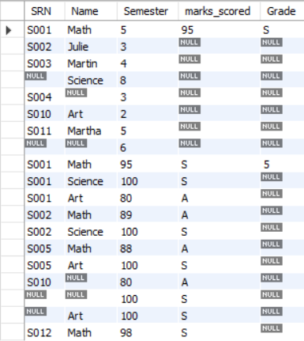

Examining the above-given query and the output screenshot, is the task assigned to the student satisfied? If not what could be the possible reason for the same? And also suggest what would be the correct way that the student should have taken to do it.

***CASE STUDY 2***

Consider the following database as shown below: (Questions 3&4)



* The "Demo" table stores random information that includes ID, name, and grade.
* The description of the demo table is as shown:

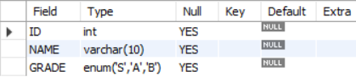

* Note that there are no primary keys and foreign key constraints placed in the above case study

For the next two questions (questions 3 & 4) answer based on the above case study. The screenshots of input values for the demo table are as shown.

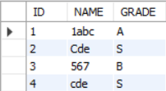

**Question 3:**

Considering the above case study, what would be the output for the given below commands?

* ***SELECT * FROM Demo ORDER BY Name DESC;***
* ***SELECT * FROM Demo ORDER BY Name;***

**Question 4:**

A student was asked to order the entries of the demo table given above by the Grade column. The query written by the student and the output is given to you below:

Query:

* ***SELECT * FROM Demo ORDER BY Grade;***

Output:

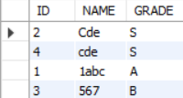

The result, however, was different from what the student expected. Since A occurs before B and B occurs before S in alphabetical order, the student assumed that all records with grade 'A' would be listed first, followed by all records with grade 'B' and finally by all records with grade 'S'. Can you explain why the result is different from the student's expectation?

***CASE STUDY 3:***

Consider the following database as shown below: (Question 5)



* The "Sample" table stores random information that includes ID, Semester, Section, Gender.
* The description of the demo table is as shown: 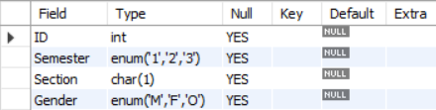
* Note that there are no primary keys and foreign key constraints placed in the above case study

The values in the Sample table are as shown below:

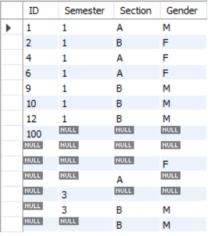

Two students (Student A and Student B) were given the task of finding out the number of students in each section of the semester. The two students had come up with the following queries:

Student A:

* ***SELECT semester, section, COUNT(gender) AS section_total***

***FROM Sample_group***

***GROUP BY semester, section***

***ORDER BY semester, section;***

Student B:

* ***SELECT semester, section, COUNT(*) AS section_total***

***FROM Sample_group***

***GROUP BY semester, section***

***ORDER BY semester, section;***

You have to examine how many of the above queries are correct and able to achieve the given task. If any query is incorrect what would be the reason for the same?

**NOTE:** Both queries could be incorrect.

**Task 2:**

Understand the various scenarios described in the given questions and write the corresponding SQL queries for the same. Support your answers with the help of the screenshot.

**Question 1**

**There are many events that are hosted in the university. You are an analyst who has been given the task of identifying which events have more female participants than male participants.**

**NOTE:**

* The output should have the event_id and the event_name only.

//Add screen shot of query and output

**Question 2:**

**Every fest has a number of stalls associated with it. Each stall could offer items that are only VEG, only NON-VEG, or both. As a stall management head, you are expected to find out the total number of veg items, and non-veg items sold in each stall present in the database.**

**NOTE:**

* If there are no items of a particular category, do not display that category.
* Order the output by the name of the items in descending order, and then type.
* In ordering the items always VEG should come before NON-VEG if the stall sells both items
* The output should contain name of the stall, type of item, and the count value corresponding called as Item_count

**Question 3 for students to solve:**

**Every participant can have zero or more number of visitors. As an analyst, you are given a task to find out the participants along with the list of all the visitors and the corresponding visitors count.**

NOTE:

* If there is a participant P with visitors V1, V2 then the table entry corresponding to it would be as shown:

|  |  |  |
| --- | --- | --- |
| Participant | Visitor_list | Visitor_count |
| P | V1, V2 | 2 |

* If there is a participant P1 with no visitors then the table entry corresponding to it would be as shown:

|  |  |  |
| --- | --- | --- |
| Participant | Visitor_list | Visitor_count |
| P1 | NULL | 0 |

**Expected OUTPUT:**

