**BASIC PYTHON EXERCISE-1:**

**1.Read a CSV file with data in multiple columns and compute mean, median mode of each of the columns.**  
import pandas as pd

import matplotlib.pyplot as plt

data = pd.read_csv('task1.csv')

numeric_columns = ["runs", "batting average", "strike rate"]

data[numeric_columns].plot(marker='o')

plt.ylabel('Values')

plt.title('Data Display')

plt.show()

**Output:**

name runs batting average strike rate

0 rohit 100 45.8 100

1 kl rahul 200 38.7 200

2 hardik 300 65.8 128

3 virat kohli 120 55.4 136

4 suryakumar 250 77.5 145

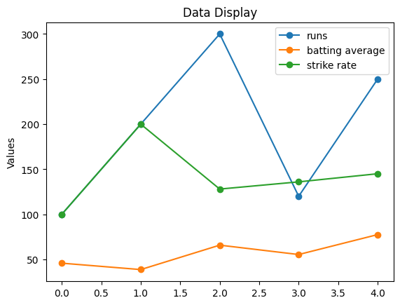

import pandas as pd

import matplotlib.pyplot as plt

data = pd.read_csv('task1.csv')

print(data.to_string())

mean_runs = data['runs'].mean()

mean_batting_avg = data['batting average'].mean()

mean_strike_rate = data['strike rate'].mean()

print(f"\nMean Runs: {mean_runs}")

print(f"Mean Batting Average: {mean_batting_avg}")

print(f"Mean Strike Rate: {mean_strike_rate}")

mean_values = [mean_runs, mean_batting_avg, mean_strike_rate]

plt.plot(numeric_columns, mean_values, marker='o')

plt.ylabel('Mean Value')

plt.title('Mean Statistics')

plt.show()

**Output:**

Mean Runs: 194.0

Mean Batting Average: 56.64000000000001

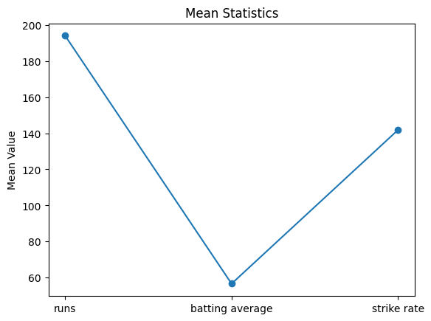Mean Strike Rate: 141.8

import pandas as pd

import matplotlib.pyplot as plt

data = pd.read_csv('task1.csv')

numeric_columns = ["Runs", "Batting average", "Strike rate"]

median_values = data[numeric_columns].median()

print(data.to_string())

print(median_values)

median_values.plot(marker='o')

plt.ylabel('Median Value')

plt.title('Median Statistics')

plt.show()

**Output:**

Runs :200.0

Batting average : 55.4

Strike rate :136.0

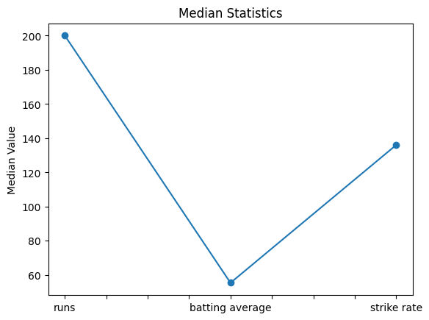

import pandas as pd

import matplotlib.pyplot as plt

data = pd.read_csv('task1.csv')

numeric_columns = ["Runs", "Batting average", "Strike rate"]

mode_values = data[numeric_columns].mode().iloc[0]

print(data.to_string())

print("Mode values:")

print(mode_values)

mode_values.plot(marker='o')

plt.ylabel('Mode Value')

plt.title('Mode Statistics')

plt.show()

**Output:**

Runs :100.0

Batting average: 38.7

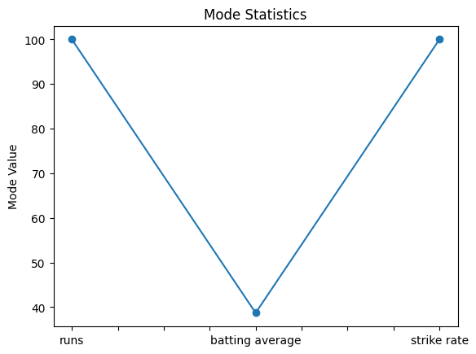Strike rate:100.0

3.Create a game like lottery and write a python code to record how many times the computer won and the user won in an excel file. Plot the graph showing the success rate of user and computer with different colours.

import random

import pandas as pd

computer_wins = 0

user_wins = 0

for i in range(10):

computer = random.randint(1, 9)

user_input = int(input("Enter the number between 1 and 9: "))

print(f"Computer: {computer}")

print(f"User: {user_input}")

if computer > user_input:

print("Computer won")

computer_wins += 1

elif computer == user_input:

print("Tie")

else:

print("You won")

user_wins += 1

data = {"Computer Wins": [computer_wins], "User Wins": [user_wins]}

df = pd.DataFrame(data)

csv_filename = 'output.csv'

df.to_csv(csv_filename, index=False)

print(f"Data saved to {csv_filename}")

**Output:**

Enter the number between 1 and 9: 1

Computer: 1

User: 1

Tie

Enter the number between 1 and 9: 2

Computer: 8

User: 2

Computer won

Enter the number between 1 and 9: 3

Computer: 5

User: 3

Computer won

Enter the number between 1 and 9: 4

Computer: 8

User: 4

Computer won

Enter the number between 1 and 9: 5

Computer: 9

User: 5

Computer won

Enter the number between 1 and 9: 6

Computer: 7

User: 6

Computer won

Enter the number between 1 and 9: 7

Computer: 9

User: 7

Computer won

Enter the number between 1 and 9: 8

Computer: 3

User: 8

You won

Enter the number between 1 and 9: 9

Computer: 8

User: 9

You won

Enter the number between 1 and 9: 0

Computer: 1

User: 0

Computer won

Data saved to output.csv

import pandas as pd

import matplotlib.pyplot as plt

csv_filename = 'output.csv'

df = pd.read_csv(csv_filename)

computer_wins = df['Computer Wins'][0]

user_wins = df['User Wins'][0]

labels = ['Computer Wins', 'User Wins']

values = [computer_wins, user_wins]

plt.bar(labels, values, color=['blue', 'green'])

plt.xlabel('Outcome')

plt.ylabel('Number of Wins')

plt.title('Computer vs User Wins')

plt.show()

