For Multiple consumer and multiple producer method

High level design

Elements are stored internally using contiguous blocks instead of linked lists for better performance. The queue is made up of a collection of sub-queues, one for each producer. When a consumer wants to dequeue an element, it checks all the sub-queues until it finds one that's not empty.
One particular consequence of this design, however, (which seems to be non-intuitive) is that if two producers enqueue at the same time, there is no defined ordering between the elements when they're later dequeued. Normally this is fine, because even with a fully linearizable queue there'd be a race between the producer threads and so you couldn't rely on the ordering anyway.

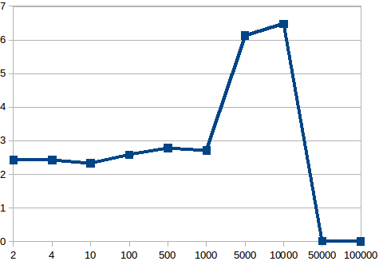

Fixing size of 1)queue = 100000 2) consumer =2

graph of throughput vs producers

producer || throughput

Fixing size of 1)queue = 100000 2) producer =10

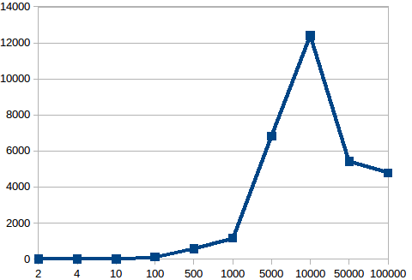

graph of throughput vs consumer

consumer || throughput

fixed producer = 2 consumer = 10

graph of throughput vs size of queue

size of queue || throughput

Single Producer and Consumer parallelism

Another method code has been implemented by me by mainaining locks on just two pointers head and tail of the queue

