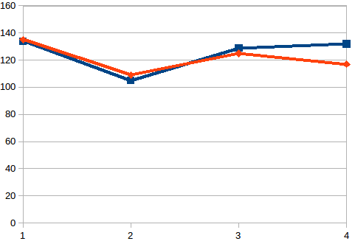

Graph of no. Of processes vs time for row_wise and column_wise size fixed to 900

red represent row wise
blue column wise

Graph of size vs time for row_wise and column_wise no. Of processes fixed to 4

Also Red is column_wise
blue row_wise

