Pi can be calculated using the following equation: π = 4 * ∫ 1 / (1+x^ 2) dx

It can be calculated by computing the area under the curve using trapezoidal rule

With OpenMP, it can be parallelized using “#pragma omp parallel for” clause.
To avoid a race condition, two methods can be utilized:
1. Use critical clause (Consider as naive version)
2. Use reduction (Consider as optimized version)

The time taken wrt. precision is shown below.

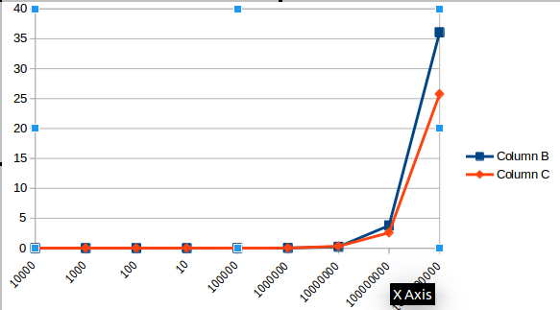
Column B represents critical clause
Column C represents reduction clause

I have fixed the no. Of threads to 4

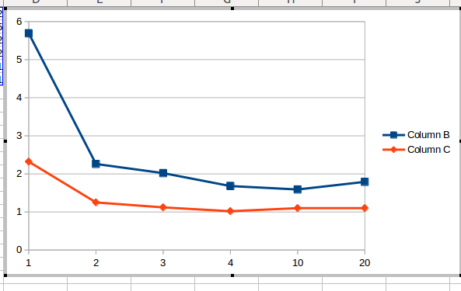

Here I have fixed the no. Of iterations to 1000000

Speedup = T_{s} / T_{p}

Number of Threads | Speedup (Critical clause) | Speedup (Reduction clause)
2 | 2.648 | 1.811
3 | 2.816 | 2.039
4 | 3.295 | 2.277
10 | 1.66 | 2.09
20 | 3.101 | 2.09

