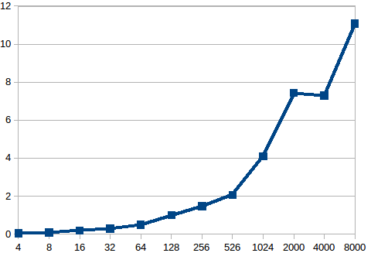
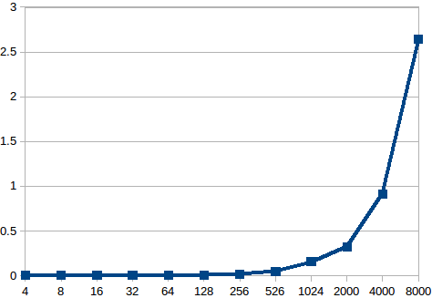

Size of the problem vs time taken in my karatsuba(hybrid though) implementation

Size of the problem vs time taken in my fft implementation

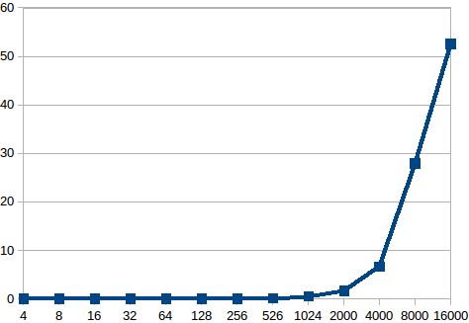

Keeping no. Of processes fixed at 4 time v/s size of problem for niave implementation

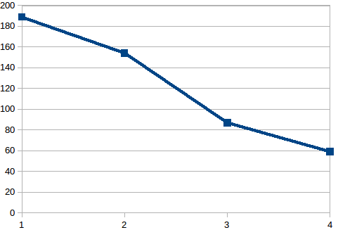

Keeping size of problem fixed at n=16000
Plot for time vs no. Of proocesses graph

