INDEX PAGE
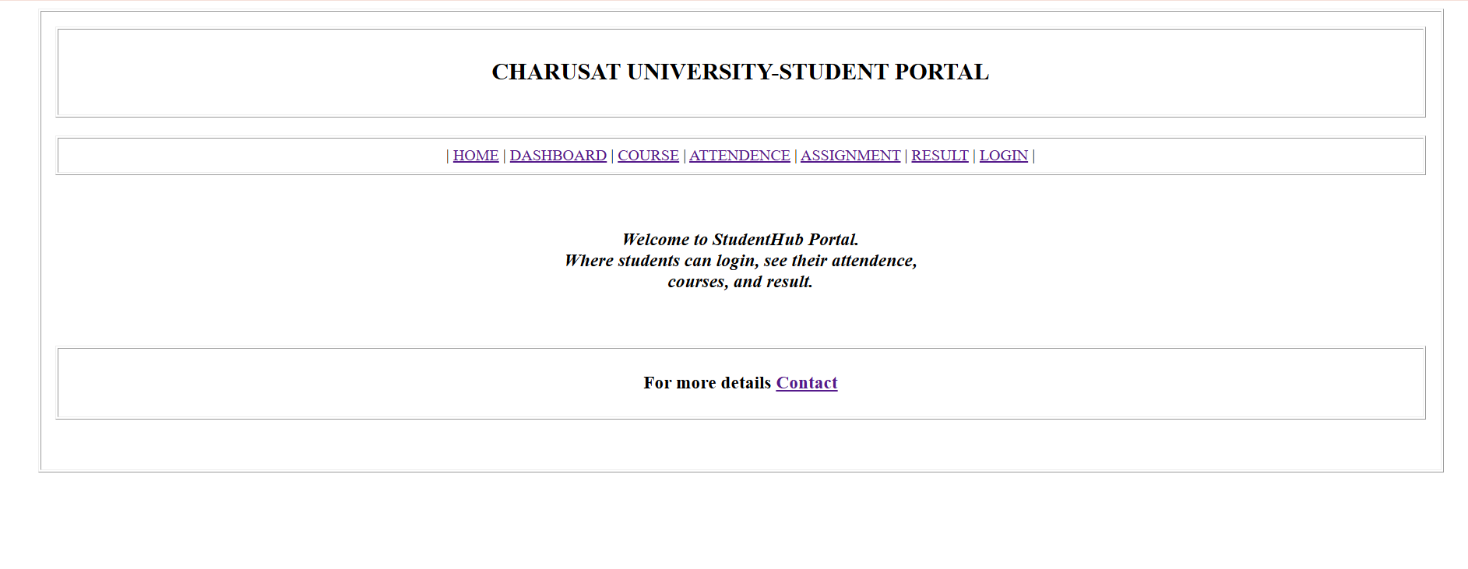
CONTACT PAGE
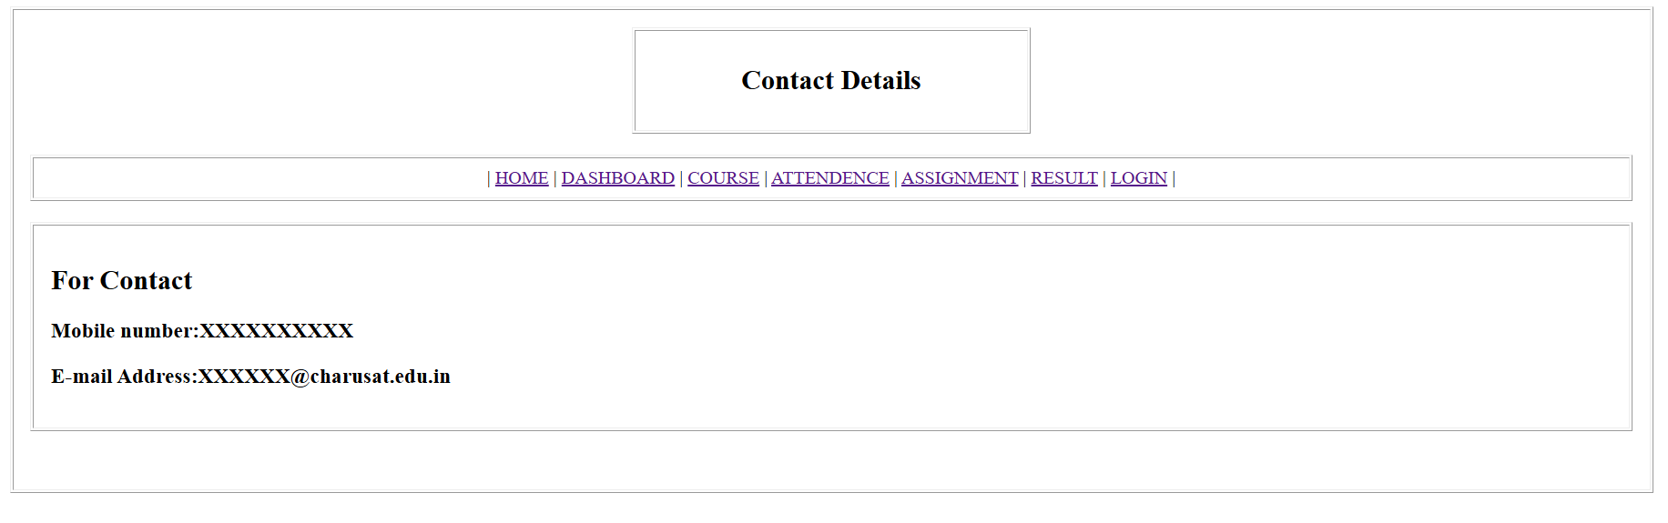

ASSIGNMENT PAGE
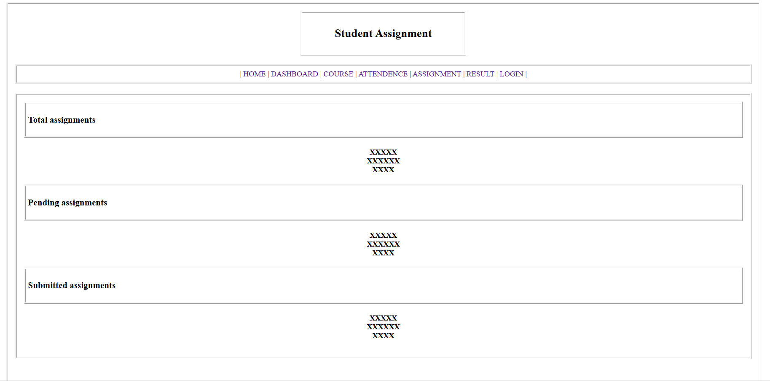

ATTENDENCE PAGE
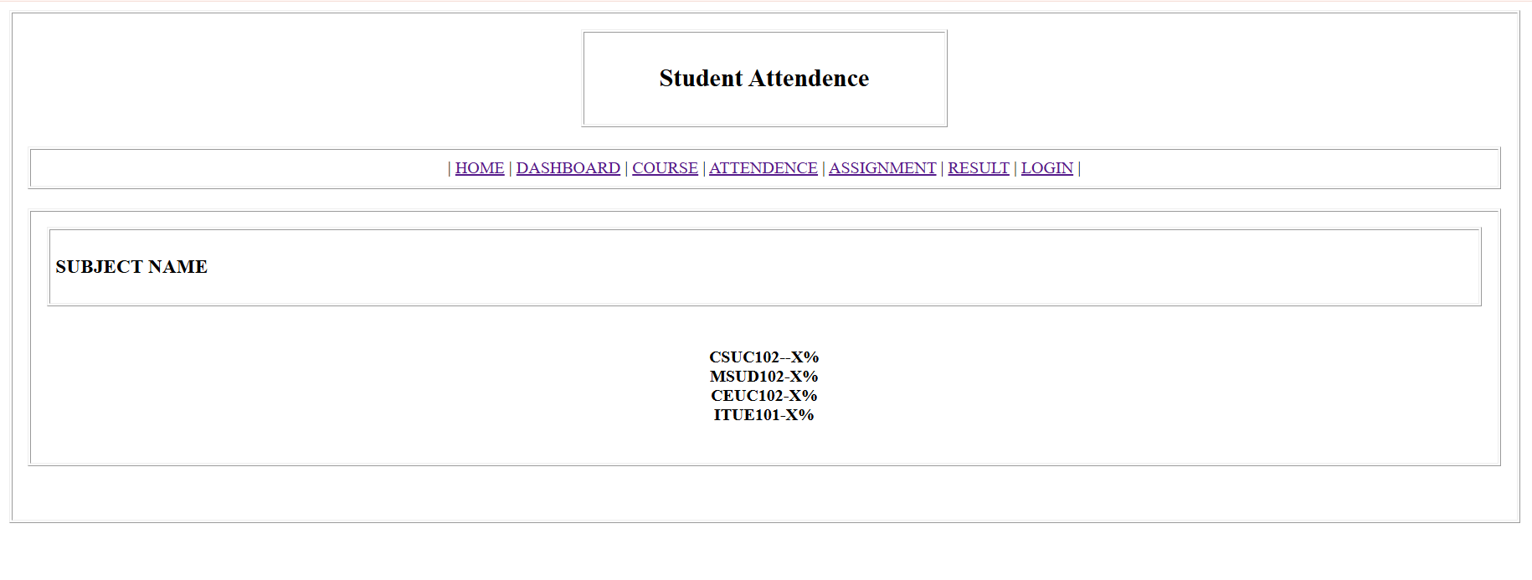

COURSE PAGE
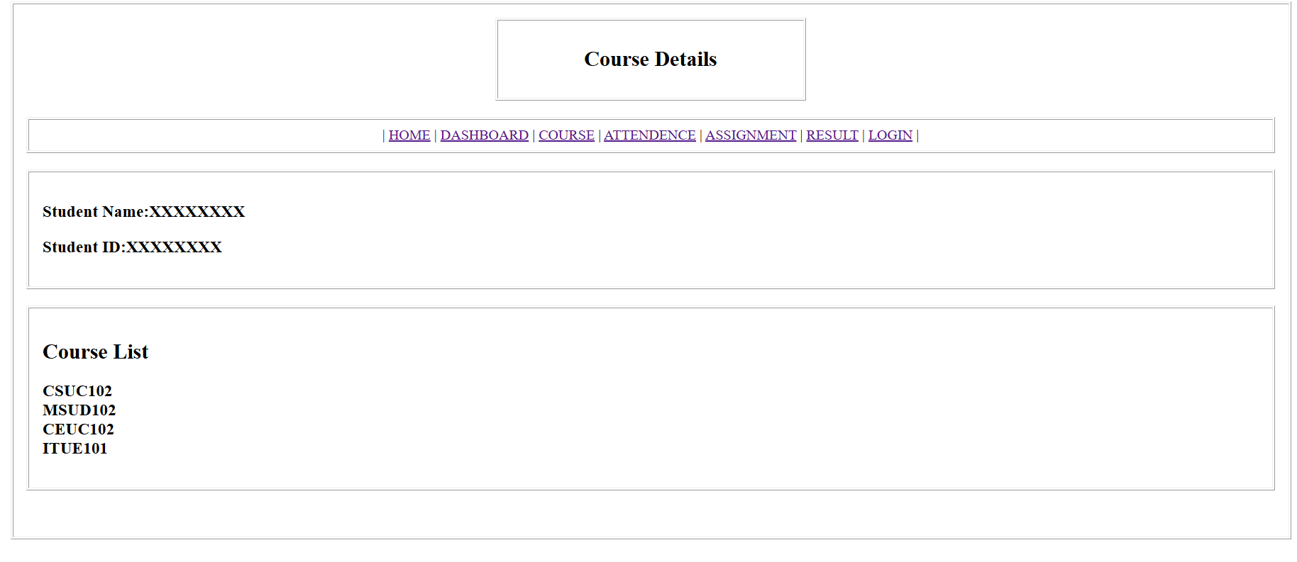

DASHBOARD PAGE
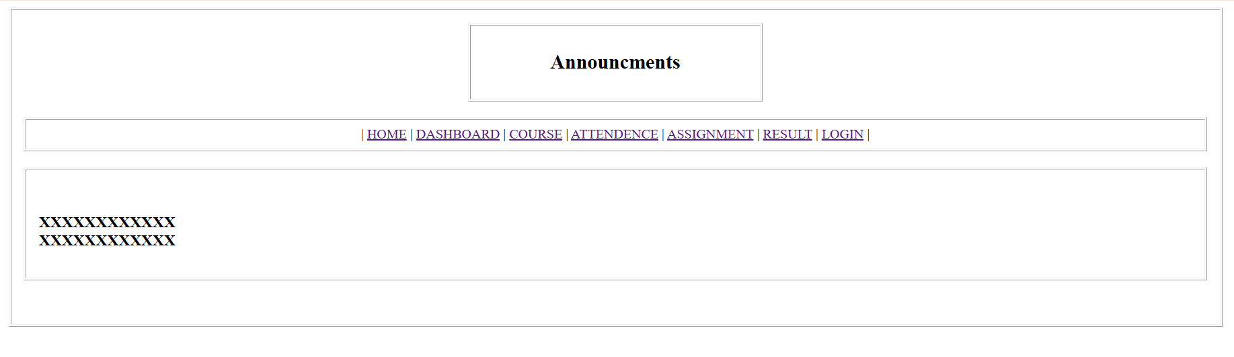

LOGIN PAGE
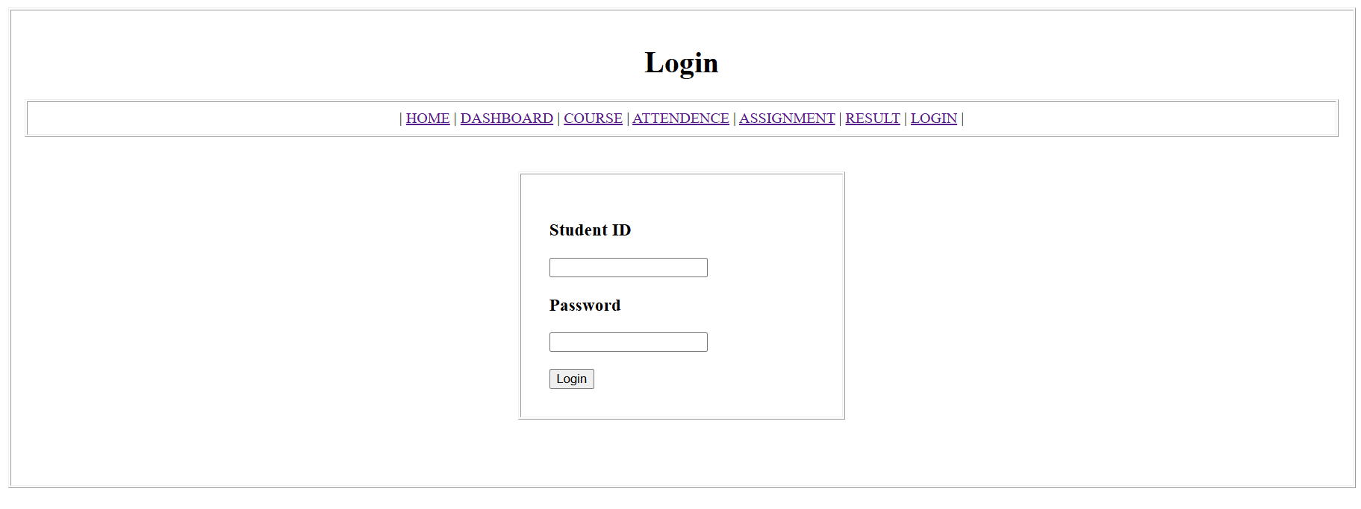

PROFILE PAGE
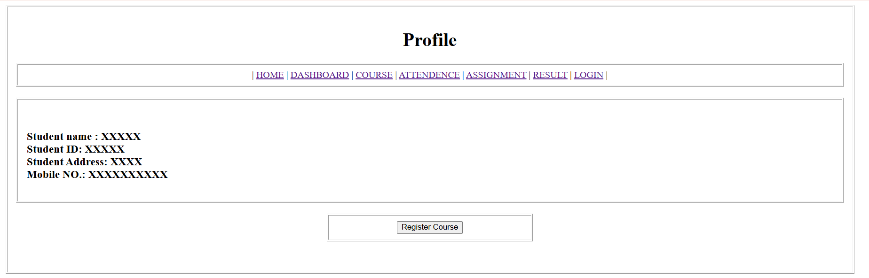

REGISTER PAGE
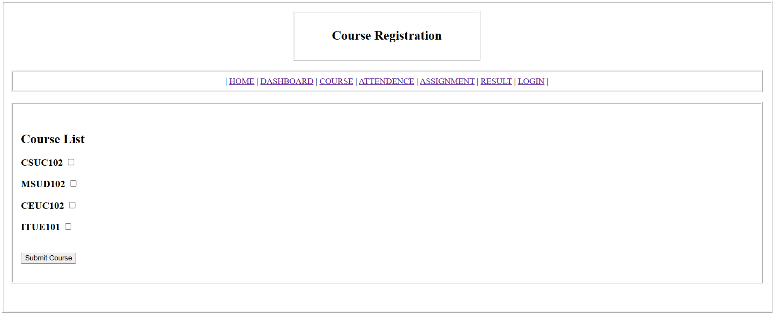

RESULT PAGE
