Practical - 2
Practical Title: Project Initiation, Requirement Analysis, Sitemap, Wireframe, and GitHub Setup

Develop static HTML5 skeletons for at least 10 StudentHub pages such as

Home, About, Register, Login, Dashboard, Events, Profile, Contact,

Admin, FAQ, and Feedback. Use semantic tags and accessibility-friendly

structure.

Theory
1. Are semantic tags such as header, nav, main, section, article, aside, and
footer used properly?
Yes, <nav> is used properly for navigation, though layout relies mainly on <table> elements for the boxed frame design.
2. Are form labels, headings, image alt text, and navigation links
Accessible?
Yes, headings and nav links are clean and readable, but adding explicit <label> tags for inputs will make form accessibility complete.
3. Is the page structure consistent across all pages?
Yes, every page uses the exact same centered container, header, navigation bar, and section layout for complete consistency.

B. Output
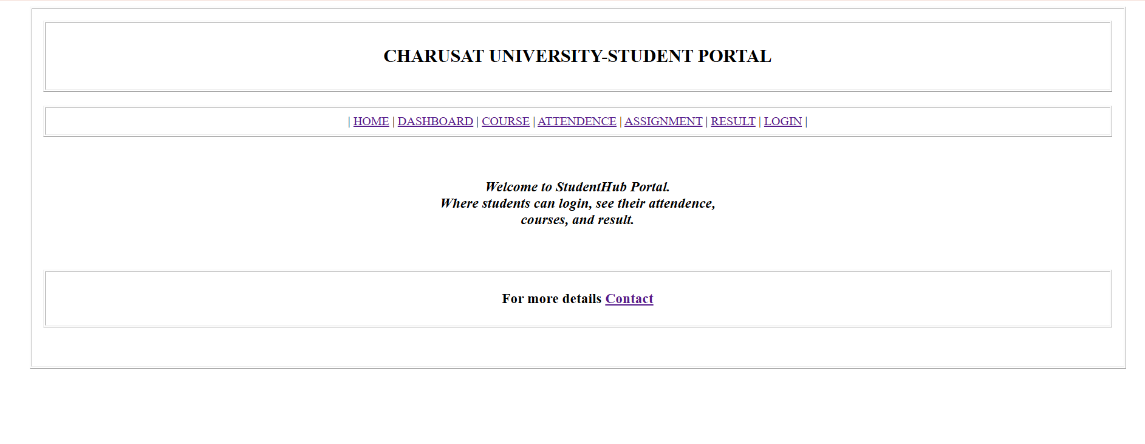
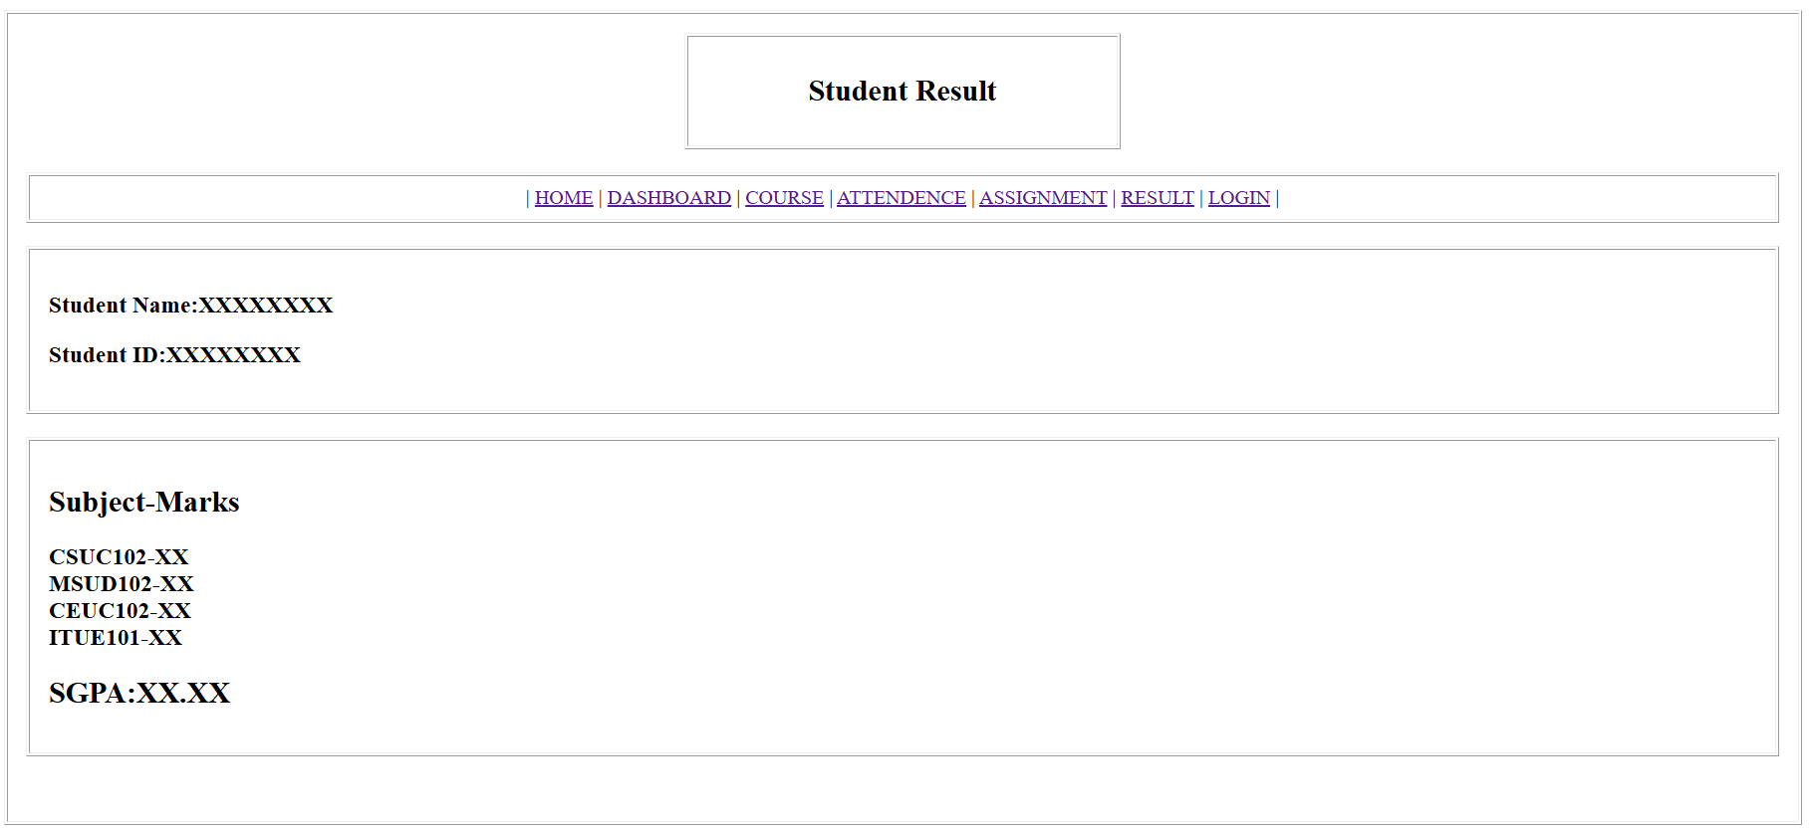
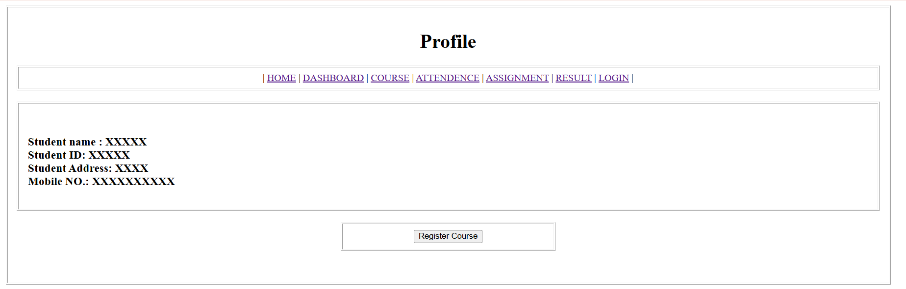

C. Evidence of Work (Screenshots)

Description:
Above picture shows the homepage of website, showing the navigation bar to navigate across website and details of university.
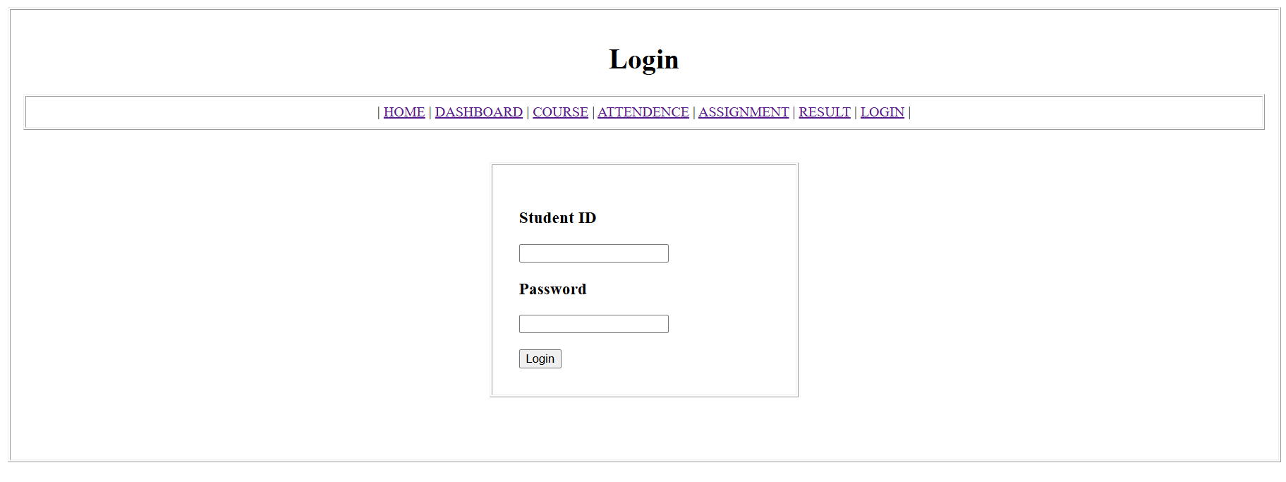

Description:
This page shows the login page of website to log into your account.
D. GitHub Repository Link: https://github.com/shreyajodhani/studenthub.git

E. Challenges Faced:

To keep same design across whole website and maintain spacing and padding.
F. Learning Outcomes:

Through this HTML5 practical, I learned how to structure a complete multi-page web portal using clean HTML tags, semantic elements, tables, and functional form inputs.

Faculty Remarks: (Keep this blank for faculty)

