Practical - 1
Practical Title: Project Initiation, Requirement Analysis, Sitemap, Wireframe, and GitHub Setup

Problem Definition: Initiate the semester-long StudentHub portal by identifying the problem scope, user roles, key modules, navigation flow, and minimum 10 pages. Create a sitemap, low-fidelity wireframe, project folder structure, README file, and GitHub repository.

Theory

What is URL and parts of URL?
Answer:
A URL (Uniform Resource Locator ) is a unique web address used to find and access resources online.
scheme(protocol): shows the rule or method used to talk to server, like http or https.
Domain: web server address hosting the resources.
Path: points to specific file or directory on server.

How does HTML file process in web browser?
Answer:
Fetch: The browser downloads your HTML code from the web server (or your computer).
Parse: It reads the HTML code top-to-bottom and converts all the tags (<table>, <h2>, <p>) into a structure called the DOM (a tree map of your page).
Style & Layout: If you have a CSS file linked, the browser reads your styles and calculates where each box, text, color, and border goes on the page.
Paint: The browser draws the final pixels onto your screen so you see the complete webpage.

3. How will page navigation flow managed among all HTML pages?
Answer:
Using a navigation bar - adding <nav> header with links (for ex. <a href=”....”>.)
Using clean perfect links so right page opens.

4. How will GitHub commits be maintained after each practical?
Answer:
GitHub commits will be maintained by:
- After every lab session push code to github and commit it.
- Writing simple commit message, telling what work has been done.

B. Output
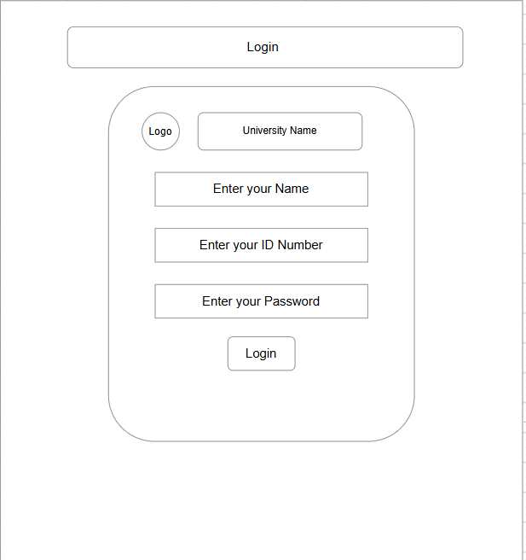
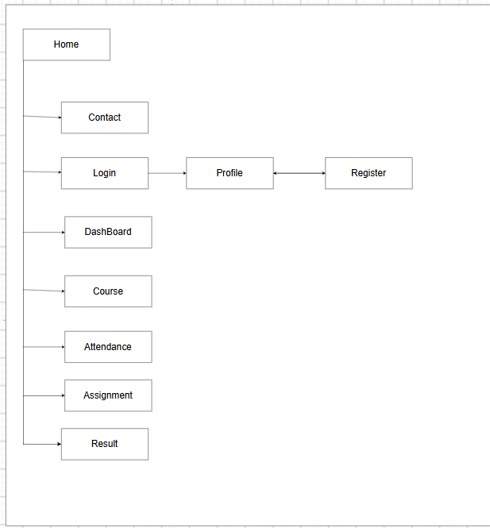

C. Evidence of Work (Screenshots)
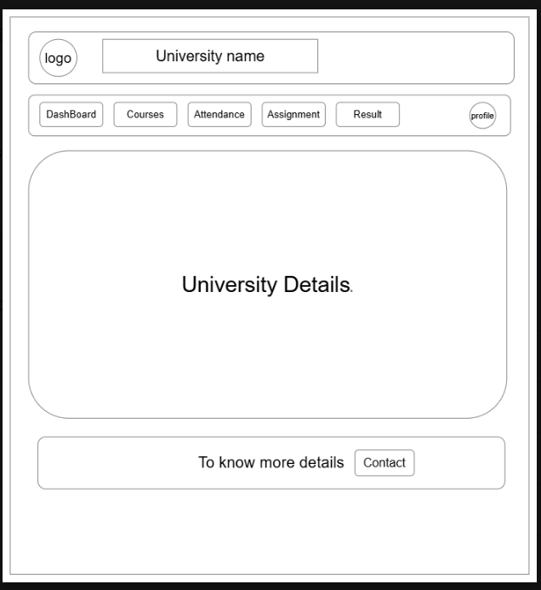
Description:
Wireframe of the index page of studenthub website. Featuring navigation bar to navigate through website, and showing basic details of university.

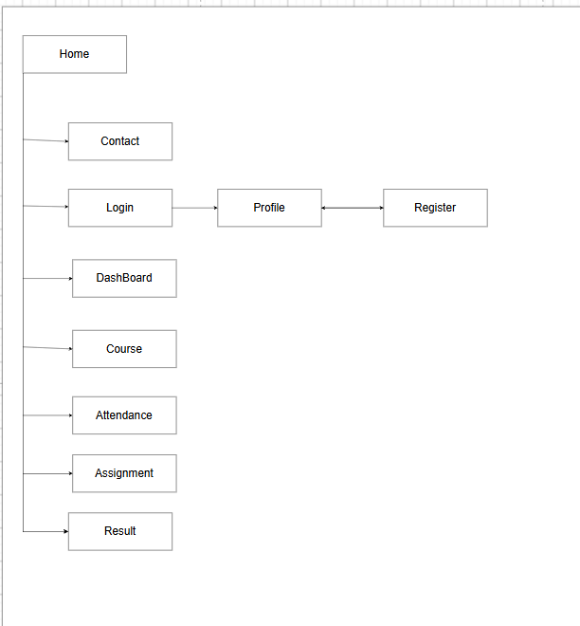
Description:
Above picture shows sitemap of app, listing all pages and path of website to make navigation easy for users.

D. GitHub Repository Link: https://github.com/shreyajodhani/studenthub.git

E. Challenges Faced:
To gather perfect information for app structure.

F. Learning Outcomes:
Requirement analysis: learn how to gather info for what will be added in app, and what user needs.
Wireframe: what will be visuals of app before we start implementing.
Sitemap: to put important information in one file for easy navigation.

Faculty Remarks: (Keep this blank for faculty)

